Lecture: Correlation vs Linear Models
  - Relationships
Bill Perry

Where We Left Off
Covered last time:
- Study design
- Causality in ecology
- Experimental design: replication, controls, randomization, independence
- Sampling in field studies
- Power analysis: a priori and post hoc
- Study design and analysis
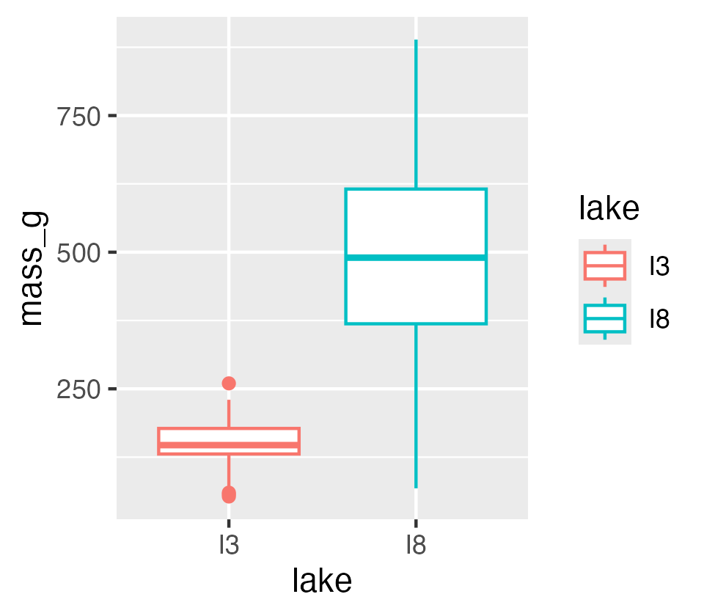

Part 1 · Overview

Today’s Objectives
This lecture covers two fundamental statistical techniques in biology: correlation and regression analysis. Based on Chapters 16–17 from Whitlock & Schluter’s The Analysis of Biological Data (3rd edition), we’ll explore:
- Correlation analysis: measuring relationships between variables
- The distinction between correlation and regression
- Simple linear regression: predicting one variable from another
- Estimating and interpreting regression parameters
- Testing assumptions and handling violations
- Analysis of variance in regression
- Model selection and comparison
 Note
📖 Reference
Whitlock & Schluter, Ch. 16 (Correlation) and Ch. 17 (Regression) are the core references for this entire lecture.

Part 2 · Correlation vs. Regression

Correlation vs. Regression — What’s the Difference?
Correlation Analysis:
- Measures the strength and direction of a relationship between two numerical variables
- Both X and Y are random variables (both measured, neither manipulated)
- Variables are typically on equal footing (either could be X or Y)
- No cause-effect relationship implied
- Quantifies the degree to which variables are related
- Expressed as a correlation coefficient (r) from −1 to +1
Regression Analysis:
- Predicts one variable (Y) from another (X)
- X is often fixed or controlled (manipulated)
- Y is the response variable of interest
- Often implies a cause-effect relationship
- Produces an equation for prediction, with slope and intercept parameters
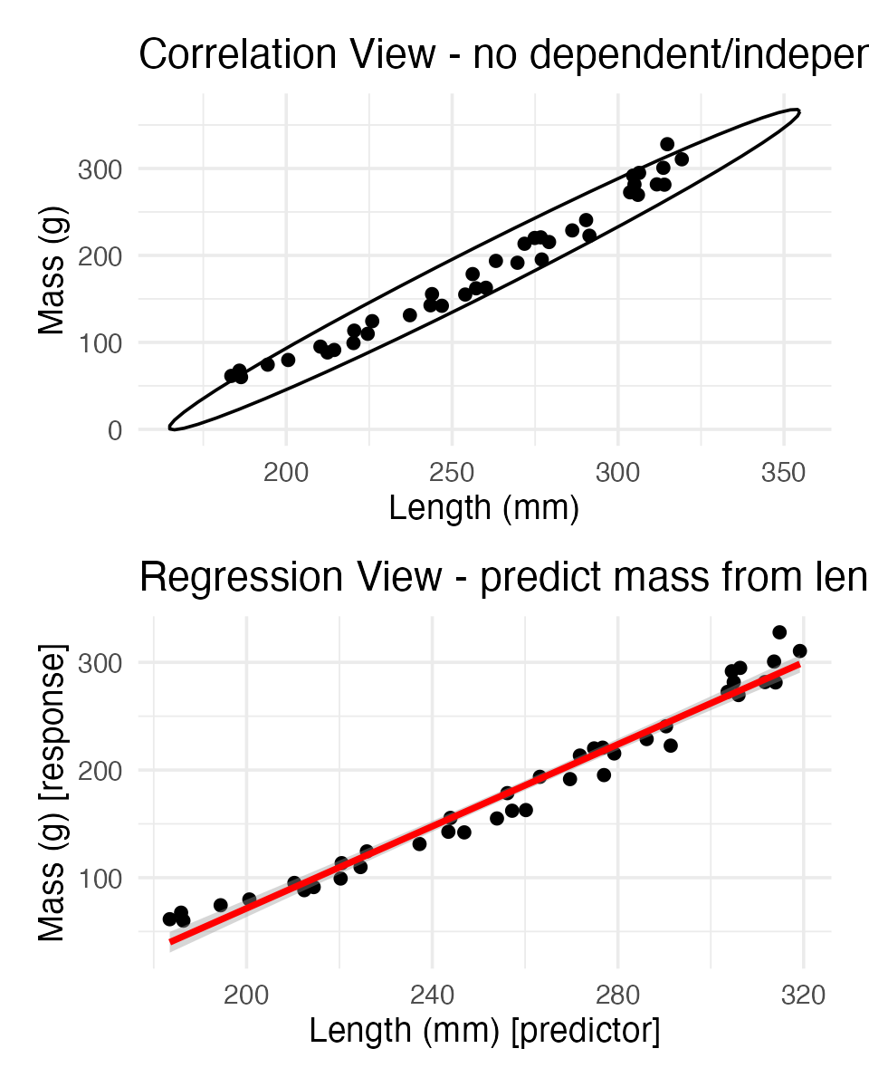

Part 3 · Correlation Analysis

What Is Correlation?
Correlation analysis measures the strength and direction of a relationship between two numerical variables:
- Ranges from −1 to +1
- +1 indicates perfect positive correlation
- 0 indicates no correlation
- −1 indicates perfect negative correlation
The Pearson correlation coefficient (r) is defined as:
r=i​(Xi−X)(Yi−Y)i​(Xi−X)2i​(Yi−Y)2
This can be simplified as:
$$r=\frac{\text{Covariance}(X,Y)}{s_{X}⋅s_{Y}}$$
Where $s_{X}$ and $s_{Y}$ are the standard deviations of X and Y.
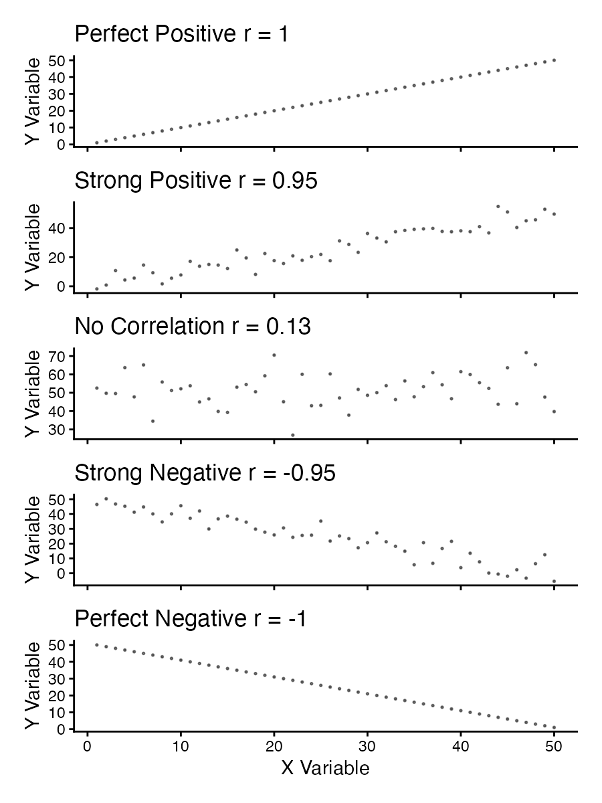

Example 16.1: Flipping the Bird
Nazca boobies (Sula granti) — do aggressive behaviors as a chick predict future aggressive behavior as an adult?
- Correlation is r = 0.534 — a moderate positive relationship
- p-value = 0.007 — correlation is statistically significant
For a Pearson correlation coefficient (r) of 0.53372:
- This is r (not ρ, as Spearman’s below), as indicated by “cor” in your output
- To determine the amount of variation explained, square this value: r² = 0.53372² = 0.2849 (≈ 28.49%)
- Means about 28.49% of the variance in one variable can be explained by the other
Tested by a t-test: $\text{t}=\frac{r}{SE_{r}}$
Pearson's product-moment correlation
data: booby_data$visits_as_nestling and booby_data$future_aggression
t = 2.9603, df = 22, p-value = 0.007229
alternative hypothesis: true correlation is not equal to 0
95 percent confidence interval:
0.1660840 0.7710999
sample estimates:
cor
0.5337225

Example 16.1: Interpretation
Interpretation: the correlation coefficient of r = 0.534 suggests that Nazca boobies who experienced more visits from non-parent adults as nestlings tend to display more aggressive behavior as adults. This supports the hypothesis that early experiences influence adult behavior patterns in this species.
Standard error:
$${\text{SE}}_{r}=\sqrt{\frac{1−r^{2}}{n−2}}$$
SE = 0.180
Need to be sure the relationship is not curved — see below.
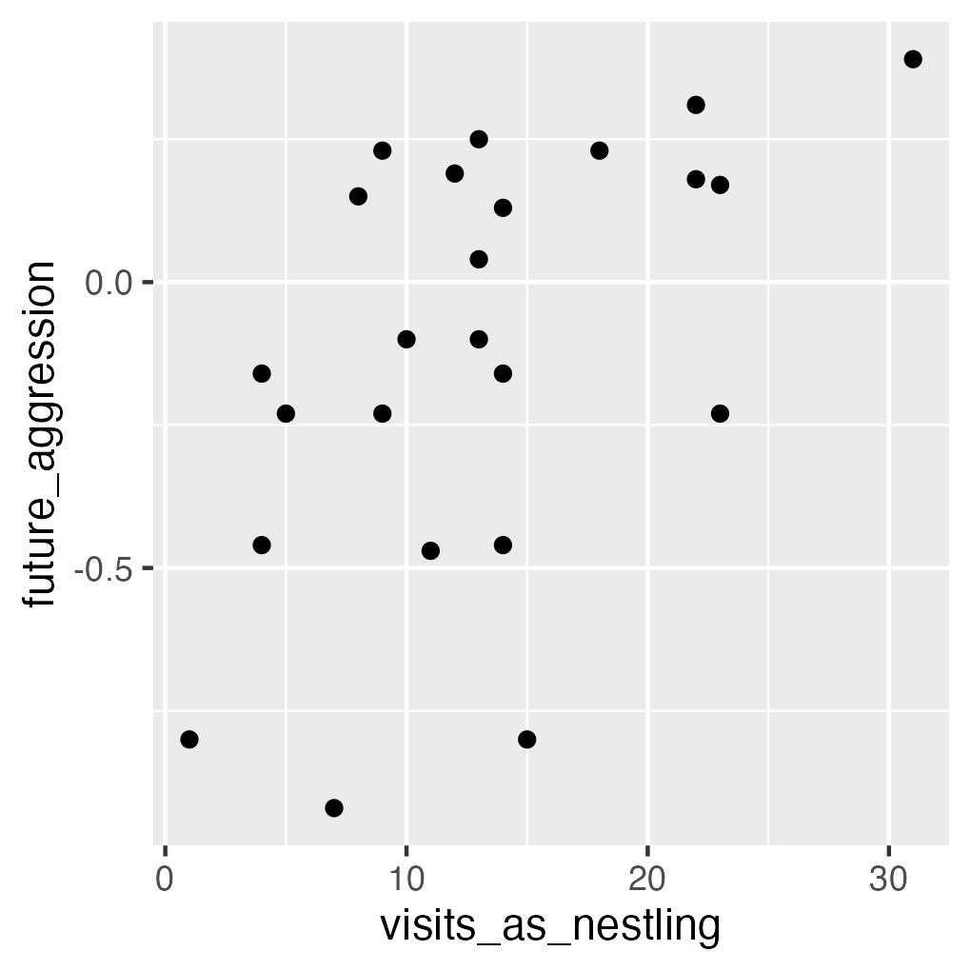

Testing Assumptions for Correlation
Note
🔮 Predict first: We’re about to run Shapiro-Wilk on both booby variables, then look at their histograms and QQ plots. If the formal test and the visual check disagree, which would you trust more for n = 24?

As described in Section 16.3, correlation analysis has key assumptions:
- Random sampling — observations should be a random sample from the population
- Bivariate normality — both variables follow a normal distribution, and their joint distribution is bivariate normal
- Linear relationship — the relationship between variables is linear, not curved
Let’s check these assumptions with the booby data.
Shapiro-Wilk normality test
data: booby_data$visits_as_nestling
W = 0.95783, p-value = 0.3965
Shapiro-Wilk normality test
data: booby_data$future_aggression
W = 0.91575, p-value = 0.04709

Testing Assumptions for Correlation — Visually
As described in Section 16.3, correlation analysis has key assumptions:
- Random sampling — observations should be a random sample from the population
- Bivariate normality — both variables follow a normal distribution, and their joint distribution is bivariate normal
- Linear relationship — the relationship between variables is linear, not curved
Let’s check these assumptions using the booby data.
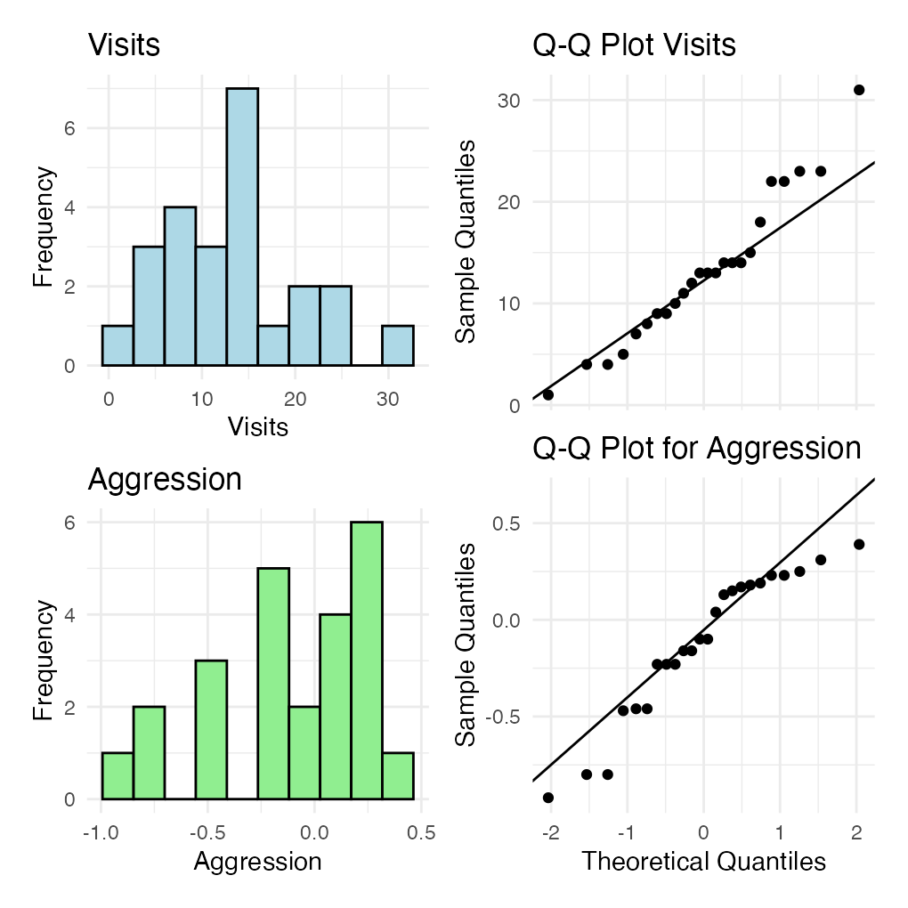

What to Do If Assumptions Are Violated
- Transform one or both variables (log, square root, etc.)
- Use a non-parametric correlation (Spearman’s rank correlation) or Kendall’s tau (τ)
- Examine the data for outliers or influential points
 Tip
🖐 Notice
The lion nose-pigmentation data (used here just as an example of non-normal data) shows a right-skewed proportion_black and clearly non-normal QQ plots — this is exactly when Spearman’s is the better tool.

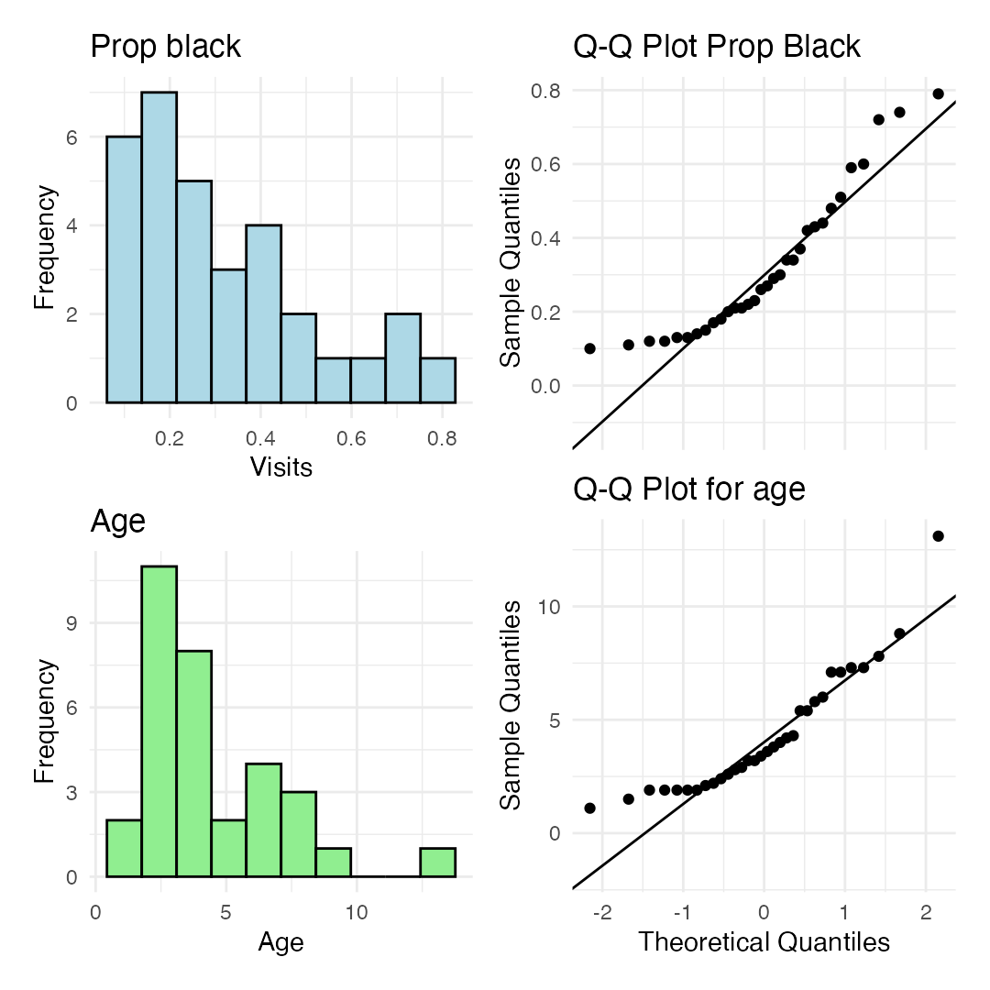

Spearman’s Rho — Interpretation
To understand the amount of variation explained, you can square the non-parametric Spearman’s rho value.
For your value of 0.74485:
$$ρ^{2}={0.74485}^{2}=0.5548$$
This means approximately 55.48% of the variance in the ranks of one variable can be explained by the ranks of the other. This is similar to how R² works in linear regression, but specifically for ranked data.
Spearman's rank correlation rho
data: lion_data$proportion_black and lion_data$age_years
S = 1392.1, p-value = 1.013e-06
alternative hypothesis: true rho is not equal to 0
sample estimates:
rho
0.7448561

Correlation — Important Considerations
- The correlation coefficient depends on the range
  - Restricting the range of values can reduce the correlation coefficient
  - Comparing correlations between studies requires similar ranges of values
- Measurement error affects correlation
  - Measurement error in X or Y tends to weaken observed correlation
  - This bias is called attenuation
  - True correlation is typically stronger than the observed correlation
- Correlation vs. Causation
  - Correlation does not imply causation
  - Three possible explanations: (1) X causes Y, (2) Y causes X, (3) Z (a third variable) causes both X and Y
- Correlation significance test
  - H₀: ρ = 0 (no correlation in population); H₁: ρ ≠ 0
  - Test statistic: t = r / SE(r), with df = n − 2
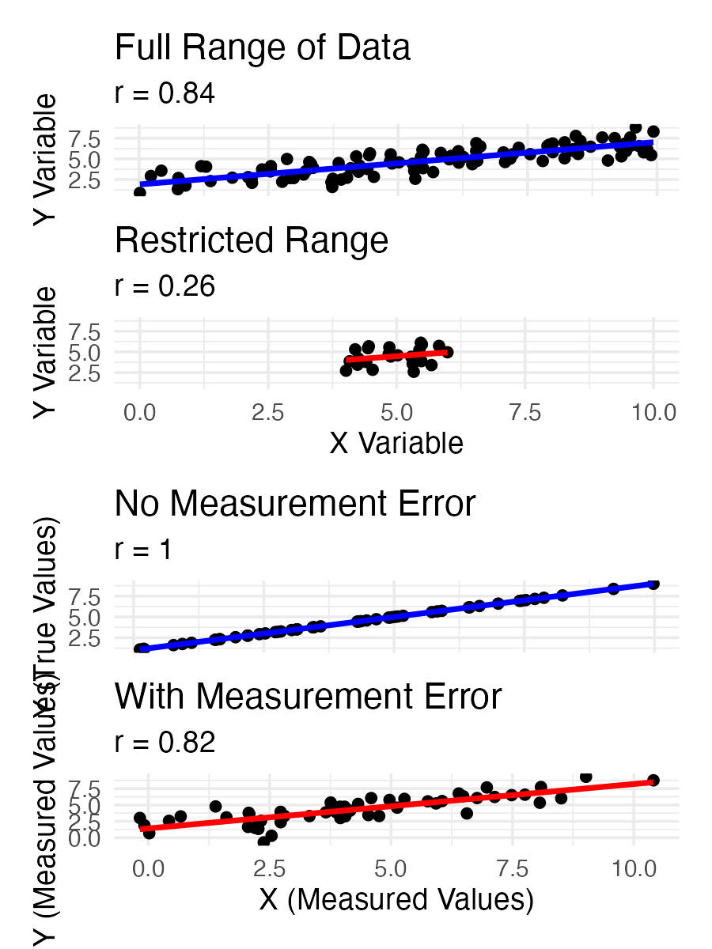

Part 4 · Linear Regression — the Model

The Simple Linear Regression Model
Simple linear regression models the relationship between a response variable (Y) and a predictor variable (X).
The population regression model: $Y=α+βX+ε$
- Y is the response variable
- X is the predictor variable
- α (alpha) is the intercept (value of Y when X = 0)
- β (beta) is the slope (change in Y per unit change in X)
- ε (epsilon) is the error term (random deviation from the line)
The sample regression equation: $\hat{Y}=a+bX$
- $\hat{Y}$ is the predicted value of Y; a estimates α; b estimates β
Method of least squares: the line is chosen to minimize the sum of squared vertical distances (residuals) between observed and predicted Y values.
Note
📖 Reference
Whitlock & Schluter, Ch. 17 — Regression, is the primary reference for the rest of this lecture.

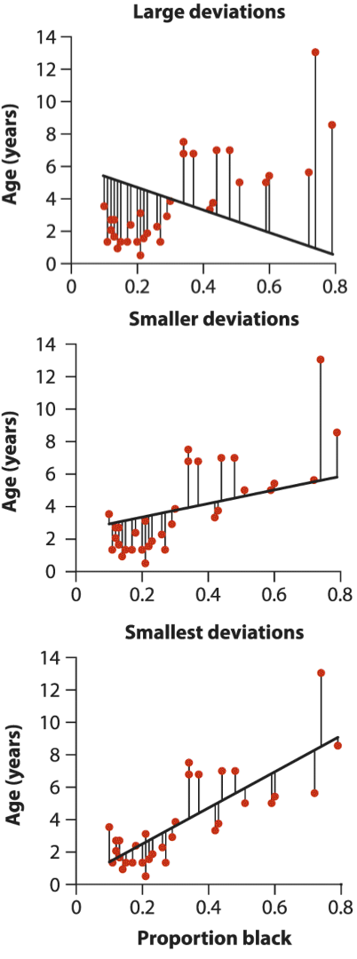
Three stacked scatterplots of lion age versus proportion black on the nose, each with a different candidate line and vertical residual segments labeled ‘Large deviations,’ ‘Smaller deviations,’ and ‘Smallest deviations,’ illustrating that least squares picks the line minimizing total squared residuals.

The Simple Linear Regression Model — the Lion Data
Simple linear regression models the relationship between a response variable (Y) and a predictor variable (X).
The population regression model: $Y=α+βX+ε$
The sample regression equation: $\hat{Y}=a+bX$
Method of least squares: the line is chosen to minimize the sum of squared vertical distances (residuals) between observed and predicted Y values.
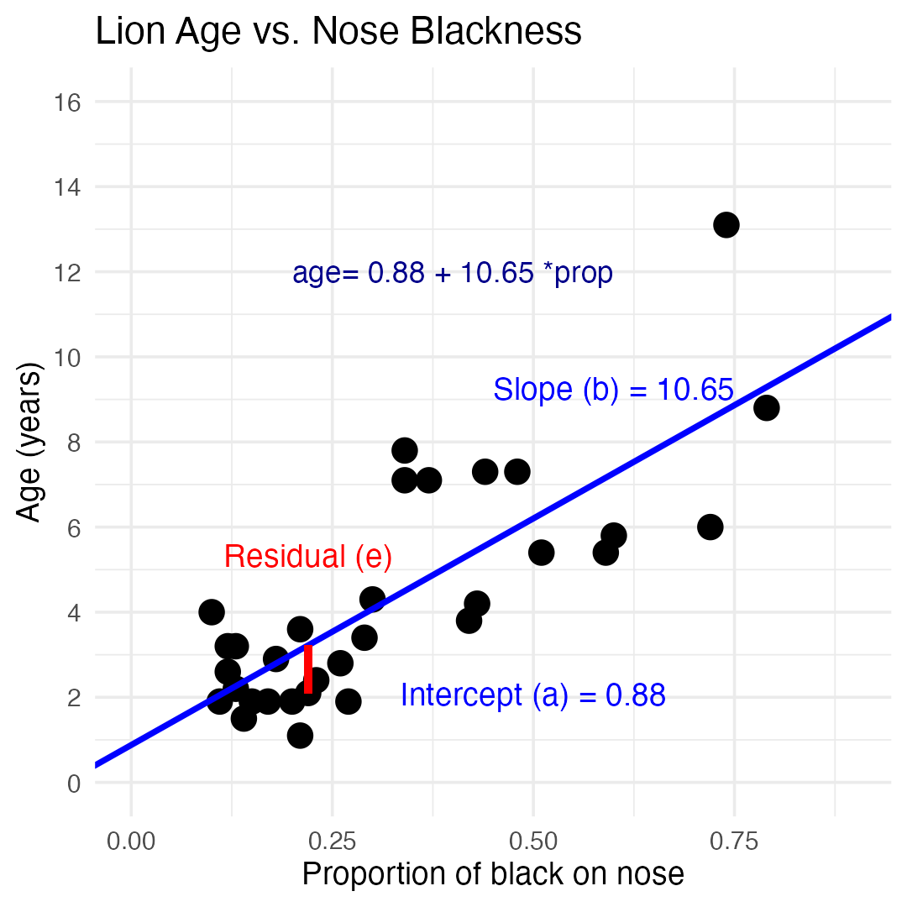

Example 17.1 — the Lion Regression Equation
From Example 17.1 in the textbook, the regression line for the lion data is:
$$\text{age}=0.88+10.65×{\text{proportion}}_{black}$$
This means:
- When a lion has no black on its nose (proportion = 0), its predicted age is 0.88 years
- For each 0.1 increase in the proportion of black, age increases by 1.065 years
- The slope (10.65) indicates that lions with more black on their noses tend to be older
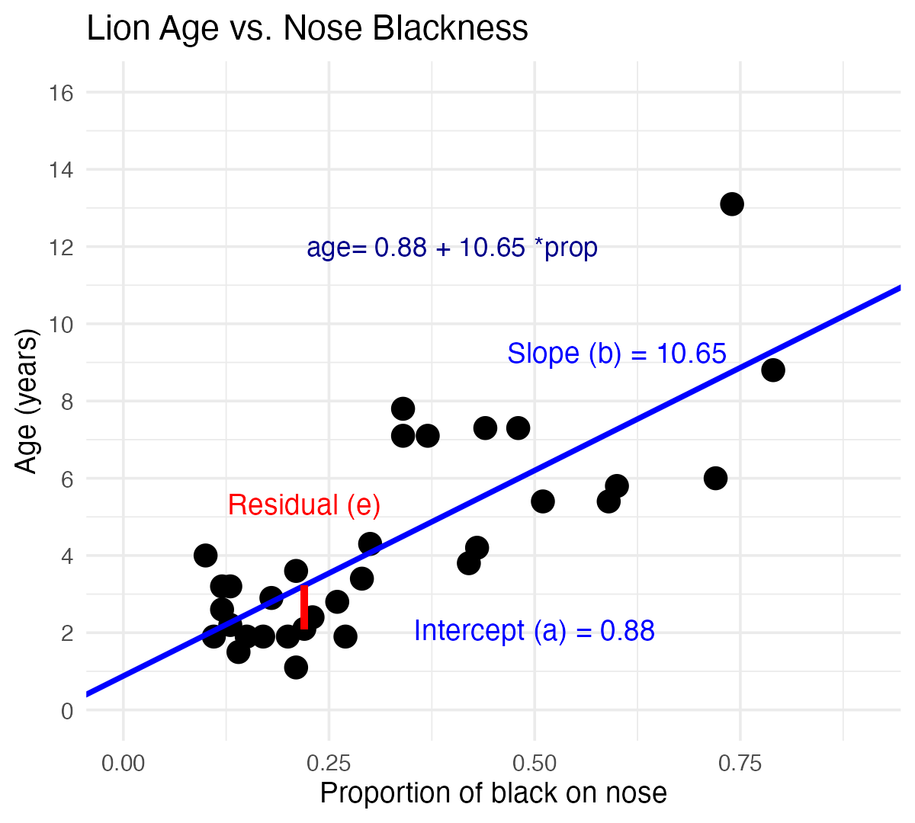

Male Lions and Nose Pigmentation
- Male lions develop more black pigmentation on their noses as they age
- This relationship can be used to estimate the age of lions in the field
Call:
lm(formula = age_years ~ proportion_black, data = lion_data)
Residuals:
Min 1Q Median 3Q Max
-2.5449 -1.1117 -0.5285 0.9635 4.3421
Coefficients:
Estimate Std. Error t value Pr(>|t|)
(Intercept) 0.8790 0.5688 1.545 0.133
proportion_black 10.6471 1.5095 7.053 7.68e-08 ***
---
Signif. codes: 0 '***' 0.001 '**' 0.01 '*' 0.05 '.' 0.1 ' ' 1
Residual standard error: 1.669 on 30 degrees of freedom
Multiple R-squared: 0.6238, Adjusted R-squared: 0.6113
F-statistic: 49.75 on 1 and 30 DF, p-value: 7.677e-08

Calculating the Slope and Intercept by Hand
The calculation for slope (m) is:
m=i​(Xi−X)(Yi−Y)i​(Xi−X)2
Given:
- $\overset{‾}{X}=0.3222$​
- $\overset{‾}{Y}=4.3094$​
- i​(Xi−X)2=1.2221​
- i​(Xi−X)(Yi−Y)=13.0123​
b = 13.0123 / 1.2221 = 10.647
Intercept: $b=\overset{‾}{Y}−m\overset{‾}{X}=4.3094−10.647(0.3222)=0.879$
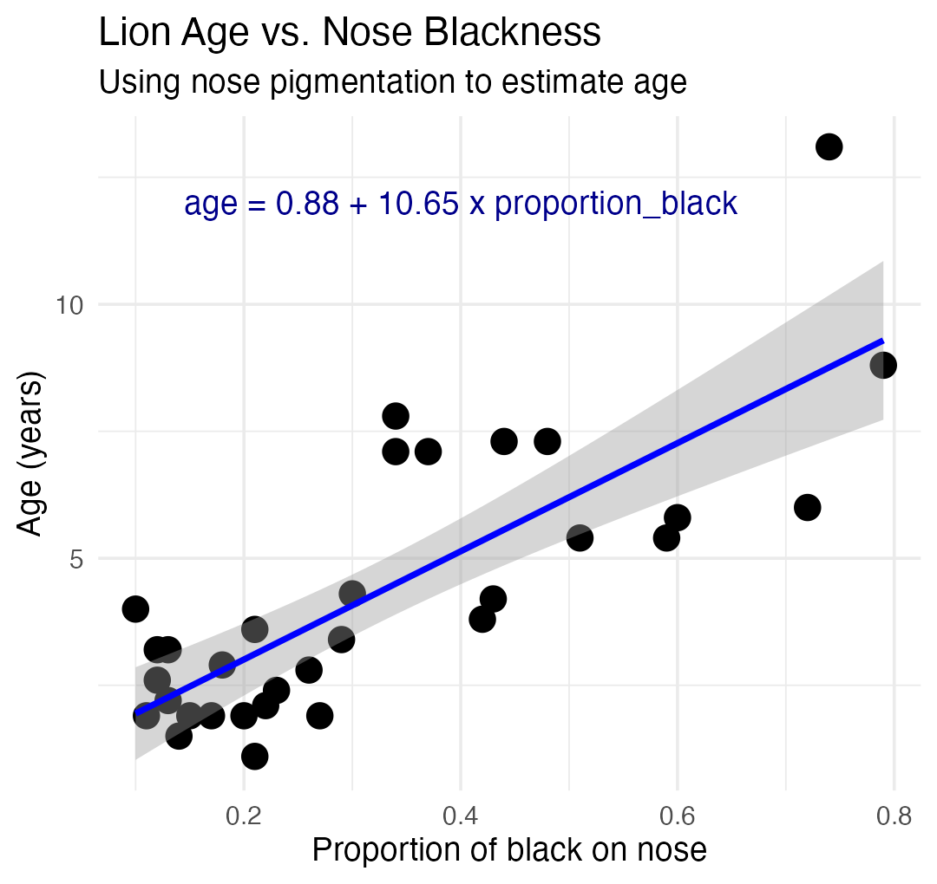

Making Predictions
To predict the age of a lion with 0.50 proportion of black on its nose:
$$\hat{Y}=0.88+10.65(0.50)=6.2\text{ years}$$
Confidence intervals vs. prediction intervals:
- Confidence interval — range for the mean age of all lions with 0.50 black
- Prediction interval — range for an individual lion with 0.50 black
Both intervals are narrowest near $\overset{‾}{X}$ and widen as X moves away from the mean.

Example: the Prairie Home Companion
- Does biodiversity affect ecosystem stability?
- Tilman et al. (2006) investigated this using experimental plots varying in plant species number
Call:
lm(formula = log_stability ~ species_number, data = prairie_data)
Residuals:
Min 1Q Median 3Q Max
-0.82774 -0.25344 -0.00426 0.27498 0.75240
Coefficients:
Estimate Std. Error t value Pr(>|t|)
(Intercept) 1.252629 0.041023 30.535 < 2e-16 ***
species_number 0.025984 0.004926 5.275 4.28e-07 ***
---
Signif. codes: 0 '***' 0.001 '**' 0.01 '*' 0.05 '.' 0.1 ' ' 1
Residual standard error: 0.3433 on 159 degrees of freedom
Multiple R-squared: 0.149, Adjusted R-squared: 0.1436
F-statistic: 27.83 on 1 and 159 DF, p-value: 4.276e-07
Analysis of Variance Table
Response: log_stability
Df Sum Sq Mean Sq F value Pr(>F)
species_number 1 3.2792 3.2792 27.829 4.276e-07 ***
Residuals 159 18.7358 0.1178
---
Signif. codes: 0 '***' 0.001 '**' 0.01 '*' 0.05 '.' 0.1 ' ' 1

The Prairie Model — Interpretation
The hypothesis test asks whether the slope equals zero:
- H₀: β = 0 (species number does not affect stability)
- H₁: β ≠ 0 (species number does affect stability)
t = estimate / SE
Interpretation:
The slope estimate is 0.033, indicating that log stability increases by 0.033 units for each additional plant species in the plot.
The p-value is very small (2.73e-10), providing strong evidence to reject the null hypothesis that species number has no effect on ecosystem stability.
R² = 0.222, meaning approximately 22.2% of the variation in log stability is explained by the number of plant species.
This supports the biodiversity-stability hypothesis: more diverse plant communities have more stable biomass production over time.
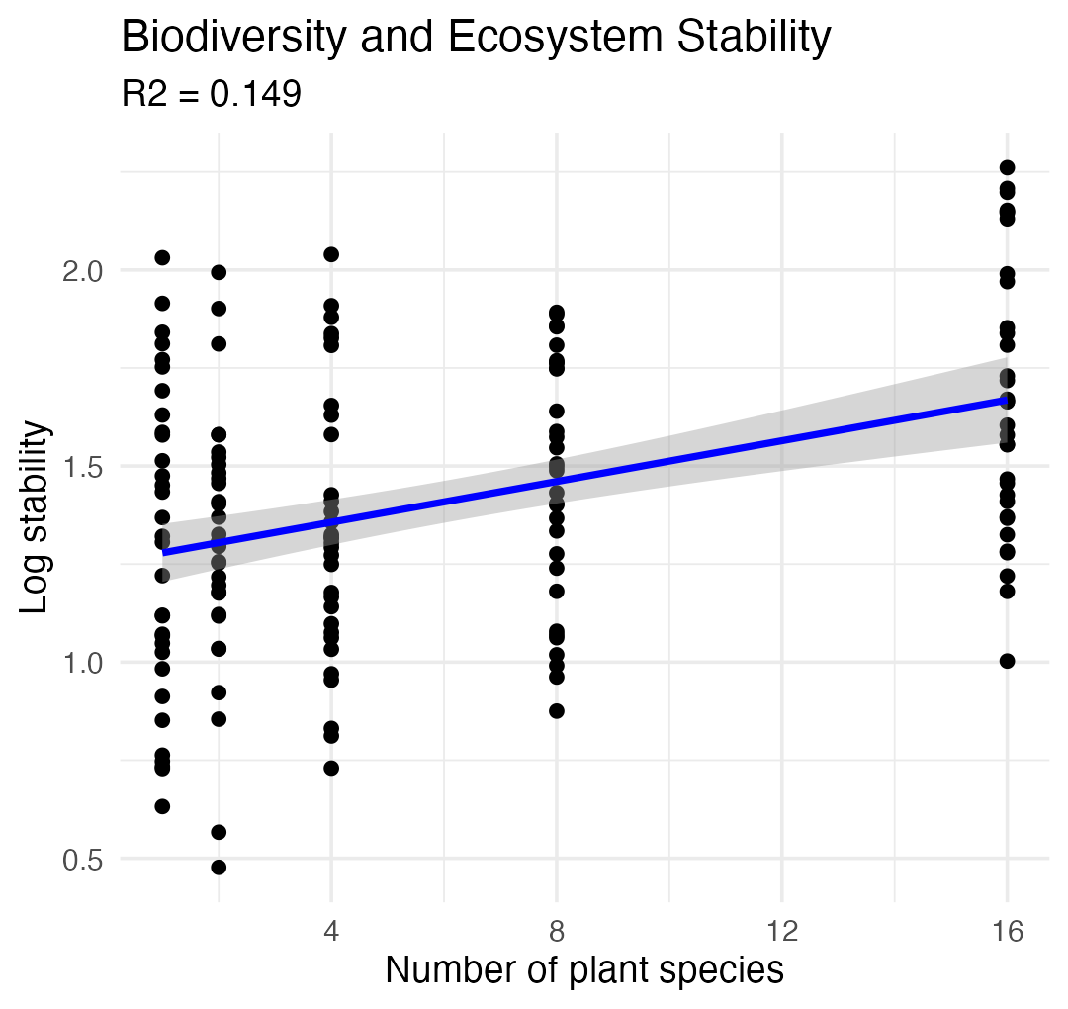

Part 5 · Testing Regression Assumptions

Testing Regression Assumptions — Overview
Linear regression has four key assumptions:
- Linearity — the relationship between X and Y is linear
- Independence — observations are independent
- Homoscedasticity — equal variance across all values of X
- Normality — residuals are normally distributed
Let’s check these assumptions for the lion regression model.
Assume that error $ε_{i}$ is normally distributed for each x_i, has the same variance, and has a mean of 0 at each x_i.
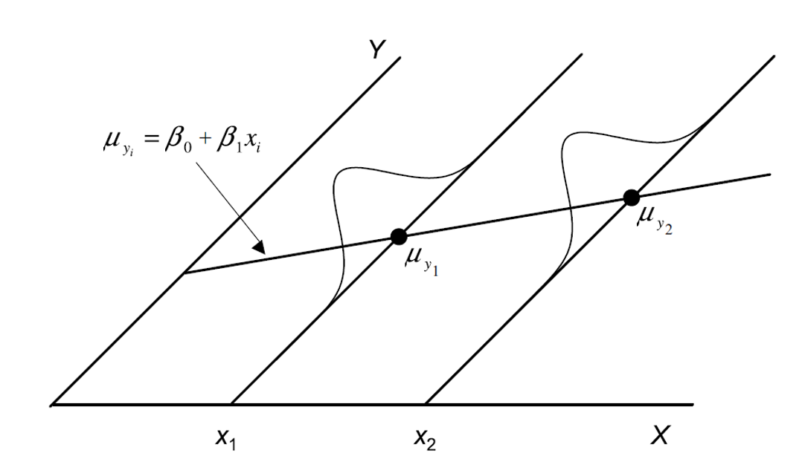
Diagram of the regression line mu_yi = beta0 + beta1*xi running through X-Y space, with small normal-distribution curves drawn at two X values (x1 and x2) around the line to show that Y is assumed to be normally distributed around the true regression line at every value of X.

Testing Regression Assumptions — Residuals
Linear regression has four key assumptions: linearity, independence, homoscedasticity, and normality.
Let’s check these assumptions for the lion regression model.
The error $ε_{i}$ is estimated as the residual: $e_{i}=y_{i}−{\hat{y}}_{i}$
Ordinary least squares estimates a and b (intercept and slope) to minimize the sum of the residuals squared:
$$\sum_{i=1}^{n}{(}y_{i}−{\hat{y}}_{i})^{2}$$
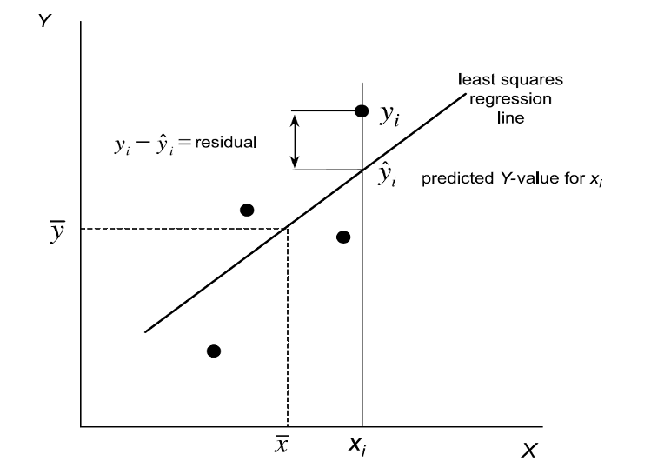
Scatterplot with a fitted least-squares regression line, labeled to show an observed point y_i, its predicted value y-hat_i on the line directly below it, and the vertical gap between them marked as the residual (y_i minus y-hat_i), with dashed lines also marking the means x-bar and y-bar.

Checking Linearity — Residuals vs. Fitted
Linear regression has four key assumptions: linearity, independence, homoscedasticity, and normality.
Let’s check these assumptions for the lion regression model. Linearity — how does this plot work?
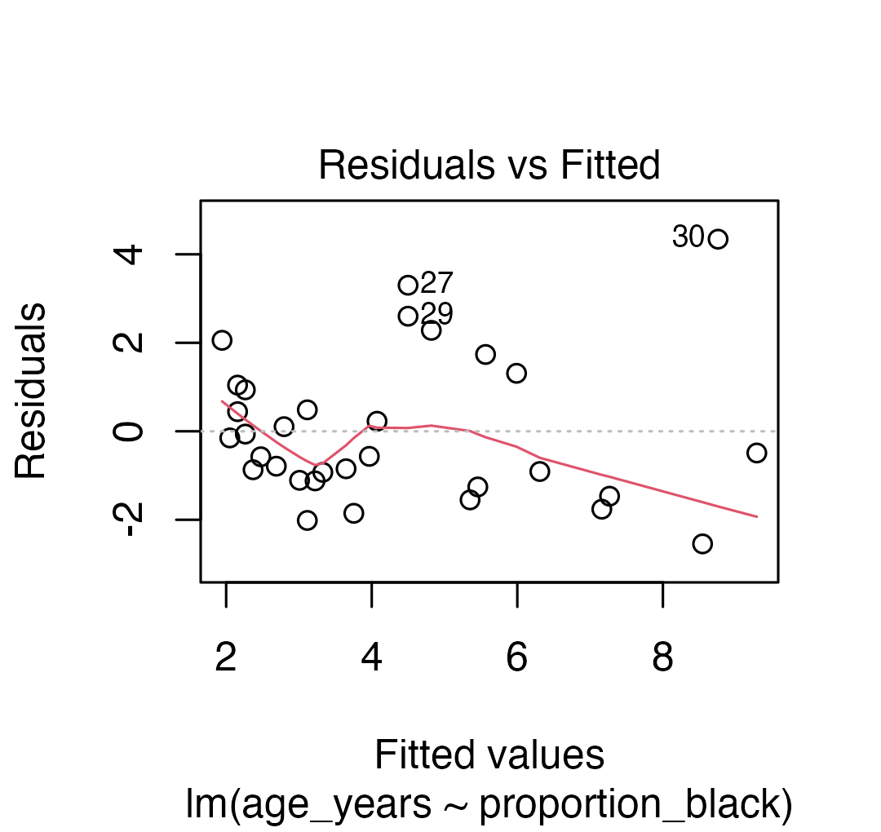

Checking Normality — QQ Plot of Residuals
Linear regression has four key assumptions: linearity, independence, homoscedasticity, and normality.
Let’s check these assumptions for the lion regression model.
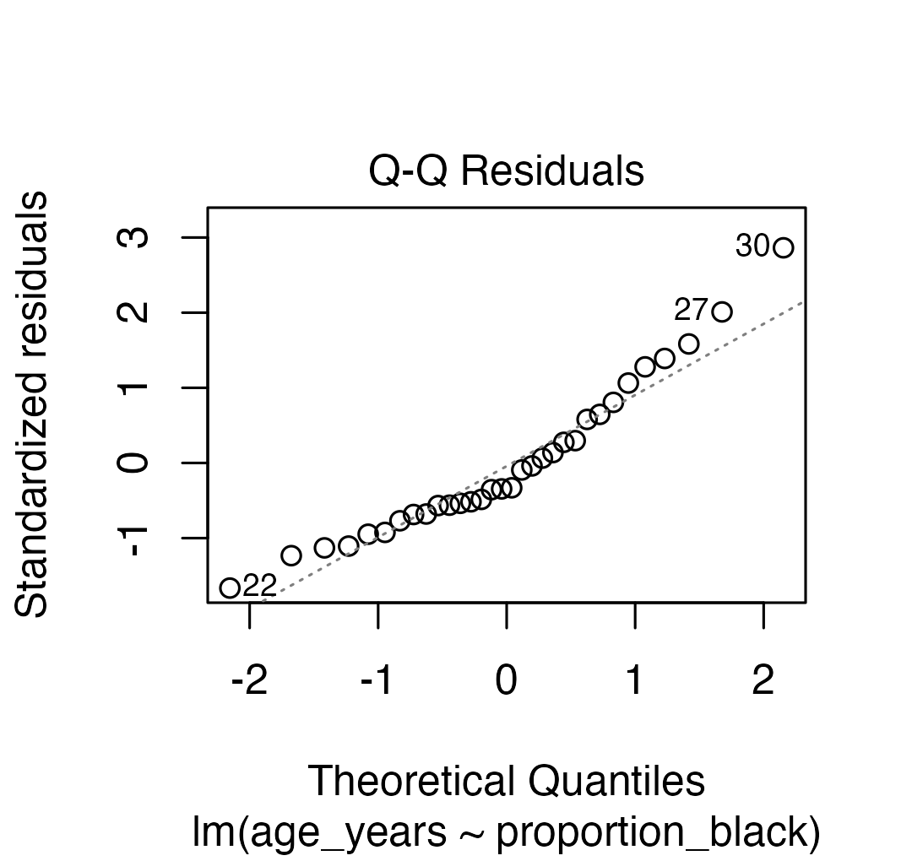

Checking Normality — Shapiro-Wilk on Residuals
Linear regression has four key assumptions: linearity, independence, homoscedasticity, and normality.
Let’s check these assumptions for the lion regression model.
Shapiro-Wilk normality test
data: residuals(lion_model)
W = 0.93879, p-value = 0.0692

When Assumptions Are Violated
Linear regression has four key assumptions: linearity, independence, homoscedasticity, and normality.
If assumptions are violated:
- Transform the data (Section 17.6)
- Use weighted least squares for heteroscedasticity
- Consider non-linear models (Section 17.8)
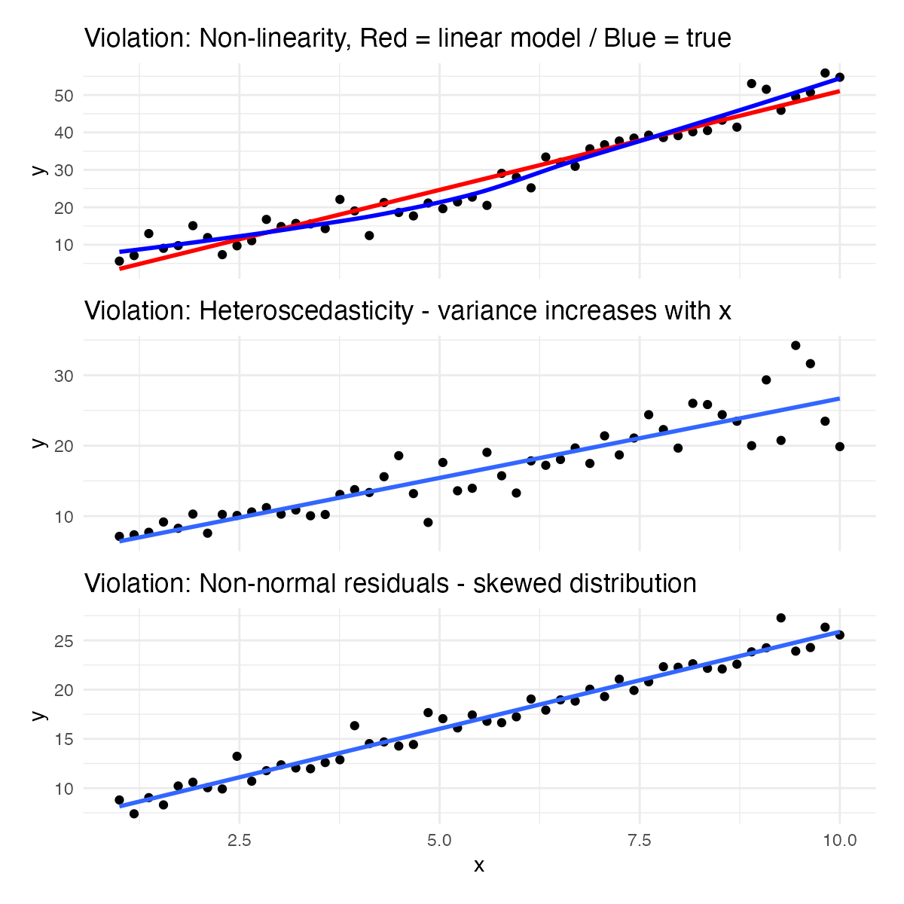

Part 6 · Regression Inference & ANOVA

Estimates of Error and Significance
- Estimates of standard error and confidence intervals for slope and intercept determine confidence bands
- The 95% confidence band will contain the true population line 95/100 times under repeated sampling
- This is usually done in R
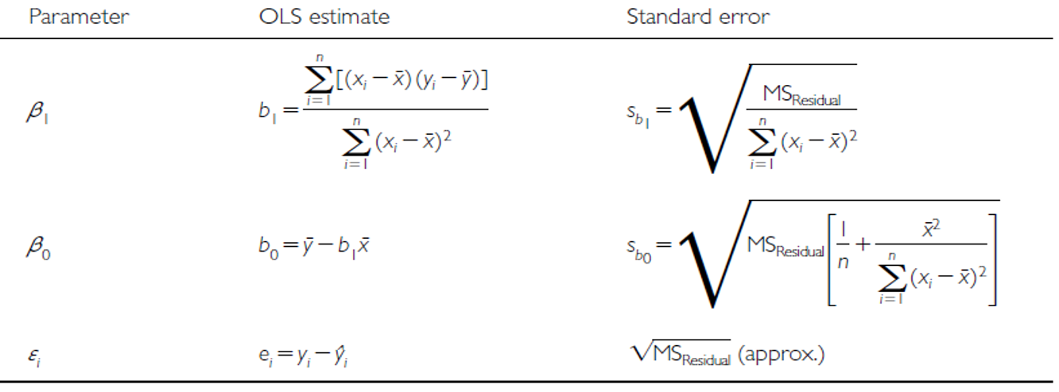
Table of formulas for the ordinary least squares estimates and standard errors of the slope (beta1), intercept (beta0), and error term (epsilon) in simple linear regression, each row giving the OLS estimate formula and its corresponding standard error formula.

From Estimates to Hypothesis Tests
In addition to getting estimates of population parameters (β₀, β₁), we want to test hypotheses about them.
- This is accomplished by analysis of variance
- Partition variance in Y: due to variation in X, and due to other things (error)
Note
📖 Reference
Gotelli & Ellison, A Primer of Ecological Statistics, Ch. 9 — Regression, covers this variance-partitioning approach to testing a regression slope.

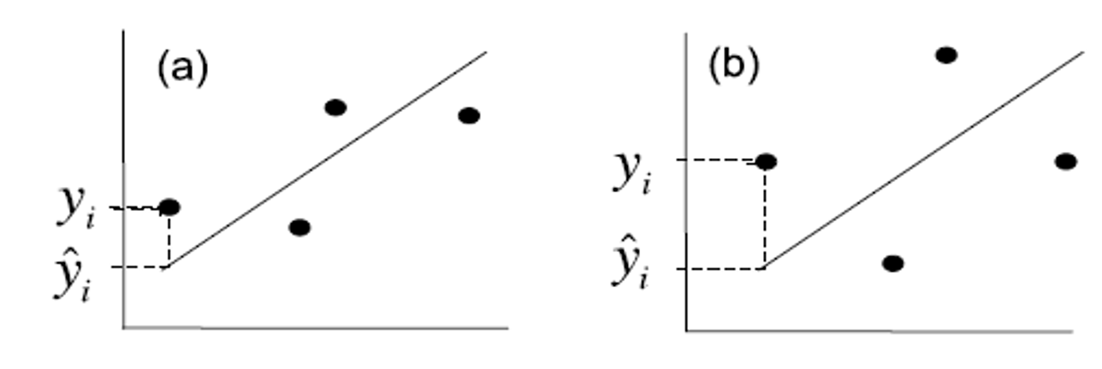
Two side-by-side scatterplots (a) and (b) each with a fitted regression line and one point marked with its observed value y_i and predicted value y-hat_i, illustrating how the residual (the gap between them) varies from point to point and feeds into partitioning total variation.

Partitioning the Variance
Total variation in Y is “partitioned” into 3 components:
- $SS_{regression}$: variation explained by regression — difference between predicted values (${\hat{y}}_{i}$) and mean y ($\overset{‾}{y}$); df = 1 for simple linear (parameters − 1)
- $SS_{residual}$: variation not explained by regression — difference between observed ($y_{i}$) and predicted (${\hat{y}}_{i}$) values; df = n − 2
- $SS_{total}$: total variation — sum of squared deviations of each observation ($y_{i}$) from the mean ($\overset{‾}{y}$); df = n − 1
Two side-by-side scatterplots (a) and (b) each with a fitted regression line and one point marked with its observed value y_i and predicted value y-hat_i, illustrating how the residual (the gap between them) varies from point to point and feeds into partitioning total variation.

Partitioning the Variance — Visually
Total variation in Y is “partitioned” into 3 components:
- $SS_{regression}$: variation explained by regression — df = 1 for simple linear
- $SS_{residual}$: variation not explained by regression — df = n − 2
- $SS_{total}$: total variation — df = n − 1
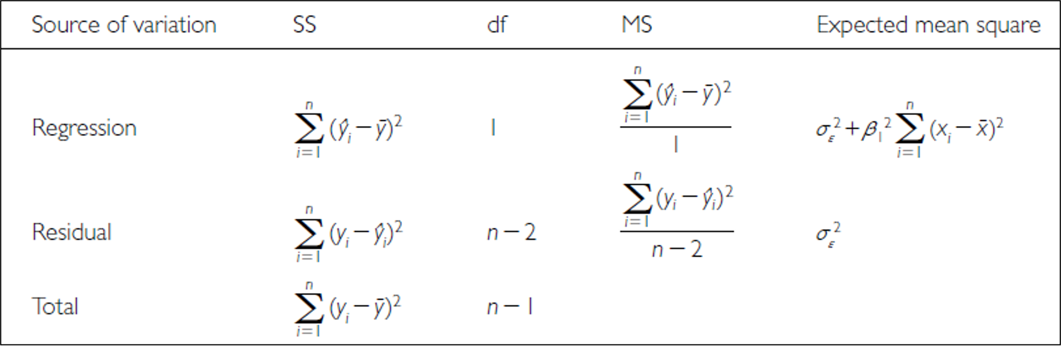
ANOVA table for simple linear regression listing Regression, Residual, and Total sources of variation with their sum-of-squares, degrees of freedom (1, n-2, n-1), mean-square, and expected-mean-square formulas.

Comparing Regression Fits
Total variation in Y is “partitioned” into 3 components:
- $SS_{regression}$: greater in C than D
- $SS_{residual}$: greater in B than A
- $SS_{total}$: total variation
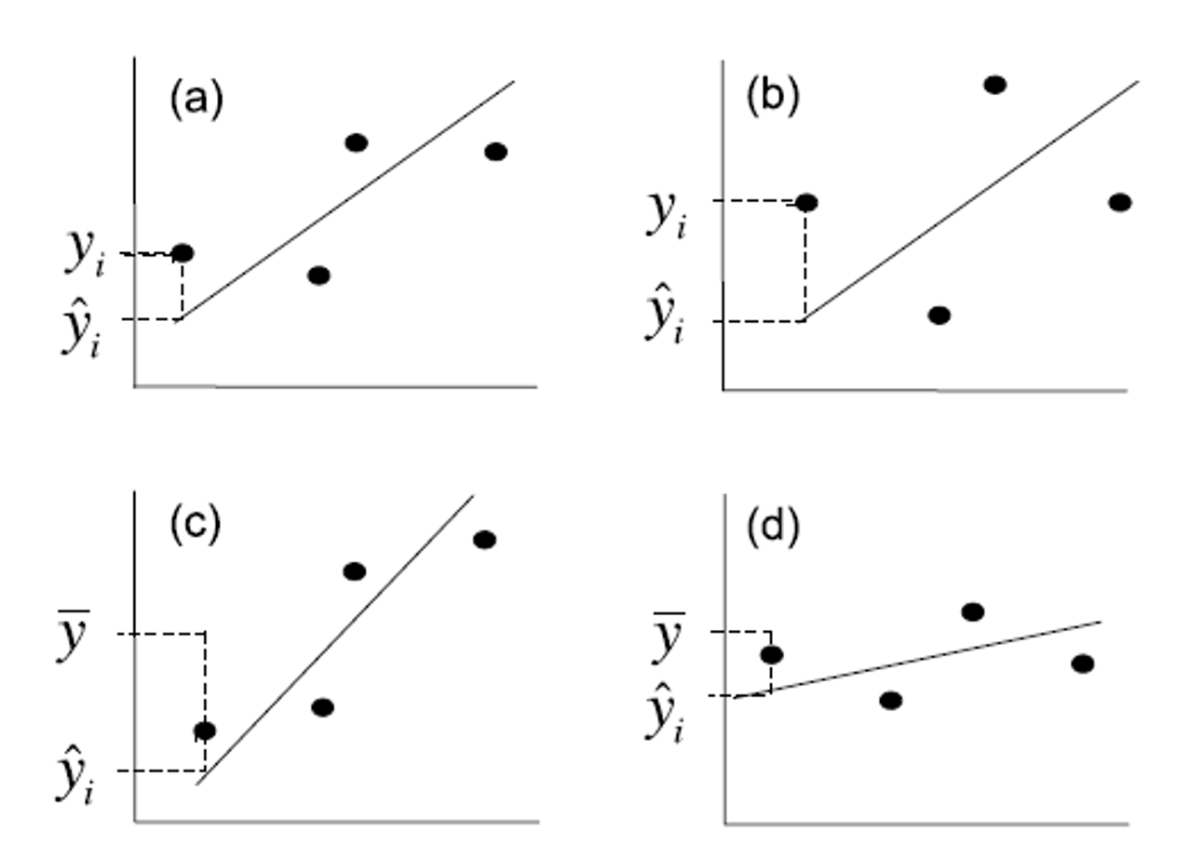
Four scatterplots (a)-(d) with fitted regression lines of differing steepness and fit quality, each annotated with an observed point y_i, its prediction y-hat_i, and the mean y-bar, used to compare how much regression sum-of-squares and residual sum-of-squares differ between a strong fit (a, c) and a weak fit (d).

Sums of Squares and Degrees of Freedom
$$SS_{regression}+SS_{residual}=SS_{total}$$
$$df_{regression}+df_{residual}=df_{total}$$
- Sums of squares depend on n
- We need a different estimate of variance
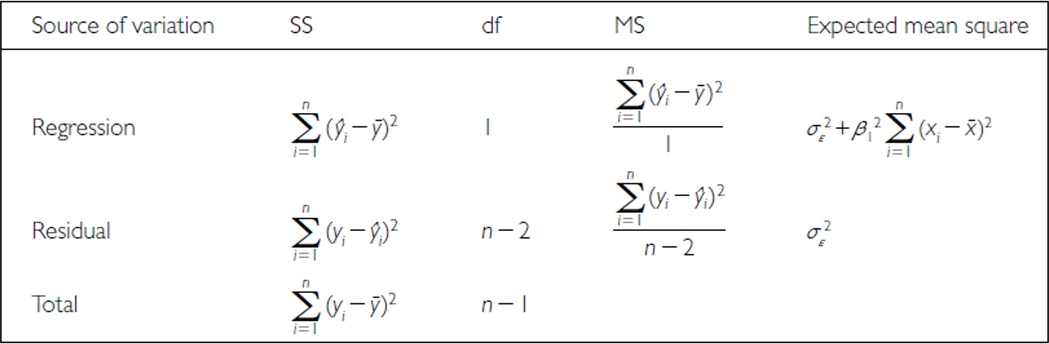
ANOVA table for simple linear regression (same layout as the earlier version) listing Regression, Residual, and Total sources of variation with their sum-of-squares, degrees of freedom, mean-square, and expected-mean-square formulas, used here to show how sums of squares convert to mean squares.

From Sums of Squares to Mean Squares
Sums of squares converted to mean squares:
- Sums of squares divided by degrees of freedom — does not depend on n
- $MS_{residual}$: estimates population variation
- $MS_{regression}$: estimates population variation and variation due to the X-Y relationship
- Mean squares are not additive
Note
✅ Key idea
The F-ratio in a regression ANOVA table is exactly $MS_{regression}/MS_{residual}$ — the same logic you’ll see again when we get to ANOVA for group comparisons.

ANOVA table for simple linear regression (same layout as the earlier version) listing Regression, Residual, and Total sources of variation with their sum-of-squares, degrees of freedom, mean-square, and expected-mean-square formulas, used here to show how sums of squares convert to mean squares.

