Lecture: Describing Your Data
  - Mean, spread, counting correctly, and group summaries
Bill Perry

Where We Left Off
Last time you:
- Imported data two ways (read_csv(), read_excel())
- Wrangled with filter(), select(), mutate(), arrange()
- Caught duplicate rows with distinct()
- Saved a new file with write_csv()
 Note
✅ Key idea from Wrangling Your Data
You can reshape a dataset and hand off a clean file. Today we start describing it — the step that comes before any formal test.

Note
Today’s roadmap
- Mean and median
- Variance and standard deviation
- Quantiles, range, and IQR
- The length() trap — and the fix
- Standard error
- skimr — a fast full-dataset overview
- group_by() + summarize()

Part 1 · Our Question, Revisited

Our Question, Revisited
- H₀: No difference in needle length between the shady and sunny sides
- Hₐ: Needle length differs between the two sides
Before we can formally test that with statistics, we need to describe what we actually measured.
Note
Plan for this unit
- Today — describe the data: center, spread, and group summaries
- A later module — formally test H₀ vs. Hₐ

library(tidyverse)
pine_df <- read_csv("data/pine_needles.csv")
 Tip
🖐 Recap
n_s codes shady (n) vs. sunny (s); group is the field team name.
Four teams, four trees, six needles per side.

Part 2 · The Mean

The Mean
$$\overset{‾}{x}=\frac{\sum_{i=1}^{n}{x_{i}}}{n}$$
- Add up every value, divide by n
- The balance point of the distribution
- Sensitive to outliers — one very large value disproportionately affects the mean
Example: Values 5, 6, 7, 8, 50 → mean = 15.2.
Is that a fair summary?
Not really — the outlier dominates.
Note
✅ Why it matters
The mean is the most commonly reported statistic
— and it’s the number every t-test, ANOVA, and regression is ultimately built around.

# Pull one side's values out as a vector -----
shady_lengths <- pine_df |>
filter(n_s == "n") |>
pull(length_mm)
shady_lengths
[1] 20 21 23 25 21 16 19 18 20 23 21 18 20 21 23 25 21 16 19 18 20 23 21 18
mean(shady_lengths)
[1] 20.41667
Tip
📖 New pattern
filter() picks rows. pull() extracts one column as a plain vector, not a data frame.

Part 3 · The Median

The Median
The middle value once the data are sorted
Sorted data | Median
5, 6, 7, 8, 50 | 7
5, 6, 7, 8, 50, 51 | (7 + 8) / 2 = 7.5
- Not pulled around by outliers — it’s robust
- If mean ≫ median → right-skewed data
- If mean ≈ median → roughly symmetric
sunny_lengths <- pine_df |>
filter(n_s == "s") |>
pull(length_mm)
median(shady_lengths)
[1] 20.5
median(sunny_lengths)
[1] 15
Note
✅ Key idea
Report mean and median together the first time you look at a new variable — a big gap between them is a signal worth investigating.

Part 4 · Variance (s²) and Standard Deviation (sd)

Variance and Standard Deviation
$$s^{2}=\frac{\sum_{i=1}^{n}{(}x_{i}−\overset{‾}{x})^{2}}{n−1} s=\sqrt{s^{2}}$$
- Distance of each value from the mean
- Square it — makes everything positive
- Average those squared distances (over $n−1$)
- Square root brings variance back into the original units as the standard deviation
Larger spread = larger variance and SD.
Note
- Variance is in squared units (mm²)
- hard to interpret directly.
- Standard deviation (SD) is why we usually report it instead

var(shady_lengths)
[1] 5.992754
sd(shady_lengths)
[1] 2.44801
var(sunny_lengths)
[1] 3.644928
sd(sunny_lengths)
[1] 1.909169
Tip
📖 Rule of thumb
- For roughly normal data:
  - ~68% of values fall within mean ± 1 SD
  - ~95% within mean ± 2 SD

Part 4b · Quantiles, Range, and IQR

Quantiles, Range, and IQR
range(shady_lengths) # min and max
[1] 16 25
max(shady_lengths) - min(shady_lengths) # range as a single number
[1] 9
quantile(shady_lengths) # 0/25/50/75/100th percentiles
0% 25% 50% 75% 100%
16.00 18.75 20.50 21.50 25.00
IQR(shady_lengths) # 75th percentile minus 25th
[1] 2.75
box_plot_1 <- ggplot(data = NULL, aes(y = shady_lengths)) +
geom_boxplot()
Note
✅ Key idea
The IQR is the range of the middle 50% of the data — it ignores the most extreme quarter on each end, which makes it robust to outliers the same way the median is.

Tip
🖐 Notice
quantile()’s 50th percentile is exactly the median. IQR() is just quantile(x, 0.75) - quantile(x, 0.25) computed for you.
📖 R4DS §12 — EDA
box_plot_1
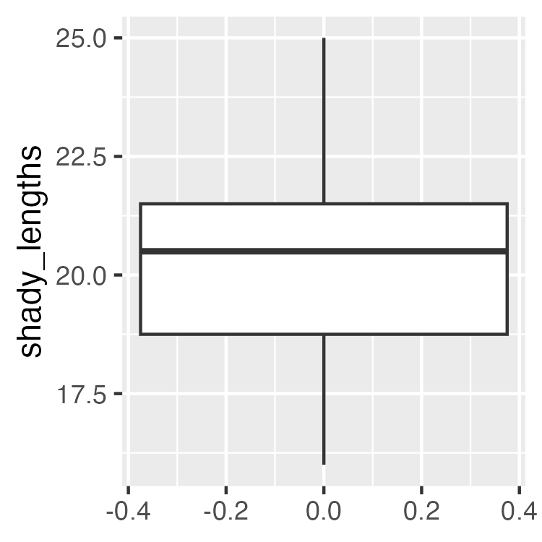

Quantiles — Why This Matters for Graphing Effectively
quantile(sunny_lengths)
0% 25% 50% 75% 100%
12.00 13.75 15.00 16.00 19.00
IQR(sunny_lengths)
[1] 2.25
Tip
📖 Preview
The box in a boxplot is the IQR — its bottom and top edges are the 25th and 75th percentiles you just computed. The boxplots you’ll build in Graphing Effectively are these five numbers, drawn.

Part 5 · The length() Trap

The length() Trap
 Important
🔮 Predict first: A vector has 5 slots, but 2 are NA. What does length() return? What should your sample size be for a mean or SE calculation?

x <- c(4, 3, NA, 7, NA) # a vector with missing values
length(x) # counts every slot — including NAs!
[1] 5
sum(is.na(x)) # how many are missing?
[1] 2
Note
📖 New words
- is.na(x) — TRUE where a value is missing
- !is.na(x) — the flip: TRUE where a value is real
- sum(!is.na(x)) — counts the real values = the correct n

The length() Trap — Why It Matters
# Using length() as n silently gives the WRONG answer
wrong_n <- length(x)
wrong_se <- sd(x, na.rm = TRUE) / sqrt(wrong_n)
wrong_n
[1] 5
round(wrong_se, 3)
[1] 0.931
# note base r rounding is really odd - use round_half_up from janitor
 Warning
⚠️ Watch out!
R will not warn you. length() happily returns 5 when only 3 values are real — a silent, common error.

Fix — sum(!is.na())
is.na(x) # TRUE where NA
[1] FALSE FALSE TRUE FALSE TRUE
!is.na(x) # flipped: TRUE where real
[1] TRUE TRUE FALSE TRUE FALSE
sum(!is.na(x)) # count the TRUEs
[1] 3
Tip
Best practice: use sum(!is.na(x)) for n every time you compute an SE — even when you’re sure there are no missing values. Field data rarely stays that clean.

How it works, step by step:
- is.na(x) → TRUE for each missing value
- !is.na(x) → flips it to TRUE for real values
- sum(...) → adds up the TRUEs (TRUE = 1)
📖 R4DS §18 — Missing Values

Fix — Applied to Real Data
# Applied to our real data — even with no NAs, make it a habit
n_shady <- sum(!is.na(shady_lengths))
n_sunny <- sum(!is.na(sunny_lengths))
n_shady
[1] 24
n_sunny
[1] 24
Tip
Even when you’re confident a column has zero missing values, run it through sum(!is.na()) anyway — it costs nothing and field data rarely stays clean for long.

Part 6 · Standard Error

Standard Error
$$SE=\frac{s}{\sqrt{n}}$$
- Measures how precisely you know the mean — not the spread of raw data
- Gets smaller as n grows: more data → a more precise estimate of the mean
 | Describes
SD | spread of individual data points
SE | precision of the sample mean
We report SE whenever we’re making a claim about a group mean.
se_shady <- sd(shady_lengths) / sqrt(n_shady)
se_sunny <- sd(sunny_lengths) / sqrt(n_sunny)
round(se_shady, 2)
[1] 0.5
round(se_sunny, 2)
[1] 0.39
Warning
⚠️ Watch out!
sqrt(length(x)) and sqrt(sum(!is.na(x))) give the same answer only when there are zero missing values. Don’t assume — check.

All Stats, One Group, Base R
n_l <- sum(!is.na(shady_lengths))
mean_l <- mean(shady_lengths, na.rm = TRUE)
med_l <- median(shady_lengths, na.rm = TRUE)
sd_l <- sd(shady_lengths, na.rm = TRUE)
se_l <- sd_l / sqrt(n_l)
cat("--- Shady side ---\n",
"n =", n_l, "\n",
"Mean =", round(mean_l, 2), "\n",
"Median =", round(med_l, 2), "\n",
"SD =", round(sd_l, 2), "\n",
"SE =", round(se_l, 2), "\n")
--- Shady side ---
n = 24
Mean = 20.42
Median = 20.5
SD = 2.45
SE = 0.5
- Every function takes na.rm = TRUE
- cat() prints clean, labeled output
Note
✅ Key idea
Copy-pasting this block for every group is exactly the repetition group_by() + summarize() exists to remove.

Part 6b · skimr — a Fast Full-Dataset Overview

skimr — Every Column, One Command
install.packages("skimr") # once per machine
library(skimr)
skim(pine_df)
Data summary
Name | pine_df
Number of rows | 48
Number of columns | 6
_______________________
Column type frequency:
character | 4
numeric | 2
________________________
Group variables | None
Variable type: character
skim_variable | n_missing | complete_rate | min | max | empty | n_unique | whitespace
date | 0 | 1 | 7 | 7 | 0 | 1 | 0
group | 0 | 1 | 5 | 11 | 0 | 4 | 0
n_s | 0 | 1 | 1 | 1 | 0 | 2 | 0
sun | 0 | 1 | 5 | 5 | 0 | 2 | 0
Variable type: numeric
skim_variable | n_missing | complete_rate | mean | sd | p0 | p25 | p50 | p75 | p100 | hist
tree_no | 0 | 1 | 2.50 | 1.13 | 1 | 1.75 | 2.5 | 3.25 | 4 | ▇▇▁▇▇
length_mm | 0 | 1 | 17.67 | 3.53 | 12 | 15.00 | 17.5 | 20.25 | 25 | ▆▇▅▆▃
Note
✅ Key idea
skim() gives you n, missing count, mean, SD, and a tiny inline histogram for every numeric column — and counts for every character column — in one call. It’s the fastest way to sanity-check a dataset the moment you load it.

skimr — Doesn’t Replace, Just Speeds Up
# Same idea, restricted to numeric columns
pine_df |>
select(length_mm, tree_no) |>
skim()
Data summary
Name | select(pine_df, length_mm…
Number of rows | 48
Number of columns | 2
_______________________
Column type frequency:
numeric | 2
________________________
Group variables | None
Variable type: numeric
skim_variable | n_missing | complete_rate | mean | sd | p0 | p25 | p50 | p75 | p100 | hist
length_mm | 0 | 1 | 17.67 | 3.53 | 12 | 15.00 | 17.5 | 20.25 | 25 | ▆▇▅▆▃
tree_no | 0 | 1 | 2.50 | 1.13 | 1 | 1.75 | 2.5 | 3.25 | 4 | ▇▇▁▇▇
Warning
⚠️ Watch out!
- skim() is a first look, not a final answer.
- you can pipe groups into it to show that length_mm should be split by n_s
  - for real per-group comparisons, you still need group_by() + summarize(), next.

Part 7 · Tidy Group Stats — group_by() + summarize()

Tidy Group Stats — group_by() + summarize()
Note
🔮 Predict first: How many rows will the result have? (Hint: how many values does n_s take?)

side_stats_df <- pine_df |>
group_by(n_s) |>
summarize(
n = sum(!is.na(length_mm)),
mean_mm = round(mean(length_mm, na.rm = TRUE), 2),
med_mm = round(median(length_mm, na.rm = TRUE), 2),
sd_mm = round(sd(length_mm, na.rm = TRUE), 2),
se_mm = round(sd_mm / sqrt(n), 2)
)
side_stats_df
# A tibble: 2 × 6
n_s n mean_mm med_mm sd_mm se_mm
<chr> <int> <dbl> <dbl> <dbl> <dbl>
1 n 24 20.4 20.5 2.45 0.5
2 s 24 14.9 15 1.91 0.39
- group_by(n_s) splits the data by side
- summarize() collapses each group to one row of stats
- Both groups, one clean table — no copy-paste
- A column you just created (sd_mm) can feed the next one (se_mm)
📖 R4DS §3.5 — summarize()

Grouping by More Than One Variable
team_stats_df <- pine_df |>
group_by(group, n_s) |>
summarize(
n = sum(!is.na(length_mm)),
mean_mm = round(mean(length_mm, na.rm = TRUE), 2),
se_mm = round(sd(length_mm, na.rm = TRUE) / sqrt(n), 2),
.groups = "drop"
)
team_stats_df
# A tibble: 8 × 5
group n_s n mean_mm se_mm
<chr> <chr> <int> <dbl> <dbl>
1 cephalopods n 6 21 1.24
2 cephalopods s 6 15 0.58
3 crayfish n 6 21 1.24
4 crayfish s 6 15 0.58
5 salmon n 6 19.8 0.79
6 salmon s 6 12.8 0.4
7 snail n 6 19.8 0.79
8 snail s 6 16.8 0.6
- group_by(group, n_s) splits by field team, then side — one row per combination
- .groups = "drop" turns off the grouping once you’re done — good habit, avoids surprises later
Tip
🖐 Notice
Four teams × two sides = 8 rows. Does every team show the same shady-vs-sunny pattern, or do some disagree?

Part 7b · Bringing Back case_when() from Wrangling Your Data

Summarizing the Categories You Built Last Class
Note
🔮 Predict first: We’re grouping by the size_class bins ("short"/"medium"/"long") from Wrangling Your Data’s case_when(). How many rows will the summary have?

size_class_stats_df <- pine_df |>
mutate(
size_class = case_when(
length_mm < 16 ~ "short",
length_mm < 20 ~ "medium",
TRUE ~ "long"
)
) |>
group_by(size_class) |>
summarize(
n = sum(!is.na(length_mm)),
mean_mm = round(mean(length_mm, na.rm = TRUE), 2),
se_mm = round(sd(length_mm, na.rm = TRUE) / sqrt(n), 2)
)
size_class_stats_df
# A tibble: 3 × 4
size_class n mean_mm se_mm
<chr> <int> <dbl> <dbl>
1 long 16 21.8 0.42
2 medium 17 17.3 0.28
3 short 15 13.7 0.3
Note
✅ Key idea
mutate() and group_by() + summarize() chain together like any other verbs — you don’t need to save the case_when() column separately first. This is the wrangling → describing pipeline in one block.

Wrap-up
Today you:
- Computed mean and median, and know why they can disagree
- Computed variance and SD by hand, with real formulas
- Computed quantiles, range, and IQR — and saw the IQR is literally the boxplot’s box
- Found the length() trap and fixed it with sum(!is.na())
- Computed SE and know how it differs from SD
- Got a fast full-dataset overview with skimr::skim()
- Used group_by() + summarize() to get every group’s stats in one table — including the case_when() categories from Wrangling Your Data
Tip
🖐 Before next class
Finish the worksheet: compute n, mean, SD, and SE for length_mm grouped by n_s, and again grouped by group. Save the summary table with write_csv().

Note
Up next — Graphing Effectively
- Boxplots and jittered points, done right
- Plotting mean ± SE directly with stat_summary()
- Faceting, themes, and ggsave() for a publication-ready figure

Getting unstuck
When code breaks — and it will, that is normal:
- Read the error message out loud; it usually names the line
- Check the usual suspects: library(tidyverse) loaded? Spelling? Did you forget na.rm = TRUE?
- ?function_name opens the help page
- Bring the exact error (copy-paste it) to class or office hours
Note
✅ Key idea
Every working scientist googles error messages daily. Getting stuck is not failing — it is the job.

