Lecture: Getting Started
  - Asking a question, meeting R, and making your first graph
Bill Perry

Welcome to Biostatistics
- This course teaches the whole pipeline: raw data → clean → summarize → visualize → test → report
- You do not need prior coding experience — everyone starts exactly here
- The only way to learn this is to type the code yourself and break it
 Important
Getting stuck is not failing — it is the job.
Every working scientist reads error messages and searches for answers every day.

 Note
Today’s roadmap
- Asking a good question
- Organizing a project
- Meeting R and Positron
- Loading data and your first plot

Part 1 · Asking a Good Question

What makes something science?
- Science makes predictions and tests them with a falsifiable approach — statistics
- A claim that could never be shown wrong is not testable, and not science
Example:
- “Needles on the sheltered side of a tree are longer” — testable ✅
- “The forest decides needle length” — not testable ❌
Note
📖 New word
Falsifiable = a prediction that could, in principle, be proven wrong. A good hypothesis is one you could disprove.

Two ways of reasoning toward that question
Inductive (specific → general)
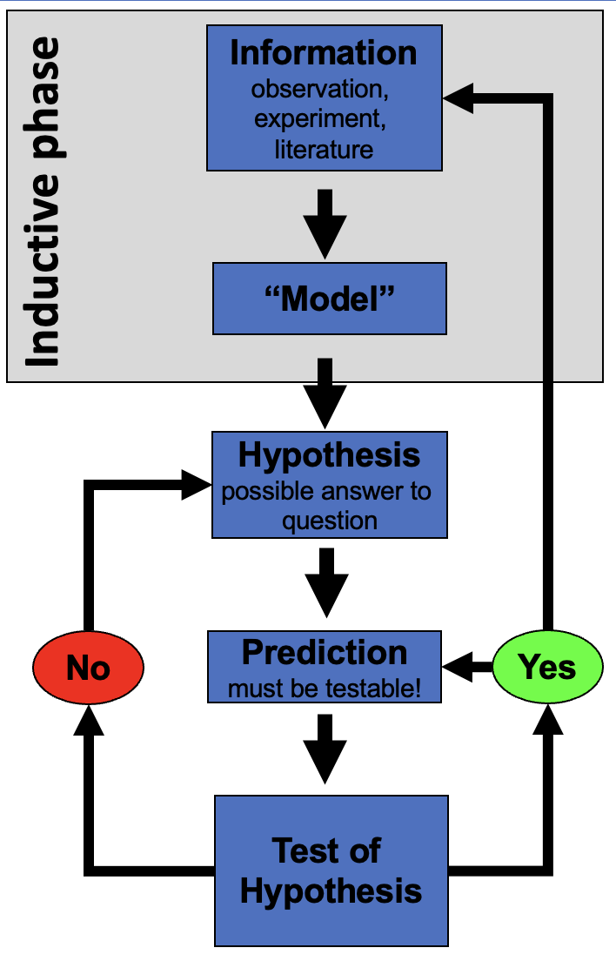
Flowchart of the inductive reasoning phase, highlighted at the top: Information (observation, experiment, literature) leads to a Model, which leads to Hypothesis, then a testable Prediction, then a Test of Hypothesis that loops back via Yes/No decision points.
You measure needles on a few trees, notice a pattern, and generalize: “needle length seems to vary with side of tree.”
Note
Weakness: the pattern held in your sample — it is not guaranteed to hold everywhere.

Deductive (general → specific)
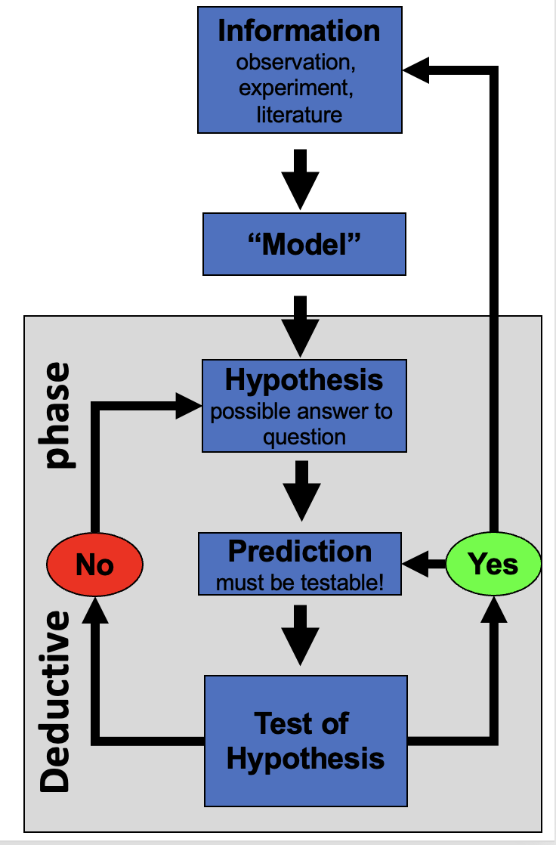
The same scientific-reasoning flowchart as the inductive diagram, but with the deductive phase highlighted instead: starting from Hypothesis, moving to a testable Prediction and Test of Hypothesis, showing deduction as reasoning from a general rule down to a specific testable case.
You start from a general rule — “exposure affects needle length” — and predict what a new tree should show, then check.
Note
Weakness: only as strong as the general rule you started from.

 Tip
In practice we do both, back and forth — notice a pattern (induction), propose a rule, then test it on new data (deduction).

Our class question
Pine needles on the north/shady side of a tree vs. the south/sunny side:
- Question:
- Prediction:
- H₀ (null):
- Hₐ (alternate):
Note
📖 New words
- Question: what is your question
- Precition: what do you think will happen
- H₀ — the “nothing is happening” claim
- Hₐ — the claim we suspect might be true
- Note: Hₐ does NOT say which side is longer — that would be a prediction, a stronger, riskier claim

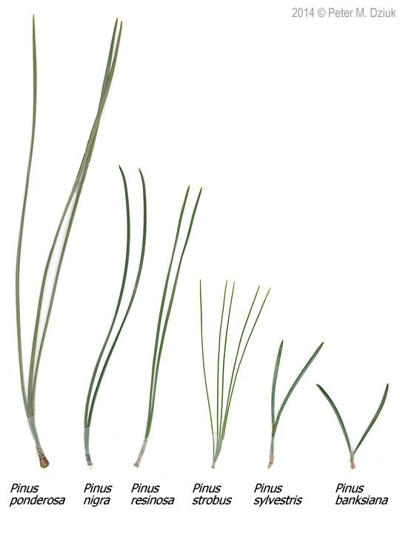
Photo comparing needle length and bundle count across six pine species (Pinus ponderosa, nigra, resinosa, strobus, sylvestris, banksiana), showing needles ranging from long single pairs to short clusters of five, illustrating the kind of length measurement the class’s own pine-needle sampling will use.

Designing a defensible sample
- Can we test this with needles from one tree?
  - No — that tree could just happen to have short needles on one side due to other drivers.
  - Treating many needles from one tree as if they were independent replicates is called pseudoreplication (Hurlbert 1984).
- The tree — not the needle — is the unit of replication.
  - We need needles from many trees, sampled the same way each time.
- Randomize which trees and branches you sample, so your own bias doesn’t sneak into the data.
Important
Dependent vs. independent variables
- Independent (X): side of tree — what we group by
- Dependent (Y): needle length — what we measure

Tip
🖐 Today in the field
Each group collects needles from the shady side and the sunny side of the same trees, using one agreed-on method — same height, same “mature needle” definition, same spot on the branch.
We are going to the field to collect pine needles - easy but yes… and then come back, decide how to measure, measure them, enter data in excel

Part 2 · Organizing Your Project

Data is the raw material — treat it that way
- Decide your variable names and units before you collect anything — this is a controlled vocabulary
- Example: length_mm, not Length (mm) — no spaces, no units hidden in the header text or variable names, all lowercase
- Plan where data goes the moment you collect it — do not let it pile up in email or texts
Note
✅ Key idea
A few minutes of naming discipline today saves hours of confusion in Wrangling Your Data, when we clean messy data.

Tip
Controlled vocabulary example
Bad | Good
Needle Length | length_mm
N/S | n_s
Sun Exposure | sun

One folder per project
pine_project/
├── data/ ← raw files, never overwritten
├── scripts/ ← your .R code
├── figures/ ← plots you save
└── output/ ← place to save modified data
- Open this folder as your workspace in Positron (File → Open Folder…)
- Every file path then becomes relative
  - no more C:/Users/.../Desktop/final_FINAL2.xlsx
  - no using set_wd to set the working directory!!! EVER!!!
Note
✅ Key idea
Keep raw data untouched.
R writes new, processed files — so you can always trace your steps back to the original numbers.

Note
📖 New word
Metadata = data about your data: who collected it, when, how, with what instrument.
Without it, data are nearly useless — even to future-you.

Tip
🖐 Preview
Tidy data — one row per observation, one column per variable — is the target we’re organizing toward. We’ll formalize this in Wrangling Your Data.

Part 3 · Meet R and Positron

R is the engine, Positron is the dashboard
- R — a free language for data and statistics
- Positron — the editor (IDE) you drive it through
- Four panes you’ll use constantly:
Pane | Where | What it does
Editor | top-left | your scripts live here
Console | bottom | where code actually runs
Environment | right | everything you’ve stored
Plots / Files | right | figures and project files
Note
📖 New word
IDE = Integrated Development Environment. R is the car engine; Positron is the seat, wheel, and dashboard.

R as a calculator, and storing values
Type math into the console and press Enter:
3 + 5
12 / 7
2 ^ 10
To keep a value, give it a name with the assignment operator <-:
x <- 7 # store 7 under the name x
x # read it back
x * 2 # use it in math
 Warning
⚠️ Watch out!
R is case-sensitive: x and X are different objects. Use <-, not =, to assign.

Note
📖 New word
Object = a named container holding a value. Look for it appear in the Environment pane the moment you create it.

Names, comments, and functions
- Use lower_snake_case: needle_length, not x2 or NeedleLength
- Anything after # is a comment — a note for humans, ignored by R
# average of four needle lengths, in mm
needle_length <- c(20, 21, 23, 25)
mean(needle_length) # a function call
A function takes arguments in () and returns a result. Stuck? Ask for help:
?mean
args(mean)
Tip
🖐 Try it yourself
Predict what round(3.14159, 2) returns before you run it.
Note round in R works odd and you should use round_half_up from janitor

Note
📖 New words
- Comment — ignored by R, read by humans
- Argument — an input handed to a function
- Function — a named, reusable operation

Vectors, data types, and scripts
A vector is a row of values made with c() — a spreadsheet column is really just a vector:
length_mm <- c(20, 21, 23, 25) # numeric
side <- c("n", "s") # character — needs quotes
The console forgets. A script (.R file) remembers:
- File → New File → R File, save it, run lines with Ctrl/Cmd+Enter
Warning
⚠️ Watch out!
Without quotes, s means “find an object called s,” not the text “s.”
R will error if no such object exists.

Note
✅ Key idea
Console = scratch paper.
Script = the lab notebook you keep and rerun.

Packages — extending what R can do
Install once, in the console:
install.packages("tidyverse")
Load every session, at the top of every script:
library(tidyverse) # wrangling + ggplot2
Warning
⚠️ Watch out!
“could not find function…” almost always means you forgot the library() line for that session.

Note
📖 New words
- Package — the installed toolbox (once)
- Library — loading it for today’s session (every time)

Part 4 · Load Data and Make Your First Plot

Bring the data in
Put the file in data/, then:
library(tidyverse)
pine_df <- read_csv("data/pine_needles.csv")
Note
✅ Key idea
read_csv() comes free with library(tidyverse). Your file’s first row becomes the column names in R.

Note
Our columns
- n_s — "n" (north/sheltered) or "s" (south/exposed)
- sun — "shady" or "sunny", same grouping said a different way
- length_mm — needle length in millimeters

Look before you trust it
glimpse(pine_df)
Rows: 48
Columns: 6
$ date <chr> "3/20/25", "3/20/25", "3/20/25", "3/20/25", "3/20/25", "3/20…
$ group <chr> "cephalopods", "cephalopods", "cephalopods", "cephalopods", …
$ n_s <chr> "n", "n", "n", "n", "n", "n", "s", "s", "s", "s", "s", "s", …
$ sun <chr> "shady", "shady", "shady", "shady", "shady", "shady", "sunny…
$ tree_no <dbl> 1, 1, 1, 1, 1, 1, 1, 1, 1, 1, 1, 1, 2, 2, 2, 2, 2, 2, 2, 2, …
$ length_mm <dbl> 20, 21, 23, 25, 21, 16, 15, 16, 14, 17, 13, 15, 19, 18, 20, …
dim(pine_df)
[1] 48 6
Tip
🖐 Notice
n_s and sun always travel together — n with shady, s with sunny. Two columns encoding the same grouping. Useful redundancy, or something to simplify? We’ll revisit this in Wrangling Your Data.

Warning
⚠️ Watch out!
If a number column shows as <chr> in glimpse(), a stray letter or comma is hiding in that column.

Your first plot: ggplot, built in layers
Every ggplot needs three things, joined with +:
- data — which data frame
- aes() — which columns map to x and y
- geom — how to draw it
ggplot(pine_df, aes(x = n_s, y = length_mm)) +
geom_point()
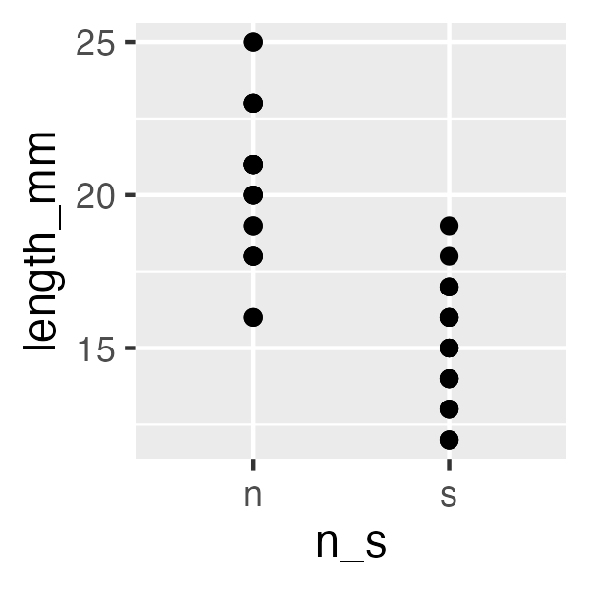
Warning
⚠️ Watch out!
+ sits at the end of a line, never the start.
this is what adds layers to the plot and order matters

Note
✅ Key idea
Seeing your data is the single most important habit in this course — before you summarize or test anything, plot it.

One layer at a time
ggplot(pine_df, aes(x = sun, y = length_mm)) +
geom_boxplot() +
geom_jitter(width = 0.15, alpha = 0.6, color = "tomato") +
labs(x = "Sun exposure",
y = "Needle length (mm)",
title = "Needle length by sun exposure")
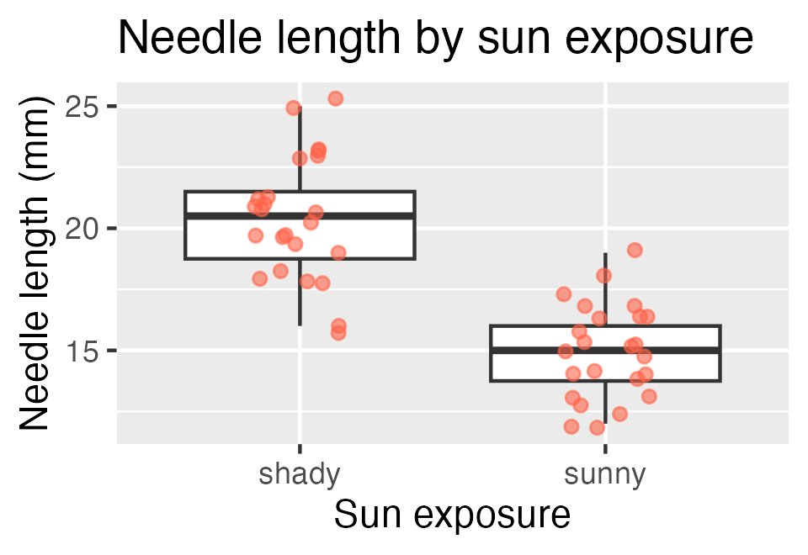
Tip
🖐 Try it yourself
Swap sun for group. What does that plot tell you instead?

Note
✅ Key idea
A boxplot shows the summary; the jittered points show every real value underneath it. Show both when you can.

Save your plot
needle_plot <- ggplot(pine_df, aes(x = sun, y = length_mm)) +
geom_boxplot() +
geom_jitter(width = 0.15, alpha = 0.6, color = "tomato") +
labs(x = "Sun exposure", y = "Needle length (mm)")
ggsave("figures/needle_length.png",
plot = needle_plot,
width = 3, height = 3, units = "in", dpi = 300)
Warning
⚠️ Watch out!
ggsave() wants the filename first, then plot =. Always use dpi = 300 — print/poster quality.

Note
📖 File format tip
Save figures as PNG for reports and submissions.

Wrap-up
Today you:
- Turned a question into a testable H₀ / Hₐ
- Organized a project folder with data/scripts/figures
- Ran your first R code — objects, functions, vectors, packages
- Loaded real data and made — and saved — your first ggplot
Tip
🖐 Before next class
Finish the worksheet: load pine_needles.csv, run glimpse(), and make one more plot — length_mm by n_s this time. Save it to figures/.

Note
Up next — Wrangling Your Data
- filter(), select(), mutate(), arrange()
- Cleaning a genuinely messy version of this dataset
- The pipe |> and building a pipeline

Getting unstuck
When code breaks — and it will, that is normal:
- Read the error message out loud; it usually names the line
- Check the usual suspects: library(tidyverse) loaded? Spelling? A missing ) or + at the start of a line?
- ?function_name opens the help page
- Bring the exact error (copy-paste it) to class or office hours
Note
✅ Key idea
Every working scientist googles error messages daily. Getting stuck is not failing — it is the job.

