Lecture: Multivariate Statistics
  - Multivariate intro
Bill Perry

Part 1 · Why Multivariate Data?

Introduction to Multivariate Analysis

Why Study Multivariate Data?
- In ecology, often measure many variables on the same organisms:
  - Plant morphology: height, width, leaf size, flower size
  - Environmental conditions: temperature, pH, nutrients
  - Species composition: presence/absence, abundance
- Challenge: How do we make sense of all these variables at once?
- PCA helps by:
  - Reducing many correlated variables to a few key dimensions
  - Visualizing patterns in high-dimensional data
  - Identifying the most important sources of variation
 Note
Gotelli & Ellison, A Primer of Ecological Statistics, Ch. 12 — The Analysis of Multivariate Data, is the core reference for this lecture.

Darlingtonia californica (Cobra Lily)

Photo of a cobra lily (Darlingtonia californica) showing its hooded, pitcher-shaped leaves and forked, tongue-like appendages, the carnivorous plant whose morphology this lecture’s PCA example analyzes.

Our Study System: Darlingtonia

The Cobra Lily Dataset
- Analyze morphological measurements from 89 individual Darlingtonia californica plants collected from 4 sites in the Siskiyou Mountains of Oregon.
- Variables measured (10 total):
  - Morphological measurements (mm):
    - height - Height of pitcher
    - mouth_diam - Mouth diameter
    - tube_diam - Tube diameter
    - keel_diam - Keel diameter
    - wing1_length, wing2_length
    - Wing lengths (2 measurements)
    - wingsprea - Wing spread
  - Biomass measurements (g):
    - hoodmass_g - Hood mass
    - tubemass_g - Tube mass
    - wingmass_g - Wing mass
Darlingtonia pitcher structure showing measured features
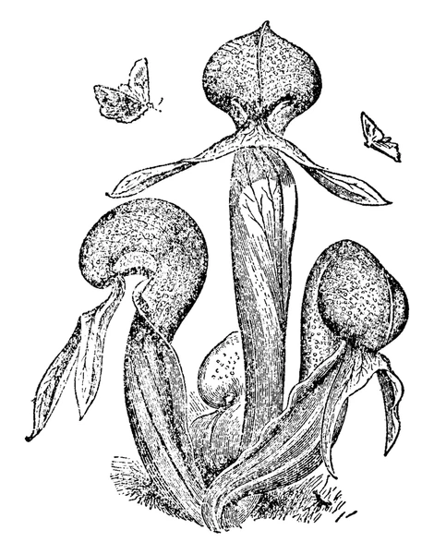
Vintage-style line illustration of three Darlingtonia pitcher-leaf structures with their hooded tops, tube bodies, and forked wing appendages labeled by shape, showing the plant parts behind variables like height, mouth diameter, tube diameter, and wing length/spread used in the PCA.
- Sites:
- TJH: T.J. Howell’s Fen
- DG: Day’s Gulch
- LEH: L.E. Hunter’s Fen
- HD: High Divide

Loading the Data

Step 1: Import and Prepare the Data
# Load the data
darlingtonia <- read_csv("darlingtonia.csv")
# View the structure
head(darlingtonia)
## # A tibble: 6 × 11
## site height mouth_diam tube_diam keel_diam wing1_length wing2_length
## <chr> <dbl> <dbl> <dbl> <dbl> <dbl> <dbl>
## 1 TJH 654 38.4 16.6 6.4 85 76
## 2 TJH 413 22.2 17.2 5.9 55 26
## 3 TJH 610 31.2 19.9 6.7 62 60
## 4 TJH 546 34.4 20.8 6.3 84 79
## 5 TJH 665 30.5 20.4 6.6 60 51
## 6 TJH 665 33.6 19.5 6.6 84 66
## # ℹ 4 more variables: wingsprea <dbl>, hoodmass_g <dbl>, tubemass_g <dbl>,
## # wingmass_g <dbl>
darlingtonia %>%
count(site, name = "n_plants")
## # A tibble: 4 × 2
## site n_plants
## <chr> <int>
## 1 DG 25
## 2 HD 12
## 3 LEH 25
## 4 TJH 25

Exploring the Raw Data

Initial Data Exploration
Before any analysis, we should always look at our data:
- Check for outliers
- Examine distributions
- Look for patterns by site
- Understand variable scales
Key observations:
- Variables measured in different units (mm vs. g)
- Different ranges: height (hundreds) vs. biomass (fractions)
- Need to standardize before PCA!
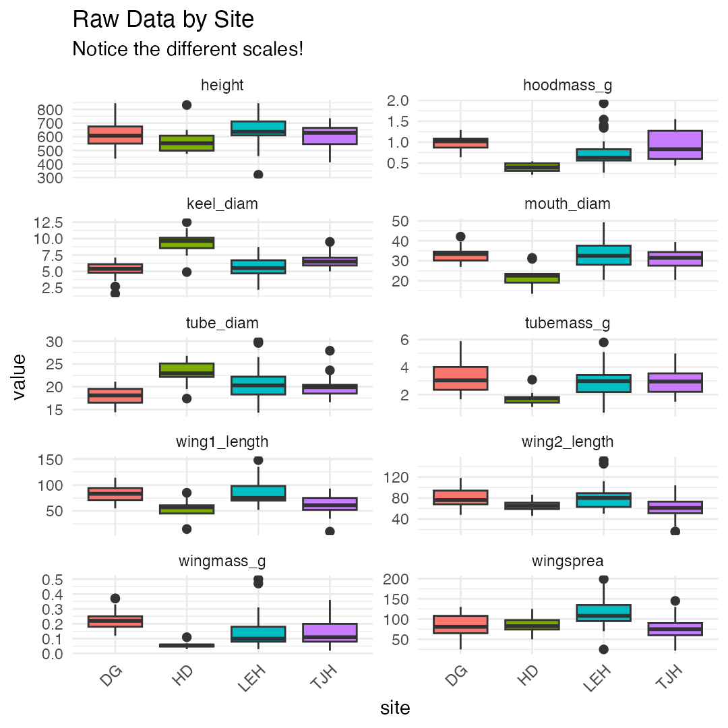

The Problem of Different Scales

Why Standardization Matters
- Without standardization:
  - Variables with larger values (like height in mm) would dominate the analysis over variables with smaller values (like biomass in g).
- Example from data:
  - Height: mean ≈ 600 mm, range 322-845 mm -
  - Wing mass: mean ≈ 0.16 g, range 0.02-5.00 g
- calculated distances without standardizing, height would have 1000× more influence than wing mass!
- Solution: Z-score standardization
  - $Z=\frac{(Y_{i}−\overset{‾}{Y})}{s}$​
- transforms each variable to:
  - Mean = 0
  - Standard deviation = 1
  - Units: “standard deviations from the mean”
- Before standardization: - Height dominates (larger scale)
- After standardization:
  - All variables contribute equally
  - Measured in “standard deviations”
# Example: standardize height
darlingtonia %>%
summarize(
mean_height = mean(height),
sd_height = sd(height),
mean_wingmass = mean(wingmass_g),
sd_wingmass = sd(wingmass_g)
)
## # A tibble: 1 × 4
## mean_height sd_height mean_wingmass sd_wingmass
## <dbl> <dbl> <dbl> <dbl>
## 1 616. 101. 0.154 0.102
# After standardization, both will have:
# mean = 0, sd = 1

Measuring Multivariate Distance

Euclidean Distance Between Individuals
- How different are two plants?
  - For two plants measured on multiple variables, calculate Euclidean distance:
    - For 2 variables (height and spread):
      - $d_{i,j}=\sqrt{(y_{i,1}−y_{j,1})^{2}+(y_{i,2}−y_{j,2})^{2}}$​
    - For n variables:
      - $d_{i,j}=\sqrt{\sum_{k=1}^{n}{(}y_{i,k}−y_{j,k})^{2}}$​
    - Pythagorean theorem extended to many dimensions!
    - Key point: Distance should use standardized values so all variables contribute equally
##
## Distance between plants 1 and 2 (standardized):
## 3.53 standard deviations
##
##
## Note: Standardization uses mean and SD from ALL plants,
## not just these two plants!

Standardizing the Data

Step 2: Z-score Transformation
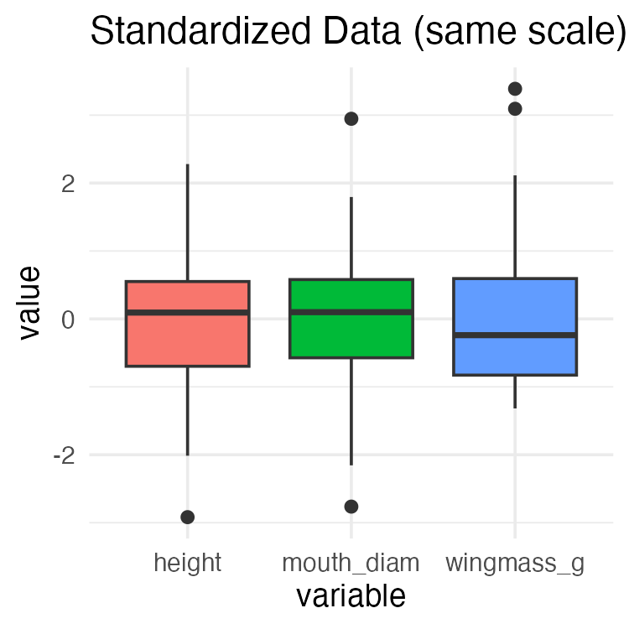

Visualizing Standardized Data
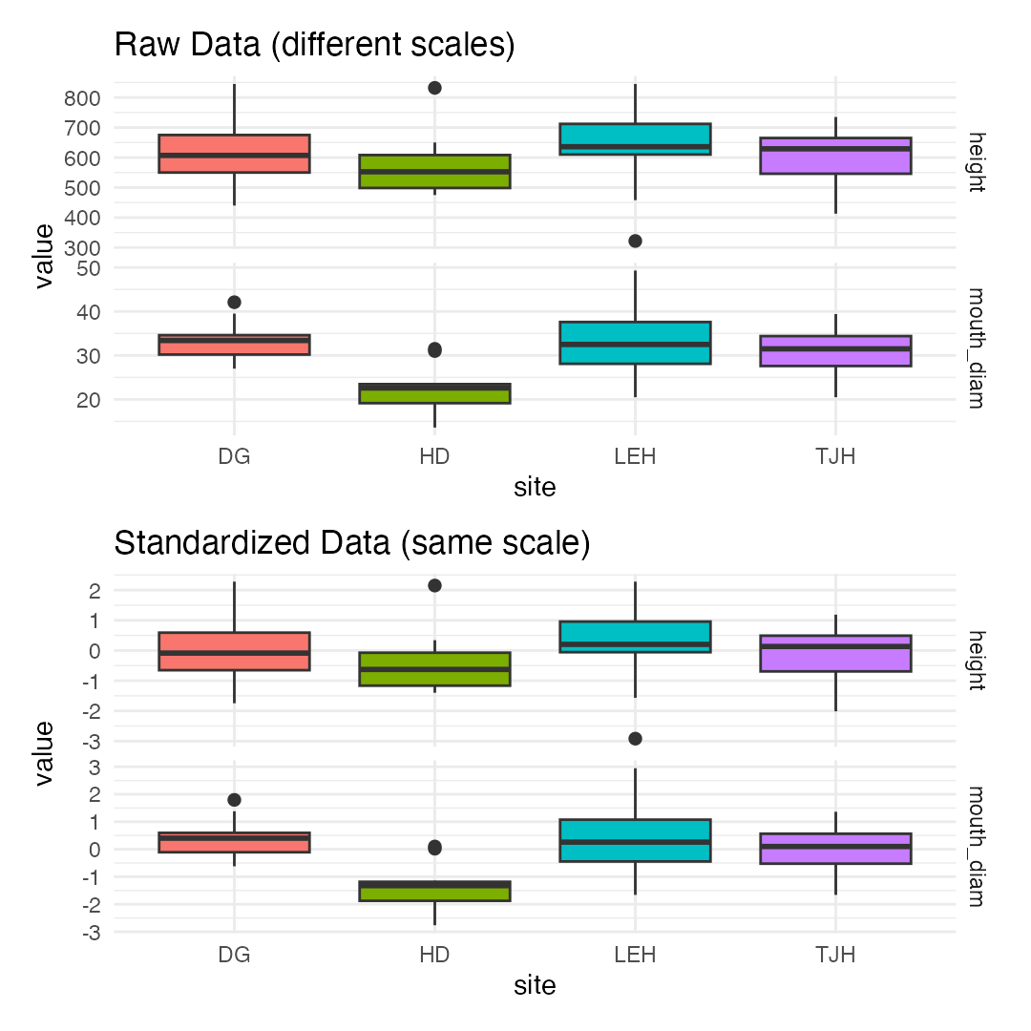

Part 2 · Correlation and the Concept of PCA

Understanding Correlations

Why Correlations Matter for PCA
- PCA works best when variables are correlated:
  - If variables are uncorrelated → PCA provides no benefit
  - If variables are highly correlated → PCA can reduce dimensions effectively
- In data, expect correlations because:
  - Larger plants have larger measurements overall
  - Wing dimensions likely correlate with each other
  - Mass measurements correlate with size measurements
- The correlation matrix shows relationships between all pairs of variables.
- Strong correlations (positive or negative) suggest PCA will be useful!
Strong positive correlations (dark blue) suggest variables measure similar aspects of plant size/shape.
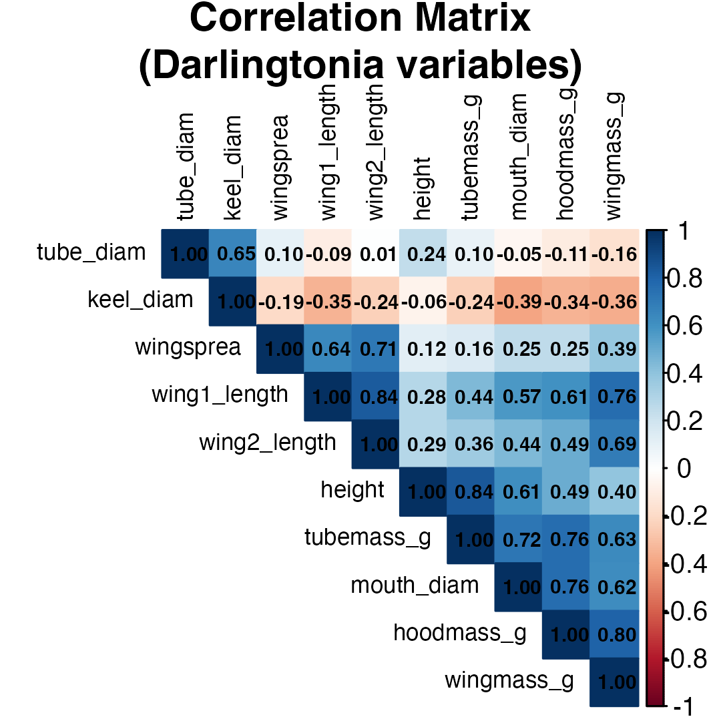

Correlation Matrix Details

Examining Variable Relationships
## height mouth_diam tube_diam keel_diam wing1_length wing2_length
## height 1.00 0.61 0.24 -0.06 0.28 0.29
## mouth_diam 0.61 1.00 -0.05 -0.39 0.57 0.44
## tube_diam 0.24 -0.05 1.00 0.65 -0.09 0.01
## keel_diam -0.06 -0.39 0.65 1.00 -0.35 -0.24
## wing1_length 0.28 0.57 -0.09 -0.35 1.00 0.84
## wing2_length 0.29 0.44 0.01 -0.24 0.84 1.00
## wingsprea 0.12 0.25 0.10 -0.19 0.64 0.71
## hoodmass_g 0.49 0.76 -0.11 -0.34 0.61 0.49
## tubemass_g 0.84 0.72 0.10 -0.24 0.44 0.36
## wingmass_g 0.40 0.62 -0.16 -0.36 0.76 0.69
## wingsprea hoodmass_g tubemass_g wingmass_g
## height 0.12 0.49 0.84 0.40
## mouth_diam 0.25 0.76 0.72 0.62
## tube_diam 0.10 -0.11 0.10 -0.16
## keel_diam -0.19 -0.34 -0.24 -0.36
## wing1_length 0.64 0.61 0.44 0.76
## wing2_length 0.71 0.49 0.36 0.69
## wingsprea 1.00 0.25 0.16 0.39
## hoodmass_g 0.25 1.00 0.76 0.80
## tubemass_g 0.16 0.76 1.00 0.63
## wingmass_g 0.39 0.80 0.63 1.00

Key Observations
- Highly correlated variables:
  - Height with tube area (r=0.89)
    - Wing lengths with each other (r=0.80)
    - Wing area with wing spread (r=0.81)
- These correlations indicate redundancy
- multiple variables measuring similar things.
- Moderate correlations:
  - Most morphological variables
  - Mass measurements with size
- Lower correlations:
  - Some specific features like keel diameter
- PCA will help by combining correlated variables into fewer components!

What is Principal Component Analysis?

The Concept of PCA
- PCA creates new variables (components) that are:
  - Linear combinations of original variables
  - Uncorrelated with each other
  - Ordered by importance (amount of variance explained)
- The mathematical idea:
  - For each plant i and component k:
  - $Z_{ik}=a_{i1}Y_{1}+a_{i2}Y_{2}+...+a_{in}Y_{n}$​
- Where:
  - $Z_{ik}$ = score on principal component k
  - $Y_{j}$ = standardized value of original variable j
  - $a_{ij}$ = loading (weight) of variable j on component i
- Goal: Find loadings that maximize variance in first component, then second, etc.
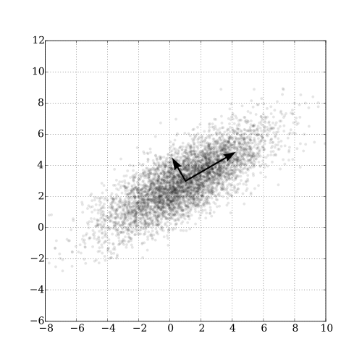
Conceptual diagram of PCA: reducing 2 variables to 1 principal axis
- The first principal axis passes through maximum variance.
- Key properties: - As many components as variables - First components explain most variation - Later components explain residual variation

Principal Components: Properties

Understanding Components are:
- 1. Orthogonal (perpendicular)
  - Components are uncorrelated
  - Each captures independent information
- 2. Ordered by variance
  - PC1 explains the most variance
  - PC2 explains second most (of remaining variance)
  - And so on…
- 3. Linear combinations
  - Each component is a weighted sum of original variables
  - Weights (loadings) show variable importance

Why this matters:
- Dimension reduction:
  - Start with 10 correlated variables
  - End with 2-3 uncorrelated components
  - Retain most information with fewer dimensions
- Easier interpretation:
  - PC1 might represent “overall size”
  - PC2 might represent “shape”
  - Components often have biological meaning
- Better for analysis:
  - Can use in regression, ANOVA
  - No multicollinearity problems
  - Variables are standardized

Part 3 · Running PCA in R

Performing PCA in R

Step 3: Run the Analysis
# Perform PCA using prcomp()
# center = TRUE: center variables (mean = 0)
# scale. = TRUE: scale variables (sd = 1)
pca_result <- prcomp(darl_numeric,
center = TRUE,
scale = TRUE)
# What's in the result?
names(pca_result)
## [1] "sdev" "rotation" "center" "scale" "x"

Understanding the Output
## Importance of components:
## PC1 PC2 PC3 PC4 PC5 PC6 PC7
## Standard deviation 2.2332 1.3288 1.2354 0.75701 0.59301 0.51062 0.46177
## Proportion of Variance 0.4987 0.1766 0.1526 0.05731 0.03517 0.02607 0.02132
## Cumulative Proportion 0.4987 0.6753 0.8279 0.88521 0.92038 0.94645 0.96777
## PC8 PC9 PC10
## Standard deviation 0.3768 0.33982 0.25457
## Proportion of Variance 0.0142 0.01155 0.00648
## Cumulative Proportion 0.9820 0.99352 1.00000
- Output components:
- sdev: standard deviations of each PC (square root of eigenvalues)
- rotation: loadings matrix (how variables load on PCs)
- x: PC scores for each observation
- center: variable means
- scale: variable standard deviations

Eigenvalues and Variance Explained

How Much Variance Does Each PC Explain?
- Eigenvalues ($λ$) measure variance explained by each component.
- The proportion of variance for PC j is:
  - ${\text{Proportion}}_{j}=\frac{λ_{j}}{\sum_{k=1}^{n}{λ_{k}}}$​
- In practice:
  - PC1 always explains the most variance
  - We want the first few PCs to explain most (>70%) of total variance
  - allows dimension reduction
## # A tibble: 10 × 4
## PC Eigenvalue Proportion Cumulative
## <chr> <dbl> <dbl> <dbl>
## 1 PC1 4.99 0.499 0.499
## 2 PC2 1.77 0.177 0.675
## 3 PC3 1.53 0.153 0.828
## 4 PC4 0.573 0.057 0.885
## 5 PC5 0.352 0.035 0.92
## 6 PC6 0.261 0.026 0.946
## 7 PC7 0.213 0.021 0.968
## 8 PC8 0.142 0.014 0.982
## 9 PC9 0.115 0.012 0.994
## 10 PC10 0.065 0.006 1

Scree Plot: Choosing Components

How Many Components to Use?
- A scree plot shows variance explained by each component.
- How to read it:
  - Look for an “elbow” - sharp change in slope
  - Keep components before the elbow
  - Discard components in the “scree” (rubble)
- In this data:
  - PC1 explains 49.9% of variance
  - PC2 explains 17.7%
  - PC3 explains 15.3%
  - First 3 PCs explain 77.3% of variance
- Decision: Use PC1, PC2, and PC3 for interpretation.
- remaining 7 components explain 17.1% (mostly noise).
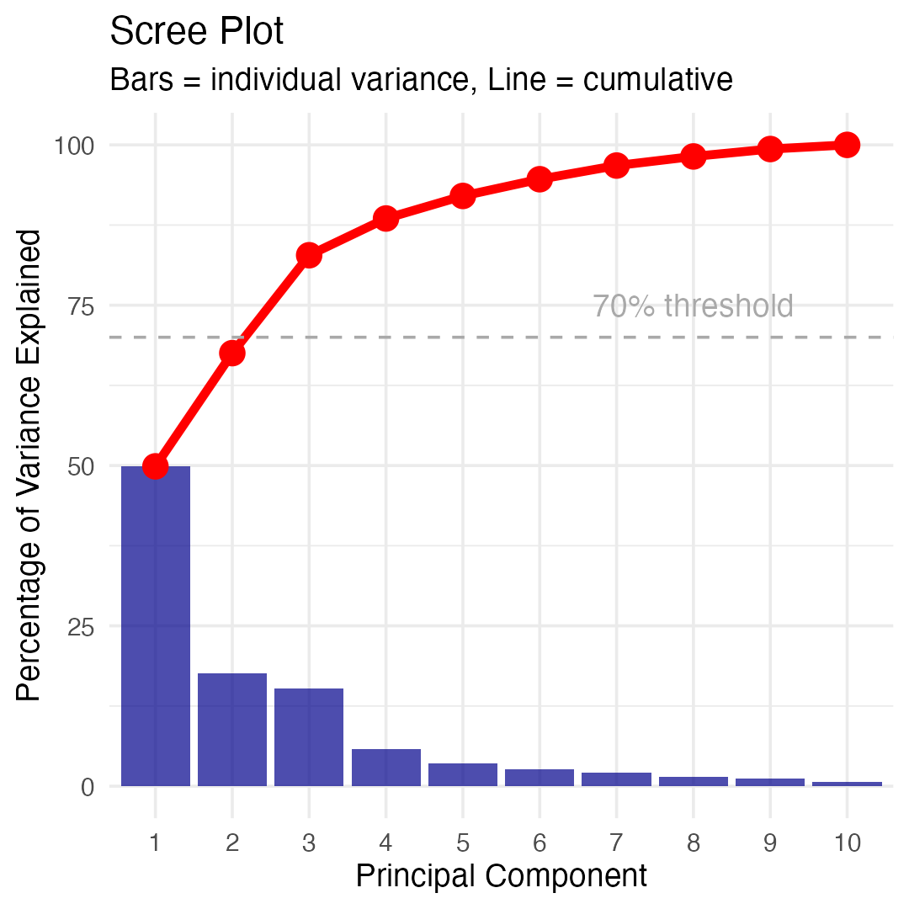

Part 4 · Interpreting Loadings and Components

Understanding Loadings

What are Loadings?
- Loadings are the weights ($a_{ij}$) that show how each original variable contributes to each principal component.
- For PC1:
  - $Z_{1}=a_{11}Y_{1}+a_{12}Y_{2}+...+a_{1p}Y_{p}$​
- Interpreting loadings:
  - Large positive loading: variable increases with PC
  - Large negative loading: variable decreases with PC
  - Near-zero loading: variable unimportant for PC
- Guidelines:
  - Loadings > 0.3 or < -0.3 are worth considering
  - Loadings > 0.5 or < -0.5 are important
  - Sign (+ or -) can flip; patterns matter more
- PC1 loadings:
  - Most variables have similar positive values
  - All ~0.31 to 0.40 except keel (-0.18) and tube (-0.002)
  - Suggests PC1 measures “overall size”
## PC1 PC2 PC3
## height -0.278 -0.449 0.198
## mouth_diam -0.369 -0.110 0.214
## tube_diam 0.040 -0.602 -0.390
## keel_diam 0.202 -0.491 -0.328
## wing1_length -0.375 0.171 -0.280
## wing2_length -0.342 0.131 -0.415
## wingsprea -0.239 0.156 -0.549
## hoodmass_g -0.385 -0.057 0.185
## tubemass_g -0.355 -0.320 0.263
## wingmass_g -0.393 0.080 -0.007

Interpreting PC1: Overall Size
- PC1 Interpretation - Looking at PC1 loadings:
- Key patterns:
- Most variables load positively and similarly: - Height: 0.310 - Mouth diameter: 0.400
  - Wing lengths: 0.386, 0.372
  - Wing spread: 0.256
  - Biomass: 0.397, 0.380, 0.230
- Exception: Keel diameter (-0.177) and tube diameter (~0)
- Biological meaning: PC1 represents overall plant size
  - most measurements scale together (bigger plants have bigger everything).
## # A tibble: 10 × 2
## Variable Loading
## <chr> <dbl>
## 1 wingmass_g -0.393
## 2 hoodmass_g -0.385
## 3 wing1_length -0.375
## 4 mouth_diam -0.369
## 5 tubemass_g -0.355
## 6 wing2_length -0.342
## 7 height -0.278
## 8 wingsprea -0.239
## 9 keel_diam 0.202
## 10 tube_diam 0.0402
- High PC1 → large plants
- Low PC1 → small plants
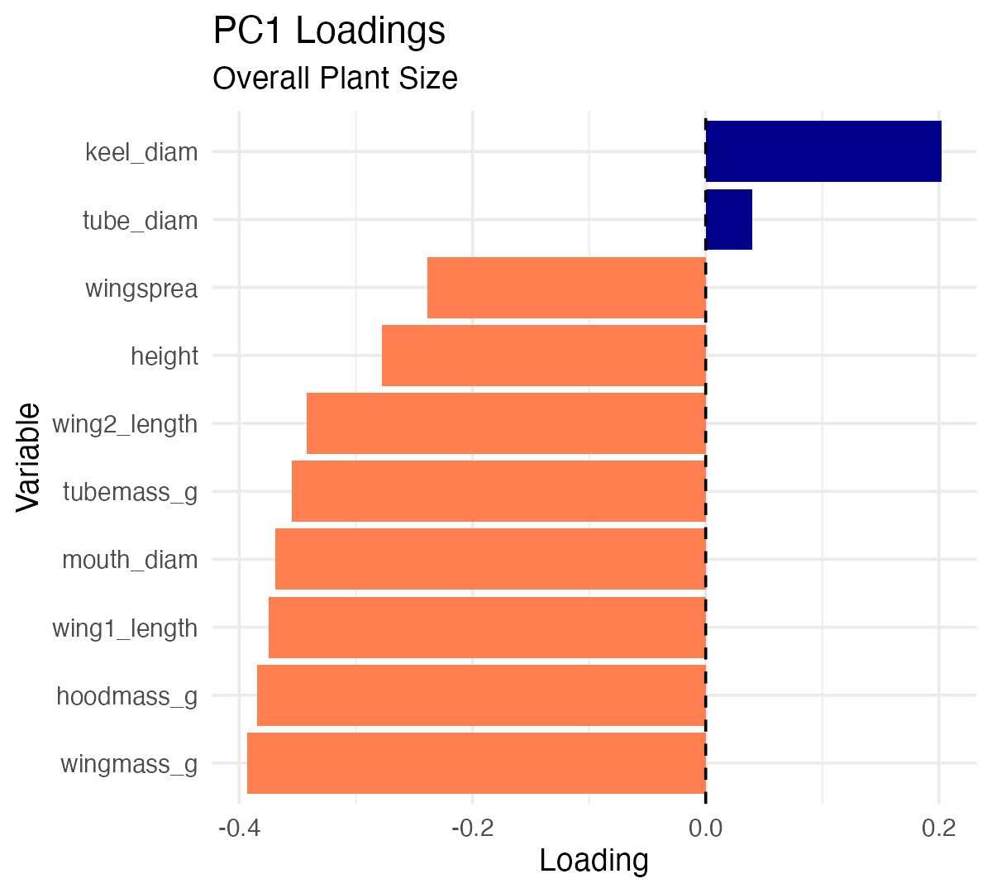

Interpreting PC2: Shape Contrast

PC2 Interpretation
- Looking at PC2 loadings:
- Key patterns:
  - Height: -0.419 (negative, moderate)
  - Mouth: -0.250 (negative, moderate)
  - Wing measurements: positive (0.275-0.434)
  - Wing spread: 0.434 (positive, strong)
  - Biomass: mostly negative
- Biological meaning: PC2 represents shape trade-offs
  - tall narrow pitchers vs. short wide pitchers with large wings.
## # A tibble: 10 × 2
## Variable Loading
## <chr> <dbl>
## 1 tube_diam -0.602
## 2 keel_diam -0.491
## 3 height -0.449
## 4 tubemass_g -0.320
## 5 wing1_length 0.171
## 6 wingsprea 0.156
## 7 wing2_length 0.131
## 8 mouth_diam -0.110
## 9 wingmass_g 0.0800
## 10 hoodmass_g -0.0575
- High PC2 → short plants with large wings
- Low PC2 → tall narrow plants
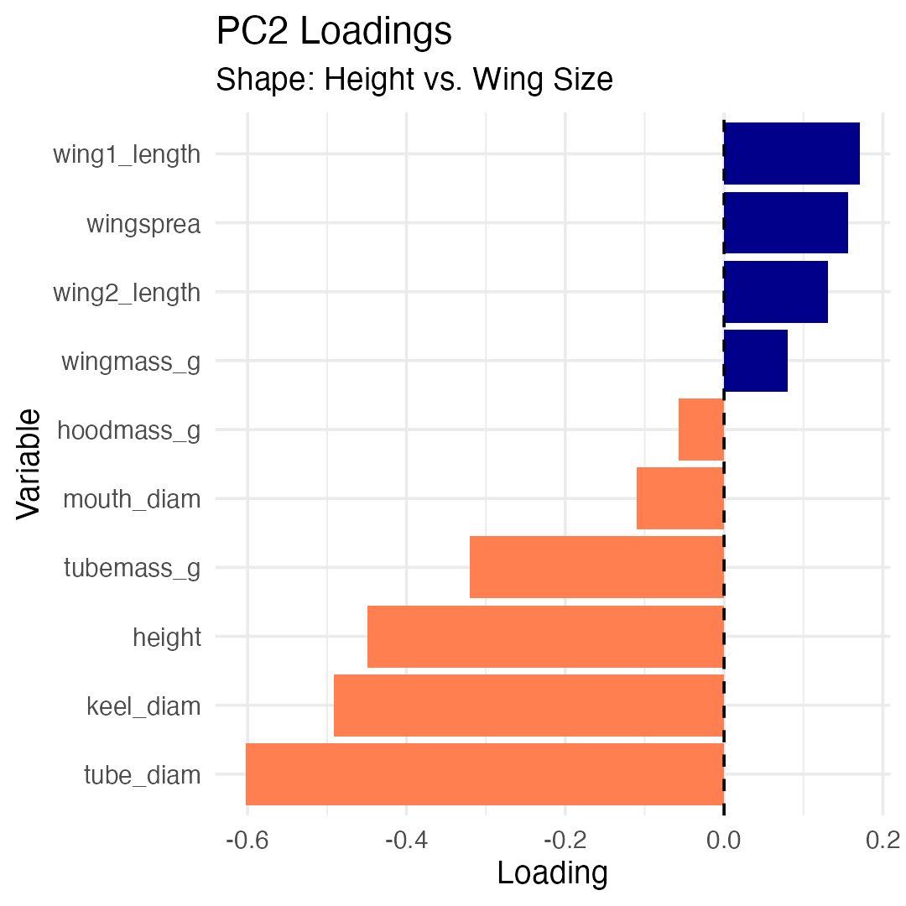

Interpreting PC3

PC3 Interpretation
- Looking at PC3 loadings:
- Key patterns:
- Dominated by:
  - Tube diameter: 0.743 (very strong positive)
  - Keel diameter: 0.576 (strong positive)
  - Most other variables near zero
- Biological meaning: PC3 represents tube girth
  - width/diameter of tube structure independent of height or wing size.
  - Plants with high PC3 scores = fat tubes, allowing to trap larger prey?
## # A tibble: 10 × 2
## Variable Loading
## <chr> <dbl>
## 1 wingsprea -0.549
## 2 wing2_length -0.415
## 3 tube_diam -0.390
## 4 keel_diam -0.328
## 5 wing1_length -0.280
## 6 tubemass_g 0.263
## 7 mouth_diam 0.214
## 8 height 0.198
## 9 hoodmass_g 0.185
## 10 wingmass_g -0.00743
- High PC3 → fat tubes
- Low PC3 → skinny tubes
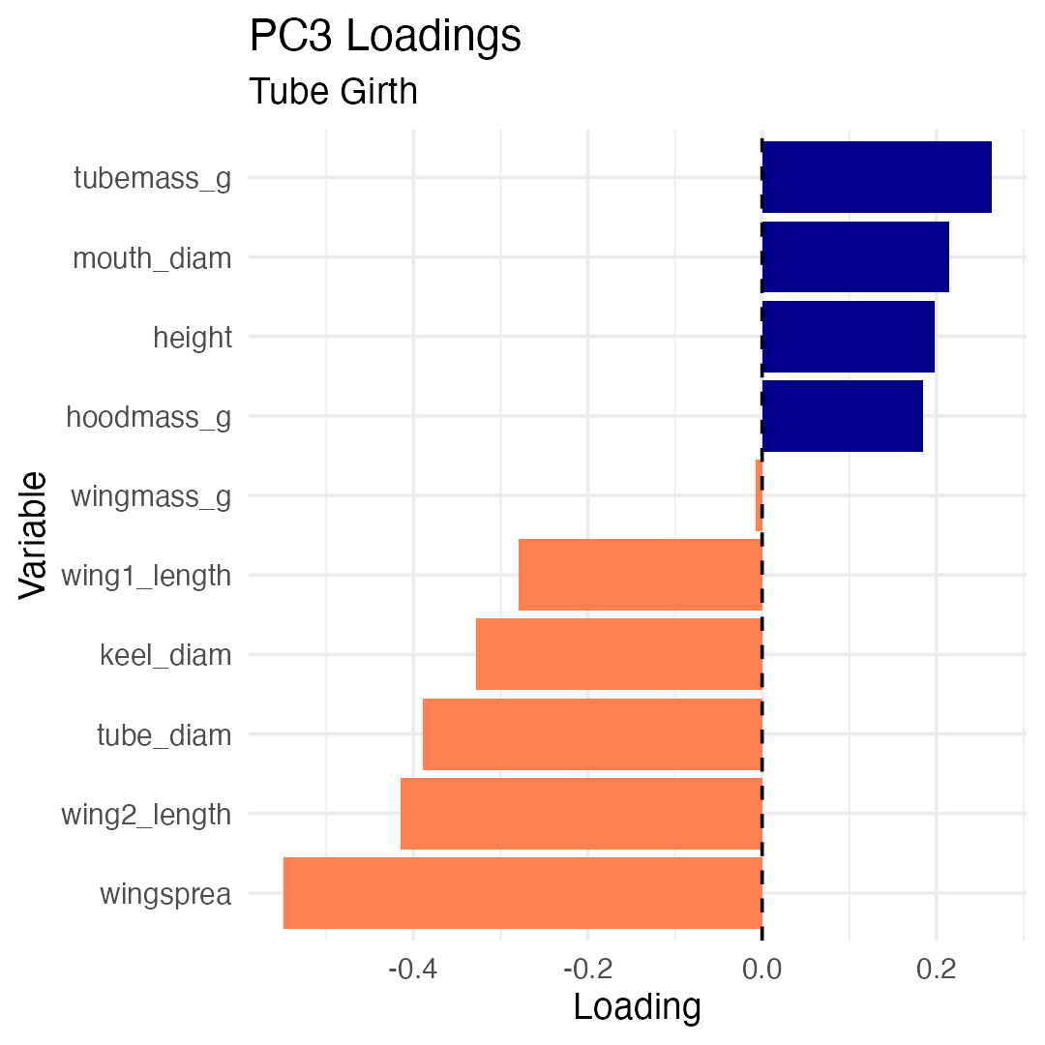

Part 5 · Scores, Ordination and Biplots

Principal Component Scores

What are PC Scores?
- PC scores are values of each principal component for each obs./plant
- Each plant gets a score on each PC:
  - PC1 score = measure of size
  - PC2 score = measure of shape
  - PC3 score = measure of tube girth
- How they’re calculated:
- For plant i on PC1:
  - ${\text{PC1}}_{i}=0.31×height_{i}+0.40×mouth_{i}+...$​
  - Using the standardized values and loadings we saw earlier.
## # A tibble: 10 × 5
## plant_id site PC1 PC2 PC3
## <int> <chr> <dbl> <dbl> <dbl>
## 1 1 TJH -1.92 0.0772 1.53
## 2 2 TJH 3.35 1.53 0.755
## 3 3 TJH 0.918 -0.0320 0.248
## 4 4 TJH -0.983 0.236 -0.242
## 5 5 TJH 1.15 -1.02 1.54
## 6 6 TJH -1.37 -0.613 0.847
## 7 7 TJH -1.50 -1.63 0.693
## 8 8 TJH -0.651 0.121 -0.412
## 9 9 TJH 2.48 -0.0786 -0.260
## 10 10 TJH -1.11 -1.27 2.27

Visualizing PCA Results: Scores Plot

Ordination of Sites
- We can plot PC scores to visualize:
  - How plants are distributed in PC space
  - Whether sites differ in morphology
  - Patterns and groupings
- In this plot:
  - Each point = one plant
  - Position determined by PC1 and PC2 scores
  - Colors indicate collection site
- Observations:
  - Sites show some separation
  - HD (orange) plants have lower PC1 (smaller)
  - TJH (pink) plants variable but lower PC2
  - Some overlap among sites
- This is called ordination - ordering objects along axes.
The ordination
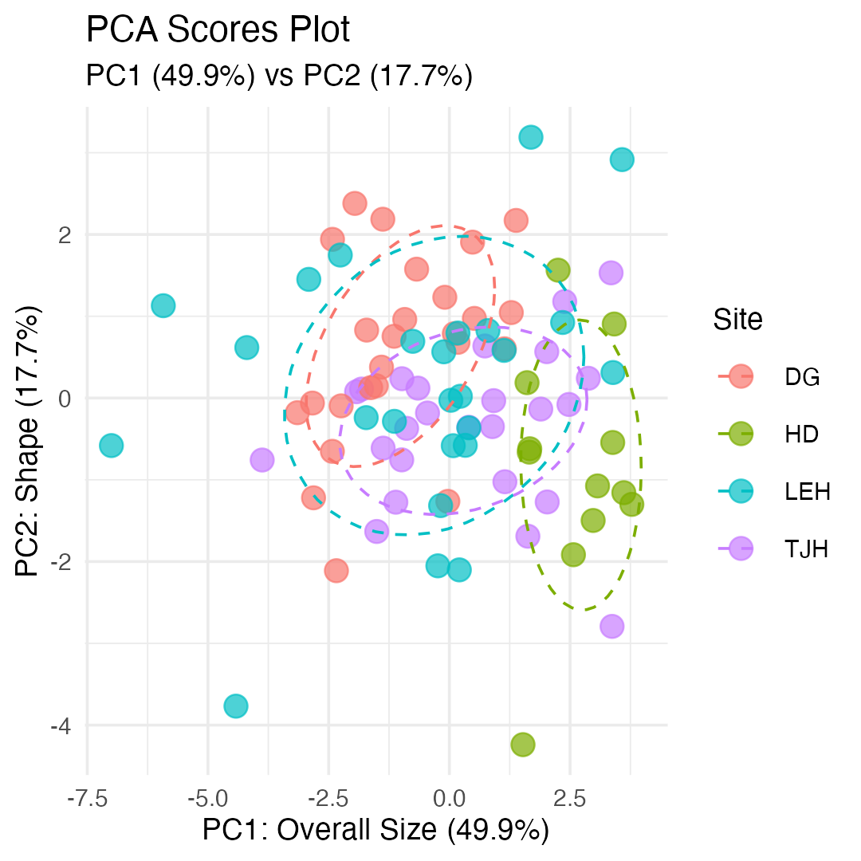

Different visualization of PCA Scores
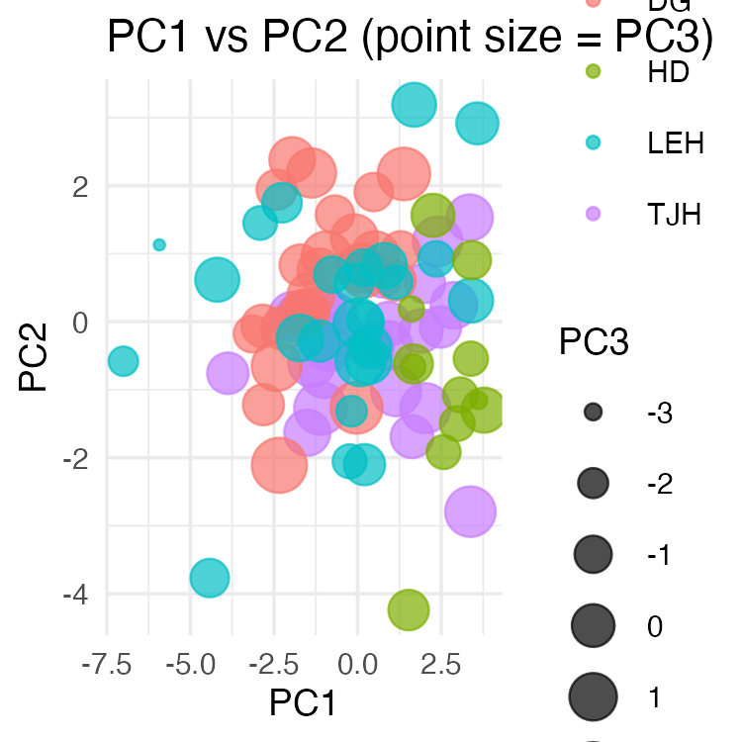

PCA Biplot: Combining Scores and Loadings

Reading a Biplot
- A biplot shows both:
  - Points = plants (PC scores)
  - Arrows = original variables (loadings)
- How to interpret arrows:
- Length = how important the variable is
- Direction = how the variable relates to PCs
- Angle between arrows = correlation
  - Small angle = positively correlated
  - 90° = uncorrelated
  - 180° = negatively correlated
- How to interpret points:
  - Plants in the direction of an arrow are high in that variable
  - Plants opposite an arrow are low in that variable
The plot
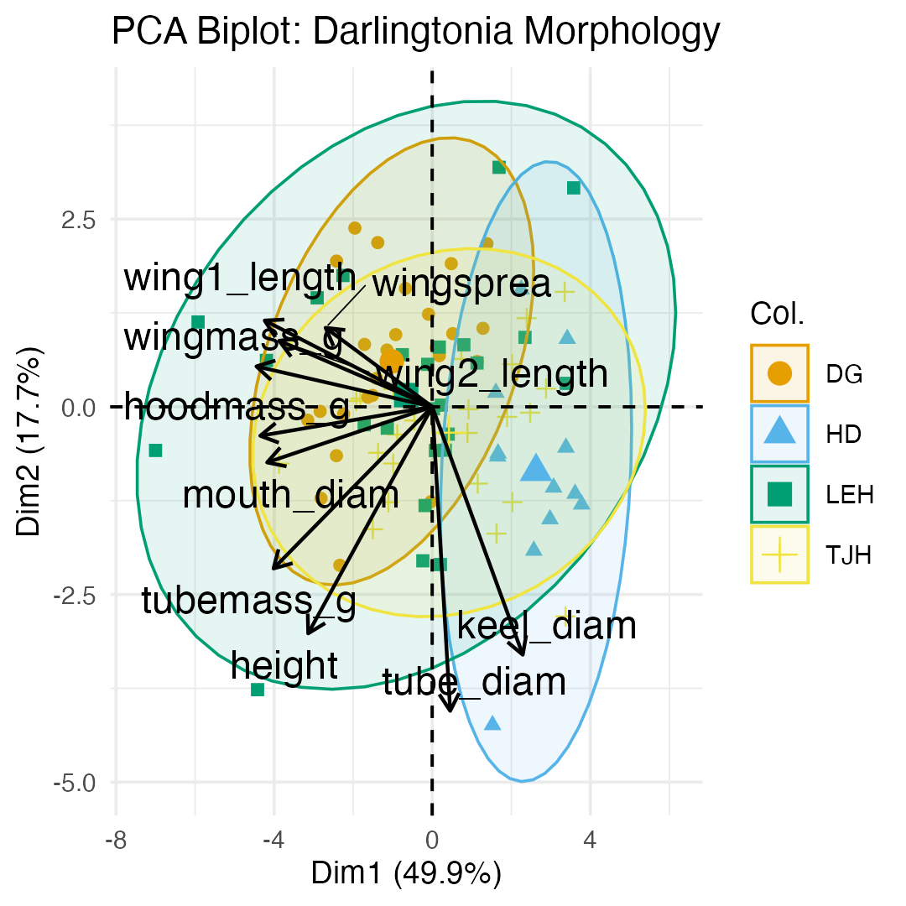

Biplot Interpretation

Key Patterns in the Biplot
- Variable relationships:
  - Most morphological and biomass variables point together (right and slightly down):
    - Height, mouth, masses - These are highly correlated
    - All contribute to PC1 (size)
- Wing variables (wing1_length, wing2_length, wingspread) point more upward:
  - Contribute positively to PC2
    - Represent the “wing dimension” of shape
- Site separation:
  - HD (blue): Lower PC1, plants are smaller overall
  - DG (orange): Higher PC1, plants are larger
  - TJH (yellow) and LEH (green): Intermediate and variable

Biological Interpretation
- What determines plant morphology?
  - Size (PC1, 45.8% variance)
    - Primary source of variation
    - Most measurements scale together
    - May reflect resource availability or age
  - Shape trade-offs (PC2, 16.7% variance)
    - Tall narrow vs. short wide with large wings
    - May reflect different trapping strategies
    - Or developmental/environmental constraints
  - Tube dimensions (PC3, 14.8% variance)
    - Independent aspect of morphology
    - May affect prey capture efficiency
  - Sites differ primarily in overall size, with some shape variation.

Part 6 · Testing Group Differences

Testing Site Differences with ANOVA

Step 4: Statistical Analysis
- Now that we have PC scores, we can test if sites differ:
  - Result: Sites differ significantly in PC1 (F = 9.26, P < 0.001)
# Test for site differences on PC1 (size)
anova_pc1 <- aov(PC1 ~ site, data = pc_scores)
summary(anova_pc1)
## Df Sum Sq Mean Sq F value Pr(>F)
## site 3 124.3 41.44 11.29 2.75e-06 ***
## Residuals 83 304.6 3.67
## ---
## Signif. codes: 0 '***' 0.001 '**' 0.01 '*' 0.05 '.' 0.1 ' ' 1
# Calculate means by site
pc_scores %>%
group_by(site) %>%
summarize(
mean_PC1 = mean(PC1),
sd_PC1 = sd(PC1),
n = n()
)
## # A tibble: 4 × 4
## site mean_PC1 sd_PC1 n
## <chr> <dbl> <dbl> <int>
## 1 DG -1.02 1.38 25
## 2 HD 2.63 0.857 12
## 3 LEH -0.659 2.61 25
## 4 TJH 0.423 1.90 25

ANOVA for PC2 and PC3

Testing Shape and Tube Differences
- Results:
  - PC2 (shape): F = 5.36, P = 0.002 (significant)
    - PC3 (tube girth): F = 1.45, P = 0.234 (not significant)
# Test for site differences on PC2 (shape)
anova_pc2 <- aov(PC2 ~ site, data = pc_scores)
summary(anova_pc2)
## Df Sum Sq Mean Sq F value Pr(>F)
## site 3 21.63 7.209 4.595 0.00502 **
## Residuals 83 130.22 1.569
## ---
## Signif. codes: 0 '***' 0.001 '**' 0.01 '*' 0.05 '.' 0.1 ' ' 1
# Test for site differences on PC3 (tube girth)
anova_pc3 <- aov(PC3 ~ site, data = pc_scores)
summary(anova_pc3)
## Df Sum Sq Mean Sq F value Pr(>F)
## site 3 43.68 14.561 13.8 2.2e-07 ***
## Residuals 83 87.58 1.055
## ---
## Signif. codes: 0 '***' 0.001 '**' 0.01 '*' 0.05 '.' 0.1 ' ' 1
# Summary statistics
pc_scores %>% group_by(site) %>% summarize(mean_PC2 = mean(PC2),mean_PC3 = mean(PC3))
## # A tibble: 4 × 3
## site mean_PC2 mean_PC3
## <chr> <dbl> <dbl>
## 1 DG 0.604 0.542
## 2 HD -0.863 -1.26
## 3 LEH 0.155 -0.555
## 4 TJH -0.345 0.618

Visualizing Site Differences

Box Plots of PC Scores
HD plants are significantly smaller than plants at other sites.
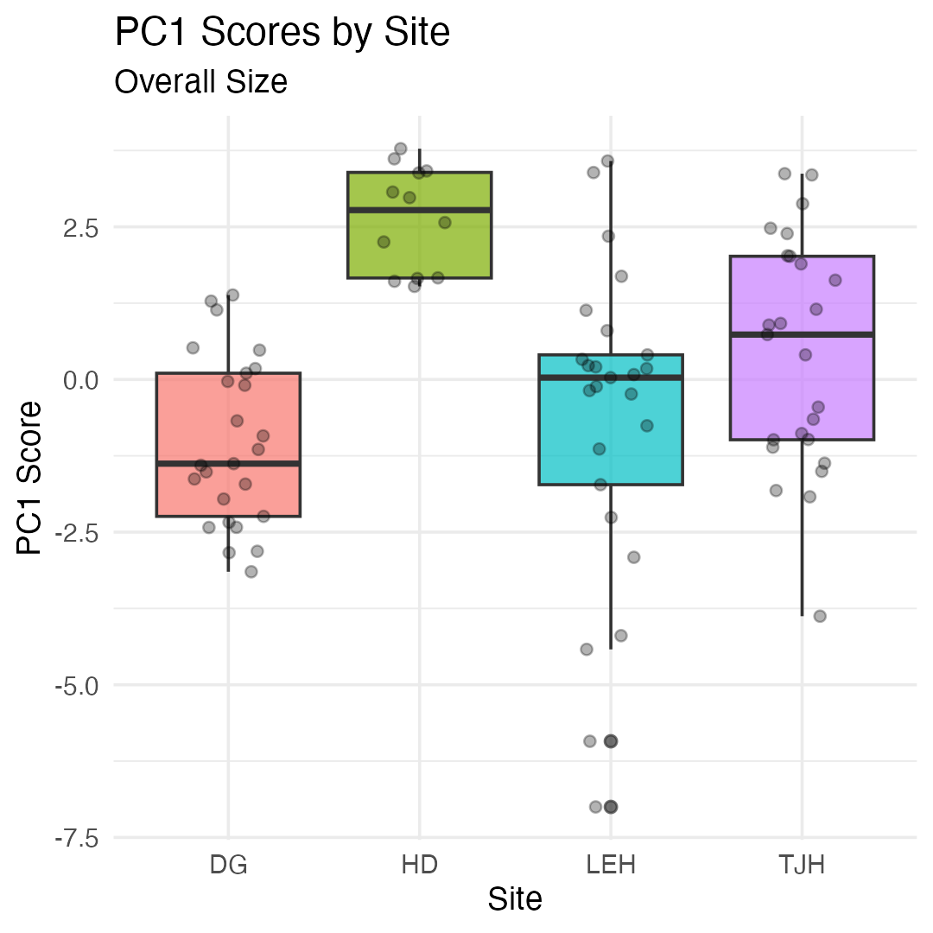
- TJH plants have different shapes
  - taller and narrower with smaller wings.
- 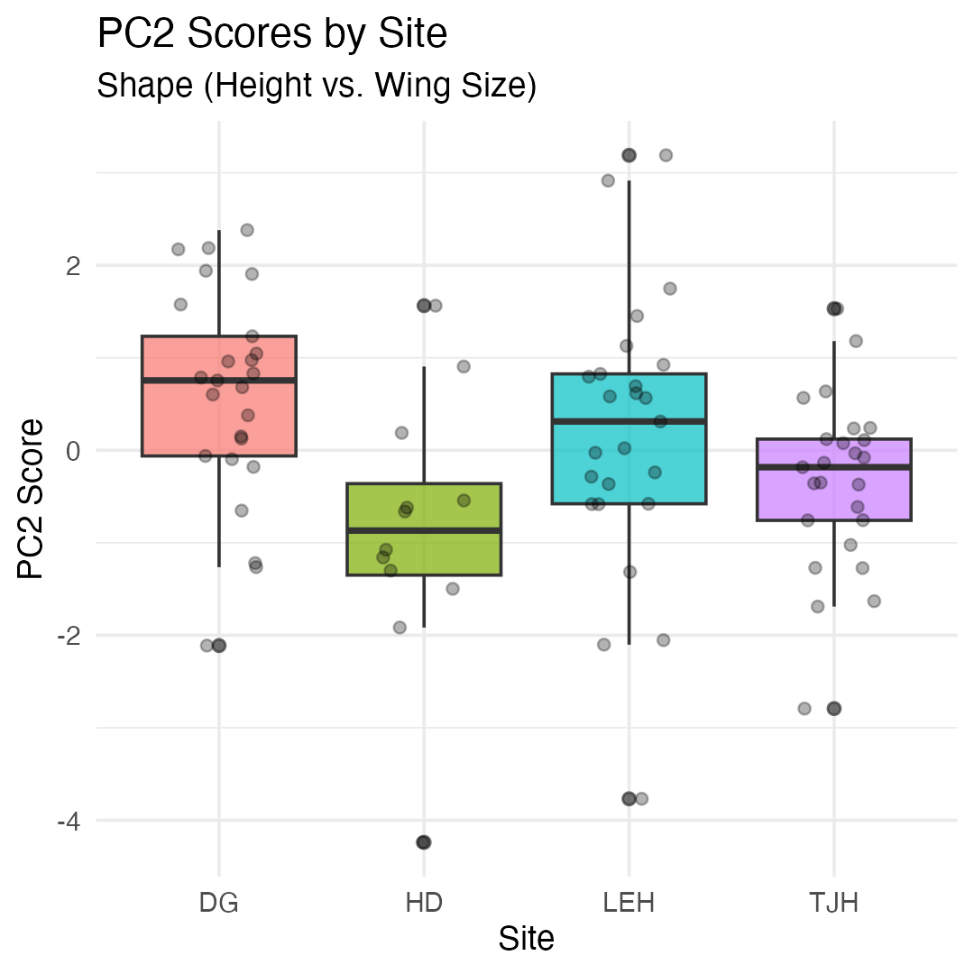

Post-hoc Comparisons

Which Sites Differ?
## contrast estimate SE df t.ratio p.value
## DG - HD -3.651 0.673 83 -5.427 <0.0001
## DG - LEH -0.366 0.542 83 -0.675 0.9064
## DG - TJH -1.447 0.542 83 -2.671 0.0442
## HD - LEH 3.285 0.673 83 4.883 <0.0001
## HD - TJH 2.204 0.673 83 3.276 0.0082
## LEH - TJH -1.082 0.542 83 -1.996 0.1977
##
## P value adjustment: tukey method for comparing a family of 4 estimates
## site emmean SE df lower.CL upper.CL .group
## DG -1.024 0.383 83 -1.786 -0.262 a
## LEH -0.659 0.383 83 -1.421 0.103 ab
## TJH 0.423 0.383 83 -0.339 1.185 b
## HD 2.626 0.553 83 1.526 3.726 c
##
## Confidence level used: 0.95
## P value adjustment: tukey method for comparing a family of 4 estimates
## significance level used: alpha = 0.05
## NOTE: If two or more means share the same grouping symbol,
## then we cannot show them to be different.
## But we also did not show them to be the same.

Distance Between Sites

Calculating Euclidean Distance Between Groups
- Calculate the distance between site centroids (mean PC scores):
  - $d_{k,j}=\sqrt{\sum_{i=1}^{p}{(}{\overset{‾}{Z}}_{i,k}−{\overset{‾}{Z}}_{i,j})^{2}}$​
  - Where ${\overset{‾}{Z}}_{i,k}$ is the mean of PC i for site k.
- Using all PCs preserves the true Euclidean distance from the original data.
- Using just PC1-PC3 (77% of variance) gives approximate distances.
HD is most different from other sites (smallest plants).
# Calculate site centroids (means)
site_means <- pc_scores %>%
group_by(site) %>%
summarize(across(PC1:PC3, mean))
site_means
## # A tibble: 4 × 4
## site PC1 PC2 PC3
## <chr> <dbl> <dbl> <dbl>
## 1 DG -1.02 0.604 0.542
## 2 HD 2.63 -0.863 -1.26
## 3 LEH -0.659 0.155 -0.555
## 4 TJH 0.423 -0.345 0.618
# Calculate distance matrix
site_dist <- site_means %>%
dplyr::select(PC1, PC2, PC3) %>%
dist() %>%
round(3)
site_dist
## 1 2 3
## 2 4.328
## 3 1.241 3.511
## 4 1.732 2.942 1.672

Visualization of the distances
# 1. Prepare PC Scores with Site
pc_scores_for_dist <- as.data.frame(pca_result$x) %>%
mutate(site = darlingtonia$site)
# 2. Calculate the mean PC scores for each site (the site "centroids")
site_centroids <- pc_scores_for_dist %>%
group_by(site) %>%
summarise(across(starts_with("PC"), mean)) %>%
ungroup()
# 3. Set site names as row names BEFORE calculating distances
site_centroids_matrix <- site_centroids %>%
column_to_rownames("site") # This keeps site names as row names
# 4. Calculate the Euclidean distance matrix between site centroids
dist_matrix <- dist(site_centroids_matrix, method = "euclidean")
# Display the distance matrix
dist_matrix
## DG HD LEH
## HD 4.346434
## LEH 1.621198 3.659711
## TJH 1.843120 3.021386 1.960547
# Visualize the distance matrix
fviz_dist(dist_matrix,
gradient = list(low = "#00AFBB", high = "#FC4E07"))
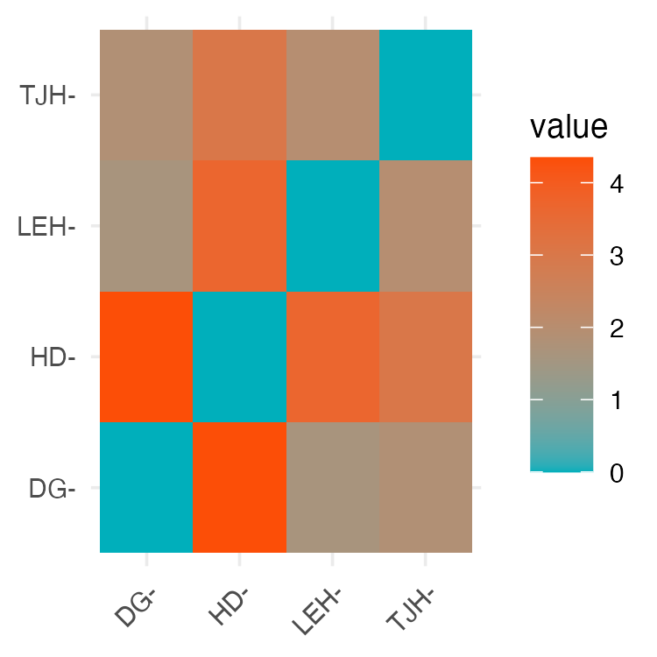

Part 7 · Summary and When to Use PCA

Summary: PCA Results for Darlingtonia

What We Learned
- Dimension Reduction Success
  - Started with: 10 correlated variables
  - Reduced to: 3 principal components
  - Retained: 77.3% of variance
- This makes data easier to visualize, interpret, and analyze.
- Biological Insights - Three major axes of morphological variation: - PC1 (45.8%): Overall size
  - Larger vs. smaller plants
  - HD site has smallest plants - PC2 (16.7%): Shape contrast
  - Tall/narrow vs. short/wide with large wings
  - TJH site has taller, narrower plants - PC3 (14.8%): Tube girth
  - Fat vs. skinny tubes
  - No significant site differences
- Statistical Findings
  - Sites differ significantly in size (PC1)
  - Sites differ significantly in shape (PC2)
  - Sites do not differ in tube girth (PC3)
- PCA Advantages
  - Reduced 10 dimensions to 3
  - Created uncorrelated variables
  - Revealed biological patterns
  - Enabled statistical testing
  - Simplified visualization
- Key Take-Home Messages
  - PCA good for exploratory analysis of multivariate data
  - Always standardize when different units/scales
  - Loadings reveal variables contributions to each component
  - Scores used in subsequent analyses (ANOVA, regression)
  - Biplots visualize both samples and variables simultaneously

When to Use PCA
- PCA is Appropriate When:
  - Variables are continuous (not categorical)
  - Variables are correlated (redundancy exists) + Linear relationships
  - Goal is dimension reduction or data exploration
  - Sample size adequate (at least 3× number of variables)
- PCA Assumptions:
  - Linearity: relationships between variables are linear
  - Adequate correlation: variables must be correlated
  - No severe outliers: can distort results
  - Sample size: need enough observations
- Always Check:
  - Correlation matrix (are variables correlated?)
  - Scree plot (how many components needed?)
  - Loadings (biological interpretation makes sense?)
  - Outliers (check scores plots)

When to Consider Alternatives:
- Different data types:
  - Categorical variables → MCA (Multiple
  - Correspondence Analysis) - Species composition data → CA (Correspondence Analysis)
  - Distance/dissimilarity matrices → PCoA (Principal Coordinates Analysis)
- Different goals: - Classification → Discriminant Analysis
  - Non-linear patterns → NMDS (Non-metric Multidimensional Scaling)
  - Hypothesis testing → MANOVA
- Problems with PCA:
  - Strong outliers present
  - Non-linear relationships
  - Variables are uncorrelated
  - Many zeros in data
- PCA works best for morphological, physiological, and environmental variables!

Additional PCA Diagnostics

Checking Assumptions and Quality
- Sampling Adequacy
- Kaiser-Meyer-Olkin (KMO) Test:
- Measures sampling adequacy
- Values > 0.6 = acceptable
- Values > 0.8 = good
Our overall KMO = 0.80 (good!)
# KMO test requires psych package
KMO(cor(darl_numeric))
## Kaiser-Meyer-Olkin factor adequacy
## Call: KMO(r = cor(darl_numeric))
## Overall MSA = 0.76
## MSA for each item =
## height mouth_diam tube_diam keel_diam wing1_length wing2_length
## 0.64 0.84 0.47 0.61 0.85 0.80
## wingsprea hoodmass_g tubemass_g wingmass_g
## 0.76 0.78 0.72 0.86

2. Outlier Detection
Check for influential observations:
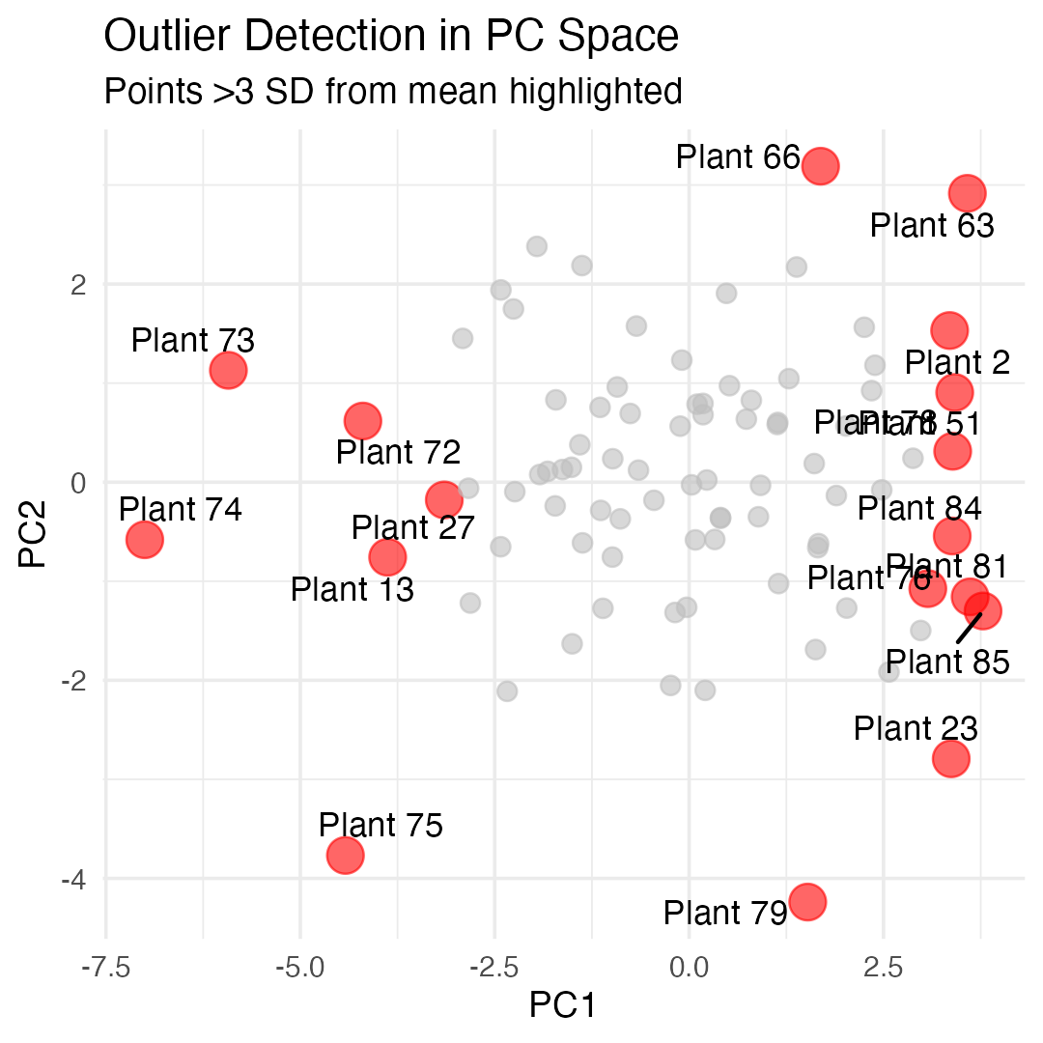

PCA vs. Other Ordination Methods

Comparison Table
Method | Data Type | Distance/Similarity | Linear? | Eigenanalysis?
PCA | Continuous, correlated | Euclidean (correlation) | Yes | Yes
CA | Count data, species | Chi-square | No | Yes
PCoA | Any (via distance matrix) | Any distance metric | N/A | Yes
NMDS | Any (via distance matrix) | Any distance metric | No | No
DCA | Species abundance | Weighted averaging | No | Yes

Advanced Topics in PCA

Topics We Haven’t Covered
- Factor Analysis: - Similar to PCA but with different goals - Assumes latent “factors” cause observed variables - Uses rotation to improve interpretation - More common in social sciences
- Robust PCA: - Less sensitive to outliers - Uses robust covariance estimators - Useful with messy ecological data
- Sparse PCA: - Forces many loadings to exactly zero - Easier to interpret - Better for very high-dimensional data
- Functional PCA: - For time series or spatial data - Treats curves as observations - Common in physiology
- Probabilistic PCA: - Includes uncertainty estimation - Can handle missing data - Maximum likelihood framework
- Kernel PCA: - Handles non-linear relationships - Uses kernel trick from machine learning - More flexible but harder to interpret
- These are beyond our scope but worth knowing exist!

Part 8 · Best Practices and Reporting

Practical Tips for PCA

Best Practices

Before PCA:
- Explore your data
  - Check distributions
  - Identify outliers
  - Understand variable scales
- Check correlations
  - Make correlation plot
  - Ensure variables are correlated
  - Consider removing redundant variables
- Standardize appropriately
  - Use scale = TRUE for different units
  - Consider centering only for same units
- Check sample size
  - Need at least 3× variables
  - More is better (50+ ideal)

During PCA:
- Examine scree plot
  - Look for elbow
  - Consider cumulative variance
  - Usually keep 2-5 components
- Interpret loadings
  - Look for patterns
  - Consider biological meaning
  - Ignore very small loadings
- Check scores plots
  - Look for outliers
  - Identify patterns/groups
  - Consider site/treatment effects

After PCA:
- Report clearly
  - State why you used PCA
  - Report variance explained
  - Describe component interpretation
- Use results appropriately
  - PC scores can go into other analyses
  - Don’t over-interpret small components
  - Remember: exploratory tool!

Reporting PCA Results

What to Include in Papers/Theses

Methods Section:
“We performed principal component analysis (PCA) on 10 morphological and biomass variables measured on 89 Darlingtonia californica plants from four sites. Variables were standardized (mean = 0, SD = 1) prior to analysis to account for different measurement scales. PCA was conducted using the prcomp() function in R. We retained principal components with eigenvalues > 1 and that cumulatively explained >70% of variance.”

Results Section:
“The first three principal components explained 77.3% of variance (PC1: 45.8%, PC2: 16.7%, PC3: 14.8%). PC1 represented overall plant size, with high positive loadings for most morphological and biomass variables…”

Essential Figures:
- Scree plot - shows variance explained
- Loadings plot - shows variable contributions
- Scores plot or biplot - shows samples in PC space

Essential Tables:
- Variance explained by each PC
- Loadings for retained PCs (usually PC1-PC3)
- ANOVA results if testing groups

Don’t Report:
- All 10 PCs if only 3 are meaningful
- Tiny loadings (< 0.3)
- Every individual PC score
- Raw eigenvalues (report % variance instead)

Common PCA Mistakes to Avoid

Mistakes Students Make:
❌ Not standardizing data with different units
→ ✓ Always use scale = TRUE for different units
❌ Forgetting to check correlations
→ ✓ Make correlation plot first
❌ Using too many components
→ ✓ Use scree plot, keep components above elbow
❌ Over-interpreting small loadings
→ ✓ Focus on loadings > |0.3|
❌ Ignoring signs on loadings
→ ✓ Sign can flip; look at patterns
❌ Treating PC scores as original data
→ ✓ Remember PCs are derived variables
❌ Using PCA on categorical data
→ ✓ Use appropriate method (CA, MCA)
❌ Not checking for outliers
→ ✓ Plot scores, check for extreme values
❌ Assuming PCs have biological meaning
→ ✓ Interpret carefully, components are mathematical
❌ Using PCA with too few samples
→ ✓ Need n > 3p (preferably n > 50)
❌ Not reporting variance explained
→ ✓ Always report % variance for each PC
❌ Forgetting that PCA is exploratory
→ ✓ Use for patterns, not hypothesis testing

Practice Exercise

Exercise 1: Subset Analysis
Try running PCA on just the morphological variables (exclude biomass):
# Select only morphological variables
darl_morph <- darlingtonia %>%
select(height, mouth_diam, tube_diam,
keel_diam, wing1_length,
wing2_length, wingsprea)
# Run PCA
pca_morph <- prcomp(darl_morph,
scale. = TRUE)
# Examine results
summary(pca_morph)
# How do results differ from full PCA?

Exercise 2: Site-Specific PCA
Run PCA on just one site (e.g., DG):
# Filter to one site
darl_dg <- darlingtonia %>%
filter(site == "DG") %>%
select(-site)
# Run PCA
pca_dg <- prcomp(darl_dg,
scale. = TRUE)
# Compare to overall PCA
summary(pca_dg)
# Do the same patterns emerge?

Exercise 3: Interpretation
- What does PC1 represent in each analysis?
- How much variance is explained?
- Do you see the same patterns?

Part 9 · PERMANOVA — Testing Group Differences

Alternative PCA Visualization: FactoMineR
# Create dataset with row names
darl_pca_data <- darlingtonia %>%
select(height, mouth_diam, tube_diam, keel_diam,
wing1_length, wing2_length, wingsprea,
hoodmass_g, tubemass_g)
# PCA
pca_facto <- PCA(darl_pca_data,
graph = FALSE,
scale.unit = TRUE)
# Create grouping factor with same length
site_groups <- factor(darlingtonia$site)
# Plot with grouping
fviz_pca_biplot(pca_facto,
col.ind = site_groups, # Use col.ind instead
palette = "jco",
addEllipses = TRUE,
ellipse.level = 0.95,
repel = TRUE)
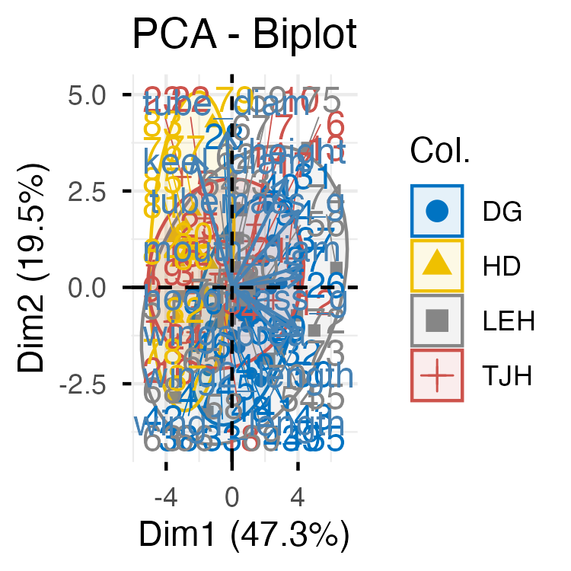
# Individual plot with better options
fviz_pca_ind(pca_facto,
geom.ind = "point",
col.ind = darlingtonia$site,
palette = "jco",
addEllipses = TRUE,
ellipse.type = "confidence",
legend.title = "Site",
repel = TRUE)
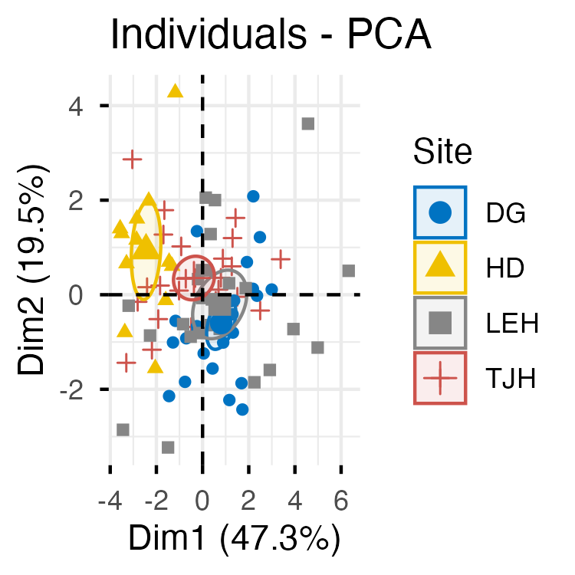

Quick PCA Plot with ggfortify
# Quick PCA plot with ggplot2
autoplot(pca_result,
data = darlingtonia,
colour = 'site',
loadings = TRUE,
loadings.label = TRUE,
frame = TRUE, # Adds ellipses
frame.type = 'norm') # or 't' for confidence
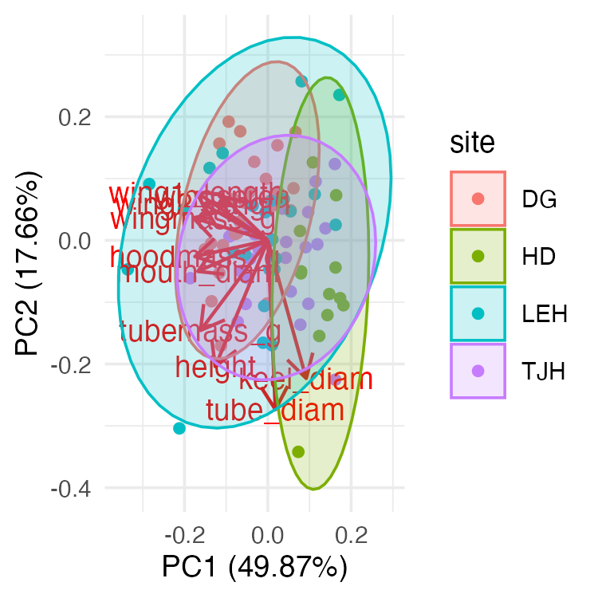

PCA with vegan: rda() and Distance Metrics
# Prepare data matrix (samples × variables)
darl_matrix <- darlingtonia %>%
select(height, mouth_diam, tube_diam, keel_diam,
wing1_length, wing2_length, wingsprea,
hoodmass_g, tubemass_g) %>%
scale()
# PCA with vegan (uses SVD, similar to prcomp)
pca_vegan <- rda(darl_matrix)
# Quick plot
biplot(pca_vegan, scaling = 2)
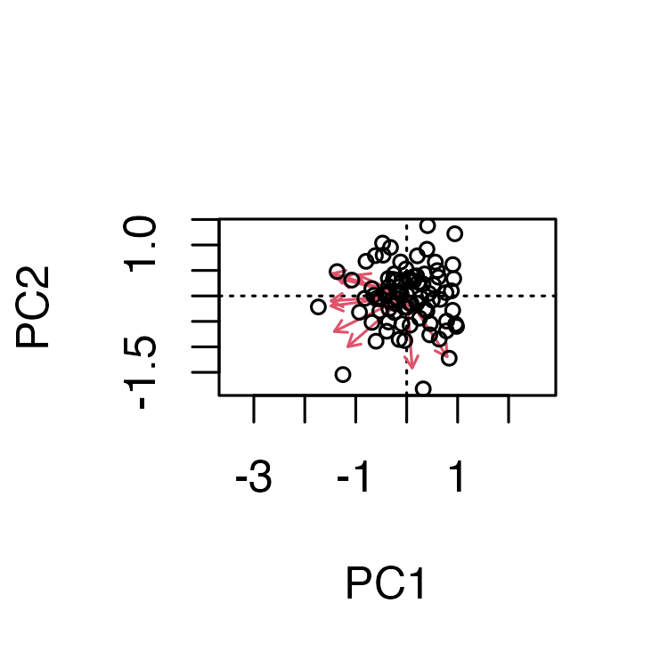
# Calculate distances between sites
site_matrix <- darlingtonia %>%
select(height, mouth_diam, wingmass_g) %>%
mutate(site = darlingtonia$site) %>%
group_by(site) %>%
summarise(across(everything(), mean)) %>%
column_to_rownames("site")
# Euclidean distance (many distance metrics available!)
dist_euclidean <- vegdist(site_matrix, method = "euclidean")
dist_bray <- vegdist(site_matrix, method = "bray") # Bray-Curtis
dist_manhattan <- vegdist(site_matrix, method = "manhattan")
# Create a nice color palette
site_factor <- factor(darlingtonia$site)
n_sites <- length(levels(site_factor))
colors <- brewer.pal(min(n_sites, 8), "Set1") # Use Set1 palette
site_colors <- colors[as.numeric(site_factor)]
# Ordination plot with sites
ordiplot(pca_vegan, type = "none")
points(pca_vegan, display = "sites", col = site_colors, pch = 19, cex = 1.5)
ordispider(pca_vegan, groups = darlingtonia$site, col = colors)
ordiellipse(pca_vegan, groups = darlingtonia$site, draw = "polygon",
col = colors, alpha = 0.2)
# Add legend
legend("topright", legend = levels(site_factor),
col = colors, pch = 19, bty = "n")
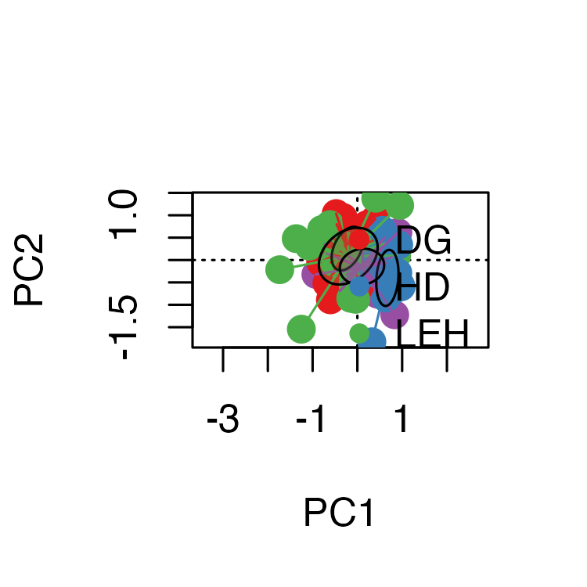

Testing Group Differences: PERMANOVA
# Analysis
pca_vegan <- rda(darl_matrix)
permanova <- adonis2(darl_matrix ~ site, data = darlingtonia)
# Visualization
fviz_pca_biplot(pca_result,
habillage = darlingtonia$site,
addEllipses = TRUE) +
labs(title = paste0("PERMANOVA: p = ",
round(permanova$`Pr(>F)`[1], 3)))
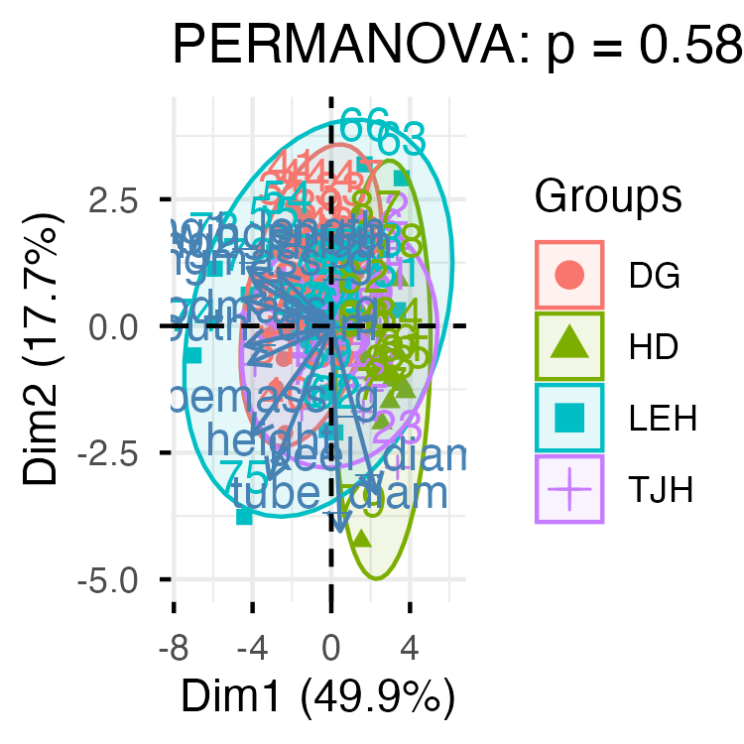
# Scale the data properly
darl_scaled <- darlingtonia %>%
select(height, mouth_diam, tube_diam, keel_diam,
wing1_length, wing2_length, wingsprea,
hoodmass_g, tubemass_g) %>%
scale() %>%
as.data.frame() # Convert back to data frame
# PERMANOVA
permanova_scaled <- adonis2(darl_scaled ~ site,
data = darlingtonia,
method = "euclidean",
permutations = 999)
permanova_scaled
## Permutation test for adonis under reduced model
## Permutation: free
## Number of permutations: 999
##
## adonis2(formula = darl_scaled ~ site, data = darlingtonia, permutations = 999, method = "euclidean")
## Df SumOfSqs R2 F Pr(>F)
## Model 3 189.72 0.24512 8.9836 0.001 ***
## Residual 83 584.28 0.75488
## Total 86 774.00 1.00000
## ---
## Signif. codes: 0 '***' 0.001 '**' 0.01 '*' 0.05 '.' 0.1 ' ' 1

Ordination with Convex Hulls
# Ordination plot with convex hulls (simpler)
ordiplot(pca_vegan, type = "none")
ordihull(pca_vegan, groups = darlingtonia$site,
draw = "polygon", col = 1:n_sites, alpha = 50)
points(pca_vegan, display = "sites", pch = 21,
bg = as.numeric(factor(darlingtonia$site)), cex = 1.5)
legend("topright", legend = levels(factor(darlingtonia$site)),
pt.bg = 1:n_sites, pch = 21, bty = "n")
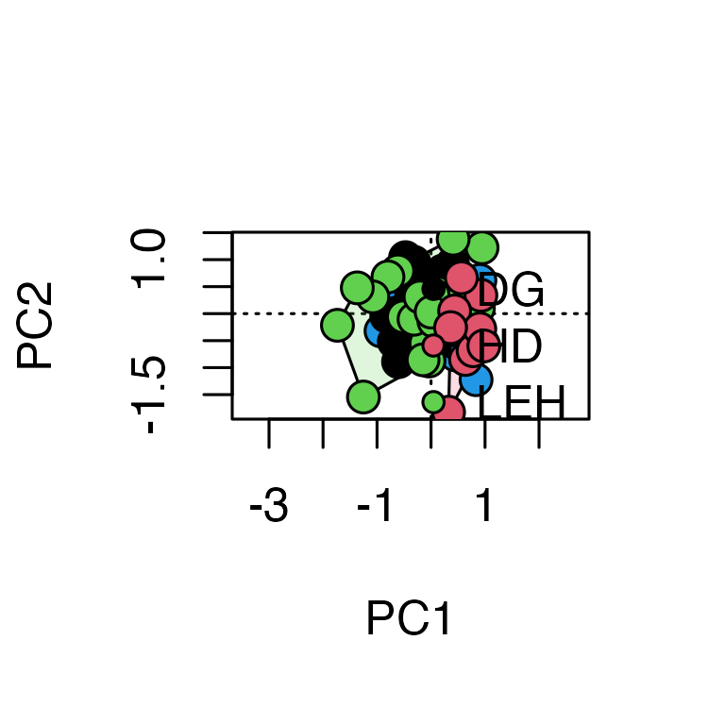

Pairwise PERMANOVA Comparisons
# Pairwise comparisons between sites
pairwise_result <- pairwise.adonis2(darl_scaled ~ site,
data = darlingtonia,
method = "euclidean", # Add this!
p.adjust.m = "bonferroni")
pairwise_result
## $parent_call
## [1] "darl_scaled ~ site , strata = Null , permutations 999"
##
## $TJH_vs_DG
## Df SumOfSqs R2 F Pr(>F)
## Model 1 32.602 0.10636 5.7128 0.001 ***
## Residual 48 273.930 0.89364
## Total 49 306.532 1.00000
## ---
## Signif. codes: 0 '***' 0.001 '**' 0.01 '*' 0.05 '.' 0.1 ' ' 1
##
## $TJH_vs_LEH
## Df SumOfSqs R2 F Pr(>F)
## Model 1 47.72 0.10517 5.6414 0.004 **
## Residual 48 406.06 0.89483
## Total 49 453.78 1.00000
## ---
## Signif. codes: 0 '***' 0.001 '**' 0.01 '*' 0.05 '.' 0.1 ' ' 1
##
## $TJH_vs_HD
## Df SumOfSqs R2 F Pr(>F)
## Model 1 69.308 0.25135 11.751 0.001 ***
## Residual 35 206.432 0.74865
## Total 36 275.740 1.00000
## ---
## Signif. codes: 0 '***' 0.001 '**' 0.01 '*' 0.05 '.' 0.1 ' ' 1
##
## $DG_vs_LEH
## Df SumOfSqs R2 F Pr(>F)
## Model 1 26.24 0.06493 3.3333 0.025 *
## Residual 48 377.85 0.93507
## Total 49 404.09 1.00000
## ---
## Signif. codes: 0 '***' 0.001 '**' 0.01 '*' 0.05 '.' 0.1 ' ' 1
##
## $DG_vs_HD
## Df SumOfSqs R2 F Pr(>F)
## Model 1 131.09 0.42382 25.745 0.001 ***
## Residual 35 178.22 0.57618
## Total 36 309.31 1.00000
## ---
## Signif. codes: 0 '***' 0.001 '**' 0.01 '*' 0.05 '.' 0.1 ' ' 1
##
## $LEH_vs_HD
## Df SumOfSqs R2 F Pr(>F)
## Model 1 101.69 0.2468 11.468 0.001 ***
## Residual 35 310.35 0.7532
## Total 36 412.04 1.0000
## ---
## Signif. codes: 0 '***' 0.001 '**' 0.01 '*' 0.05 '.' 0.1 ' ' 1
##
## attr(,"class")
## [1] "pwadstrata" "list"

Pairwise MANOVA-Based Comparisons
# install.packages("RVAideMemoire")
library(RVAideMemoire)
# Pairwise PERMANOVA
pairwise.perm.manova(vegdist(darl_scaled, method = "euclidean"),
darlingtonia$site,
test = "Wilks",
nperm = 999,
p.method = "bonferroni")
##
## Pairwise comparisons using permutation MANOVAs on a distance matrix
##
## data: vegdist(darl_scaled, method = "euclidean") by darlingtonia$site
## 999 permutations
##
## DG HD LEH
## HD 0.006 - -
## LEH 0.090 0.006 -
## TJH 0.012 0.006 0.018
##
## P value adjustment method: bonferroni

Comparing the Pairwise Test Results
These results come from different statistical tests being used:
1. pairwise.adonis2() — PERMANOVA on subsets
- What it does: For each pair, it subsets the data to just those 2 sites and runs a separate PERMANOVA.
- Results: All p-values ≤ 0.016 (5 of 6 are p = 0.001).
- Interpretation: Tests if centroids (mean positions) differ between site pairs.
2. pairwise.perm.manova() — a different test entirely
- What it does: Uses a MANOVA-based approach with permutations on the full distance matrix.
- Results: More conservative — DG vs LEH now p = 0.078 (not significant).
- Interpretation: Also tests centroid differences but uses a different statistical framework.
Why the differences matter — both are Location (Centroid) tests:
pairwise.adonis2() and pairwise.perm.manova() both test if site means differ. They give slightly different p-values due to different algorithms, but similar conclusions. Use these to answer: “Are sites morphologically different?”

