Lecture: Nested ANOVA
  - Hierarchical designs
Bill Perry

Where We Left Off
Covered last time — two-factor ANOVA:
- Example, linear model, analysis of variance
- Null hypotheses
- Interactions and main effects
- Unequal sample size
- Assumptions
 Note
✅ Key idea from last lecture
In a factorial design, every level of B appears under every level of A. Today: what happens when B is only ever nested inside one specific level of A?

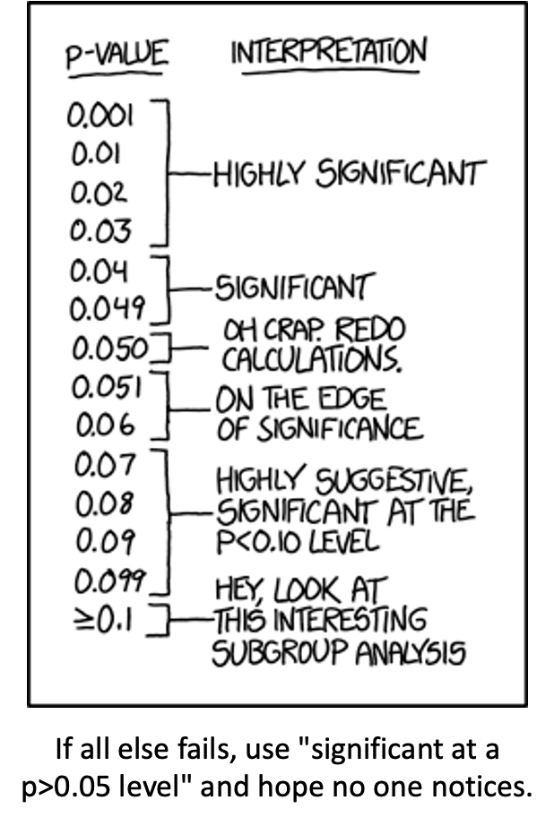
XKCD comic listing p-value ranges with increasingly tongue-in-cheek interpretations, from ‘Highly Significant’ at p under 0.03 down through ‘On the edge of significance’ and ‘Hey, look at this interesting subgroup analysis’ at p >= 0.1, captioned ‘If all else fails, use significant at a p>0.05 level and hope no one notices’ — a joke about p-hacking and misusing significance thresholds.

Part 1 · Multifactor Designs

Two-Factor (2-Way) ANOVA, Recap
- We often consider more than 1 factor (independent categorical variables) to reduce unexplained variance and look at interactions
- 2-factor designs (2-way ANOVA) are very common in ecology
- Can have more factors (e.g., 3-way ANOVA) — interpretation gets tricky
- Most multifactor designs are: factorial, nested, or mixed
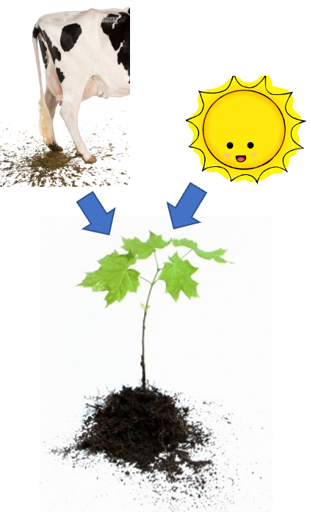
Diagram of a cow (representing manure/fertilizer) and a smiling sun icon, each with an arrow pointing down to a small green seedling, illustrating two factors that can each affect plant growth.

Factorial Versus Nested Designs
Consider two factors, A and B:
- Factorial/crossed: every level of B in every level of A
- Nested/hierarchical: levels of B occur only in 1 level of A
  - both fixed — rare
  - one fixed, one random
  - both random — rare in ecology, common in genetics
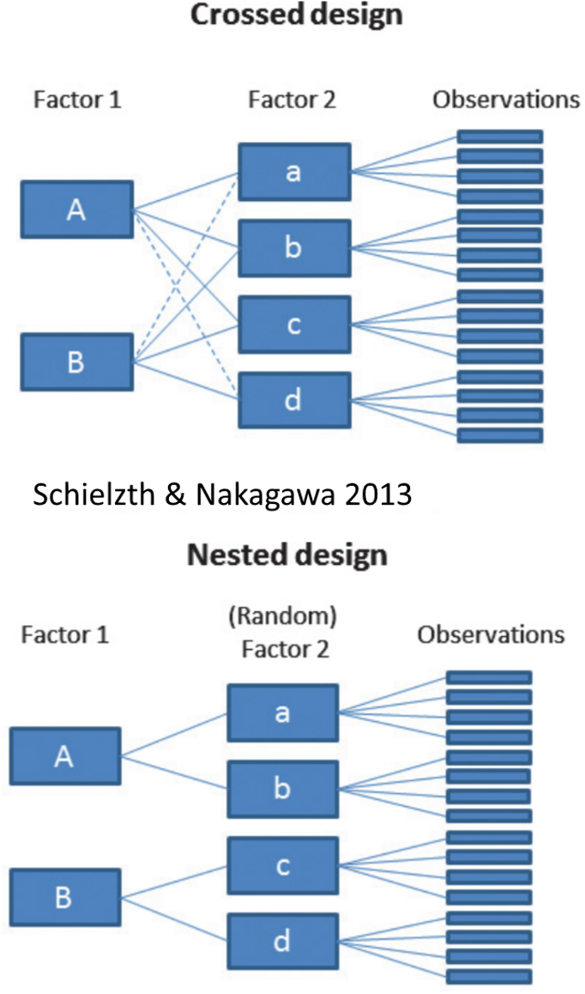
Diagram contrasting a crossed design, where both levels of Factor 1 (A, B) connect to every level of Factor 2 (a, b, c, d), against a nested design below it, where each level of Factor 1 connects only to its own subset of (random) Factor 2 levels, both feeding into individual observations (Schielzth & Nakagawa 2013).

Part 2 · Factorial Designs — Examples

Factorial Designs Overview
Factorial designs: both factors are typically fixed (but not always).
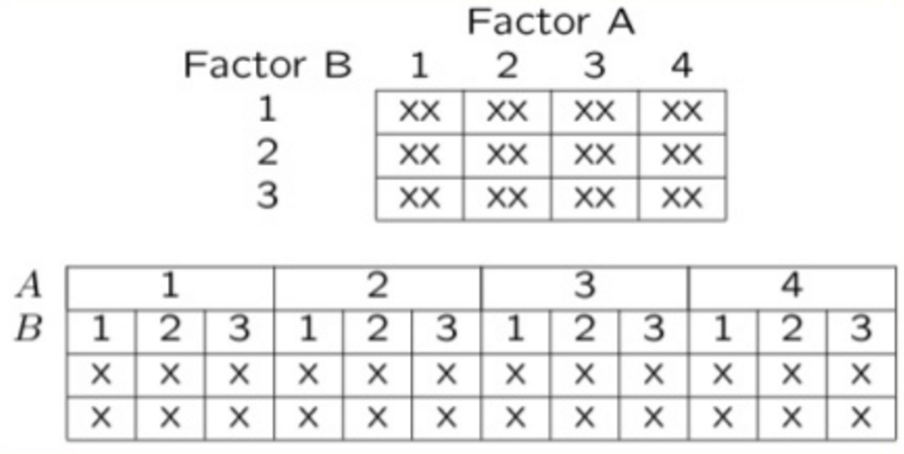
Two grid diagrams of a factorial design with Factor A across the top (4 levels) and Factor B down the side (3 levels): a compact 4x3 grid marked ‘XX’ in every cell, and an expanded layout below showing each of the 12 A-by-B combinations as its own column with two replicate marks (X, X).

Factorial Design Example: Seedling Growth
Effects of light level on growth of seedlings of different size:
- 3 light levels (Factor A)
- 3 size classes (Factor B)
- 5 replicate seedlings in each cell
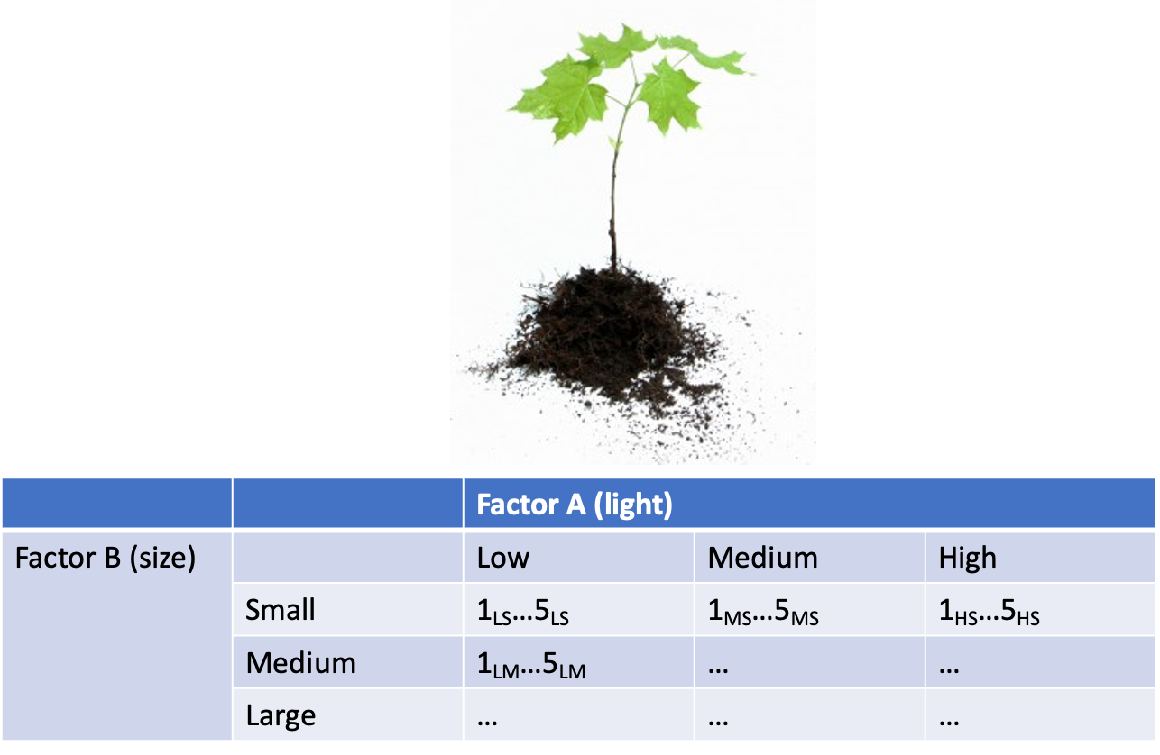
Photo of a small seedling above a table crossing Factor A (light: Low, Medium, High) with Factor B (size: Small, Medium, Large), with each cell showing 5 replicate seedling IDs (e.g., 1_LS…5_LS), illustrating the seedling-growth factorial design example.

Factorial Design Example: Salamander Growth
Effects of food level and tadpole presence on larval salamander growth:
- 2 food levels (Factor A)
- Presence/absence of tadpoles (Factor B)
- 8 replicates in each cell
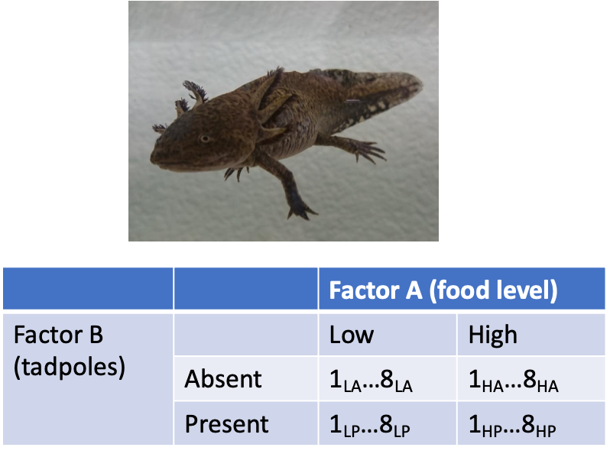
Photo of a larval salamander above a table crossing Factor A (food level: Low, High) with Factor B (tadpoles: Absent, Present), with each cell showing 8 replicate IDs (e.g., 1_LA…8_LA), illustrating the salamander-growth factorial design example.

Factorial Design Example: Limpet Fecundity
Effect of season and density on limpet fecundity:
- 2 seasons (Factor A)
- 4 density treatments (Factor B)
- 3 replicates in each cell
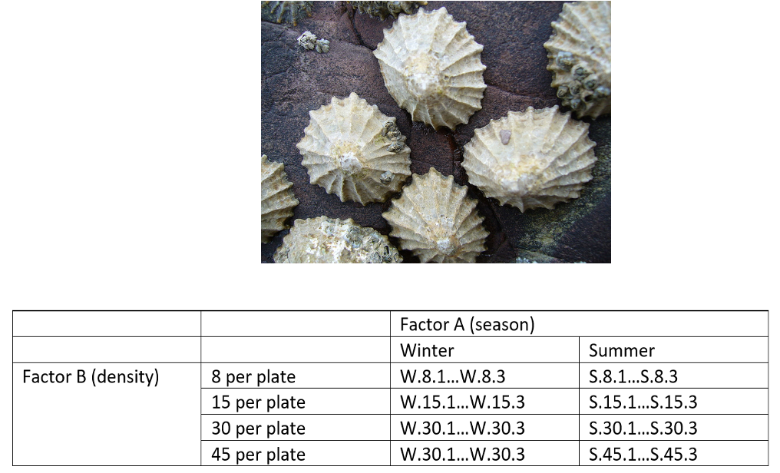
Photo of limpets clustered on a rock above a table crossing Factor A (season: Winter, Summer) with Factor B (density: 8, 15, 30, 45 per plate), with each cell showing 3 replicate IDs (e.g., W.8.1…W.8.3), illustrating the limpet-fecundity factorial design example.

Part 3 · Nested Designs — Examples

Nested Designs Overview
Nested designs cover: nested design examples, the linear model, analysis of variance, null hypotheses, unbalanced designs, assumptions, mixed-model ANOVA.
Nested designs: Factor A is usually fixed; Factor B is usually random.
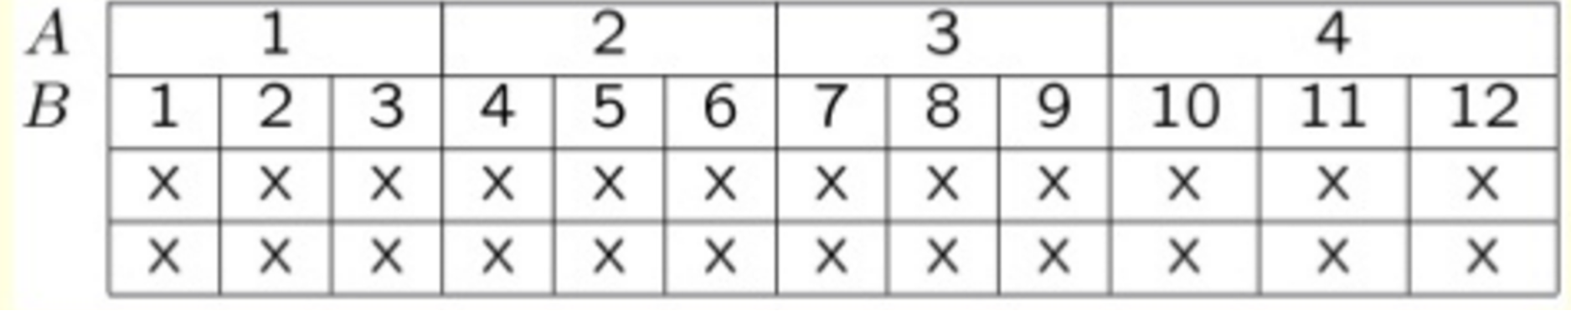
Grid layout with Factor A across the top (4 levels) and Factor B down the side, each of the 4 levels of B uniquely numbered 1 through 12 nested within its own level of A, with two rows of X’s marking replicate observations under each B level.

Nested Design Example: Limpet Growth
Study on effects of enclosure size on limpet growth:
- 2 enclosure sizes (Factor A)
- 5 replicate enclosures (Factor B)
- 5 replicate limpets per enclosure
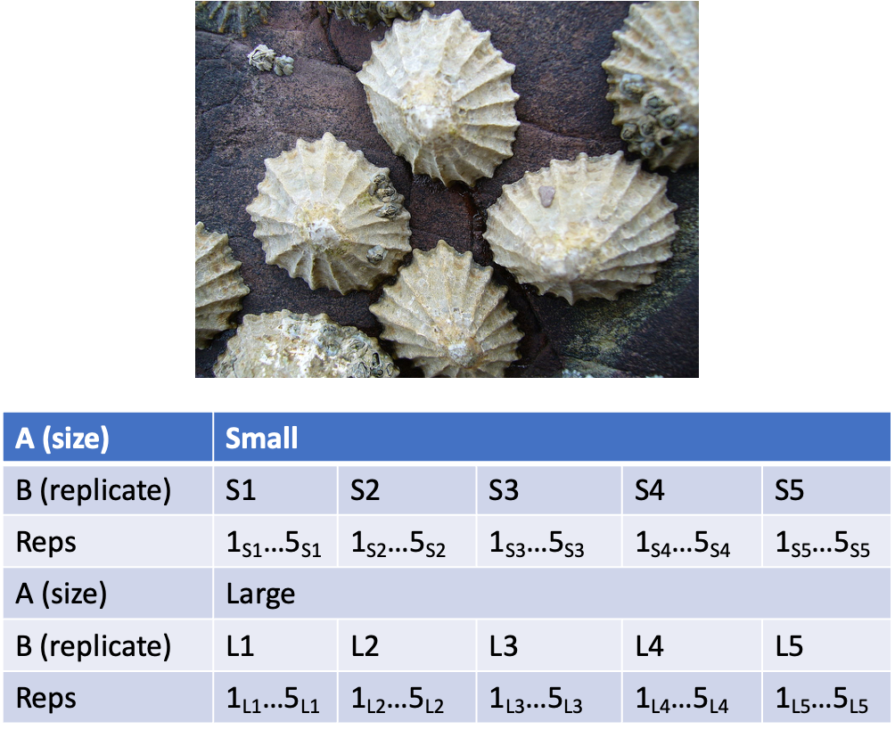
Photo of limpets on a rock above a table for Factor A (enclosure size: Small, Large), each with 5 replicate enclosures (S1-S5 or L1-L5) and 5 replicate limpets per enclosure, illustrating the limpet-growth nested design example.

Nested Design Example: Reef Fish
Study on reef fish recruitment:
- 5 sites (Factor A)
- 6 transects at each site (Factor B)
- Replicate observations along each transect
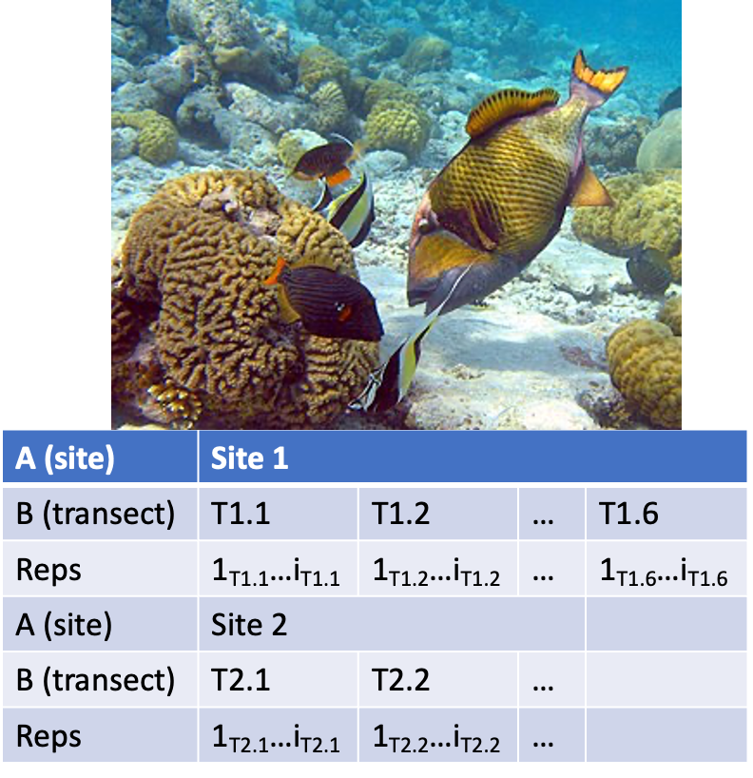
Underwater photo of reef fish above coral, above a table for Factor A (site: Site 1, Site 2), each with several transects (T1.1, T1.2, … T1.6) and replicate observations along each transect, illustrating the reef-fish recruitment nested design example.

Nested Design Example: Sea Urchin Grazing
Effects of sea urchin grazing on biomass of filamentous algae:
- 4 levels of urchin grazing: none, low, medium, high
- 4 patches of rocky bottom (3–4 m²) nested in each grazing level
- 5 replicate quadrats per patch
This is our worked example for the rest of the lecture.
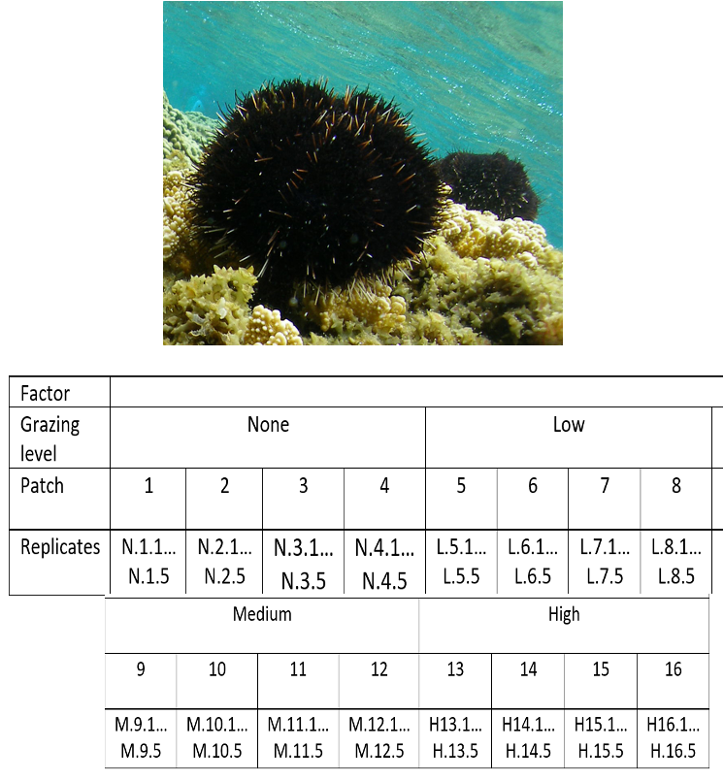
Underwater photo of a black sea urchin on coral, above a table for grazing level (None, Low, Medium, High) each with 4 patches nested inside it and 5 replicate quadrats per patch, illustrating the sea urchin grazing worked example used for the rest of this lecture.

Part 4 · The Nested Design Model

Nested Design: Linear Model Structure
Consider a nested design with:
- p levels of factor A (i = 1…p) — e.g., 4 grazing levels
- q levels of factor B (j = 1…q), nested within each level of A — e.g., 4 different patches per grazing level
- n replicates (k = 1…n) in each combination of A and B — e.g., 5 replicate quadrats in each patch in each grazing level
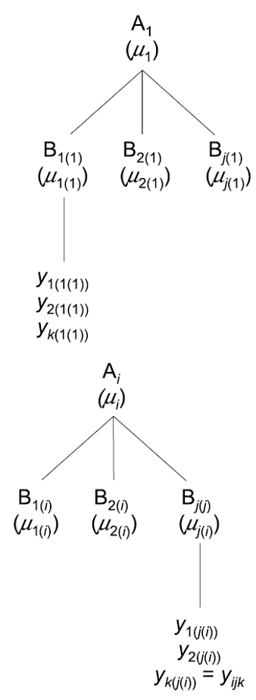
Hierarchical tree diagram of the nested design structure: a top-level factor A_1 branching into several B levels nested within it, each branching further into individual replicate y observations, repeated for a general level A_i.

Calculating Means in a Nested Design
We can calculate several means:
- Overall mean (across all levels of A and B) = $\overset{‾}{y}$
- A mean for each level of A (across all levels of B in that A) = ${\overset{‾}{y}}_{i}$
- A mean for each level of B within each A = ${\overset{‾}{y}}_{j(i)}$
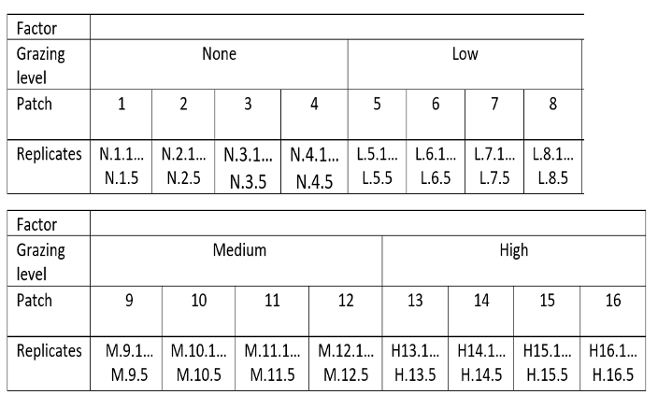
Grazing-level-by-patch table (grazing level: None, Low, Medium, High, each with 4 patches numbered 1-16) with each patch cell listing 5 replicate quadrat IDs, the layout used to compute overall, A-level, and B-within-A means.

Nested Design Means, Visualized
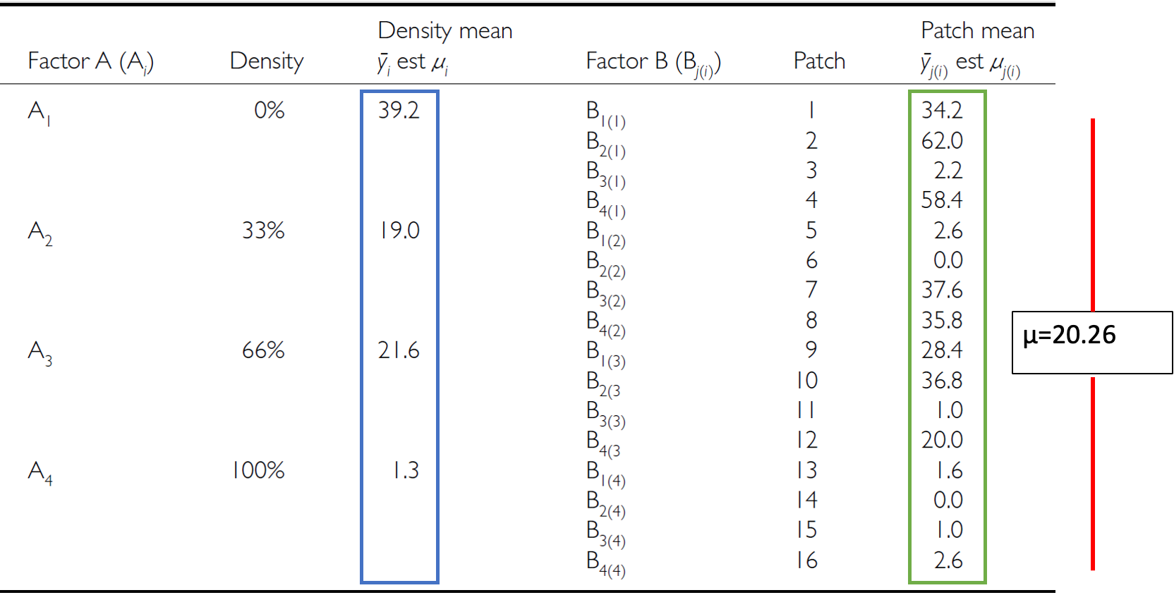
Full worked data table for the sea urchin example: for each grazing level (A1-A4, 0-100%) the density mean is shown boxed in blue (e.g., 39.2 for 0%), and for each patch nested within it the patch mean is shown boxed in green, with the overall mean mu = 20.26 marked on the right by a red bar spanning all values.

The Nested Design Linear Model
$$y_{ijk}=μ+α_{i}+β_{j(i)}+ε_{ijk}$$
- $y_{ijk}$ is the response variable — the value of the k-th replicate in the j-th level of B in the i-th level of A (e.g., algal biomass in the 3rd quadrat, in the 2nd patch, in the low-grazing treatment)
- $μ$ is the overall mean (overall average algal biomass)
 Tip
🖐 Notice
This looks almost identical to the two-way ANOVA model — the difference is entirely in the subscript: $β_{j(i)}$, not $β_{j}$. B only exists inside a specific A.

Fixed and Random Effects in the Nested Model
$$y_{ijk}=μ+α_{i}+β_{j(i)}+ε_{ijk}$$
- $α_{i}$ is the fixed effect of factor A — the difference between the average biomass in all low-grazing-level quadrats and the overall mean
- $β_{j(i)}$ is the random effect of factor B nested within factor A — usually a random variable measuring variance among all possible levels of B within each level of A (variance among all possible patches that could have been used in the low-grazing treatment)
Note
✅ Key idea
B being random is the whole point of nesting: you don’t care about these specific patches — you care about patch-to-patch variability in general.

The Error Term in the Nested Model
$$y_{ijk}=μ+α_{i}+β_{j(i)}+ε_{ijk}$$
- $ε_{ijk}$ is the error term — the unexplained variance associated with the k-th replicate in the j-th level of B in the i-th level of A
- $α_{i}$ is the effect of the i-th level of A: $μ_{i}−μ$
- $ε_{ijk}$: the difference between the observed algal biomass in the 3rd quadrat in the 2nd patch in the low-grazing treatment, and the predicted biomass (the average biomass in that 2nd patch in the low-grazing treatment)
Tip
🖐 Notice
The residual is measured against the cell mean (this specific patch), not the treatment mean — that’s what makes it “nested,” arithmetically.

Part 5 · Partitioning Variance

Analysis of Variance: Residual and Total
- $SS_{resid}$ is the difference between each observation and the mean for its level of factor B, summed over all observations
- $SS_{total}=SS_{A}+SS_{B}+SS_{resid}$​
- SS can be turned into MS by dividing by the appropriate df
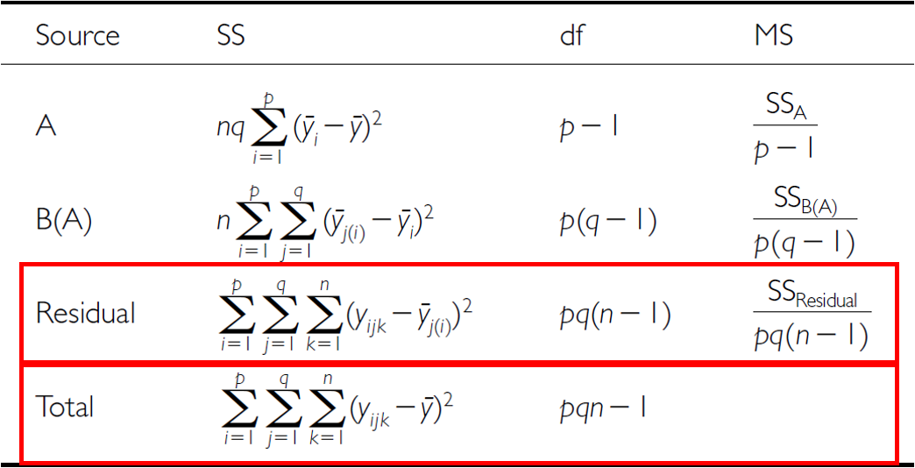
Nested ANOVA table listing Source (A, B(A), Residual, Total), each with its sum-of-squares formula and degrees of freedom (p-1, p(q-1), pq(n-1), pqn-1), with the Residual and Total rows outlined in red to highlight how SS_residual is the deviation of each observation from its own B(A) cell mean.

Analysis of Variance: SSA
As before, we partition the variance in the response variable using SS. $SS_{A}$ is the SS of differences between the mean in each level of A and the overall mean.
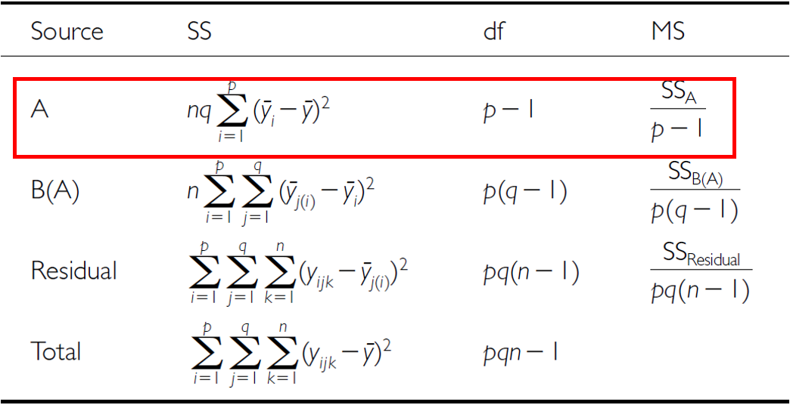
The same nested ANOVA table with the A row outlined in red, highlighting SS_A as the sum of squared deviations of each level-A mean from the overall mean.

Analysis of Variance: SSB
$SS_{B}$ is the SS of the difference between the mean in each level of B and the mean of the corresponding level of A, summed across all levels of A.
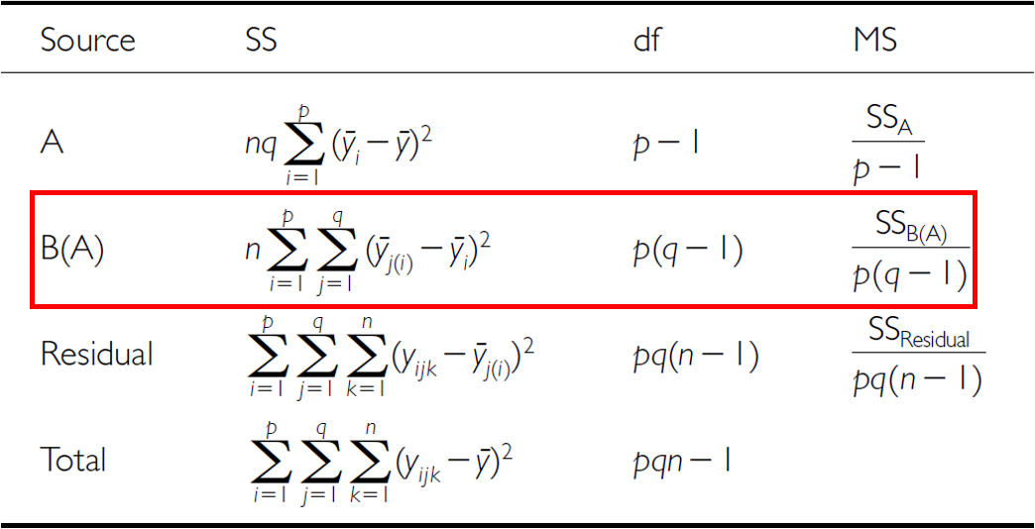
The same nested ANOVA table with the B(A) row outlined in red, highlighting SS_B(A) as the sum of squared deviations of each level-B-within-A mean from its corresponding level-A mean.

The Nested ANOVA Table
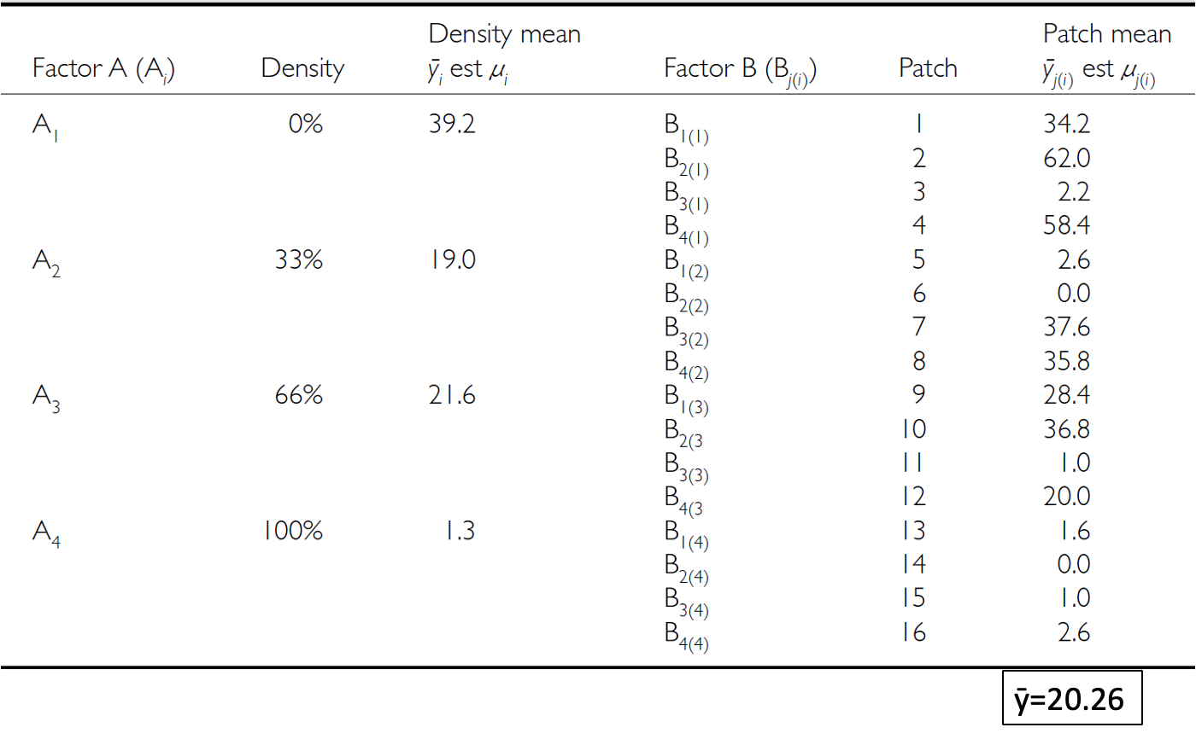
The full sea urchin data table repeated (density means per grazing level, patch means nested within each, overall mean y-bar = 20.26), shown here alongside the nested ANOVA table structure it feeds into.

Part 6 · Hypotheses and Assumptions

Null Hypotheses: Factor A
Two hypotheses are tested on values of MS. 1. No effects of factor A — assuming A is fixed:
- $H_{0}(A)$: $μ_{1}=μ_{2}=...=μ_{i}=μ$
- Same as in 1-factor ANOVA, using means from B factors nested within each level of A
- (no difference in algal biomass across all grazing levels: $μ_{none}=μ_{low}=μ_{med}=μ_{high}$)
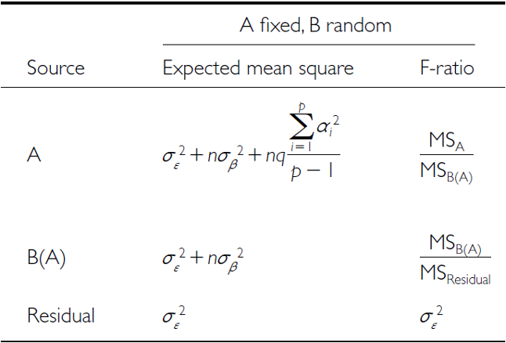
Table for the ‘A fixed, B random’ case listing the expected mean square and F-ratio formula for each source (A, B(A), Residual), showing that A is tested against MS_B(A) rather than MS_Residual because B is a random effect.

Null Hypotheses: Factor B
2. No effects of factor B nested in A — assuming B is random:
- $H_{0}(B)$: $σ_{β}^{2}=0$ (no variance added due to differences between all possible levels of B)
- (no variance added due to differences between patches)
Table for the ‘A fixed, B random’ case listing the expected mean square and F-ratio formula for each source (A, B(A), Residual), showing that A is tested against MS_B(A) rather than MS_Residual because B is a random effect.

Conclusions from the Analysis
Conclusion:
“Significant variation between replicate patches within each treatment, but no significant difference in the amount of filamentous algae between treatments.”
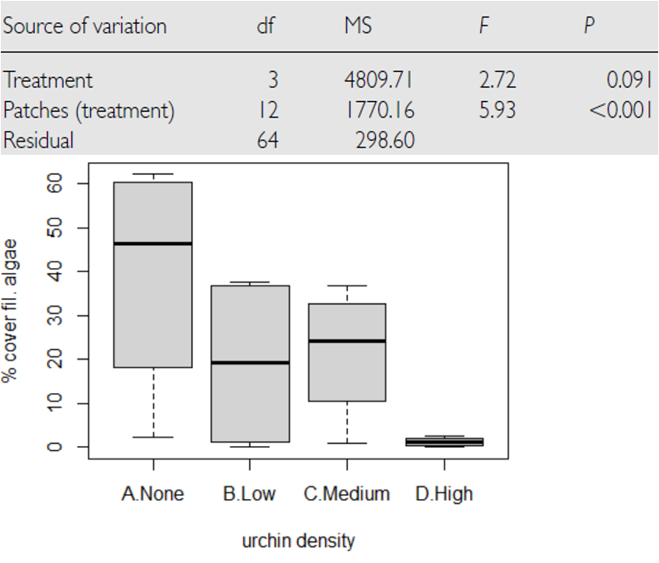
Published nested ANOVA results table for the sea urchin study, showing Treatment not significant (F = 2.72, p = 0.091) but Patches(treatment) highly significant (F = 5.93, p < 0.001), with a boxplot below showing percent cover of filamentous algae declining from the None to High urchin-density treatments.

Unbalanced Nested Designs
Unequal sample sizes can arise from:
- An uneven number of B levels within each A
- An uneven number of replicates within each level of B
Not a problem unless you have unequal variance or a large deviation from normality.
The same grazing-level-by-patch layout table repeated, shown here in the context of unequal sample sizes in unbalanced nested designs.

Nested Design Assumptions
As usual, we assume: equal variance, normality, no outliers, independence of observations.
Equal variance + normality need to be assessed at both levels:
- Since means for each level of B within each A are used for the H-test about A, need to assess whether those means meet normality and equal variance
- Examine residuals for the H-test about B
- Transformations can be used
 Warning
⚠️ Watch out!
This is the part people most often get wrong: checking assumptions on the raw data isn’t enough for a nested design — you need to check them at the level each hypothesis test actually operates on.

Part 7 · The Sea Urchin Example — Data

The Nested Design, the Hard Way
This analysis examines the effects of varying sea urchin densities on the percentage cover of filamentous algae. The experiment was designed with:
- Four random patches
- Four urchin density treatments (none = removed, low = control, medium = 33% of original density, high = 66% of original density)
- Five replicate quadrats measured within each treatment-patch combination
Note
📖 Reference
Quinn & Keough (2002), Experimental Design and Data Analysis for Biologists — this dataset and analysis follow their treatment of the sea urchin/algae example.

Data Overview
The data frame contains: patch (random patches 1–16 where treatments were applied), treat (urchin density treatment), quad (replicate quadrats within each treatment-patch combination), algae (percentage cover of filamentous algae — the response variable).
## Data
## # A tibble: 6 × 4
## treat patch quad algae
## <fct> <fct> <dbl> <dbl>
## 1 high 1 1 0
## 2 high 1 2 0
## 3 high 1 3 0
## 4 high 1 4 6
## 5 high 1 5 2
## 6 high 2 1 0
##
##
## Treatment levels:
## [1] "none" "low" "medium" "high"
## Summary statistics by treatment:
## # A tibble: 4 × 7
## treat n mean sd se min max
## <fct> <int> <dbl> <dbl> <dbl> <dbl> <dbl>
## 1 none 20 39.2 28.7 6.41 0 83
## 2 low 20 21.6 25.1 5.62 0 79
## 3 medium 20 19 25.7 5.74 0 71
## 4 high 20 1.3 3.18 0.711 0 13

A First Look at the Data
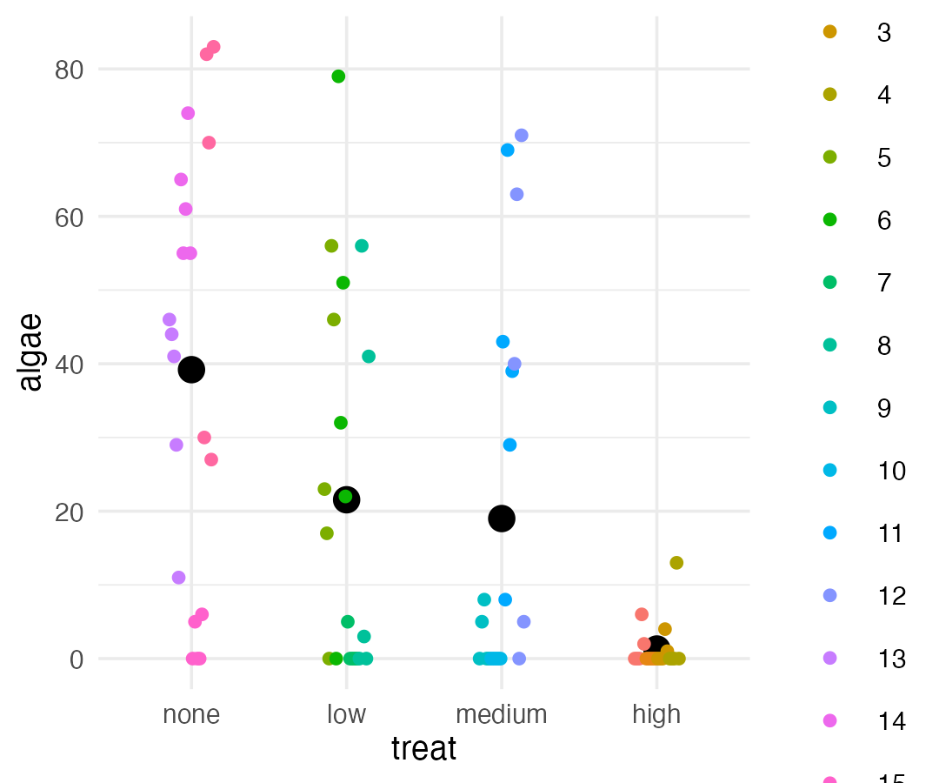

Part 8 · The Wrong Way — Naive Factorial Model

Manual Nested ANOVA — Setting Up
In this experimental design, patch is nested within treat because each patch received only one treatment level — a hierarchical design where the effect of patches must be considered within each treatment (Quinn & Keough 2002).
We’ll use a traditional nested ANOVA. You could make this easy by averaging algae per patch and running a one-way ANOVA — but your power is significantly reduced, and you lose estimates of variability among patches.
This first attempt is really a regular factorial ANOVA — not appropriate, since it’s pseudoreplicated. Also, the F-value for Treat is using $MS_{resid}$ when it should use $MS_{treat:patch}$.
u_fact_model <- aov(algae ~ treat + treat:patch, data = u_df)
cat("Factorial model summary:\n\n")
## Factorial model summary:
summary(u_fact_model)
## Df Sum Sq Mean Sq F value Pr(>F)
## treat 3 14429 4810 16.108 0.0000000658 ***
## treat:patch 12 21242 1770 5.928 0.0000008323 ***
## Residuals 64 19110 299
## ---
## Signif. codes: 0 '***' 0.001 '**' 0.01 '*' 0.05 '.' 0.1 ' ' 1

Why the Factorial ANOVA Is Not Correct
- We can correct this by specifying the error term
- The MS needed for the F-value is really MS(patch nested in treatment), because those are the true replicates
- We can specify that — the problem is this approach can’t really handle unbalanced designs
u_nested_model <- aov(algae ~ treat + Error(treat:patch), data = u_df)
cat("Correctly specified nested ANOVA:\n\n")
## Correctly specified nested ANOVA:
summary(u_nested_model)
##
## Error: treat:patch
## Df Sum Sq Mean Sq F value Pr(>F)
## treat 3 14429 4810 2.717 0.0913 .
## Residuals 12 21242 1770
## ---
## Signif. codes: 0 '***' 0.001 '**' 0.01 '*' 0.05 '.' 0.1 ' ' 1
##
## Error: Within
## Df Sum Sq Mean Sq F value Pr(>F)
## Residuals 64 19110 298.6

