Lecture: T-Tests: One, Two, Paired
  - Comparing means
Bill Perry

Where We Left Off
Last time:
- Histograms / frequency distributions
- Probability distribution functions (PDFs)
- Z-scores and t-scores
- Tests of means using t-tests: one sample, two sample
 Note
✅ Key idea from last lecture
A t-score is just a z-score computed with the sample standard deviation instead of the population standard deviation — that substitution is why we need the t-distribution at all. Today we put it to work.

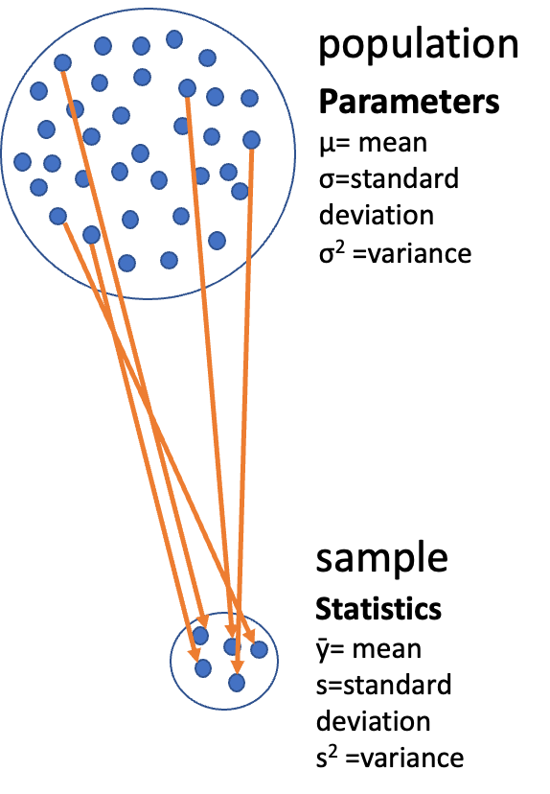
Diagram of a large circle labeled ‘population’ with dots representing individuals and Greek-letter parameters (mu, sigma, sigma-squared), with orange arrows showing a subset of dots being drawn down into a small circle labeled ‘sample’ with its statistics (y-bar, s, s-squared), illustrating that a sample is used to estimate unknown population parameters.
Note
Today’s roadmap
- Hypothesis testing framework
- The t-distribution
- One-sample t-test
- Two-sample t-test (Student’s and Welch’s)
- Paired t-test
- Checking assumptions throughout

Part 1 · Our Data

Setup — Loading the Class Pine Needle Data
library(readxl)
library(tidyverse)
library(patchwork)
library(car) # For diagnostic tests
pine_df <- read_excel("data/class_pine needle length.xlsx")
pine_switch_df <- read_excel("data/class_pine needle length switched.xlsx")
glimpse(pine_df)
Rows: 361
Columns: 5
$ group <chr> "five", "five", "five", "five", "five", "five", "five", "fiv…
$ tree_no <dbl> 1, 1, 1, 1, 1, 1, 1, 1, 1, 1, 1, 1, 1, 1, 1, 1, 1, 1, 1, 1, …
$ tree_char <chr> "tree_1", "tree_1", "tree_1", "tree_1", "tree_1", "tree_1", …
$ side <chr> "sunny", "sunny", "sunny", "sunny", "sunny", "sunny", "sunny…
$ length_mm <dbl> 22.66, 21.14, 18.55, 18.65, 20.99, 18.94, 19.75, 18.46, 20.5…
Note
✅ Key idea
For two sample T-tests, degrees of freedom = n₁ + n₂ − 2. Once we average the needles up to one value per tree side (next slide), we have 8 trees per side — so df = 8 + 8 − 2 = 14. Note that n is the number of trees, not needles.

 Tip
🖐 Recap
group is the class team, tree_no/tree_char identify the tree, side is sunny vs. shady, length_mm is the needle length.

Averaging Out Pseudoreplication
# Multiple needles per tree side are pseudoreplicates —
# average them so each tree/side is ONE data point
p_df <- pine_df %>%
group_by(group, tree_no, tree_char, side) %>%
summarise(length_mm = mean(length_mm, na.rm = TRUE), .groups = "drop")
ps_df <- pine_switch_df %>%
group_by(group, tree_no, tree_char, side) %>%
summarise(length_mm = mean(length_mm, na.rm = TRUE), .groups = "drop")
ps_shady_df <- ps_df %>% filter(side == "shady")
ps_sunny_df <- ps_df %>% filter(side == "sunny")
 Important
Why average first? The true experimental unit here is tree side, not needle. Treating every needle as independent would inflate our sample size and our confidence — the same pseudoreplication trap from earlier in the course.

stats_df <- ps_df %>%
group_by(side) %>%
summarize(
mean_length = mean(length_mm, na.rm = TRUE),
sd_length = sd(length_mm, na.rm = TRUE),
se_length = sd(length_mm, na.rm = TRUE) / sum(!is.na(length_mm))^.5,
count = sum(!is.na(length_mm)),
.groups = "drop"
)
stats_df
# A tibble: 2 × 5
side mean_length sd_length se_length count
<chr> <dbl> <dbl> <dbl> <int>
1 shady 17.6 2.51 0.886 8
2 sunny 16.2 2.64 0.934 8

The Data — Two Versions
p_plot <- p_df %>%
ggplot(aes(side, length_mm, fill = side)) +
geom_boxplot(alpha = 0.7) +
geom_point(aes(group = group, color = group)) +
geom_line(aes(group = group, color = group)) +
labs(x = "Side of tree", y = "Length (mm)", caption = "Pine needles") +
theme_minimal(base_size = 9) +
theme(legend.position = "none")
p_plot
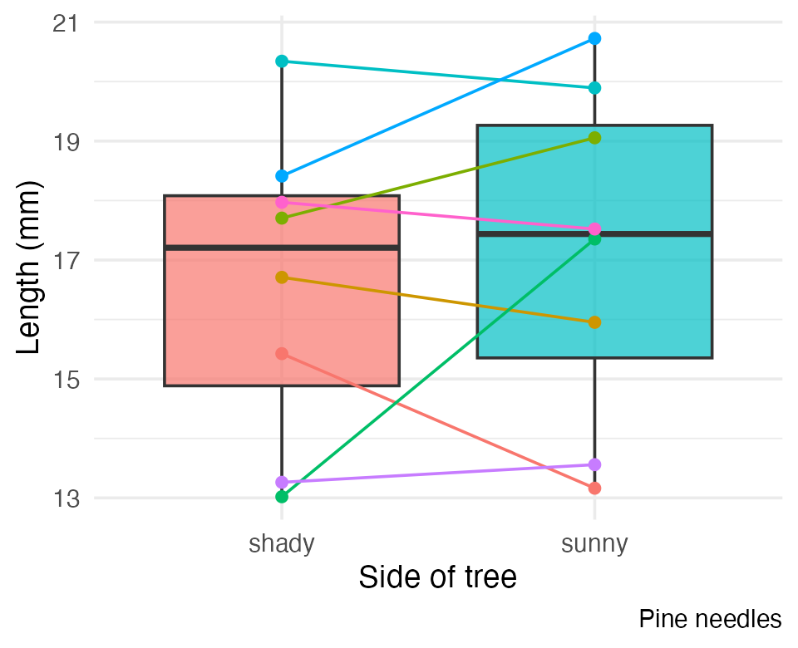
 Warning
⚠️ Watch out!
class_pine needle length switched.xlsx has the sunny/shady labels swapped relative to the original file. From here on, ps_df (the switched version) is the dataset we’ll actually test — it’s the one that matches the field notes.

The Data We’ll Test — ps_df
ps_plot <- ps_df %>%
ggplot(aes(side, length_mm, fill = side)) +
geom_boxplot(alpha = 0.7) +
geom_point(aes(group = group, color = group)) +
geom_line(aes(group = group, color = group)) +
labs(x = "Side of tree", y = "Length (mm)", caption = "Pine needles switched") +
theme_minimal(base_size = 9) +
theme(legend.position = "none")
ps_plot
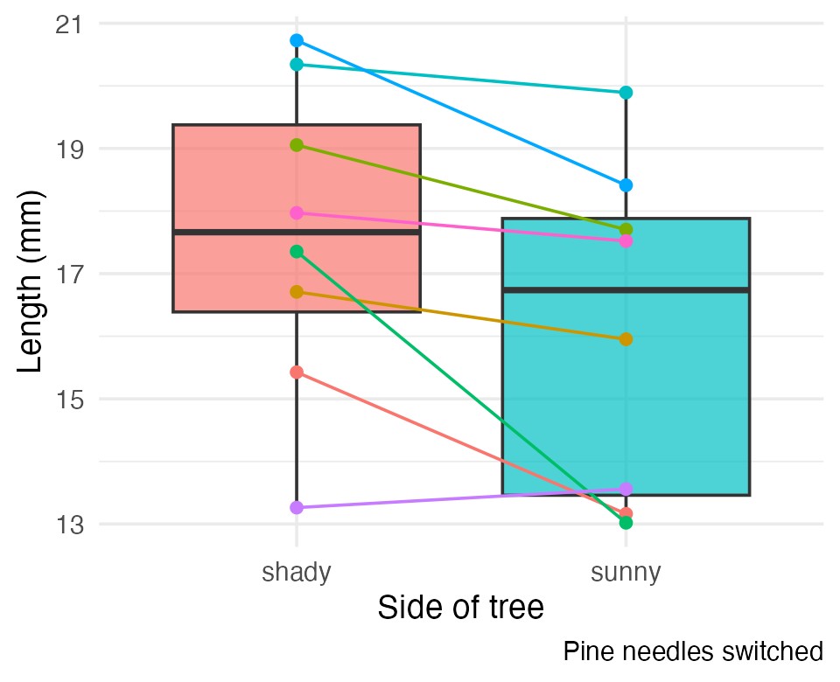
Goals for today, using ps_df:
- Statistical inference fundamentals
- Hypothesis testing principles
- t-distributions
- One-sample, two-sample, and paired t-tests
- Assumption tests

Part 2 · Hypothesis Testing Framework

Hypothesis Testing — the Key Components
Hypothesis testing is a systematic way to evaluate research questions using data.
Key components:
- Null hypothesis (H₀) — typically “no effect” or “no difference”
- Alternative hypothesis (Hₐ) — the claim we’re trying to support
- Statistical test — method for evaluating evidence against H₀
- P-value — probability of observing our result (or more extreme) if H₀ is true
- Significance level (α) — threshold for rejecting H₀, typically 0.05
Decision rule: Reject H₀ if p-value < α.
Note
📖 Reference
Gotelli & Ellison, A Primer of Ecological Statistics, Ch. 4 — Framing and Testing Hypotheses (Statistical Significance and P-Values).

The Logic of a Statistical Test
A test assesses the likelihood of the null hypothesis being true.
- If H₀ is likely false, Hₐ is assumed correct
- More precisely: the long-run probability of obtaining our sample value (or a more extreme one) if the null hypothesis is true
- Written p(data | H₀) — the probability of the data, given H₀
Note
✅ Key idea
p(data | H₀) is not the same as p(H₀ | data). A t-test never tells you the probability that H₀ is true — only how surprising your data would be if it were.

p-value range | Interpretation
p > 0.10 | No evidence against H₀
0.05 < p < 0.10 | Weak evidence against H₀
0.01 < p < 0.05 | Moderate evidence against H₀
0.001 < p < 0.01 | Strong evidence against H₀
p < 0.001 | Very strong evidence against H₀

Part 3 · The t-Distribution

One-Tailed Questions
One-tailed questions ask about the area of the distribution to the left (or right) of a certain value, for a one-sample test.
- n = 8 (df = 7) — 95% of the observations found to the left
- t = 1.895 (5% are outside)
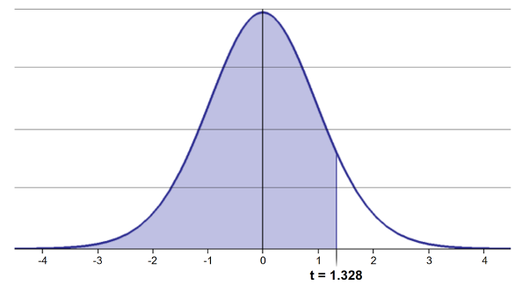
Bell-shaped t-distribution curve with the area to the left of the critical value shaded, illustrating a one-tailed cutoff where the shaded region represents the proportion of the distribution below that t-value (here t = 1.895 at df = 7).
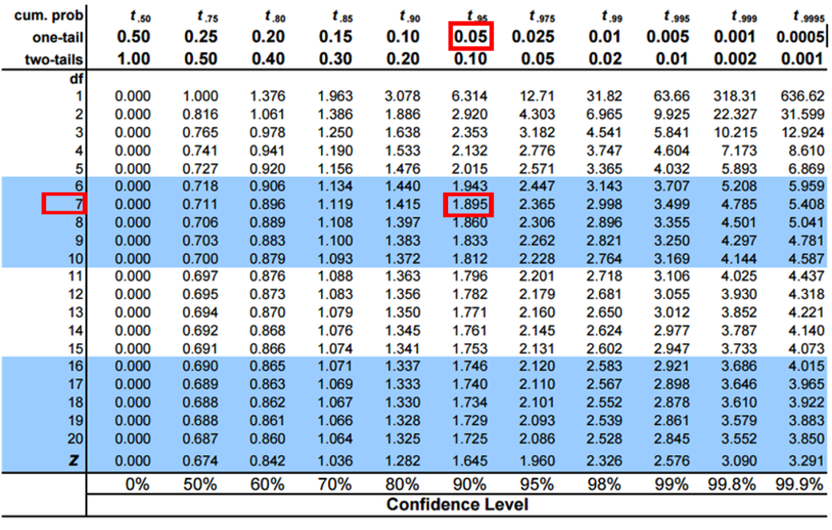
Student’s t critical-value table with the one-tail 0.05 column and df = 7 row highlighted, intersecting at the critical value 1.895, the value used for a one-tailed test at alpha = 0.05.

Two-Tailed Questions
Two-tailed questions refer to the area between certain values.
- n = 8 (df = 7), 95% of the observations are between t = −2.365 and t = 2.365 (2.5% outside on each side)
- Compare to the one-tailed cutoff: t = 1.895 (5% outside)
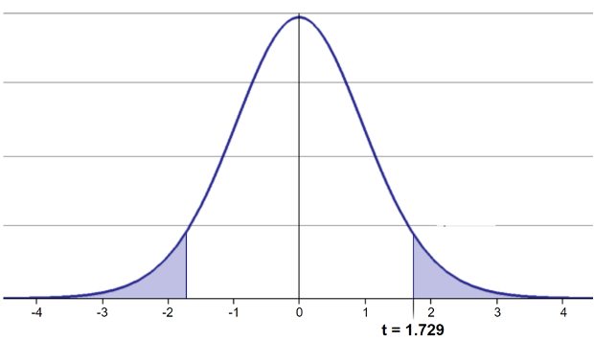
Bell-shaped t-distribution curve with both tails shaded beyond the critical values (here t = -2.365 and t = 2.365 at df = 7), illustrating a two-tailed cutoff where the two shaded regions together represent the proportion of the distribution outside that range.
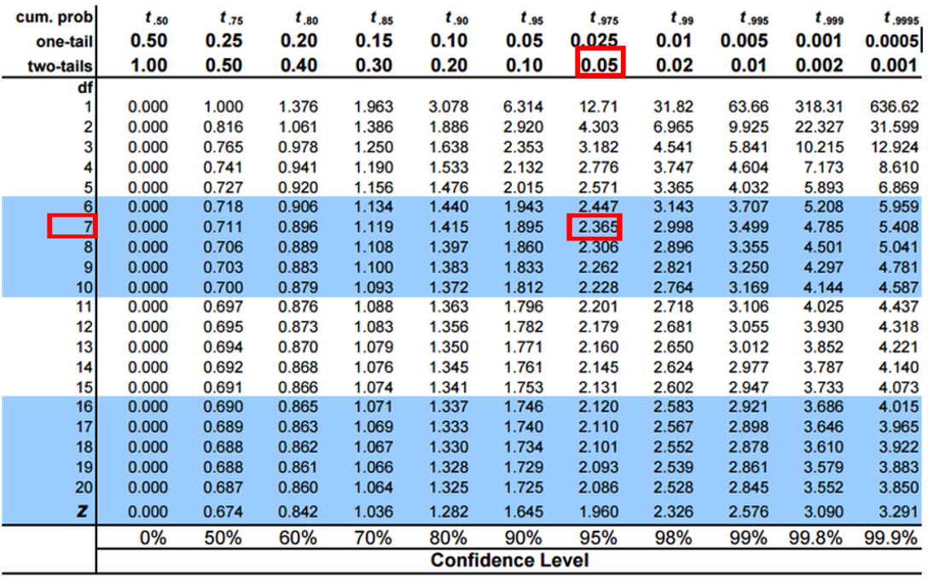
Student’s t critical-value table with the two-tail 0.05 column and df = 7 row highlighted, intersecting at the critical value 2.365, the value used for a two-tailed test/95% confidence interval at alpha = 0.05.
Tip
🖐 Notice
The two-tailed critical value is farther from zero than the one-tailed value — splitting 5% into two tails means each tail only gets 2.5%.

Calculating a Confidence Interval
Using a two-sided test:
$$\text{CI}=\overset{‾}{y}±t⋅\frac{s}{\sqrt{n}}$$
- 95% CI, Sample A: 17.6 ± 2.365 × (2.51 / 8^0.5) = ± 2.10
- The 95% CI is between 15.50 and 19.70
- “The 95% CI for the population mean from sample A is 17.6 ± 2.1”
Note
📖 Reference
Whitlock & Schluter, Analysis of Biological Data, Ch. 11 — Inference for a Normal Population.

Student’s t critical-value table with the two-tail 0.05 column and df = 7 row highlighted, intersecting at the critical value 2.365, the value used for a two-tailed test/95% confidence interval at alpha = 0.05.

Applications of the t-Distribution
- Can assess confidence that the population mean is within a certain range
- Can use the t-distribution to ask:
  - “What is the probability of getting a sample with mean = ȳ from a population with mean = µ?” (1-sample t-test)
  - “What is the probability that two samples came from the same population?” (2-sample t-test)
Tip
🖐 Try it yourself
Before the next slide: which of these two questions do you think a one-sample t-test answers, and which needs a two-sample t-test?

Part 4 · One-Sample T-Test

One-Sample T-Test — Hypotheses and Assumptions
We want to test if the mean needle length on the shady side differs from 15mm.
Activity: define hypotheses and identify assumptions
- H₀: μ = 15 (the mean needle length on the shady side is 15mm)
- Hₐ: μ ≠ 15 (the mean needle length on the shady side is not 15mm)
Assumptions for a t-test:
- Data is normally distributed
- Observations are independent
- No significant outliers
Note
📖 Reference
Whitlock & Schluter, Ch. 11, covers the one-sample t-test as the simplest hypothesis test on a normally distributed variable.

Checking Normality — QQ Plot
# The one-sample test below is on the SHADY side, so that is the group
# whose normality we need to check -- not the two sides pooled together.
qqPlot(ps_shady_df$length_mm,
main = "QQ Plot — shady side needle length",
ylab = "Sample Quantiles")
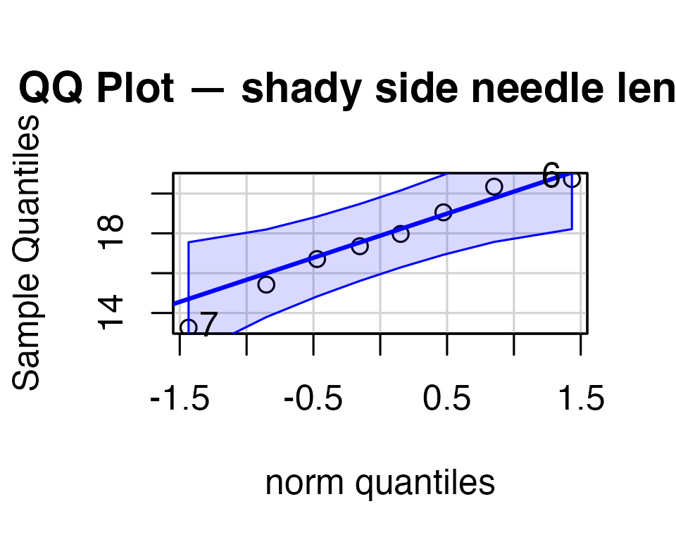
[1] 7 6
Tip
🖐 Notice
Points that hug the blue line support normality; points that curve away — especially in the tails — are a warning sign.

Checking Normality — Shapiro-Wilk Test
shapiro.test(ps_shady_df$length_mm)
Shapiro-Wilk normality test
data: ps_shady_df$length_mm
W = 0.96639, p-value = 0.8683
Important
H₀ for Shapiro-Wilk is “the data ARE normal.” A non-significant result (p > 0.05) is what we’re hoping for here — it means we fail to reject normality.

Tip
🖐 Why the shady side only?
We test the group the hypothesis is about. Pooling shady and sunny would mix two distributions with different means, which can look non-normal even when each group is perfectly normal.

Checking for Outliers
shady_sunny_plot <- ps_df %>%
ggplot(aes(x = side, y = length_mm, fill = side)) +
geom_boxplot() +
labs(x = "side", y = "Length (mm)", fill = "side") +
theme_minimal(base_size = 9)
shady_sunny_plot
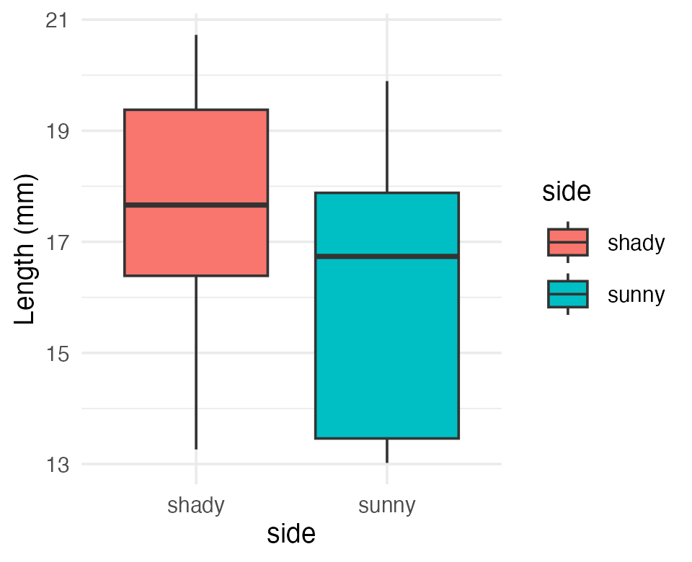
Tip
Points beyond the whiskers are potential outliers — always look before you test.

Practice Exercise 1: One-Sample t-Test
Tip
Practice Exercise 1: One-sample t-test
Let’s perform a one-sample t-test to determine if the mean needle length on the shady side differs from 15mm:
ps_shade_mean <- mean(ps_shady_df$length_mm, na.rm = TRUE)
cat("Mean:", round(ps_shade_mean, 1), "mm\n")
Mean: 17.6 mm
t_test_result <- t.test(ps_shady_df$length_mm, mu = 15)
t_test_result
One Sample t-test
data: ps_shady_df$length_mm
t = 2.9414, df = 7, p-value = 0.02167
alternative hypothesis: true mean is not equal to 15
95 percent confidence interval:
15.51092 19.70030
sample estimates:
mean of x
17.60561
Interpret this test result by answering these questions:
- What was the null hypothesis?
- What was the alternative hypothesis?
- What does the p-value tell us?
- Should we reject or fail to reject the null hypothesis at α = 0.05?
- What is the practical interpretation of this result for botanists?

Visualizing the One-Sample Test — t Scale
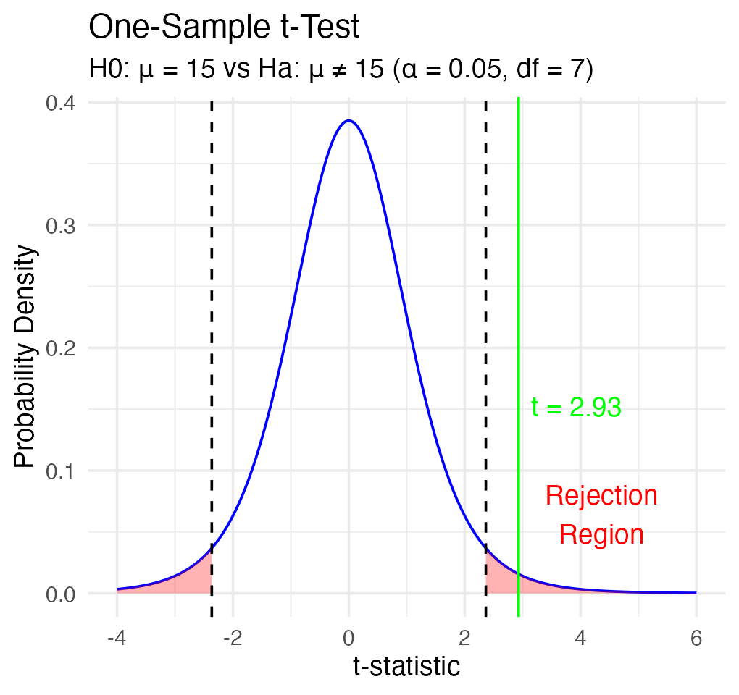
Note
✅ Key idea
The green line (our observed t) falls inside the red rejection region — that’s what “significant” looks like on a t-distribution.

Visualizing the One-Sample Test — Original Units
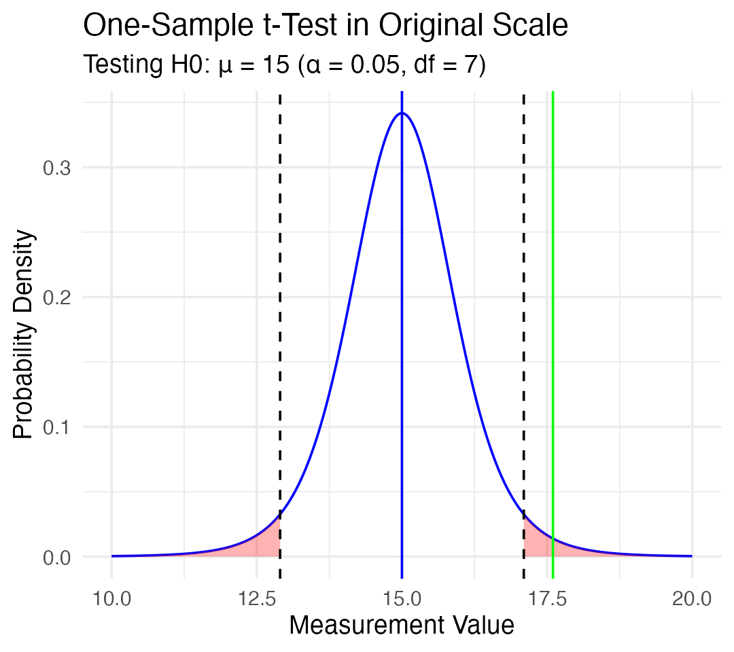
Tip
🖐 Notice
Same test, same conclusion — just relabeled onto the millimeter scale instead of the t scale. The blue line (H₀ = 15) sits outside the sample’s plausible range.

Interpreting the One-Sample T-Test
Activity: interpret the t-test results
- What does the p-value tell us?
- Should we reject or fail to reject the null hypothesis?
Note
How to report this result in a scientific paper
“A one-sample t-test at α = 0.05 showed that the mean needle length (… mm, SD = …) [was/was not] significantly different from the expected 15mm, t(…) = …, p = …”

Part 5 · Two-Sample T-Test

Two-Sample T-Tests — Introduction
For example — what is the probability that population X is the same as population Y?
How would you assess this question using what we learned?
This is what we will do with the needle length again…
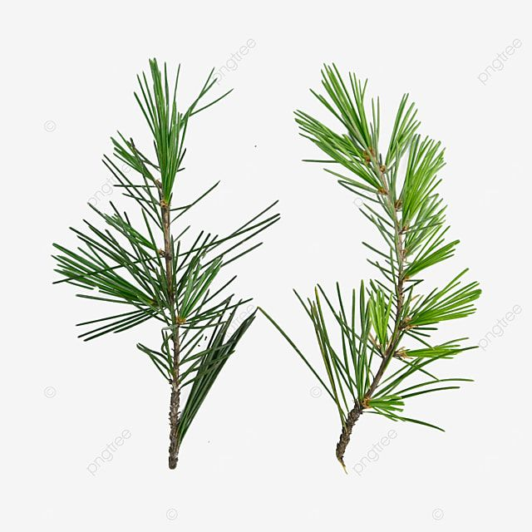
Photo of two separate green pine branches side by side, each with needle clusters, representing the two independent samples (populations X and Y) being compared in a two-sample t-test.

Comparing Two Samples
What is the probability that population X is the same as population Y?
How would you assess this question using what we learned?
shady_sunny_plot
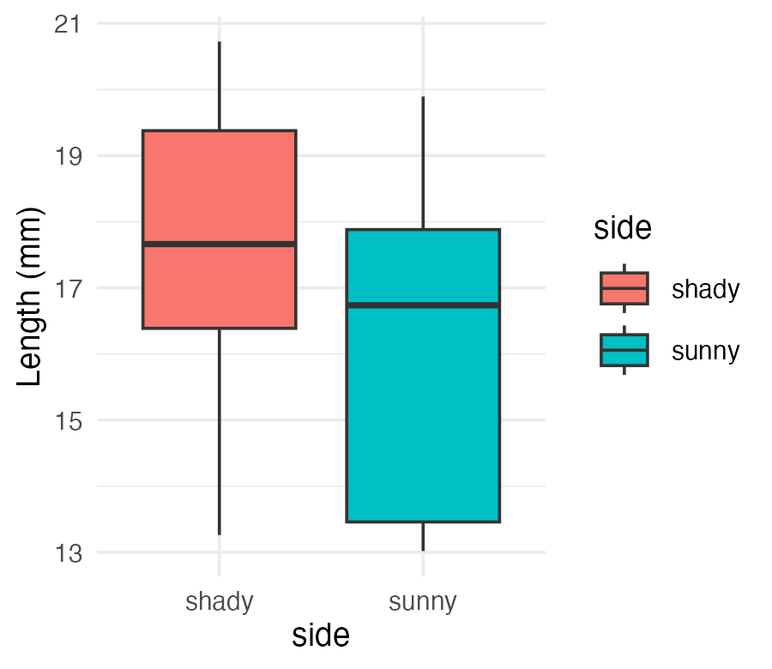
Tip
🖐 Try it yourself
Based on the boxplot alone, what would you guess the two-sample t-test will conclude about needle length on the two sides?

Practice Exercise 2: Formulating Hypotheses
Tip
Practice Exercise 2: Formulating hypotheses
For the following research question about needle lengths, write the null and alternative hypotheses:
Are needle lengths on shady and sunny sides different?
H0 =
Ha =

Two-Sample T-Test Framework
Now let’s compare needle lengths from the two sides.
Question: Is there a significant difference in needle length between the sides?
This requires a two-sample t-test, which compares means from two independent groups.
$$t=\frac{{\overset{‾}{x}}_{1}−{\overset{‾}{x}}_{2}}{S_{p}\sqrt{\frac{1}{n_{1}}+\frac{1}{n_{2}}}}$$
Where:
- x̄₁, x̄₂: sample means of the two groups
- s²ₚ: pooled variance = [(n₁−1)s₁² + (n₂−1)s₂²] / (n₁+n₂−2)
- Sₚ = √s²ₚ: the pooled standard deviation (that’s what appears in the formula)
- n₁, n₂: sample sizes of the two groups
- Sₚ√(1/n₁ + 1/n₂): the standard error of the difference — the whole denominator, not just the square-root term
$$t=\frac{\text{SIGNAL}}{\text{NOISE}}$$
Note
📖 Reference
Whitlock & Schluter, Ch. 12 — Comparing Two Means.

Practice Exercise 3: Summary Statistics
Tip
Practice Exercise 3: Calculate summary statistics grouped by side
Before conducting the test, we need to understand the data for each group.
group_summary <- ps_df %>%
group_by(side) %>%
summarize(
mean_length = mean(length_mm, na.rm = TRUE),
sd_length = sd(length_mm, na.rm = TRUE),
n = sum(!is.na(length_mm)),
se_length = sd_length / sqrt(n),
.groups = "drop"
)
group_summary
# A tibble: 2 × 5
side mean_length sd_length n se_length
<chr> <dbl> <dbl> <int> <dbl>
1 shady 17.6 2.51 8 0.886
2 sunny 16.2 2.64 8 0.934

Practice Exercise 4: Effect Size
Tip
Practice Exercise 4: Effect size
We could also look at the difference in means:
group_summary %>%
summarize(difference = mean_length[side == "shady"] - mean_length[side == "sunny"])
# A tibble: 1 × 1
difference
<dbl>
1 1.45

Practice Exercise 5: Plotting Mean ± SE Directly
Tip
Practice Exercise 5: Using ggplot to get a summary plot
ggplot can compute and plot the mean and standard error directly:
needle_mean_se_plot <- ggplot(ps_df, aes(x = side, y = length_mm, color = side)) +
stat_summary(fun = mean, geom = "point") +
stat_summary(fun.data = mean_se, geom = "errorbar", width = 0.2) +
labs(x = "side", y = "Mean Length (mm)") +
theme_classic(base_size = 9)
needle_mean_se_plot
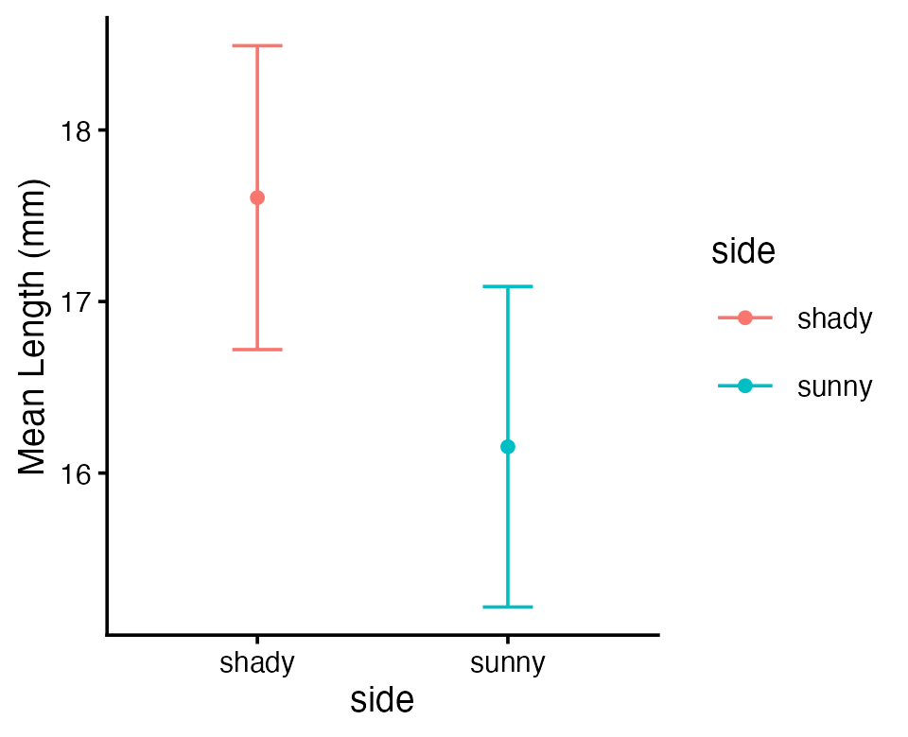

Testing Assumptions for a Two-Sample T-Test
For a two-sample t-test, we need to check:
- Normality within each group
- Equal variances between groups (for the standard t-test)
- Independent observations
If assumptions are violated:
- Welch’s t-test (unequal variances)
- Non-parametric alternatives (Mann-Whitney U test)
Note
📖 Reference
Whitlock & Schluter, Ch. 13 — Handling Violations of Assumptions, covers non-parametric alternatives when normality or equal variance fails.

Practice Exercise 6: Separate Group Data
Tip
Practice Exercise 6: separate group data
Note you need to test each group separately for normality — first, split the data:
head(ps_shady_df)
# A tibble: 6 × 5
group tree_no tree_char side length_mm
<chr> <dbl> <chr> <chr> <dbl>
1 big_fat_fecund_female_fish 2 tree_2 shady 15.4
2 bill 3 tree_3 shady 16.7
3 ciabatta 5 tree_5 shady 19.1
4 fake_data 8 tree_8 shady 17.4
5 five 1 tree_1 shady 20.3
6 moose_walkin 7 tree_7 shady 20.7
head(ps_sunny_df)
# A tibble: 6 × 5
group tree_no tree_char side length_mm
<chr> <dbl> <chr> <chr> <dbl>
1 big_fat_fecund_female_fish 2 tree_2 sunny 13.2
2 bill 3 tree_3 sunny 16.0
3 ciabatta 5 tree_5 sunny 17.7
4 fake_data 8 tree_8 sunny 13.0
5 five 1 tree_1 sunny 19.9
6 moose_walkin 7 tree_7 sunny 18.4

Practice Exercise 7: Combined Normality Test
Tip
Practice Exercise 7: test normality at one time
There are always a lot of ways to do this in R:
normality_results <- ps_df %>%
group_by(side) %>%
summarize(
shapiro_stat = shapiro.test(length_mm)$statistic,
shapiro_p_value = shapiro.test(length_mm)$p.value,
normal_distribution = if_else(shapiro_p_value > 0.05, "Normal", "Non-normal"))
normality_results
# A tibble: 2 × 4
side shapiro_stat shapiro_p_value normal_distribution
<chr> <dbl> <dbl> <chr>
1 shady 0.966 0.868 Normal
2 sunny 0.900 0.289 Normal

Practice Exercise 8: Test Equal Variances
Tip
Practice Exercise 8: test equal variances
Levene’s test can be done on the original data frame.
Note: the Levene’s test result should be NOT significant — what is the null hypothesis here?
# leveneTest needs the grouping variable as a factor
levene_result <- leveneTest(length_mm ~ factor(side), data = ps_df)
print("Levene's Test for Homogeneity of Variance:")
[1] "Levene's Test for Homogeneity of Variance:"
print(levene_result)
Levene's Test for Homogeneity of Variance (center = median)
Df F value Pr(>F)
group 1 0.2062 0.6567
14

Conducting the Two-Sample T-Test — Standard
Now we can compare the mean needle lengths between shady and sunny sides.
- H₀: μ₁ = μ₂ (the needle lengths do not differ)
- Hₐ: μ₁ ≠ μ₂ (the mean needle lengths differ — direction not specified)
Deciding between:
- Standard t-test (equal variances)
- Welch’s t-test (unequal variances)
# Use var.equal = TRUE for standard t-test,
# var.equal = FALSE for Welch's t-test
t_test_result <- t.test(length_mm ~ side, data = ps_df, var.equal = TRUE)
print("Standard two-sample t-test:")
[1] "Standard two-sample t-test:"
print(t_test_result)
Two Sample t-test
data: length_mm by side
t = 1.1279, df = 14, p-value = 0.2783
alternative hypothesis: true difference in means between group shady and group sunny is not equal to 0
95 percent confidence interval:
-1.309330 4.214005
sample estimates:
mean in group shady mean in group sunny
17.60561 16.15328

Conducting the Two-Sample T-Test — Welch’s
Now we can compare the mean needle lengths between shady and sunny sides.
- H₀: μ₁ = μ₂ (the needle lengths do not differ)
- Hₐ: μ₁ ≠ μ₂ (the mean needle lengths differ — direction not specified)
Deciding between:
- Standard t-test (equal variances)
- Welch’s t-test (unequal variances)
t_test_result <- t.test(length_mm ~ side, data = ps_df, var.equal = FALSE)
print("Welch's two-sample t-test:")
[1] "Welch's two-sample t-test:"
print(t_test_result)
Welch Two Sample t-test
data: length_mm by side
t = 1.1279, df = 13.96, p-value = 0.2784
alternative hypothesis: true difference in means between group shady and group sunny is not equal to 0
95 percent confidence interval:
-1.310069 4.214743
sample estimates:
mean in group shady mean in group sunny
17.60561 16.15328

Standard vs. Welch’s t-Test
Standard t-test (Student’s t-test)
- Assumes equal variances between groups
- Uses a pooled variance estimate combining both groups
- Has higher statistical power when the equal-variance assumption is met
- Degrees of freedom = n₁ + n₂ − 2
Welch’s t-test
- Does not assume equal variances (the “unequal variances t-test”)
- Uses separate variance estimates for each group
- More robust when group variances differ
- Uses the Welch-Satterthwaite equation — df is typically non-integer and smaller than the standard t-test’s

Interpreting the Two-Sample T-Test
Interpret the results of the two-sample t-test
What can we conclude about needle lengths on the sunny vs. shady sides?
Note
How to report this result in a scientific paper
“A two-tailed, two-sample t-test at α = 0.05 showed [a significant/no significant] difference in needle length between sunny (M = …, SD = …) and shady (M = …, SD = …) sides of pine trees, t(…) = …, p = …”

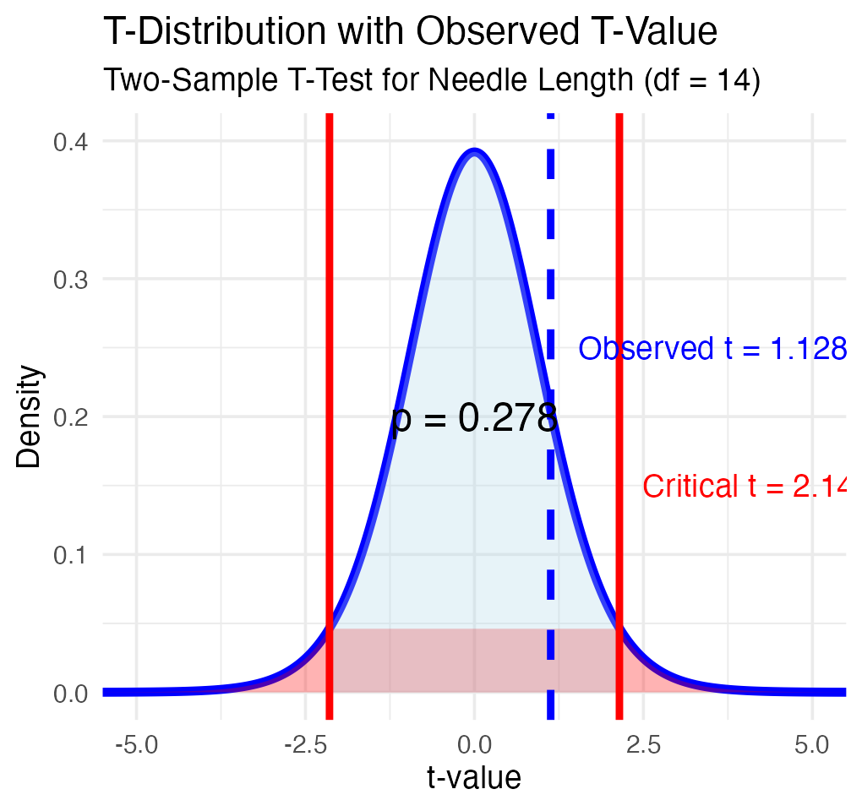

Part 6 · Paired T-Test

What Does a Paired T-Test Tell Us?
Paired t-test:
- Compares two measurements from the same subjects or matched pairs
- Tests whether the mean difference between paired observations equals zero
- Examples: before/after measurements on the same individuals, left vs. right measurements, matched case-control studies
- Uses the differences between pairs as the data
- Generally more powerful, because it controls for individual variation
Note
📖 Reference
Whitlock & Schluter, Ch. 12, section on the paired design.

ps_wide_df <- ps_df %>%
pivot_wider(
names_from = "side",
values_from = length_mm
)
paired_t_test_result <- t.test(ps_wide_df$sunny, ps_wide_df$shady, paired = TRUE)
print("Paired t-test:")
[1] "Paired t-test:"
print(paired_t_test_result)
Paired t-test
data: ps_wide_df$sunny and ps_wide_df$shady
t = -2.7818, df = 7, p-value = 0.02723
alternative hypothesis: true mean difference is not equal to 0
95 percent confidence interval:
-2.6868652 -0.2178092
sample estimates:
mean difference
-1.452337

Same Data, Two Different Answers
Look carefully at what just happened — both tests used exactly the same 16 numbers:
Test | t | df | p | Conclusion
Two-sample | 1.128 | 14 | 0.278 | Not significant
Paired | −2.782 | 7 | 0.027 | Significant
Why the difference?
- The two-sample test throws the pairing away. Tree-to-tree variation (some teams’ trees just have longer needles) lands in the noise, swamping the signal.
- The paired test looks only at the shady−sunny difference within each tree, so tree-to-tree variation cancels out entirely.
Important
These data are paired by design — each team measured both sides of the same tree. The paired test is the correct one here; the two-sample test is the wrong tool, and it would have made us miss a real effect.

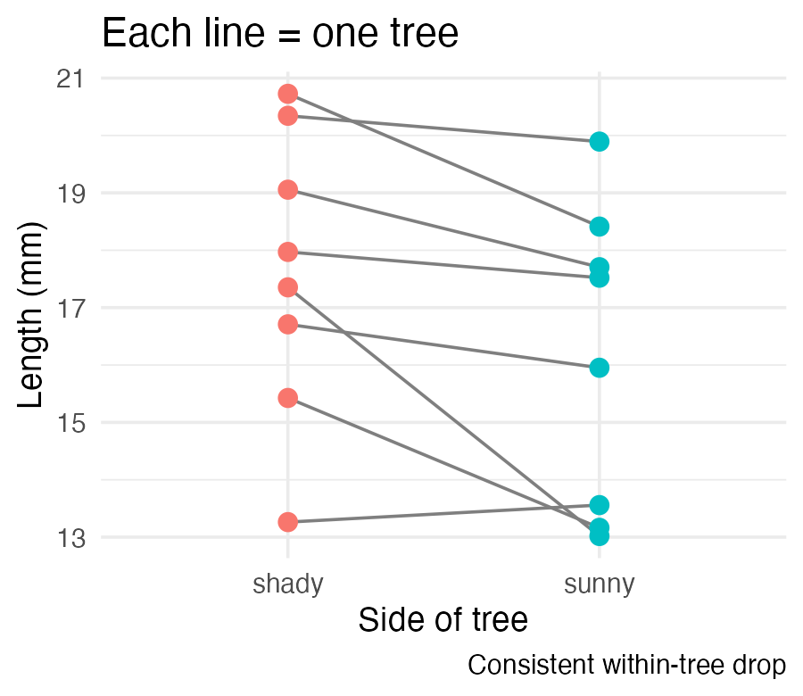

What Is Going On?
Note that there is a lot of variation within trees, but the trend is the same across trees.
ps_plot
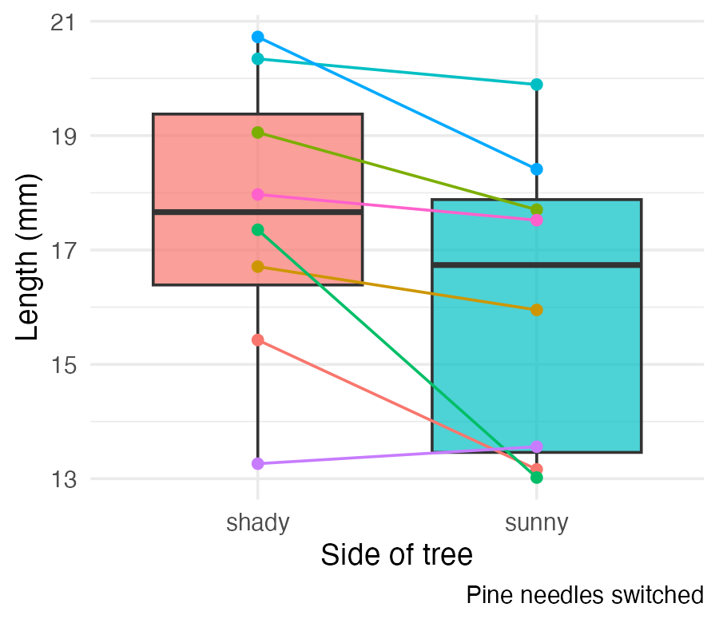

Part 7 · Assumptions and Wrap-Up

Assumptions of Parametric Tests
Common assumptions for t-tests:
- Normality — data comes from normally distributed populations
- Equal variances (for two-sample tests)
- Independence — observations are independent
- No outliers — extreme values can influence results
What can we do if our data violates these assumptions?
Alternatives when assumptions are violated:
- Data transformation (log, square root, etc.)
- Non-parametric tests
- Robust statistical methods

Summary and Conclusions
In this lecture, we’ve:
- Formulated hypotheses about pine needle length
- Tested assumptions for parametric tests
- Conducted one-sample, two-sample, and paired t-tests
- Visualized data using appropriate methods
- Learned how to interpret and report t-test results
Note
Key takeaways
- Always check assumptions before conducting tests
- Visualize your data to understand patterns
- Report results comprehensively
- Consider alternatives when assumptions are violated — non-parametric tests, coming up soon

