How an ANOVA IS A REGRESSION WIHT DUMMY VARIABLES
Bill Perry

Introduction
This document demonstrates how Analysis of Variance (ANOVA) is mathematically equivalent to a regression model with dummy variables using an example with R code and visualizations.

Setup and Data Creation
Let’s begin by loading necessary packages and creating a dataframe about plant heights with three different fertilizer treatments.
# install.packages("flextable")
library(tidyverse)
library(flextable)
# Create the dataset
fertilizer_data <- tibble(
fertilizer = rep(c("A", "B", "C"), each = 3),
height = c(10, 12, 8, # Fertilizer A
14, 16, 18, # Fertilizer B
20, 22, 24) # Fertilizer C
)
# Display the dataset using flextable
flextable(fertilizer_data) %>%
set_caption("Plant Heights by Fertilizer Type") %>%
theme_vanilla() %>%
autofit()
fertilizer | height
A | 10
A | 12
A | 8
B | 14
B | 16
B | 18
C | 20
C | 22
C | 24

Calculating Group Means (ANOVA Approach)
In ANOVA, we calculate the mean of each group and compare variation between groups to variation within groups.
group_means <- fertilizer_data %>%
group_by(fertilizer) %>%
summarize(mean_height = mean(height))
flextable(group_means) %>%
set_caption("Group Means (ANOVA Approach)") %>%
theme_vanilla() %>%
autofit()
fertilizer | mean_height
A | 10
B | 16
C | 22
Let’s visualize the raw data and group means:
ggplot(fertilizer_data, aes(x = fertilizer, y = height)) +
geom_jitter(width = 0.1, alpha = 0.6) +
geom_point(data = group_means, aes(y = mean_height),
color = "red", size = 3) +
labs(title = "Plant Height by Fertilizer Type",
x = "Fertilizer Type",
y = "Plant Height (cm)") +
theme_minimal()
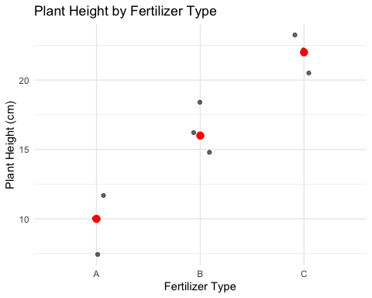

Running the ANOVA
# Run ANOVA
anova_model <- aov(height ~ fertilizer, data = fertilizer_data)
anova_summary <- summary(anova_model)
anova_summary
Df Sum Sq Mean Sq F value Pr(>F)
fertilizer 2 216 108 27 0.001 **
Residuals 6 24 4
---
Signif. codes: 0 '***' 0.001 '**' 0.01 '*' 0.05 '.' 0.1 ' ' 1

Regression with Dummy Variables
For the regression approach, we’ll create dummy variables for fertilizer types, using fertilizer A as the reference level.
# Set fertilizer A as the reference level
fertilizer_data$fertilizer <- factor(fertilizer_data$fertilizer, levels = c("A", "B", "C"))
# Run regression with dummy variables
reg_model <- lm(height ~ fertilizer, data = fertilizer_data)
reg_summary <- summary(reg_model)
reg_summary
Call:
lm(formula = height ~ fertilizer, data = fertilizer_data)
Residuals:
Min 1Q Median 3Q Max
-2 -2 0 2 2
Coefficients:
Estimate Std. Error t value Pr(>|t|)
(Intercept) 10.000 1.155 8.660 0.000131 ***
fertilizerB 6.000 1.633 3.674 0.010402 *
fertilizerC 12.000 1.633 7.348 0.000325 ***
---
Signif. codes: 0 '***' 0.001 '**' 0.01 '*' 0.05 '.' 0.1 ' ' 1
Residual standard error: 2 on 6 degrees of freedom
Multiple R-squared: 0.9, Adjusted R-squared: 0.8667
F-statistic: 27 on 2 and 6 DF, p-value: 0.001

Understanding the Regression Coefficients
In our regression model:
- The intercept (10) is equal to the mean of the reference group (A)
- The coefficient for fertilizer B (6) is the difference between mean of group B and mean of group A
- The coefficient for fertilizer C (12) is the difference between mean of group C and mean of group A
# Create a table showing the relationship between coefficients and means
coefs <- coef(reg_model)
coefficients_explained <- tibble(
Term = c("Intercept", "fertilizerB", "fertilizerC"),
Coefficient = coefs,
Meaning = c(
"Mean of Group A (reference group)",
"Difference between Group B and Group A means",
"Difference between Group C and Group A means"
),
Mathematical_Expression = c(
"β₀ = μA",
"β₁ = μB - μA",
"β₂ = μC - μA"
),
Numeric_Value = c(coefs[1],
paste0(round(group_means$mean_height[2], 1), " - ",
round(group_means$mean_height[1], 1), " = ",
round(coefs[2], 1)),
paste0(round(group_means$mean_height[3], 1), " - ",
round(group_means$mean_height[1], 1), " = ",
round(coefs[3], 1))))
# Use flextable to format the table
flextable(coefficients_explained) %>%
set_caption("Regression Coefficients Explained") %>%
theme_vanilla() %>%
fit_to_width(max_width = 8, unit = "in") %>%
bold(j = 1) %>%
colformat_double(j = 2, digits = 2)
Term | Coefficient | Meaning | Mathematical_Expression | Numeric_Value
Intercept | 10.00 | Mean of Group A (reference group) | β₀ = μA | 10
fertilizerB | 6.00 | Difference between Group B and Group A means | β₁ = μB - μA | 16 - 10 = 6
fertilizerC | 12.00 | Difference between Group C and Group A means | β₂ = μC - μA | 22 - 10 = 12
Let’s visualize these coefficients:
coef_data <- tibble(
Term = factor(c("Intercept\n(Group A Mean)", "Group B - Group A", "Group C - Group A"),
levels = c("Intercept\n(Group A Mean)", "Group B - Group A", "Group C - Group A")),
Value = c(coefs[1], coefs[2], coefs[3])
)
ggplot(coef_data, aes(x = Term, y = Value)) +
geom_col(fill = "steelblue") +
geom_text(aes(label = round(Value, 1)), vjust = -0.5) +
labs(title = "Regression Coefficients with Dummy Variables",
subtitle = "Intercept represents Group A mean; other coefficients show differences from reference",
x = "",
y = "Coefficient Value (cm)") +
theme_minimal()
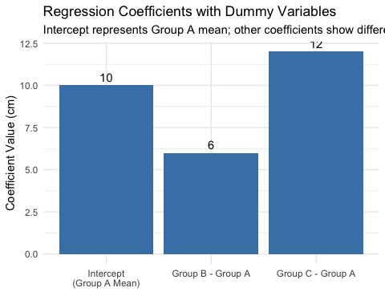

Demonstrating the Equivalence
Now, let’s prove that the regression model predictions are identical to the ANOVA group means:
# Get predictions from regression model
predicted_values <- predict(reg_model, fertilizer_data)
# Create a dataframe for comparison
comparison_data <- fertilizer_data %>%
mutate(predicted = predicted_values) %>%
group_by(fertilizer) %>%
mutate(group_mean = mean(height))
# Generate the predicted values for each group
predicted_values_by_group <- comparison_data %>%
group_by(fertilizer) %>%
reframe(
anova_mean = mean(height),
regression_prediction = mean(predicted),
formula = case_when(
fertilizer == "A" ~ paste0(round(coefs[1], 1), " + 0 + 0 = ", round(coefs[1], 1)),
fertilizer == "B" ~ paste0(round(coefs[1], 1), " + ", round(coefs[2], 1), " + 0 = ", round(coefs[1] + coefs[2], 1)),
fertilizer == "C" ~ paste0(round(coefs[1], 1), " + 0 + ", round(coefs[3], 1), " = ", round(coefs[1] + coefs[3], 1))
)
)
Let’s visualize this equivalence:
# Create data for plotting the equivalence
plot_data <- predicted_values_by_group %>%
pivot_longer(cols = c(anova_mean, regression_prediction),
names_to = "method",
values_to = "value") %>%
mutate(method = ifelse(method == "anova_mean", "ANOVA Group Mean", "Regression Prediction"))
ggplot(plot_data, aes(x = fertilizer, y = value, fill = method)) +
geom_bar(stat = "identity", position = position_dodge(), alpha = 0.7) +
geom_text(aes(label = round(value, 1)), position = position_dodge(width = 0.9), vjust = -0.5) +
labs(title = "ANOVA Mean vs. Regression Prediction by Fertilizer Type",
subtitle = "Both methods produce identical values",
x = "Fertilizer Type",
y = "Plant Height (cm)",
fill = "Method") +
theme_minimal() +
scale_fill_brewer(palette = "Set1")
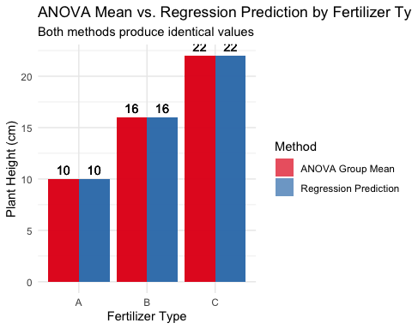

Comparing Statistical Tests
Both ANOVA and regression provide an F-test. Let’s compare them:
# ANOVA: Extract F-value and p-value
anova_f <- anova_summary[[1]]$`F value`[1]
anova_p <- anova_summary[[1]]$`Pr(>F)`[1]
# Regression: Extract F-value and p-value
reg_f <- reg_summary$fstatistic[1]
reg_p <- pf(reg_f, reg_summary$fstatistic[2], reg_summary$fstatistic[3], lower.tail = FALSE)
# Compare them
test_comparison <- tibble(
Test = c("ANOVA F-test", "Regression F-test"),
`F-value` = c(anova_f, reg_f),
`p-value` = c(anova_p, reg_p)
)
# Format with flextable
flextable(test_comparison) %>%
set_caption("Comparison of Statistical Tests") %>%
theme_vanilla() %>%
autofit() %>%
colformat_double(j = 2:3, digits = 4)
Test | F-value | p-value
ANOVA F-test | 27.0000 | 0.0010
Regression F-test | 27.0000 | 0.0010

The Mathematical Relationship
For a one-way ANOVA with a categorical variable having k levels, we can express the relationship with regression as:
$$Y=β_{0}+β_{1}X_{1}+β_{2}X_{2}+...+β_{k−1}X_{k−1}+ϵ$$
Where: - $β_{0}$ is the mean of the reference group - $β_{1},β_{2},...,β_{k−1}$ are the differences between each group’s mean and the reference group mean - $X_{1},X_{2},...,X_{k−1}$ are dummy variables (0 or 1)
In our example: - $β_{0}=10$ (mean of group A) - $β_{1}=6$ (difference between B and A) - $β_{2}=12$ (difference between C and A)

Conclusion
This demonstration shows that one-way ANOVA is mathematically equivalent to regression with dummy variables. The key equivalences are:
- ANOVA group means = Regression predictions for each group
- F-statistic from ANOVA = F-statistic from regression
- p-values are identical in both approaches
This confirms that both techniques are special cases of the General Linear Model, just expressed in different ways. For a categorical predictor with k levels, we need k-1 dummy variables in the regression approach, with one level serving as the reference category.

