Lecture 17 - Principal Component Analysis (PCA)
Bill Perry

Lecture 16: Review

Review
- Multivariate data
- Multivariate statistics in ecology: overview
- Eigenvectors, eigenvalues, components
- Distance and dissimilarity in MV space
- Data standardization
- Graphics
- Screening MV data
- MANOVA
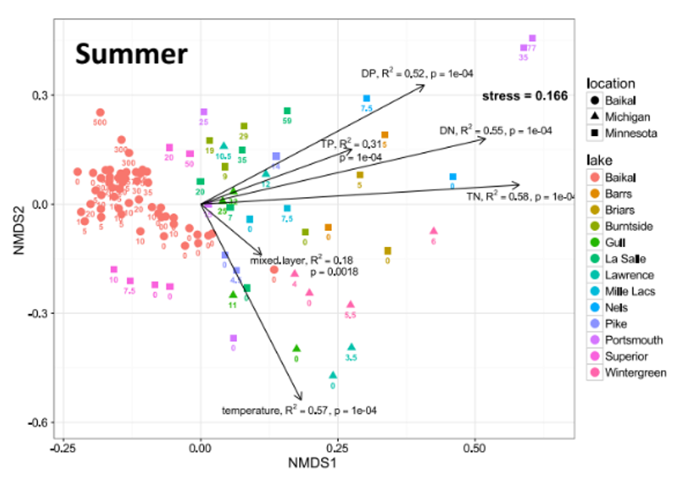

Review: Eigenvectors and Components
Eigenvectors, eigenvalues and components
- Common goal of MV analysis is variable reduction: can we derive new variables (based on linear combinations of “original” variables) that explain variation in data?
- For data set with i= 1 to n objects and j = 1 to p original variables we seek new variables (principal components) using the equation:

$$z_{ik}=c_{1}y_{i1}+c_{2}y_{i2}+⋯c_{j}y_{ij}+⋯+c_{p}y_{ip}$$

Review: Component Interpretation
- zik is value of new variable k for object I
- yi1- yip are values of original variables for object i
- c1-cp are coefficients that show importance of the original variables to new derived variable

$$z_{ik}=c_{1}y_{i1}+c_{2}y_{i2}+⋯c_{j}y_{ij}+⋯+c_{p}y_{ip}$$

Review: Component Properties
Eigenvectors, eigenvalues and components
Derived variables are found so that:
- First derived variable explains most of the variation in the data
- Second most of the remaining variation
- And so on…
- As many derived variables as original variables (p)
- Derived variables are uncorrelated with each other
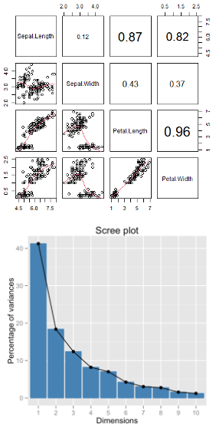

Review: Eigenvalues and Eigenvectors
Eigenvectors, eigenvalues and components
- Eigenvalues (latent roots) represent amount of variation in data explained by the new k= 1 to p derived variables (λ1, λ2 …λp).
- Eigenvalues are population parameters and are estimated using ML to get sample statistics (l1, l2…lp)
- Eigenvectors are lists of coefficients (c) that show contribution of original variables to new, derived variables
- Each new variable has an eigenvalue and an eigenvector
- New variables (components) are derived from a p x p covariance or correlation matrix of original variables

Lecture 17: PCA Goals and Introduction
- Common goals of MV data analysis are variable reduction (finding derived variables that summarize data) and exploration of patterns in data (scaling/ordination)
- Can use association (correlation/ covariance) matrices (PCA) or dissimilarity measures (MDS)
- In PCA: take p old variables and transform them into p “new/derived” uncorrelated variables (principal components)

Data for PCA Analysis
# Load the iris dataset
iris_df <- iris %>% clean_names() %>% mutate(ind = row_number()) %>%
mutate(species_ind = paste(species, ind, sep="_"))
# get values only
iris_data <- iris_df %>% select(-species, -ind, -species_ind)
# Keep species for later visualization
iris_species <- iris_df %>% select(species, ind, species_ind)
# pivot to long formt for viewing
iris_long_df <- iris_df %>%
pivot_longer(
cols = -c(species, ind, species_ind),
names_to = "variable",
values_to = "values")
iris_df
sepal_length sepal_width petal_length petal_width species ind
1 5.1 3.5 1.4 0.2 setosa 1
2 4.9 3.0 1.4 0.2 setosa 2
3 4.7 3.2 1.3 0.2 setosa 3
4 4.6 3.1 1.5 0.2 setosa 4
5 5.0 3.6 1.4 0.2 setosa 5
6 5.4 3.9 1.7 0.4 setosa 6
7 4.6 3.4 1.4 0.3 setosa 7
8 5.0 3.4 1.5 0.2 setosa 8
9 4.4 2.9 1.4 0.2 setosa 9
10 4.9 3.1 1.5 0.1 setosa 10
11 5.4 3.7 1.5 0.2 setosa 11
12 4.8 3.4 1.6 0.2 setosa 12
13 4.8 3.0 1.4 0.1 setosa 13
14 4.3 3.0 1.1 0.1 setosa 14
15 5.8 4.0 1.2 0.2 setosa 15
16 5.7 4.4 1.5 0.4 setosa 16
17 5.4 3.9 1.3 0.4 setosa 17
18 5.1 3.5 1.4 0.3 setosa 18
19 5.7 3.8 1.7 0.3 setosa 19
20 5.1 3.8 1.5 0.3 setosa 20
21 5.4 3.4 1.7 0.2 setosa 21
22 5.1 3.7 1.5 0.4 setosa 22
23 4.6 3.6 1.0 0.2 setosa 23
24 5.1 3.3 1.7 0.5 setosa 24
25 4.8 3.4 1.9 0.2 setosa 25
26 5.0 3.0 1.6 0.2 setosa 26
27 5.0 3.4 1.6 0.4 setosa 27
28 5.2 3.5 1.5 0.2 setosa 28
29 5.2 3.4 1.4 0.2 setosa 29
30 4.7 3.2 1.6 0.2 setosa 30
31 4.8 3.1 1.6 0.2 setosa 31
32 5.4 3.4 1.5 0.4 setosa 32
33 5.2 4.1 1.5 0.1 setosa 33
34 5.5 4.2 1.4 0.2 setosa 34
35 4.9 3.1 1.5 0.2 setosa 35
36 5.0 3.2 1.2 0.2 setosa 36
37 5.5 3.5 1.3 0.2 setosa 37
38 4.9 3.6 1.4 0.1 setosa 38
39 4.4 3.0 1.3 0.2 setosa 39
40 5.1 3.4 1.5 0.2 setosa 40
41 5.0 3.5 1.3 0.3 setosa 41
42 4.5 2.3 1.3 0.3 setosa 42
43 4.4 3.2 1.3 0.2 setosa 43
44 5.0 3.5 1.6 0.6 setosa 44
45 5.1 3.8 1.9 0.4 setosa 45
46 4.8 3.0 1.4 0.3 setosa 46
47 5.1 3.8 1.6 0.2 setosa 47
48 4.6 3.2 1.4 0.2 setosa 48
49 5.3 3.7 1.5 0.2 setosa 49
50 5.0 3.3 1.4 0.2 setosa 50
51 7.0 3.2 4.7 1.4 versicolor 51
52 6.4 3.2 4.5 1.5 versicolor 52
53 6.9 3.1 4.9 1.5 versicolor 53
54 5.5 2.3 4.0 1.3 versicolor 54
55 6.5 2.8 4.6 1.5 versicolor 55
56 5.7 2.8 4.5 1.3 versicolor 56
57 6.3 3.3 4.7 1.6 versicolor 57
58 4.9 2.4 3.3 1.0 versicolor 58
59 6.6 2.9 4.6 1.3 versicolor 59
60 5.2 2.7 3.9 1.4 versicolor 60
61 5.0 2.0 3.5 1.0 versicolor 61
62 5.9 3.0 4.2 1.5 versicolor 62
63 6.0 2.2 4.0 1.0 versicolor 63
64 6.1 2.9 4.7 1.4 versicolor 64
65 5.6 2.9 3.6 1.3 versicolor 65
66 6.7 3.1 4.4 1.4 versicolor 66
67 5.6 3.0 4.5 1.5 versicolor 67
68 5.8 2.7 4.1 1.0 versicolor 68
69 6.2 2.2 4.5 1.5 versicolor 69
70 5.6 2.5 3.9 1.1 versicolor 70
71 5.9 3.2 4.8 1.8 versicolor 71
72 6.1 2.8 4.0 1.3 versicolor 72
73 6.3 2.5 4.9 1.5 versicolor 73
74 6.1 2.8 4.7 1.2 versicolor 74
75 6.4 2.9 4.3 1.3 versicolor 75
76 6.6 3.0 4.4 1.4 versicolor 76
77 6.8 2.8 4.8 1.4 versicolor 77
78 6.7 3.0 5.0 1.7 versicolor 78
79 6.0 2.9 4.5 1.5 versicolor 79
80 5.7 2.6 3.5 1.0 versicolor 80
81 5.5 2.4 3.8 1.1 versicolor 81
82 5.5 2.4 3.7 1.0 versicolor 82
83 5.8 2.7 3.9 1.2 versicolor 83
84 6.0 2.7 5.1 1.6 versicolor 84
85 5.4 3.0 4.5 1.5 versicolor 85
86 6.0 3.4 4.5 1.6 versicolor 86
87 6.7 3.1 4.7 1.5 versicolor 87
88 6.3 2.3 4.4 1.3 versicolor 88
89 5.6 3.0 4.1 1.3 versicolor 89
90 5.5 2.5 4.0 1.3 versicolor 90
91 5.5 2.6 4.4 1.2 versicolor 91
92 6.1 3.0 4.6 1.4 versicolor 92
93 5.8 2.6 4.0 1.2 versicolor 93
94 5.0 2.3 3.3 1.0 versicolor 94
95 5.6 2.7 4.2 1.3 versicolor 95
96 5.7 3.0 4.2 1.2 versicolor 96
97 5.7 2.9 4.2 1.3 versicolor 97
98 6.2 2.9 4.3 1.3 versicolor 98
99 5.1 2.5 3.0 1.1 versicolor 99
100 5.7 2.8 4.1 1.3 versicolor 100
101 6.3 3.3 6.0 2.5 virginica 101
102 5.8 2.7 5.1 1.9 virginica 102
103 7.1 3.0 5.9 2.1 virginica 103
104 6.3 2.9 5.6 1.8 virginica 104
105 6.5 3.0 5.8 2.2 virginica 105
106 7.6 3.0 6.6 2.1 virginica 106
107 4.9 2.5 4.5 1.7 virginica 107
108 7.3 2.9 6.3 1.8 virginica 108
109 6.7 2.5 5.8 1.8 virginica 109
110 7.2 3.6 6.1 2.5 virginica 110
111 6.5 3.2 5.1 2.0 virginica 111
112 6.4 2.7 5.3 1.9 virginica 112
113 6.8 3.0 5.5 2.1 virginica 113
114 5.7 2.5 5.0 2.0 virginica 114
115 5.8 2.8 5.1 2.4 virginica 115
116 6.4 3.2 5.3 2.3 virginica 116
117 6.5 3.0 5.5 1.8 virginica 117
118 7.7 3.8 6.7 2.2 virginica 118
119 7.7 2.6 6.9 2.3 virginica 119
120 6.0 2.2 5.0 1.5 virginica 120
121 6.9 3.2 5.7 2.3 virginica 121
122 5.6 2.8 4.9 2.0 virginica 122
123 7.7 2.8 6.7 2.0 virginica 123
124 6.3 2.7 4.9 1.8 virginica 124
125 6.7 3.3 5.7 2.1 virginica 125
126 7.2 3.2 6.0 1.8 virginica 126
127 6.2 2.8 4.8 1.8 virginica 127
128 6.1 3.0 4.9 1.8 virginica 128
129 6.4 2.8 5.6 2.1 virginica 129
130 7.2 3.0 5.8 1.6 virginica 130
131 7.4 2.8 6.1 1.9 virginica 131
132 7.9 3.8 6.4 2.0 virginica 132
133 6.4 2.8 5.6 2.2 virginica 133
134 6.3 2.8 5.1 1.5 virginica 134
135 6.1 2.6 5.6 1.4 virginica 135
136 7.7 3.0 6.1 2.3 virginica 136
137 6.3 3.4 5.6 2.4 virginica 137
138 6.4 3.1 5.5 1.8 virginica 138
139 6.0 3.0 4.8 1.8 virginica 139
140 6.9 3.1 5.4 2.1 virginica 140
141 6.7 3.1 5.6 2.4 virginica 141
142 6.9 3.1 5.1 2.3 virginica 142
143 5.8 2.7 5.1 1.9 virginica 143
144 6.8 3.2 5.9 2.3 virginica 144
145 6.7 3.3 5.7 2.5 virginica 145
146 6.7 3.0 5.2 2.3 virginica 146
147 6.3 2.5 5.0 1.9 virginica 147
148 6.5 3.0 5.2 2.0 virginica 148
149 6.2 3.4 5.4 2.3 virginica 149
150 5.9 3.0 5.1 1.8 virginica 150
species_ind
1 setosa_1
2 setosa_2
3 setosa_3
4 setosa_4
5 setosa_5
6 setosa_6
7 setosa_7
8 setosa_8
9 setosa_9
10 setosa_10
11 setosa_11
12 setosa_12
13 setosa_13
14 setosa_14
15 setosa_15
16 setosa_16
17 setosa_17
18 setosa_18
19 setosa_19
20 setosa_20
21 setosa_21
22 setosa_22
23 setosa_23
24 setosa_24
25 setosa_25
26 setosa_26
27 setosa_27
28 setosa_28
29 setosa_29
30 setosa_30
31 setosa_31
32 setosa_32
33 setosa_33
34 setosa_34
35 setosa_35
36 setosa_36
37 setosa_37
38 setosa_38
39 setosa_39
40 setosa_40
41 setosa_41
42 setosa_42
43 setosa_43
44 setosa_44
45 setosa_45
46 setosa_46
47 setosa_47
48 setosa_48
49 setosa_49
50 setosa_50
51 versicolor_51
52 versicolor_52
53 versicolor_53
54 versicolor_54
55 versicolor_55
56 versicolor_56
57 versicolor_57
58 versicolor_58
59 versicolor_59
60 versicolor_60
61 versicolor_61
62 versicolor_62
63 versicolor_63
64 versicolor_64
65 versicolor_65
66 versicolor_66
67 versicolor_67
68 versicolor_68
69 versicolor_69
70 versicolor_70
71 versicolor_71
72 versicolor_72
73 versicolor_73
74 versicolor_74
75 versicolor_75
76 versicolor_76
77 versicolor_77
78 versicolor_78
79 versicolor_79
80 versicolor_80
81 versicolor_81
82 versicolor_82
83 versicolor_83
84 versicolor_84
85 versicolor_85
86 versicolor_86
87 versicolor_87
88 versicolor_88
89 versicolor_89
90 versicolor_90
91 versicolor_91
92 versicolor_92
93 versicolor_93
94 versicolor_94
95 versicolor_95
96 versicolor_96
97 versicolor_97
98 versicolor_98
99 versicolor_99
100 versicolor_100
101 virginica_101
102 virginica_102
103 virginica_103
104 virginica_104
105 virginica_105
106 virginica_106
107 virginica_107
108 virginica_108
109 virginica_109
110 virginica_110
111 virginica_111
112 virginica_112
113 virginica_113
114 virginica_114
115 virginica_115
116 virginica_116
117 virginica_117
118 virginica_118
119 virginica_119
120 virginica_120
121 virginica_121
122 virginica_122
123 virginica_123
124 virginica_124
125 virginica_125
126 virginica_126
127 virginica_127
128 virginica_128
129 virginica_129
130 virginica_130
131 virginica_131
132 virginica_132
133 virginica_133
134 virginica_134
135 virginica_135
136 virginica_136
137 virginica_137
138 virginica_138
139 virginica_139
140 virginica_140
141 virginica_141
142 virginica_142
143 virginica_143
144 virginica_144
145 virginica_145
146 virginica_146
147 virginica_147
148 virginica_148
149 virginica_149
150 virginica_150

Step 1: Explore the Iris Dataset
As in every case you should be looking at the data first - every time…
Right is the data on iris from a long dataframe
overview_plot <- iris_long_df %>%
ggplot(aes(species, values, color=species)) +
geom_boxplot() +
facet_wrap(~variable, scales = "free")
overview_plot
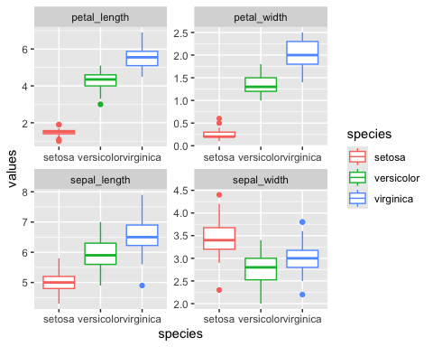

What is PCA? Goals and Overview

Principal Component Analysis Goals:
- Variable Reduction: Transform many correlated variables into fewer uncorrelated components
- Data Exploration: Visualize patterns and relationships in high-dimensional data
- Noise Reduction: Focus on the most important sources of variation
- Dimension Reduction: Make complex datasets easier to analyze and interpret
Today’s Example: Iris flower measurements - can we reduce 4 measurements to 2-3 components that capture most variation?
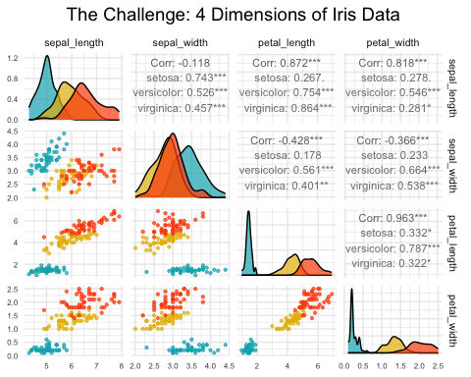

High-Dimensional Data Visualization

Principal Component Analysis Goals:
- Variable Reduction: Transform many correlated variables into fewer uncorrelated components
- Data Exploration: Visualize patterns and relationships in high-dimensional data
- Noise Reduction: Focus on the most important sources of variation
- Dimension Reduction: Make complex datasets easier to analyze and interpret
Today’s Example: Iris flower measurements - can we reduce 4 measurements to fewer components that capture most variation?

PCA Assumptions - Critical to Check First!

Key Assumptions:
- Linear relationships between variables
- No extreme outliers (can distort results)
- Variables should be correlated (if not, PCA won’t reduce dimensions)
- Adequate sample size (generally n > 50, preferably n > 100)
- No missing data (complete cases only)
- Consider standardization when variables have different scales
Important: PCA works best when original variables are moderately to highly correlated!
Let’s check these assumptions with our iris data…

Step 2: Check PCA Assumptions - Correlations
[1] "Correlation Matrix:"
sepal_length sepal_width petal_length petal_width
sepal_length 1.000 -0.118 0.872 0.818
sepal_width -0.118 1.000 -0.428 -0.366
petal_length 0.872 -0.428 1.000 0.963
petal_width 0.818 -0.366 0.963 1.000
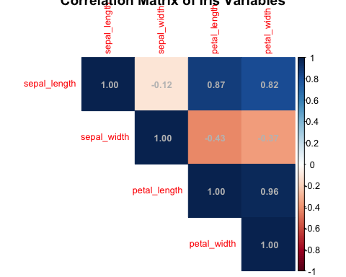

Step 2: Check PCA Assumptions - Linearity
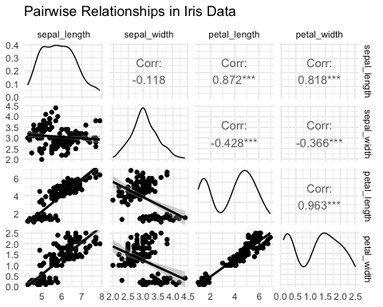

Step 2: Check PCA Assumptions - Outliers
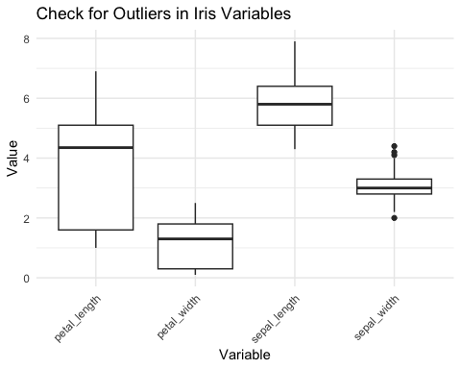

Step 3: Standardize the Data

STANDARDIZATION: Making all variables comparable
Why standardize?
Our measurements have different units and scales:
- Sepal length: ranges from ~4-8 cm
- Sepal width: ranges from ~2-4 cm
- Petal length: ranges from ~1-7 cm
- Petal width: ranges from ~0.1-2.5 cm
Without standardization, PCA would be dominated by variables with larger numbers (like petal length) simply because they have bigger values, not because they’re more important biologically
What does standardization do?
- Converts each variable to have:
  - Mean = 0 (centered at zero)
  - Standard deviation = 1 (same spread)
  - This gives all variables equal weight in the analysis
How to interpret standardized values: Example: A sepal length of 5.1 cm might become -0.9 after standardization, meaning it’s 0.9 standard deviations below the average sepal length
[1] "Means after standardization (should be ~0):"
sepal_length sepal_width petal_length petal_width
0 0 0 0
[1] "Standard deviations after standardization (should be 1):"
sepal_length sepal_width petal_length petal_width
1 1 1 1

Step 4: Perform PCA - The Mathematics

What is PCA doing?
Principal Component Analysis finds new variables (called components) that capture the most variation in your data. Think of it as finding the “best viewing angles” to see differences between flowers.

The mathematics (simplified):
- PCA rotates your data to find the direction with maximum spread (PC1)
- Then finds the next direction with maximum spread perpendicular to PC1 (PC2)
- Continues until it has as many components as original variables (4 in our case)

Why center = FALSE and scale = FALSE?
We already standardized our data in Step 3, so we tell R not to do it again: - center = FALSE: Don’t subtract the mean (we already did) - scale = FALSE: Don’t divide by standard deviation (we already did)

What the summary shows:
- Standard deviation: How much variation each component captures
- Proportion of Variance: Percentage of total variation explained by each component
- Cumulative Proportion: Running total of variance explained
# Perform PCA on standardized data
iris_pca <- prcomp(iris_scaled, center = FALSE, scale. = FALSE)
# Note: center and scale are FALSE because we already standardized
# Alternative using vegan package
iris_pca_vegan <- rda(iris_scaled)
# Summary of PCA results
summary(iris_pca)
Importance of components:
PC1 PC2 PC3 PC4
Standard deviation 1.7084 0.9560 0.38309 0.14393
Proportion of Variance 0.7296 0.2285 0.03669 0.00518
Cumulative Proportion 0.7296 0.9581 0.99482 1.00000

Deriving Components: 2D Visualization
How are new uncorrelated components derived? One way to think it is in terms of axis rotation Consider a 2-variable dataset:
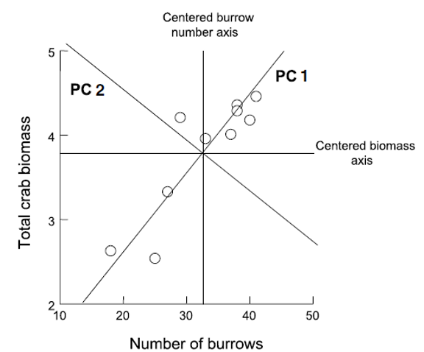

Component Derivation: Axis Rotation
Goal is to “rotate the axes” around center of the data “cloud” in such a way that most of the variation lies along the first axis Then find second axis that explains the second-most variation AND is orthogonal to first axis
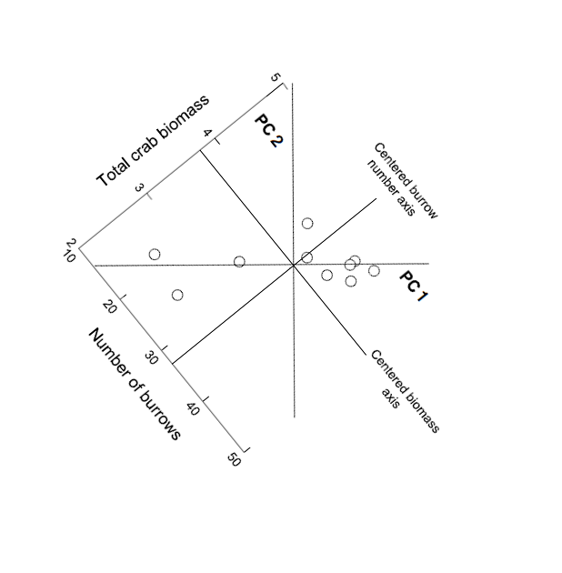

Component Derivation: Multivariate Extension
Easy to picture in 2D (or even 3D), but harder in multivariate space Practically, components are “extracted” from a covariance of correlation matrix among original variables Will extract as many principal components as original variables
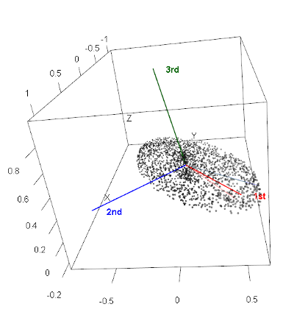

Component Information: Eigenvalues and Eigenvectors
- Get two important pieces of information from PCA: eigenvectors and eigenvalues
- Eigenvalues (latent roots)- how much of the variation is explained by each component?
- Eigenvectors- list of coefficients for original variables. There are p coefficients in an eigenvector and p eigenvectors
- Correlation bw original variables will result in fewer components explaining more variance; variable reduction will fail if original variables are not correlated

Step 4: Understanding Eigenvalues and Variance

Understanding Eigenvalues and Variance

What are eigenvalues?
- Eigenvalues tell us how much variation each principal component captures.
- Larger eigenvalues = more important components.

Key terms explained:
- Eigenvalue: The amount of variance captured by each component (always positive)
- Proportion of Variance: What percentage of total variation this component explains
- Cumulative Variance: Running total - helps us decide how many components we need

How to read the results:
- If PC1 has eigenvalue = 2.9, it captures 2.9 “units” of variance
- If Prop_Variance = 0.728, PC1 explains 72.8% of all variation in the data
- If Cumsum_Variance = 0.959 at PC2, the first 2 components together explain 95.9% of variation

Why this matters:
This table helps us decide how many components to keep.
- If 2 components explain 95% of variance, we’ve successfully reduced 4 variables to 2
- We only lose 5% of information without including the other variables!
# Extract eigenvalues (variance explained by each component)
eigenvalues <- iris_pca$sdev^2
prop_variance <- eigenvalues / sum(eigenvalues)
cumsum_variance <- cumsum(prop_variance)
# Create a summary table
pca_summary <- data.frame(
Component = paste0("PC", 1:length(eigenvalues)),
Eigenvalue = eigenvalues,
Prop_Variance = prop_variance,
Cumsum_Variance = cumsum_variance
)
print("PCA Summary:")
[1] "PCA Summary:"
kable(pca_summary, digits = 3)
Component | Eigenvalue | Prop_Variance | Cumsum_Variance
PC1 | 2.918 | 0.730 | 0.730
PC2 | 0.914 | 0.229 | 0.958
PC3 | 0.147 | 0.037 | 0.995
PC4 | 0.021 | 0.005 | 1.000

Step 5: Determine Number of Components - Scree Plot

What is a Scree Plot?
A scree plot shows how much variance each component explains, helping us decide how many components we need. The name comes from the geological term “scree” - loose rocks at the base of a cliff - because the plot often looks like a steep cliff followed by rubble.

How to read a Scree Plot:
- Y-axis: Percentage of variance explained by each component
- X-axis: Component number (PC1, PC2, etc.)
- The pattern: Usually shows a steep drop followed by a leveling off

The “Elbow Method”:
Look for where the line “bends” or forms an elbow:
- Components before the elbow = important (steep slope)
- Components after the elbow = less important (gentle slope)
- Keep components up to and including the elbow

What to look for in our plot:
- If PC1 explains 70% and PC2 explains 20%, but PC3 only explains 5%, the elbow is at PC2
- This suggests keeping the first 2 components
- The dramatic drop from PC1 to PC2, then gentle decline after, confirms our dimension reduction worked well

Step 5: Component Selection Rules
# Eigenvalue > 1 rule (Kaiser criterion)
components_to_keep <- sum(eigenvalues > 1)
print(paste("Components with eigenvalue > 1:", components_to_keep))
[1] "Components with eigenvalue > 1: 1"
# Components explaining at least 80% of variance
components_80_percent <- which(cumsum_variance >= 0.80)[1]
print(paste("Components needed for 80% variance:", components_80_percent))
[1] "Components needed for 80% variance: 2"

Step 6: Interpret the Components - Loadings

What are Component Loadings
Loadings tell us how much each original variable contributes to each principal component. Think of them as “recipes” that show how to mix your original measurements to create the new components.

How to read the loadings table
- Values range from -1 to +1 (like correlations)
- Large positive values (e.g., 0.8): This variable contributes strongly in the positive direction
- Large negative values (e.g., -0.8): This variable contributes strongly in the negative direction
- Values near 0: This variable doesn’t contribute much to this component

Interpreting the patterns:
- If all loadings have similar signs: Component represents overall size (all measurements increase/decrease together)
- If loadings have mixed signs: Component represents shape or proportions (some measurements increase while others decrease)
- Dominant variables: Variables with the largest absolute loadings drive that component’s meaning

Example interpretation:
If PC1 has all negative loadings around -0.5, it means:
- Flowers with high PC1 scores have small values for ALL measurements
- This component captures “overall flower size”
- The negative sign just indicates direction (could flip signs and interpretation)
# Component loadings (how much each original variable contributes)
loadings_df <- data.frame(
Variable = rownames(iris_pca$rotation),
PC1 = iris_pca$rotation[, 1],
PC2 = iris_pca$rotation[, 2],
PC3 = iris_pca$rotation[, 3],
PC4 = iris_pca$rotation[, 4]
)
print("Component Loadings:")
[1] "Component Loadings:"
loadings_df
Variable PC1 PC2 PC3 PC4
sepal_length sepal_length 0.5210659 -0.37741762 0.7195664 0.2612863
sepal_width sepal_width -0.2693474 -0.92329566 -0.2443818 -0.1235096
petal_length petal_length 0.5804131 -0.02449161 -0.1421264 -0.8014492
petal_width petal_width 0.5648565 -0.06694199 -0.6342727 0.5235971

Step 6: Eigenvector Properties

Key properties of eigenvectors/loadings:
- Unit length: Each eigenvector has length 1 (sum of squares = 1)
- Orthogonal: Eigenvectors are perpendicular to each other (dot product = 0)
- Ordered by importance: First eigenvector (PC1) explains most variance

The complete picture:
- Eigenvectors = The directions (loadings)
- Eigenvalues = The importance of each direction (variance explained)
- Together they fully describe the PCA transformation

Step 6b: Visualization of Component Loadings
What does this plot show?
This is a visual representation of the loadings table, showing how each original variable contributes to PC1 and PC2. It’s like a map of how your original measurements relate to the new principal components.
How to read the plot:
- Arrows represent your original variables (sepal_length, sepal_width, etc.)
- Arrow direction shows which PC the variable contributes to
- Arrow length indicates the strength of contribution (longer = stronger)
- Arrow color shows the overall contribution magnitude (red = highest, blue = lowest)
- The circle represents the maximum possible contribution
Key interpretations from this plot:
- PC1 (horizontal axis, 73% variance):
  - All arrows point roughly left (negative direction)
  - All variables contribute almost equally to PC1
  - This confirms PC1 represents “overall flower size”
PC2 (vertical axis, 22.9% variance):
- Sepal_width points down (negative)
- Other variables point slightly up (positive)
- This creates a contrast: sepal width vs. everything else
- PC2 captures “flower shape” - wide sepals vs. long petals

Loading Plot Interpretation
What the arrow positions tell us:
- Variables pointing in same direction = positively correlated
- Variables at 90° angles = uncorrelated
- Variables pointing opposite directions = negatively correlated
The practical meaning:
- Flowers with high PC1 scores have large values for all measurements
- Flowers with high PC2 scores have narrow sepals but long/wide petals
- The plot confirms our dimension reduction worked - we’ve captured 95.9% of variation in just 2 dimensions!

Step 7: PCA Biplot - The Main Result

Key insights from this biplot:

Species separation:
- Setosa (blue): Clearly separated on the left (negative PC1)
- Versicolor (yellow): In the middle
- Virginica (red): On the right (positive PC1)
- PCA successfully separates species without being told about them!

Understanding flower characteristics:
- Setosa flowers: Small overall (negative PC1), relatively wide sepals (positive PC2)
- Virginica flowers: Large overall (positive PC1), especially long petals
- Versicolor flowers: Intermediate in most characteristics

Variable relationships:
- Petal measurements point together → highly correlated
- Sepal width points differently → captures different information
- All arrows point right → all measurements increase from setosa to virginica

Step 7: PCA Scores Plot - Alternative Visualization
# Alternative scores plot
ggplot(pca_scores, aes(x = PC1, y = PC2, color = species)) +
geom_point(size = 3, alpha = 0.7) +
stat_ellipse(level = 0.68, linetype = 2) + # Add ellipses
labs(title = "PCA Scores Plot",
subtitle = paste0("PC1 explains ", round(prop_variance[1]*100, 1),
"% of variance, PC2 explains ", round(prop_variance[2]*100, 1), "%"),
x = paste0("PC1 (", round(prop_variance[1]*100, 1), "%)"),
y = paste0("PC2 (", round(prop_variance[2]*100, 1), "%)"),
color = "Species") +
theme_minimal() +
scale_color_manual(values = c("#00AFBB", "#E7B800", "#FC4E07"))

Step 8: Interpret PC1 Results

Understanding PC1 Loadings:
The loadings show how each original variable contributes to PC1:
- Sepal length: 0.521 - Strong positive contribution
- Sepal width: -0.269 - Moderate negative contribution
- Petal length: 0.580 - Strong positive contribution
- Petal width: 0.565 - Strong positive contribution
# What does PC1 represent?
pc1_loadings <- iris_pca$rotation[, 1]
print("PC1 Loadings (all variables contribute similarly):")
[1] "PC1 Loadings (all variables contribute similarly):"
round(pc1_loadings, 3)
sepal_length sepal_width petal_length petal_width
0.521 -0.269 0.580 0.565
cat("\nPC1 Interpretation: Overall flower size")
PC1 Interpretation: Overall flower size
cat("\n- All variables have similar negative loadings")
- All variables have similar negative loadings
cat("\n- Higher PC1 values = smaller flowers overall")
- Higher PC1 values = smaller flowers overall
cat("\n- Lower PC1 values = larger flowers overall")
- Lower PC1 values = larger flowers overall

PC1 Interpretation: Overall Flower Size

PC1 Interpretation: Overall flower size (with a twist)
Note: The output says “all variables have similar negative loadings” but the actual values show mostly positive loadings. This is likely due to a sign flip - PCA signs can be arbitrary. Let’s interpret based on the actual values shown:
- Three variables (sepal length, petal length, petal width) have similar positive loadings (~0.52-0.58)
- Sepal width has a negative loading (-0.269)
- This means PC1 captures flowers where length and width measurements (except sepal width) vary together

What PC1 scores mean:
- Higher PC1 values = Longer petals, longer sepals, wider petals, but narrower sepals
- Lower PC1 values = Shorter petals, shorter sepals, narrower petals, but wider sepals
- PC1 essentially captures “overall flower size except sepal width goes opposite”

Biological interpretation:
PC1 distinguishes between:
- Small flowers with relatively wide sepals (negative PC1) - typical of setosa
- Large flowers with relatively narrow sepals (positive PC1) - typical of virginica

Step 8: Interpret PC2 Results

Understanding PC2 Loadings:
The loadings show how each original variable contributes to PC2:
- Sepal length: -0.377 - Moderate negative contribution
- Sepal width: -0.923 - Very strong negative contribution
- Petal length: -0.024 - Almost no contribution
- Petal width: -0.067 - Very small negative contribution
# What does PC2 represent?
pc2_loadings <- iris_pca$rotation[, 2]
print("PC2 Loadings:")
[1] "PC2 Loadings:"
round(pc2_loadings, 3)
sepal_length sepal_width petal_length petal_width
-0.377 -0.923 -0.024 -0.067
cat("\nPC2 Interpretation: Flower shape contrast")
PC2 Interpretation: Flower shape contrast
cat("\n- Positive loadings: sepal width")
- Positive loadings: sepal width
cat("\n- Negative loadings: petal length and width, sepal length")
- Negative loadings: petal length and width, sepal length
cat("\n- Higher PC2 = wider sepals relative to petal size")
- Higher PC2 = wider sepals relative to petal size
cat("\n- Lower PC2 = longer/wider petals relative to sepal width")
- Lower PC2 = longer/wider petals relative to sepal width

PC2 Interpretation: Flower Shape Contrast

PC2 Interpretation: Correcting the output
Note: The output says “Positive loadings: sepal width” but the actual value is -0.923 (negative). All loadings are actually negative, with sepal width being the most strongly negative.

What PC2 actually represents:
- All variables have negative loadings, but sepal width is dominant (-0.923)
- Petal measurements contribute very little (-0.024 and -0.067)
- This component is primarily driven by sepal width, with some contribution from sepal length

What PC2 scores mean:
- Higher PC2 values = Smaller measurements overall, especially narrow sepals
- Lower PC2 values = Larger measurements overall, especially wide sepals
- Since sepal width has the strongest loading, PC2 primarily captures sepal width variation

Biological interpretation:
PC2 helps distinguish:
- Flowers with narrow sepals and smaller overall size (positive PC2)
- Flowers with wide sepals and larger overall size (negative PC2)
- This dimension helps separate species that have similar PC1 scores but different sepal proportions

Step 9: How Well Does PCA Work?
# Calculate total variance explained by first 2 components
variance_explained_2pc <- sum(prop_variance[1:2])
caption_pca <- paste("Variance explained by first 2 components:", round(variance_explained_2pc * 100, 1), "%")
# This means we reduced 4 variables to 2 components while retaining most information!
# Create a summary plot showing dimension reduction success
tibble(
Component = factor(paste0("PC", 1:4), levels = paste0("PC", 1:4)),
Variance = prop_variance * 100,
Cumulative = cumsum_variance * 100
) %>%
ggplot(aes(x = Component)) +
geom_col(aes(y = Variance), fill = "lightblue", alpha = 0.7) +
geom_line(aes(y = Cumulative, group = 1), color = "red", size = 1) +
geom_point(aes(y = Cumulative), color = "red", size = 3) +
labs(title = "PCA Dimension Reduction Success",
subtitle = "Blue bars = individual variance, Red line = cumulative variance",
caption = caption_pca,
x = "Principal Component",
y = "Percentage of Variance Explained") +
theme_minimal()

Summary: What We Learned

Key Findings:
- Successful dimension reduction: 4 variables → 2 components explaining ~96% of variance
- PC1 (72.8% variance): Overall flower size
  - All measurements contribute similarly
  - Separates large from small flowers
- PC2 (23.1% variance): Shape contrast
  - Sepal width vs. petal dimensions
  - Separates flower shape types
- Species separation: PCA naturally groups the three iris species based on their morphological differences

PCA Success Criteria Met:
✓ Variables were correlated
✓ Linear relationships
✓ No major outliers
✓ Adequate sample size
✓ Clear dimension reduction
✓ Interpretable components

When to Use PCA vs. Other Methods

Use PCA when:
- Variables are continuous and correlated
- Goal is dimension reduction or data exploration
- Linear relationships between variables
- Want to remove redundancy in measurements

Consider alternatives when:
- Variables are categorical → use MCA (Multiple Correspondence Analysis)
- Focus on species composition → use ordination methods like NMDS
- Want to classify/predict → use discriminant analysis or machine learning
PCA is excellent for exploring patterns in biological measurements like morphology, physiology, or environmental variables!

