Lecture 18 - Multivariate Community Analysis
Bill Perry

Introduction: Why NMDS?

The Problem with Ecological Community Data
- Ecological community data presents unique challenges for traditional statistical methods
- When sampling species abundances across sites
- encounter data that is sparse (most species are absent from most sites) - many zeros
- exhibits non-linear relationships between species and environmental gradients
- has no clear distributional form
- Principal Components Analysis (PCA) works beautifully for continuous environmental variables
  - assumes linear relationships
  - can leverage correlations between variables
  - for species abundance data - assumptions often fail spectacularly
- NMDS offers a fundamentally different approach:
  - instead of trying to preserve exact distances or maximize variance explained
  - focuses on preserving the rank order of similarities between samples
  - makes it remarkably robust for ecological data.

Lecture 18: NMDS - Multivariate Community Analysis
Data - built in R and other places
Code | Description of the variable
das | Distance from the source [km]
alt | Altitude [m a.s.l.]
pen | Slope [per thousand]
deb | Mean minimum discharge [m³s⁻¹]
pH | pH of water
dur | Calcium concentration (hardness) [mgL⁻¹]
pho | Phosphate concentration [mgL⁻¹]
nit | Nitrate concentration [mgL⁻¹]
amn | Ammonium concentration [mgL⁻¹]
oxy | Dissolved oxygen [mgL⁻¹]
dbo | Biological oxygen demand [mgL⁻¹]
Code | Common Name (English) | Family
Chb | Bullhead | Cottidae
Tru | Brown trout | Salmonidae
Vai | Minnow | Cyprinidae
Loc | Stone loach | Balitoridae
Omb | Grayling | Salmonidae
Bla | Souffia | Cyprinidae
Hot | Common nase | Cyprinidae
Tox | Sofie | Cyprinidae
Van | Dace | Cyprinidae
Che | Chub | Cyprinidae
Bar | Barbel | Cyprinidae
Lot | Burbot | Lotidae
Spi | Spirlin | Cyprinidae
Gou | Gudgeon | Cyprinidae
Bro | Pike | Esocidae
Per | Perch | Percidae
Tan | Tench | Cyprinidae
Gar | Roach | Cyprinidae
Lam | Brook lamprey | petromizonidae

Today’s Data: The Doubs River

About the Doubs River Dataset
- Study System:
  - Doubs River, France
  - 29 sites from upstream to downstream
  - Collected by Verneaux (1973)
  - Classic community ecology dataset
- Two Datasets:
  - Environmental: 11 water quality variables
  - Species: 27 fish species abundances (0-5 scale)
- Research Questions:
  - How do fish communities change along the river?
  - Which environmental factors drive community composition?
  - Are there distinct community types?
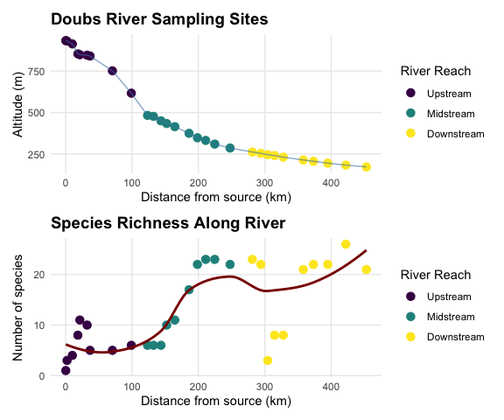

Non-metric Multidimensional Scaling (NMDS)
- What is NMDS?
  - Overview of NMDS:
    - Purpose: Visualize dissimilarity between objects in 2D/3D space
    - Goal: Preserve rank order of distances, not exact distances
    - Method: Iterative re-positioning to minimize stress
    - Output: Ordination plot showing relationships between samples
  - Key Differences from PCA:
    - Uses dissimilarity matrices (not covariance)
    - Non-parametric (rank-based)
    - Better for non-linear ecological relationships
    - No assumption about data distribution
- Before running NMDS - analyzing dissimilarity matrices not raw abundance data
  - dissimilarity matrix contains values for every pair of samples = “how different”
  - typically range from 0 (identical) to 1 (completely different).
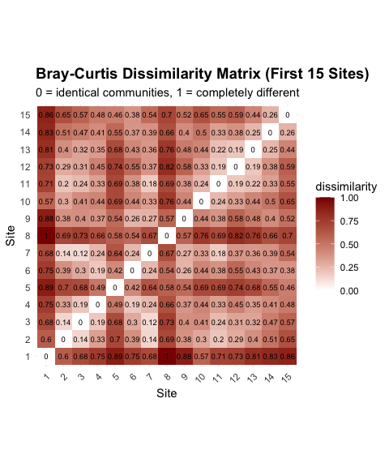

Why Bray-Curtis for Community Data?
- Bray-Curtis dissimilarity is standard choice for community data because it handles zeros appropriately (joint absences don’t contribute to similarity)
  - bounded between 0 and 1
  - weights by abundance (not just presence/absence) - ignores joint absences entirely
  - Similarity is based only on what’s actually present and shared between sites
  - performs well with sparse data
The formula is:
BCjk=i​|yij−yik|i​(yij+yik)
Where $y_{ij}$ is the abundance of species $i$ at site $j$
- numerator sums up the absolute differences in abundance for each species between two sites
- denominator sums up the total abundance at both sites
- Bray-Curtis asks: “Of all the individuals at these two sites, what proportion would need to be moved to make the sites identical?”

The NMDS Algorithm
- What NMDS Actually Does
  - NMDS tries to place samples in a low-dimensional space (usually 2D)
  - so rank order of distances in ordination matches rank order of dissimilarities in original matrix
- Not your PCA which preserves exact distances (or variance)
- NMDS only cares about relative ordering:
  - if site A is more similar to site B than to site C in the original data
  - then A should be closer to B than to C in the ordination

How NMDS Works step by step
- The NMDS Algorithm:
  - Calculate dissimilarity matrix between all pairs of sites
  - Start with random configuration of points in 2D space
  - Calculate stress = difference between original distances and ordination distances
  - Move points to reduce stress
  - Repeat until stress cannot be reduced further
  - Try multiple random starts to avoid local minima
- Stress Values:
  - < 0.1: Good representation
  - 0.1-0.2: Acceptable
  - > 0.2: Poor representation
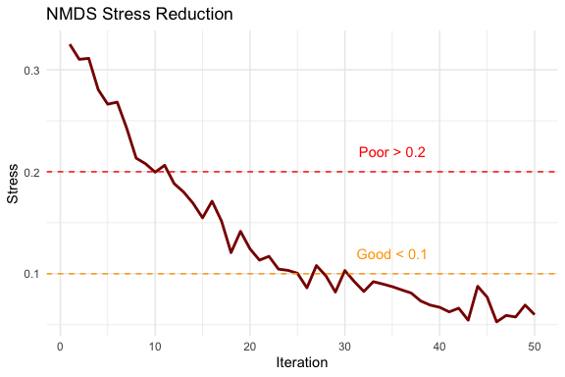

Understanding Stress
- What is Stress?
  - Stress is key diagnostic for NMDS quality
  - measures disagreement between original dissimilarities and distances in ordination
  - stress is calculated by first ranking all pairwise dissimilarities
  - then calculating corresponding distances in the ordination
  - fitting a monotonic regression line to the relationship between these
  - finally computing sum of squared deviations from this line.
- Lower stress means ordination better represents original relationships
- The Shepard Diagram: Visualizing Stress
  - Shepard diagram (or stress plot) is primary diagnostic tool for NMDS
  - shows relationship between original dissimilarities (x-axis) and ordination distances (y-axis) with a fitted monotonic line
  - If NMDS is working well - points should closely follow the line
  - Scatter indicates loss of information.
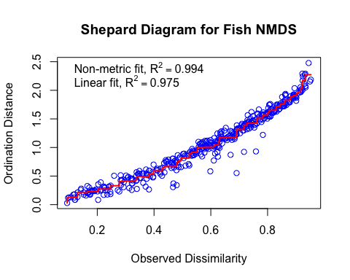

Interpreting the Shepard Diagram
- Shepard diagram
  - each point represents one pair of sites
  - x-axis shows their original Bray-Curtis dissimilarity
  - y-axis shows their distance in the 2D ordination
  - stepped line is a monotonic regression, = can only go up/stay flat not down
  - because NMDS preserves rank order - “stress” = scatter around line
- Insights from our Shepard diagram:
  - minimal scatter
- Stress Guidelines
  - Clarke (1993) widely-used guidelines for interpreting stress
    - <0.05 excellent representation w/no misinterpretation
    - 0.05 - 0.10 good ordination - no real risk of false inferences
    - 0.10 - 0.20 usable ordination but details at lower end interpreted cautiously
    - 0.20 and 0.30 used with caution/potentially higher dimensions considered
    - >0.30 = random placement.

Choosing the Number of Dimensions
- How do we know 2 dimensions is enough?
- create a scree plot showing stress for different numbers of dimensions:
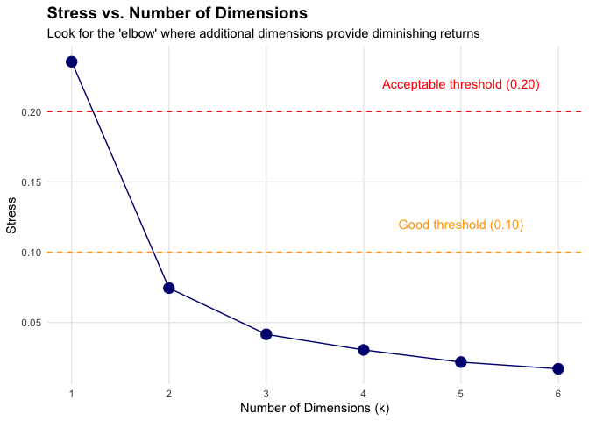

NMDS Assumptions
- NMDS Assumptions:
- ✅ Few assumptions:
  - Samples are independent
  - Dissimilarity measure is appropriate
  - Sufficient data for stable solution
- ❌ No assumptions about:
  - Data distribution
  - Linear relationships
  - Homoscedasticity
  - Normality
- This makes NMDS very robust for ecological data!
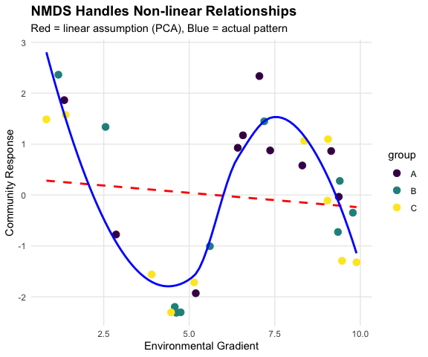

NMDS in Practice

Running NMDS on Fish Communities
# Prepare species data (remove site column)
spe_matrix <- doubs_spe %>% select(-site, -reach) %>% as.matrix()
# Add small constant to avoid issues with zeros
spe_matrix <- spe_matrix + 0.1
# Run NMDS with multiple random starts
set.seed(123)
fish_nmds <- metaMDS(spe_matrix, distance = "bray", # Bray-Curtis dissimilarity
k = 2, trymax = 100) # 2 dimensions + Maximum tries
## Run 0 stress 0.07449349
## Run 1 stress 0.1201175
## Run 2 stress 0.1201749
## Run 3 stress 0.1195174
## Run 4 stress 0.1201175
## Run 5 stress 0.1468615
## Run 6 stress 0.1395204
## Run 7 stress 0.09450578
## Run 8 stress 0.07460885
## ... Procrustes: rmse 0.02069815 max resid 0.09861179
## Run 9 stress 0.1273318
## Run 10 stress 0.1200159
## Run 11 stress 0.1273318
## Run 12 stress 0.07449349
## ... Procrustes: rmse 4.373445e-06 max resid 1.595028e-05
## ... Similar to previous best
## Run 13 stress 0.09450578
## Run 14 stress 0.140665
## Run 15 stress 0.07459993
## ... Procrustes: rmse 0.02014078 max resid 0.09796964
## Run 16 stress 0.1262615
## Run 17 stress 0.07460885
## ... Procrustes: rmse 0.02069823 max resid 0.09861196
## Run 18 stress 0.09134568
## Run 19 stress 0.07460885
## ... Procrustes: rmse 0.02069807 max resid 0.09861147
## Run 20 stress 0.07460885
## ... Procrustes: rmse 0.02069863 max resid 0.09861444
## *** Best solution repeated 1 times
cat("Final stress:", round(fish_nmds$stress, 3))
## Final stress: 0.074

NMDS in Practice
- Code Explanation:
- fish_nmds <- metaMDS(spe_matrix, distance = "bray", # Bray-Curtis dissimilarity
  - k = 2, trymax = 100) # 2 dimensions + Maximum tries
- metaMDS(): Main NMDS function from vegan package
  - distance = "bray": Bray-Curtis dissimilarity (best for abundances)
  - k = 2: Two dimensions for plotting
  - trymax = 100: Try 100 random starting configurations
  - Small constant added to avoid zero-distance issues
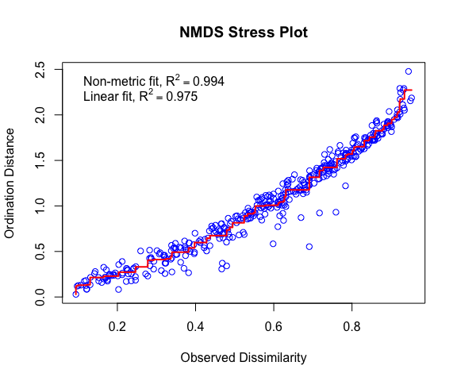

Interpreting NMDS Output
- Understanding the Output:
  - Stress = 0.074 : This is “excellent”
  - Our 2D representation preserves the original distances well
  - Convergent solutions: Found stable solutions from multiple tries
  - Two dimensions: Axis 1 and Axis 2 have no inherent meaning (unlike PCA components)
  - No eigenvalues: NMDS doesn’t calculate variance explained per axis
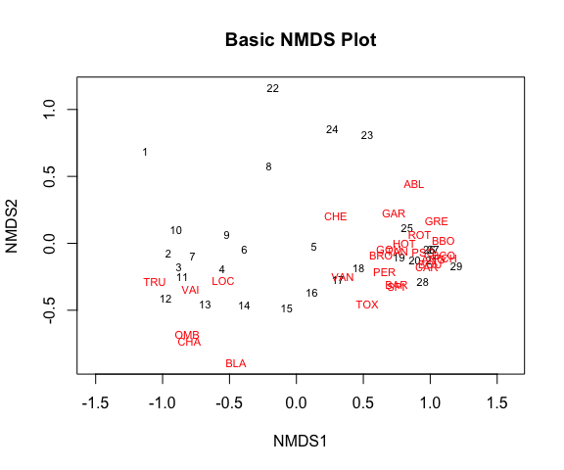

Creating Enhanced NMDS Plots
- What the NMDS Shows:
  - Clear separation between river reaches
  - Gradient pattern from upper to lower reaches
  - Sites within each reach are more similar to each other than to other reaches
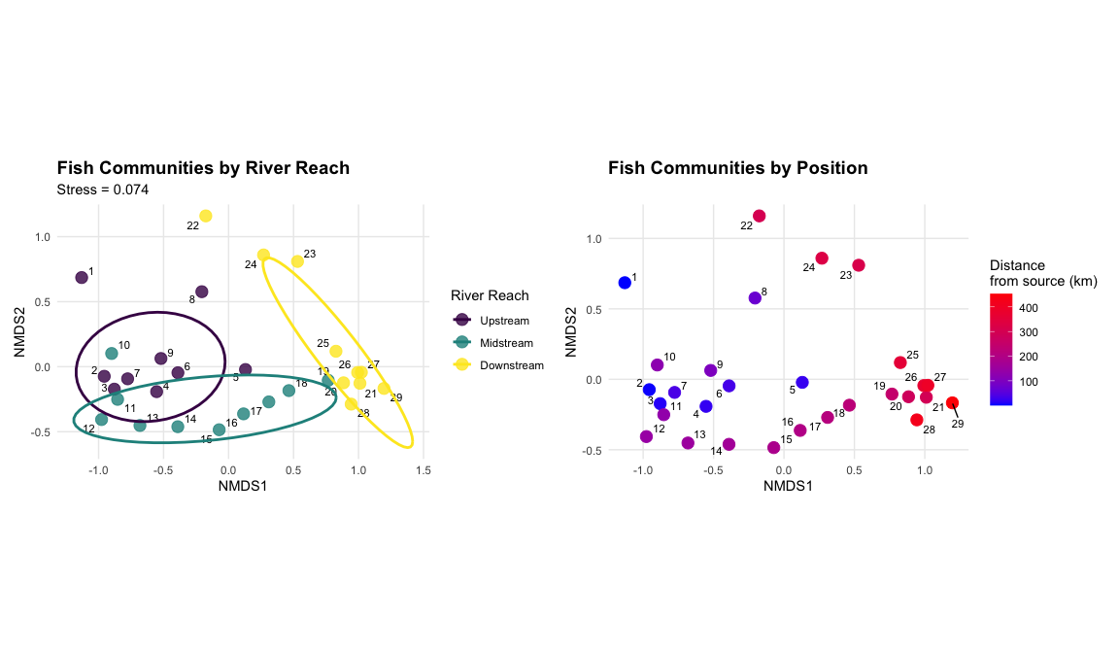

Different plot using the actual hull definitions from vegan
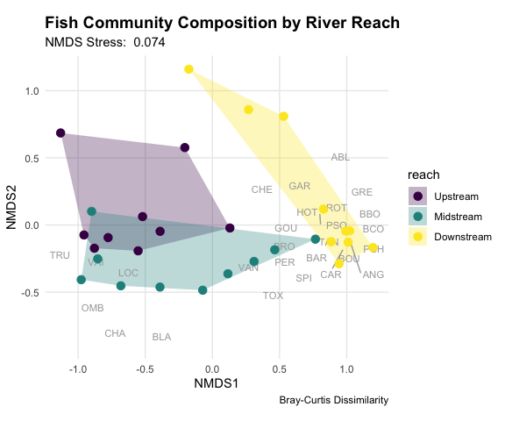

PERMANOVA: Testing Multivariate Differences
- What is PERMANOVA?
  - PERMANOVA (Permutational Multivariate ANOVA):
    - Purpose: Test whether groups have different multivariate centroids
    - Method: ANOVA using distance matrices instead of raw data
    - Advantage: No distributional assumptions
    - Permutation: Creates null distribution by randomly reassigning group labels
  - Think of it as:
    - Multivariate version of ANOVA
    - Uses distances between samples instead of means
    - Tests: “Are the centers of these groups different in multivariate space?” .
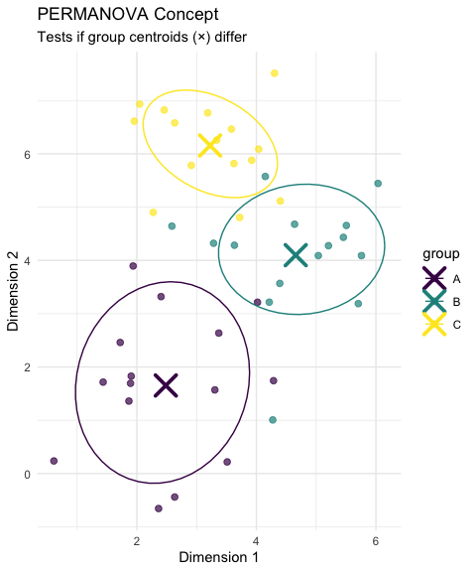

How PERMANOVA Works
- PERMANOVA Algorithm:
  - Calculate distance matrix between all pairs of samples
  - Calculate F-statistic based on distances:
    - Between-group sum of squares
    - Within-group sum of squares
  - Permute group labels randomly (e.g., 999 times)
  - Recalculate F-statistic for each permutation
  - Compare observed F to permutation distribution
  - P-value = proportion of permuted F ≥ observed F
- Why permutation?
  - No assumptions about data distribution
  - Creates empirical null distribution
  - Accounts for complex dependency structures
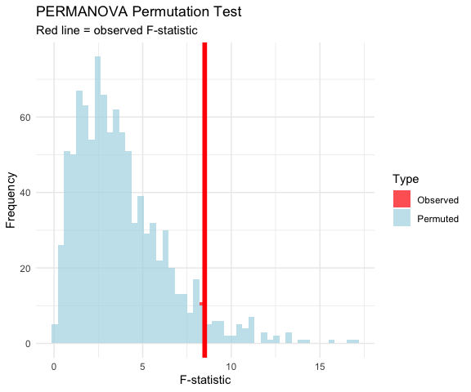

PERMANOVA Hypotheses
- Research Question: “Do fish communities differ significantly between river reaches?”
- Statistical Hypotheses:
  - H₀: The centroids of fish communities are the same across all river reaches (Upper = Middle = Lower)
  - H₁: At least one river reach has a different community centroid
- In practical terms: -
  - H₀: River position doesn’t affect community composition
  - H₁: River position significantly affects community composition
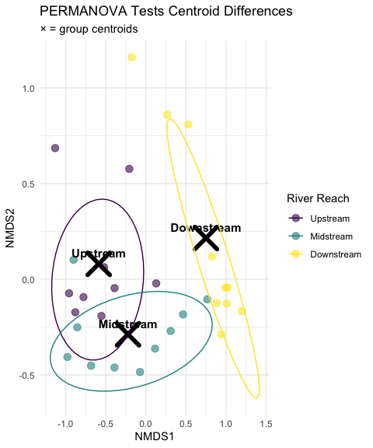

PERMANOVA Assumptions
- PERMANOVA Assumptions:
- ✅ Required:
  - Independence: Samples are independent
  - Exchangeability: Under H₀, observations are exchangeable between groups
  - Homogeneity of dispersion: Groups have similar multivariate spread
- ❌ Not required:
  - Normality or other distribution
  - Linearity
- Checking Assumptions:
  - Use betadisper() to test homogeneity of dispersion
  - If violated, PERMANOVA is testing dispersion differences and not location differences
## Homogeneity of dispersion test p-value: 0.8037
- vegan::betadisper() converts bray-curtis to euclidean distances to calculate distance from sample to center
- Principal Coordinates Analysis (PCoA) - ordination for distances between samples in a low-dimensional, Euclidean space
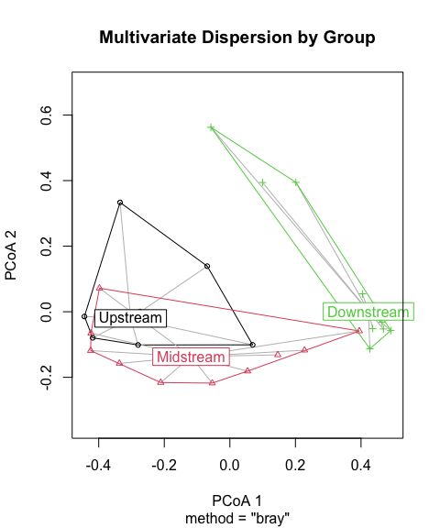

Running PERMANOVA
- PERMANOVA on Fish Communities
  - Line-by-line interpretation:
    - reach: The factor being tested (river reach)
    - Df = 2: Degrees of freedom (3 groups - 1)
    - SumOfSqs: Between-group sum of squares
    - R2: Proportion of variance explained by reach
    - F: F-statistic (ratio of between/within group variation)
    - Pr(>F): P-value from permutation test
## Permutation test for adonis under reduced model
## Permutation: free
## Number of permutations: 999
##
## adonis2(formula = spe_matrix ~ reach, data = doubs_env, permutations = 999, distance = "bray")
## Df SumOfSqs R2 F Pr(>F)
## Model 2 2.3631 0.42634 9.6614 0.001 ***
## Residual 26 3.1798 0.57366
## Total 28 5.5429 1.00000
## ---
## Signif. codes: 0 '***' 0.001 '**' 0.01 '*' 0.05 '.' 0.1 ' ' 1
- What this means:
  - Significant result (p < 0.001): We reject H₀
  - River reach explains substantial variation in fish communities
  - Fish communities differ significantly between river reaches
  - Very few permutations gave F ≥ observed F

Pairwise PERMANOVA Tests
- Interpretation of Pairwise Results:
  - All pairwise comparisons are statistically significant even after Bonferroni correction
  - Upper vs Lower shows the strongest difference (highest F-statistic)
  - Downstream comparisons to up and middle explains a substantial portion of variance (R² > 0.3)
  - Biological interpretation: Fish communities change progressively down the river
## pairs Df SumsOfSqs F.Model R2 p.value p.adjusted
## 1 Upstream vs Midstream 1 0.4068962 3.434528 0.1680747 0.021 0.063
## 2 Upstream vs Downstream 1 1.8495110 15.490360 0.4767679 0.001 0.003
## 3 Midstream vs Downstream 1 1.2829784 9.972485 0.3565105 0.001 0.003
## sig
## 1
## 2 *
## 3 *

Visualizing PERMANOVA Results
Results:
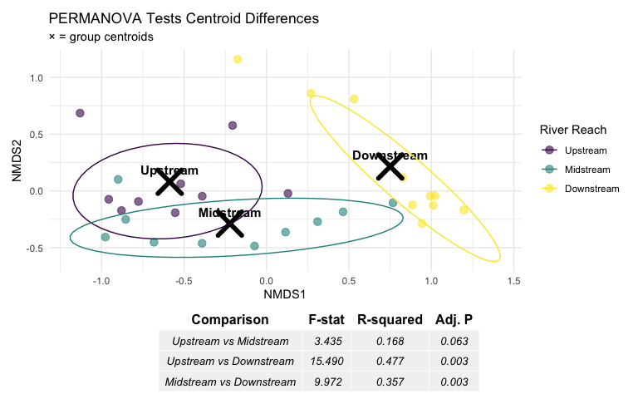

ANOSIM: Analysis of Similarities
- ANOSIM (Analysis of Similarities):
  - Purpose: are samples w/in groups are more similar than samples between groups
  - Method: Based on rank dissimilarities
  - Statistic: R-statistic ranging from -1 to +1
  - Interpretation:
    - R ≈ 1: Groups are completely separated
    - R ≈ 0: Groups are indistinguishable
    - R < 0: More dissimilarity within groups than between
- Differences from PERMANOVA:
  - ANOSIM uses ranks of distances
  - PERMANOVA uses actual distances
  - ANOSIM is more robust but less powerful
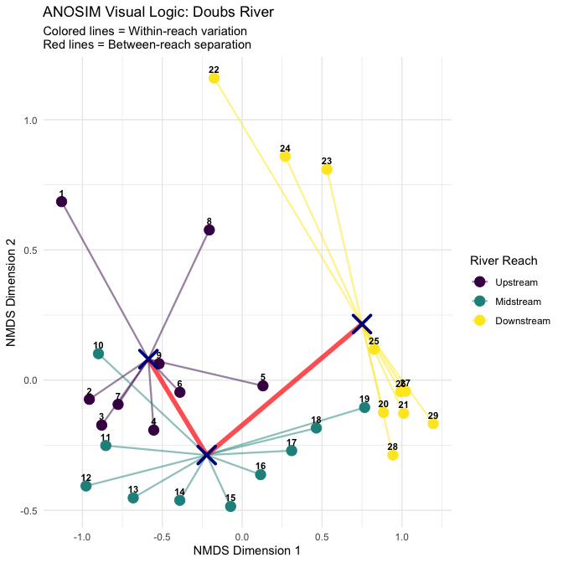

How ANOSIM Works
- ANOSIM Algorithm:
  - Calculate dissimilarity matrix between all samples
  - Rank all dissimilarities from smallest to largest
  - Calculate mean rank of within-group dissimilarities (r̄w)
  - Calculate mean rank of between-group dissimilarities (r̄b)
  - Compute R-statistic: R = (r̄b - r̄w) / (N(N-1)/4) where N = total number of samples
  - Permute group labels and recalculate R many times
  - P-value = proportion of permuted R ≥ observed R
- R-statistic interpretation:
  - R = 1: Perfect separation
  - R = 0: No separation
  - R = -1: More similar between groups than within
# Run ANOSIM
anosim_result <- anosim(spe_matrix, doubs_env$reach,
distance = "bray", permutations = 999)
# Display results
anosim_result
##
## Call:
## anosim(x = spe_matrix, grouping = doubs_env$reach, permutations = 999, distance = "bray")
## Dissimilarity: bray
##
## ANOSIM statistic R: 0.5082
## Significance: 0.001
##
## Permutation: free
## Number of permutations: 999

Running ANOSIM
- ANOSIM Results Interpretation:
  - R = 0.5082 : This indicates “good” separation between groups
  - **p-value = 0.001 - significant result
  - Biological meaning: Fish communities well-separated between river reaches, with communities within each reach being much more similar to each other than to communities in other reaches
- “Within” box is clearly lower than the “Between” box
  - sites within same river reach tend to be more similar to each other (lower dissimilarity ranks) than sites in different reaches (higher dissimilarity ranks)
  - R statistic of 0.51 quantifies this separation
    - there’s clear differentiation, but with some overlap.
- Interpreting R:
  - R = 1 - Complete separation
    - all within-group dissimilarities smaller than between-group dissimilarities
  - R > 0.75 Well separated
  - R > 0.5 Separated, but overlapping
  - R > 0.25 Barely separated
  - R ≈ 0 No difference between groups
- 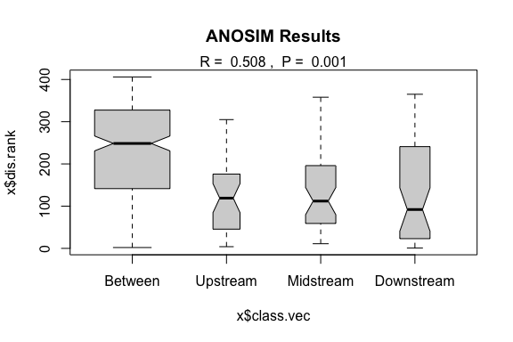

ANOSIM vs PERMANOVA Comparison
## # A tibble: 2 × 6
## Method `Test Statistic` `P-value` Interpretation `What it tests` Approach
## <chr> <chr> <dbl> <chr> <chr> <chr>
## 1 PERMANOVA F = 9.66 0.001 Groups have dif… Differences in… Uses ac…
## 2 ANOSIM R = 0.508 0.001 Excellent group… Overlap betwee… Uses ra…

ANOSIM vs PERMANOVA Comparison
- When to use which:
  - PERMANOVA:
    - More powerful for detecting differences
    - Better for complex experimental designs
    - Can handle interactions and covariates
    - Preferred for most applications
  - ANOSIM:
    - More robust to outliers
    - Simpler interpretation
    - Good for initial exploratory analysis
    - Useful when distributions are very non-normal

PERMANOVA vs ANOSIM
- What’s the Difference? Three Scenarios
- Both methods test whether groups differ, but they ask different questions:
  - PERMANOVA asks: Do the group centroids differ in location?
    - Uses actual squared distances and partitions variance like ANOVA
  - ANOSIM asks: Are within-group dissimilarities smaller than between-group?
    - Uses ranked distances to compares rank distributions
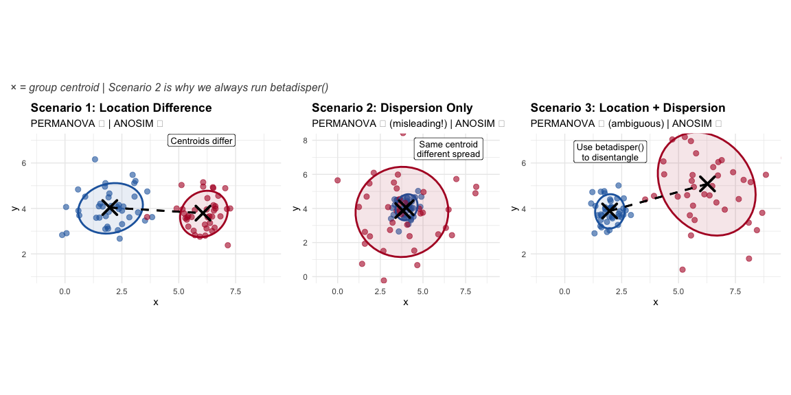

Scenario 2 is Key!
- The Problem:
  - Groups A and B have the same centroid (same average community)
  - But Group B is much more variable (spread out)
  - PERMANOVA will detect this as “significant”!
- Why?
  - PERMANOVA tests distances from points to centroids
  - More spread = larger distances = detected as “different”
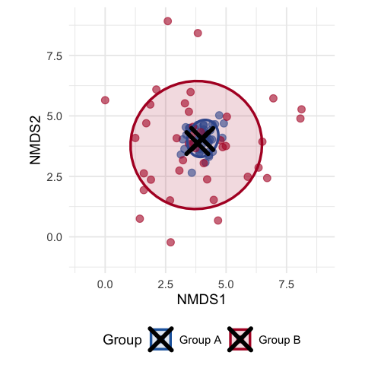

Dispersion test for PERMANOVA
- Solution: Always run betadisper() before interpreting PERMANOVA!
  - What PERMANOVA “Sees”
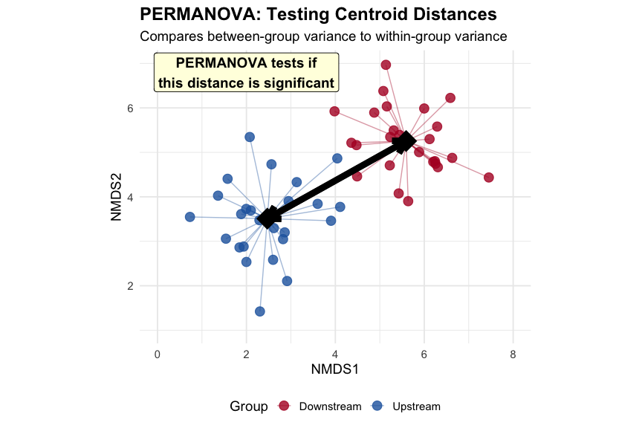

What ANOSIM “Sees”
- This is different
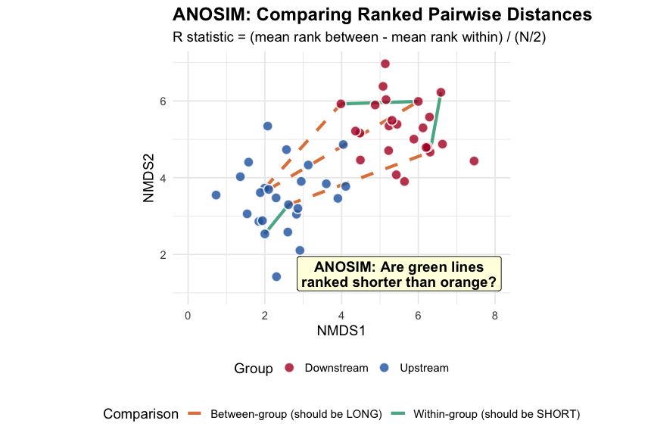

Side-by-Side Comparison of PCA and ANOSIM
Comparison
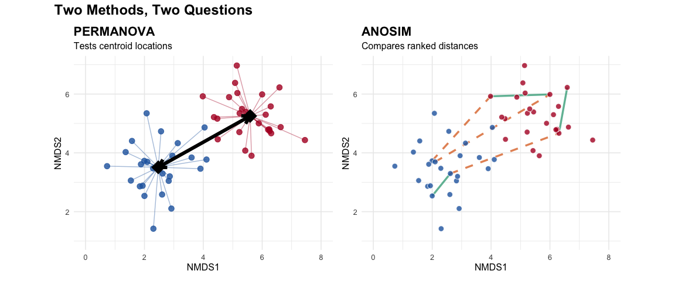

Environmental Drivers
- Environmental Vector Results:
  - Which Environmental Variables Matter?
  - Significant variables (p < 0.05):
- What this means:
  - variables significantly correlate w/ comm. comp
  - explain spatial arrangement of sites in NMDS
- arrows show direction of max change for env. variables
  - Longer arrows = stronger correlations with ordination
  - Arrow direction = sites have high vs. low values of variable
- distance from source (das) and altitude (alt) point opp. directions
  - (expected - altitude decreases as distance increases)
- Oxygen (oxy) decreases downstream
- BOD (dbo) increases downstream = more org. pollution
##
## ***VECTORS
##
## NMDS1 NMDS2 r2 Pr(>r)
## das 0.98098 0.19411 0.7284 0.001 ***
## alt -1.00000 -0.00057 0.5650 0.001 ***
## pen -0.61902 0.78538 0.2546 0.026 *
## deb 0.99744 -0.07146 0.5701 0.001 ***
## pH -0.09760 -0.99523 0.0746 0.374
## dur 0.99967 -0.02575 0.2960 0.008 **
## pho 0.22860 0.97352 0.5228 0.001 ***
## nit 0.66665 0.74537 0.5200 0.001 ***
## amm 0.19902 0.98000 0.5471 0.002 **
## oxy -0.46402 -0.88583 0.7826 0.001 ***
## dbo 0.20211 0.97936 0.6883 0.001 ***
## ---
## Signif. codes: 0 '***' 0.001 '**' 0.01 '*' 0.05 '.' 0.1 ' ' 1
## Permutation: free
## Number of permutations: 999
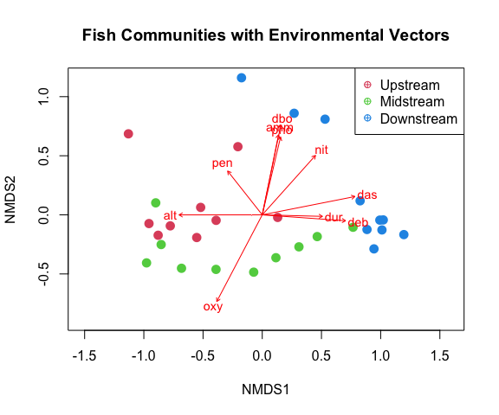

Environmental Gradient Analysis
- Key Environmental Patterns:
  - Distance from source (das): Strong correlate with community change
  - Oxygen (oxy): Decreases downstream, affects fish communities
  - Biological oxygen demand (dbo): Increases downstream (pollution indicator)
  - Altitude (alt): Decreases downstream, associated with temperature changes
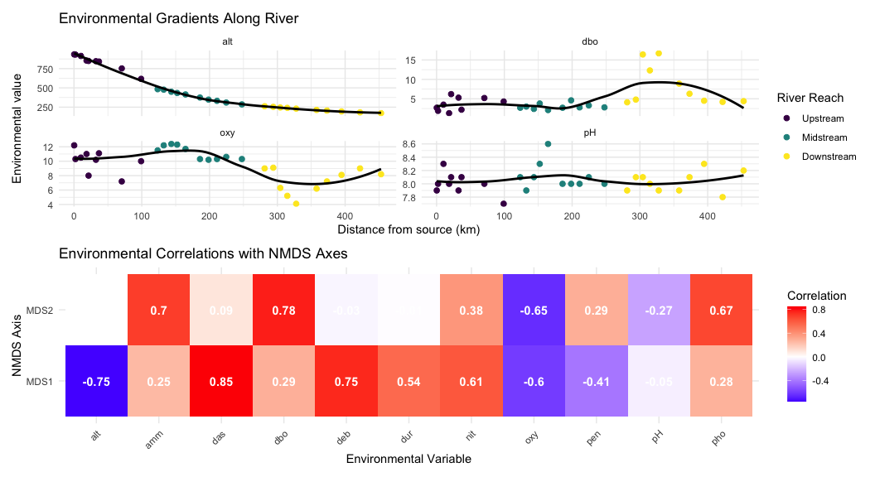

Summary and Conclusions
- Key Findings
- NMDS Results:
  - Stress =: Excellent representation
  - Clear gradient from upper to lower river reaches
  - Within-reach similarity greater between-reach similarity
- PERMANOVA Results:
  - Highly significant differences between reaches (p < 0.001)
  - River reach explains substantial variance in community composition
  - All pairwise comparisons significant after correction
- ANOSIM Results:
  - R = 0.508 p = 0.001 : Excellent separation
  - Confirms PERMANOVA findings with different approach
  - Strong within-group coherence
- Environmental Drivers:
  - Distance from source: Primary gradient
  - Dissolved oxygen: Decreases downstream
  - Biological oxygen demand: Increases downstream
  - Multiple correlated factors drive community change
- Biological Interpretation:
  - River continuum concept supported
  - Progressive community change from source to mouth
  - Environmental filtering shapes community assembly
  - Pollution gradient evident in lower reaches

Take-Home
- NMDS (Non-metric Multidimensional Scaling):
  - Visualizes community dissimilarity in 2D/3D
  - Preserves rank order of distances (non-metric)
  - No distributional assumptions
  - Stress < 0.2 for acceptable solutions
  - Great for exploring ecological gradients
- PERMANOVA (Permutational MANOVA):
  - Tests for differences in group centroids
  - Uses distance matrices, not raw data
  - No distributional assumptions
  - Can handle complex designs
  - Check dispersion homogeneity assumption
- ANOSIM (Analysis of Similarities):
  - Tests group separation using rank distances
  - R-statistic: -1 (no separation) to +1 (complete)
  - More robust to outliers than PERMANOVA
  - Simpler but less powerful
  - Good for exploratory analysis
- Environmental Drivers:
  - Use envfit() to correlate environment with ordination
  - Identifies which variables explain community patterns
  - Helps understand ecological mechanisms
  - Essential for management implications

