# **Lecture 1: Syllabus**

* Please look over the syllabus as it has all the details of the class and how it will run.

# **Lecture 1:** Who am I?

* Bill Perry
* Office is in SSB 13
* Phone 218-726-8145
* Email is wlperry_at_d.umn.edu

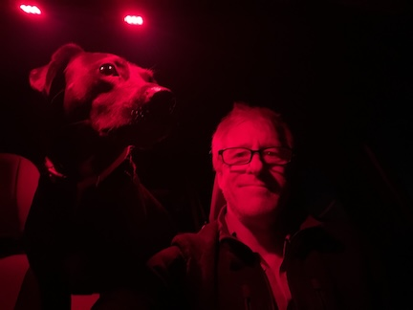

# Lecture 1: My goals

* How do we make observations and hypotheses?
* How do we design an experiment
* How do we collect data?
* How do we organize, clean, summarize, and view the data?
* How do we use statistics to test our hypotheses
  + what tests to use
  + what are the assumptions
  + what are the interpretations

# Lecture 1: My expectations

* Communication
* Practice
* Failure
* Learn to correct and troubleshoot

# **Lecture 1: Science**

* Way to acquire knowledge, organize it and apply it back to the real world
* Make predictions and testing these predictions using a falsifiable approach - statistics
* Explanations that cannot be falsified are not science

# What is Statistics?

Zar (1999) - “analysis and interpretation of data with view towards objective evaluation of conclusions based on the data”

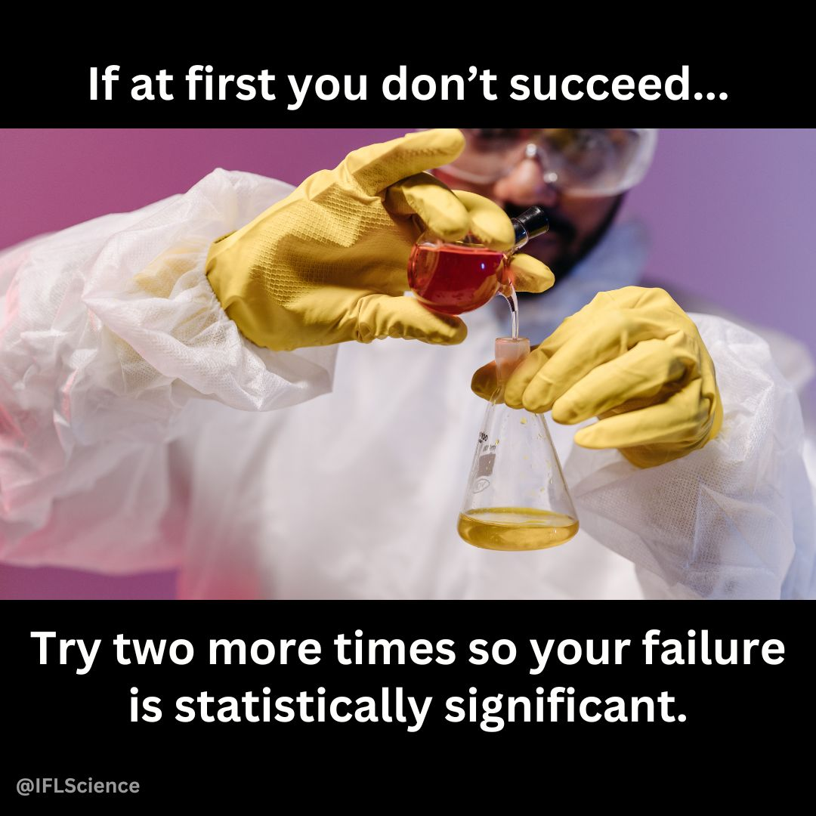

# **Lecture 1:** Inductive reasoning (Specific → General)

### **Inductive Reasoning (Specific → General)**

Inductive reasoning involves observing specific cases and using them to form a general conclusion.

**Example:**

1. Measure **10 pine needles** from a tree - average length is **75 mm**.
2. Measure **10 more needles** from the same tree and gets similar results.
3. Measures needles from second tree - average length is **120 mm** .
4. You **generalize** pine needles from different trees **vary in length**, but each tree tends to have a characteristic range.

**Conclusion (Induction):** *“Pine needle length varies by tree, but each tree seems to have a typical range of lengths.*

**Potential Issue:** Conclusion is **not guaranteed** to be true - based on patterns observed in a sample, and there could be exceptions.

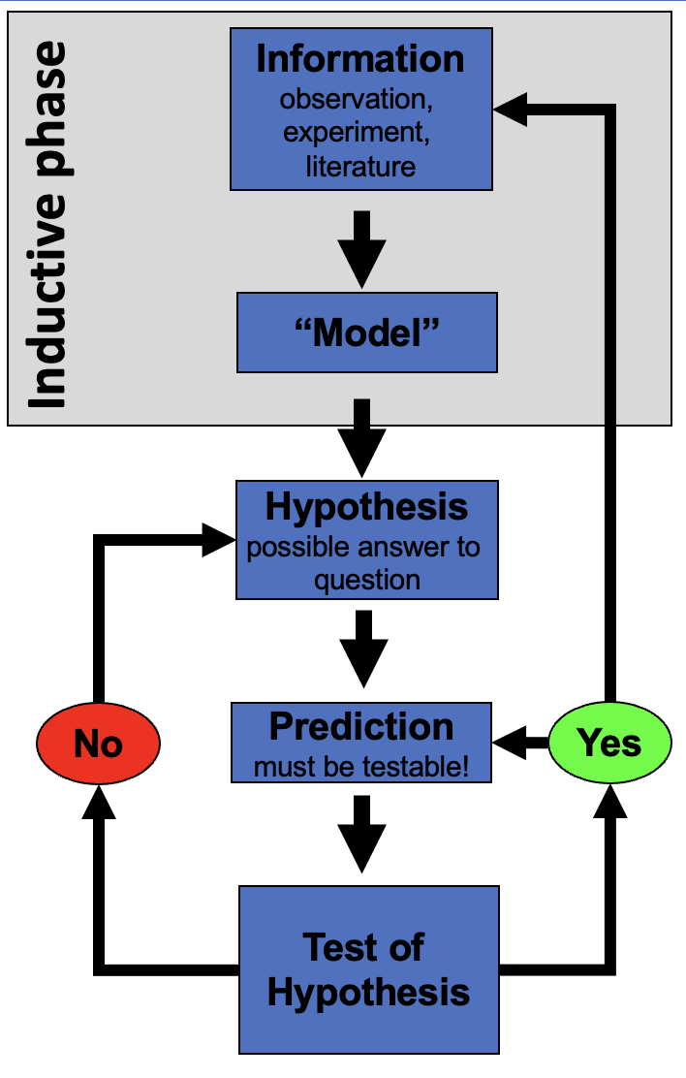

# **Lecture 1:** Deductive reasoning (General → Specific)

### **Deductive Reasoning (General → Specific)**

Deductive reasoning starts with a general principle and applies it to a specific case.

**Example:**

1. **General Principle:** *Pine needles from a species of pine tree have a predictable length range (e.g., 70–80 mm).*
2. **Specific Case:** Collect sample of pine needles and measure them.
3. **Prediction:** Since its the species the needle lengths **should** fall within 70–80 mm.
4. **Measurement:** Check the data and confirm needles fall within this expected range.

**Conclusion (Deduction):** *“This tree belongs the species with a needle length range of 70–80 mm, we expect its needle lengths to fall in this range.”*

**Stronger than induction** because it’s based on a general rule—but if the assumption (length range) is incorrect, conclusion could still be wrong.

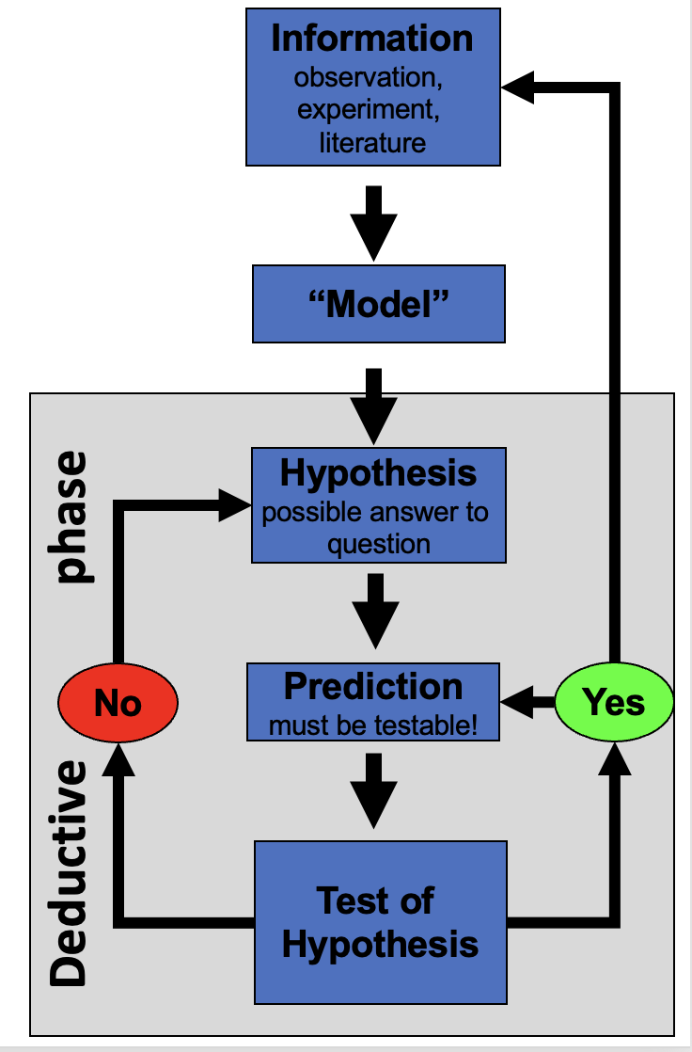

# **Lecture 1:** Reality of reasoning

### **In reality we are doing both of these processes**



# How do we test hypotheses

### Statistics

* Design good experiments
* Design good tests
* Summarize patterns/data
* Use to make probabilistic determinations to see if differences are “real”

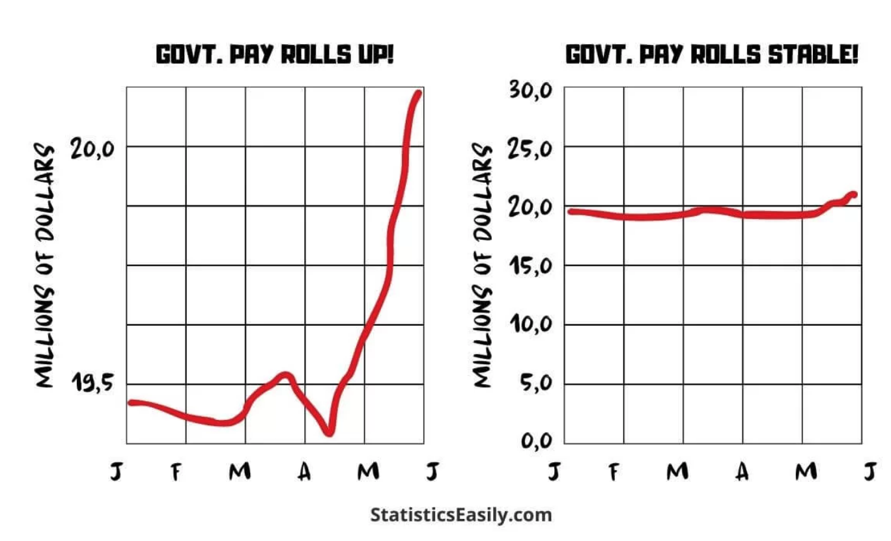

# Data Types

* **Continuous**
  + numeric
* **Discrete**
  + integer or numerical
* **Categorical**
  + nominal – up, down, right, left…
  + ordinal – order - a, b, c, d or morning, afternoon, evening

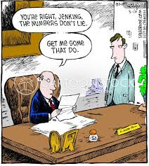

# Measurements

Data is obtained through measurement

The world is a messy place and how you measure matters

Our measures depend on

* **accuracy** - how close we are to the real value
* **precision** - how close all our measurements are but may not be precise

