06_Class_Activity

Bill Perry

# In class activity 6:

## What did we do last time in activity 5?

* Understanding standard normal distributions and z-scores
* Calculating and interpreting standard error
* Creating confidence intervals
* Working with the Student’s t-distribution

## Today’s focus:

* Review more r code
* understand α alpha and **β** beta errors
* do more
  + 1 sample t tests
  + 2 sample t tests

# Goes with Lecture 6

# Install packages if needed (uncomment if necessary)  
# install.packages("readr")  
# install.packages("tidyverse")  
# install.packages("car")  
# install.packages("here")  
  
# Load libraries  
library(patchwork)  
library(car) # For diagnostic tests

Loading required package: carData

library(tidyverse) # For data manipulation and visualization

── Attaching core tidyverse packages ──────────────────────── tidyverse 2.0.0 ──  
✔ dplyr 1.1.4 ✔ readr 2.1.5  
✔ forcats 1.0.0 ✔ stringr 1.5.1  
✔ ggplot2 3.5.2 ✔ tibble 3.3.0  
✔ lubridate 1.9.4 ✔ tidyr 1.3.1  
✔ purrr 1.1.0

── Conflicts ────────────────────────────────────────── tidyverse_conflicts() ──  
✖ dplyr::filter() masks stats::filter()  
✖ dplyr::lag() masks stats::lag()  
✖ dplyr::recode() masks car::recode()  
✖ purrr::some() masks car::some()  
ℹ Use the conflicted package (<http://conflicted.r-lib.org/>) to force all conflicts to become errors

# Load the pine needle data  
# Use here() function to specify the path  
pine_data <- read_csv("data/pine_needles.csv")

Rows: 48 Columns: 6  
── Column specification ────────────────────────────────────────────────────────  
Delimiter: ","  
chr (4): date, group, n_s, wind  
dbl (2): tree_no, length_mm  
  
ℹ Use `spec()` to retrieve the full column specification for this data.  
ℹ Specify the column types or set `show_col_types = FALSE` to quiet this message.

# Examine the first few rows  
head(pine_data)

# A tibble: 6 × 6  
 date group n_s wind tree_no length_mm  
 <chr> <chr> <chr> <chr> <dbl> <dbl>  
1 3/20/25 cephalopods n lee 1 20  
2 3/20/25 cephalopods n lee 1 21  
3 3/20/25 cephalopods n lee 1 23  
4 3/20/25 cephalopods n lee 1 25  
5 3/20/25 cephalopods n lee 1 21  
6 3/20/25 cephalopods n lee 1 16

# **Part 1:** Exploratory Data Analysis

Before conducting hypothesis tests, we should always explore our data to understand its characteristics.

Let’s calculate summary statistics and create visualizations.

**Activity: Calculate basic summary statistics for pine needle length**

# YOUR TASK: Calculate summary statistics for pine needle length  
# Hint: Use summarize() function to calculate mean, sd, n, etc.  
  
# Create a summary table for all pine needles  
pine_summary <- pine_data %>%  
 group_by(wind) %>%   
 summarize(  
 mean_length = mean(length_mm, na.rm=TRUE),  
 sd_length = sd(length_mm, na.rm=TRUE),  
 n = sum(!is.na(length_mm)),  
 se_length = sd_length / (n^0.5),  
 t_critical = qt(0.975, df = n - 1), # 95% CI uses 0.975 (two-tailed)  
 ci_lower = mean_length - t_critical * se_length,  
 ci_upper = mean_length + t_critical * se_length  
 )  
  
print(pine_summary)

# A tibble: 2 × 8  
 wind mean_length sd_length n se_length t_critical ci_lower ci_upper  
 <chr> <dbl> <dbl> <int> <dbl> <dbl> <dbl> <dbl>  
1 lee 20.4 2.45 24 0.500 2.07 19.4 21.5  
2 wind 14.9 1.91 24 0.390 2.07 14.1 15.7

# Now calculate summary statistics by wind exposure  
# YOUR CODE HERE

# **Part 1:** Visualizing the Data

**Activity: Create visualizations of pine needle length**

Create a histogram and a boxplot to visualize the distribution of pine needle length values.

Effective data visualization helps us understand:

* The central tendency
* The spread of the data
* Potential outliers
* Shape of distribution

# Your Task

# YOUR TASK: Create a histogram of pine needle length  
# Hint: Use ggplot() and geom_histogram()  
  
# Histogram of all pine needle lengths  
ggplot(pine_data, aes(x = length_mm)) +  
 geom_histogram(binwidth = 2, fill = "steelblue", color = "black") +  
 labs(title = "Distribution of Pine Needle Length",  
 x = "Length (mm)",  
 y = "Frequency") +  
 theme_minimal()

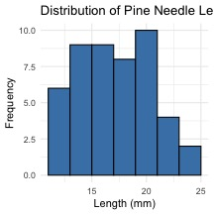

# how can you do this by wind to see both plots

# Boxplot of pine needle length by wind exposure  
# YOUR CODE HERE

# Can you plot the density distributions for the two samples

# Histogram of all pine needle lengths  
pine_data %>%   
 ggplot(aes(x = length_mm, fill=wind)) +  
 geom_density(color = "black", alpha=0.3, trim = TRUE) +  
 labs(title = "Pine Needle Lengths by Wind Exposure",  
 x = "Position",  
 y = "Length (mm)",  
 fill = "Wind Position") +  
  
 scale_fill_manual(values = c("lee" = "forestgreen", "wind" = "skyblue"),  
 labels = c("lee" = "Leeward", "wind" = "Windward"))

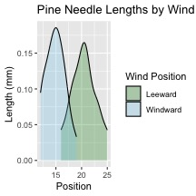

# what is the Effect size or difference in means?

|  |
| --- |
| Practice Exercise: Calculate Effect size |
| We could also look at the difference in means… some cool code here  # Assuming your dataframe is called df pine_summary %>%  summarize(difference = mean_length[wind == "lee"] -mean_length[wind == "wind"])  # A tibble: 1 × 1  difference  <dbl> 1 5.5 |

# **Part 1:** Two Sample T-Test

Now, let’s compare pine needle lengths between windward and leeward sides of trees.

Question: **Is there a significant difference in needle length between the windward and leeward sides?**

This requires a two-sample t-test.

Two-sample t-test compares means from two independent groups.

$t=\frac{{\overset{‾}{x}}_{1}−{\overset{‾}{x}}_{2}}{S_{p}\sqrt{\frac{1}{n_{1}}+\frac{1}{n_{2}}}}$

where:

* x̄₁ and x̄₂: These represent the sample means of the two groups you’re comparing
* s²ₚ: This is the pooled variance, calculated as: s²ₚ = [(n₁ - 1)s₁² + (n₂ - 1)s₂²] / (n₁ + n₂ - 2), where s₁² and s₂² are the sample variances of the two groups.
* **n₁ and n₂:** These are the sample sizes of the two groups.
* **√(1/n₁ + 1/n₂):** This represents the pooled standard error.

# **Part 1:** Testing Assumptions for Two-Sample T-Test

**Activity: Test assumptions for two-sample t-test**

For a two-sample t-test, we need to check:

1. Normality within each group
2. Equal variances between groups (for standard t-test)
3. Independent observations

If assumptions are violated:

* Welch’s t-test (unequal variances)
* Non-parametric alternatives (Mann-Whitney U test)

# Your task

# YOUR TASK: Test normality of windward pine needle lengths  
# QQ Plot  
qqPlot(pine_data$length_mm,   
 main = "QQ Plot for Windward Pine Needles",  
 ylab = "Sample Quantiles")

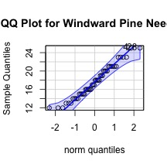

[1] 4 28

# Testing normality for each group  
# Leeward group  
lee_data <- pine_data %>% filter(wind == "lee")  
shapiro_lee <- shapiro.test(lee_data$length_mm)  
print("Shapiro-Wilk test for leeward data:")

[1] "Shapiro-Wilk test for leeward data:"

print(shapiro_lee)

Shapiro-Wilk normality test  
  
data: lee_data$length_mm  
W = 0.95477, p-value = 0.3425

# windward group

# Windward group  
# YOUR CODE HERE for windward group normality test

# Remember you can always do it in one go

# there are always two ways  
# Test for normality using Shapiro-Wilk test for each wind group  
# All in one pipeline using tidyverse approach  
normality_results <- pine_data %>%  
 group_by(wind) %>%  
 summarize(  
 shapiro_stat = shapiro.test(length_mm)$statistic,  
 shapiro_p_value = shapiro.test(length_mm)$p.value,  
 normal_distribution = if_else(shapiro_p_value > 0.05, "Normal", "Non-normal")  
 )  
  
# Print the results  
print(normality_results)

# A tibble: 2 × 4  
 wind shapiro_stat shapiro_p_value normal_distribution  
 <chr> <dbl> <dbl> <chr>   
1 lee 0.955 0.343 Normal   
2 wind 0.961 0.451 Normal

# Conduct a Levene’s Test

# Test for equal variances  
# YOUR TASK: Conduct Levene's test for equality of variances  
levene_test <- leveneTest(length_mm ~ wind, data = pine_data)

Warning in leveneTest.default(y = y, group = group, ...): group coerced to  
factor.

print(levene_test)

Levene's Test for Homogeneity of Variance (center = median)  
 Df F value Pr(>F)  
group 1 1.2004 0.2789  
 46

# Visual check for normality with QQ plots  
# YOUR CODE HERE

# **Part 2:** Conducting the Two-Sample T-Test

**Activity: Conduct a two-sample t-test**

Now we can compare the mean pine needle lengths between windward and leeward sides.

H₀: μ₁ = μ₂ (The mean needle lengths are equal)

H₁: μ₁ ≠ μ₂ (The mean needle lengths are different)

Deciding between:

* Standard t-test (equal variances)
* Welch’s t-test (unequal variances)

# Based on our Levene’s test result.

# YOUR TASK: Conduct a two-sample t-test  
# Use var.equal=TRUE for standard t-test or var.equal=FALSE for Welch's t-test  
  
# Standard t-test (if variances are equal)  
t_test_result <- t.test(length_mm ~ wind, data = pine_data, var.equal = TRUE)  
print("Standard two-sample t-test:")

[1] "Standard two-sample t-test:"

print(t_test_result)

Two Sample t-test  
  
data: length_mm by wind  
t = 8.6792, df = 46, p-value = 3.01e-11  
alternative hypothesis: true difference in means between group lee and group wind is not equal to 0  
95 percent confidence interval:  
 4.224437 6.775563  
sample estimates:  
 mean in group lee mean in group wind   
 20.41667 14.91667

# Calculate t-statistic manually (optional - uggg - maybe )  
# YOUR CODE HERE: t = (mean1 - mean2) / sqrt((s1^2/n1) + (s2^2/n2))

# **Part 2:** Interpreting and Reporting Two-Sample T-Test Results

**Activity: Interpret the results of the two-sample t-test**

What can we conclude about the needle lengths on windward vs. leeward sides?

**How to report this result in a scientific paper:**

“A two-tailed, two-sample t-test at α=0.05 showed [a significant/no significant] difference in needle length between windward (M = …, SD = …) and leeward (M = …, SD = …) sides of pine trees, t(…) = …, p = ….”

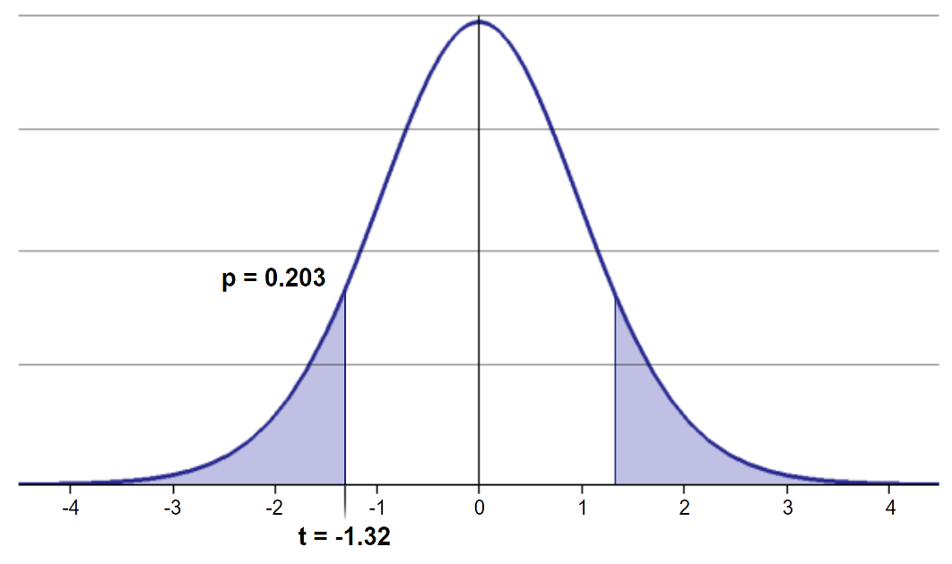

# What is Power

Statistical power represents the probability of detecting a true effect (rejecting the null hypothesis when it is false). In this case, with a power of 97%, there’s a 97% chance of detecting a true difference of 30 units between the means of the two groups if such a difference actually exists.

A power analysis like this is typically done for one of these purposes:

1. Before data collection to determine required sample size
2. After a study to evaluate if the sample size was adequate
3. To determine the minimum detectable effect size with the given sample

With 97% power, this test has excellent ability to detect the specified effect size. Generally, **80% power is considered acceptable**, so 97% indicates a very well-powered study for detecting a difference of 30mm between the groups.

lee_df <- pine_data %>% filter(wind == "lee")  
wind_df <- pine_data %>% filter(wind == "wind")  
# Calculate power for detecting a 1 mm difference  
wind_diff = 1  
  
lee_n <- nrow(lee_df)  
wind_n <- nrow(wind_df)  
  
wind_sd_pooled <- sqrt((var(lee_df$length_mm) * (lee_n-1) +   
 var(wind_df$length_mm) * (wind_n-1)) /   
 (lee_n + wind_n - 2))  
  
# Calculate power  
wind_effect_size <- wind_diff / wind_sd_pooled # Cohen's d  
wind_df <- lee_n + wind_n - 2  
wind_alpha <- 0.05  
wind_power <- power.t.test(n = min(lee_n,wind_n),   
 delta = wind_effect_size,  
 sd = 1, # Using standardized effect size  
 sig.level = 0.5,  
 type = "two.sample",  
 alternative = "two.sided")  
  
# Display results  
wind_power

Two-sample t test power calculation   
  
 n = 24  
 delta = 0.4555423  
 sd = 1  
 sig.level = 0.5  
 power = 0.8158402  
 alternative = two.sided  
  
NOTE: n is number in *each* group

# Now to make a final plot

Typically we will make a plot that has the mean and standard error on it to represent the data

## your Task is to make this plot

pine_mean_se <- pine_data %>%   
 ggplot(aes(wind, length_mm, color = wind))+  
 stat_summary(fun = "mean", na.rm=TRUE, geom="point", size = 3)+  
 stat_summary(fun.data = "mean_se", width = 0.2, geom = "errorbar")  
  
pine_mean_se

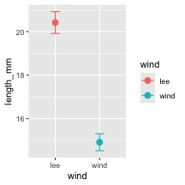

# **Summary and Conclusions**

In this activity, we’ve:

1. Formulated hypotheses about pine needle length
2. Tested assumptions for parametric tests
3. Conducted a two-sample t-tests
4. Visualized data using appropriate methods
5. Learned how to interpret and report t-test results

**Key takeaways:**

* Always check assumptions before conducting tests
* Visualize your data to understand patterns
* Report results comprehensively
* Consider alternatives when assumptions are violated

# Reflection Questions

After completing the activities, discuss these questions with your group:

1. How does sample size affect our confidence in estimating the population mean?
2. Why is the t-distribution more appropriate than the normal distribution when working with small samples?
3. When comparing two populations, what can we learn from looking at confidence intervals versus performing a t-test?
4. How would you explain the concept of statistical significance to someone who has never taken a statistics course?
5. What do we do if assumptions FAIL!!!