Lecture 10 - Class Activity: Multiple Regression

Bill Perry

# Analysis of Net Primary Production in Forests: A Modern Tidyverse Approach

*Based on Michaletz et al. (2014) data*

## Introduction

This analysis examines the relationships between Net Primary Production (npp) and various climate and forest characteristics across global forest sites. We’ll explore multicollinearity, model selection, and variable transformations.

**Key Learning Objectives:**

* Understand multicollinearity in multiple regression
* Learn model diagnostics and assumption checking
* Practice variable selection techniques
* Apply data transformations appropriately

## Load Required Packages

# Load required packages  
library(tidyverse) # For data manipulation and visualization  
library(car) # For regression diagnostics (VIF, etc.)  
library(corrplot) # For correlation plots  
library(GGally) # For pairs plots  
library(broom) # For tidy model outputs  
library(performance) # For model performance metrics  
library(see) # For better diagnostic plots

## Load and Explore the Data

# Load the forest npp data  
forest_df <- read_csv("data/michaletz_etal_2014_clean.csv")  
  
# Display top lines  
head(forest_df)

# A tibble: 6 × 8  
 npp age biomass season temp precip teb leaf   
 <dbl> <dbl> <dbl> <dbl> <dbl> <dbl> <dbl> <chr>   
1 2084 104. 18198. 11 25.3 1888 0.55 broadleaf  
2 2234 333. 54523. 12 26.9 2348. 0.6 broadleaf  
3 2714 213. 41358. 12 26.9 2348. 0.6 broadleaf  
4 2828 114. 31557. 12 26.7 2784. 1.25 broadleaf  
5 2882 113. 21417 12 26.7 2784. 1.25 broadleaf  
6 774 79 11188 3 -3.53 408. 1.8 broadleaf

## Data Preparation

Following the original analysis, we’ll focus on the key variables from a cleaned dataframe

## 1. Initial Exploration: Variable Relationships and Multicollinearity

### Correlation Matrix and Visualization

# Create correlation matrix for numeric variables only  
num_vars <- forest_df %>%  
 select_if(is.numeric)  
  
# Calculate correlation matrix  
cor_matrix <- cor(num_vars, use = "complete.obs")  
  
# Display correlation matrix  
cor_matrix

npp age biomass season temp precip  
npp 1.0000000 -0.153215979 0.4591083 0.5614272 0.5520590 0.531186333  
age -0.1532160 1.000000000 0.5923809 -0.2715014 -0.2307658 0.003642104  
biomass 0.4591083 0.592380901 1.0000000 0.1317097 0.1551923 0.353901541  
season 0.5614272 -0.271501387 0.1317097 1.0000000 0.9226905 0.567630275  
temp 0.5520590 -0.230765849 0.1551923 0.9226905 1.0000000 0.576659967  
precip 0.5311863 0.003642104 0.3539015 0.5676303 0.5766600 1.000000000  
teb -0.3167187 -0.011779155 -0.2748724 -0.2491779 -0.2495479 -0.291376661  
 teb  
npp -0.31671865  
age -0.01177916  
biomass -0.27487245  
season -0.24917787  
temp -0.24954794  
precip -0.29137666  
teb 1.00000000

# Create a visual correlation plot  
corrplot(cor_matrix, method = "color", type = "upper",   
 addCoef.col = "grey45", tl.cex = 0.8, number.cex = 0.7)

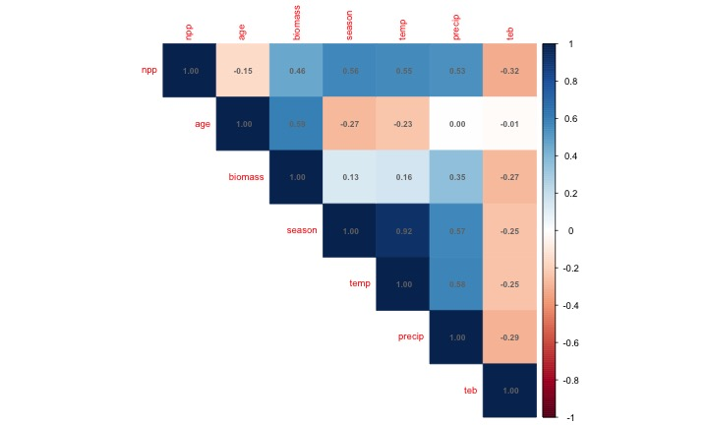

### Pairs Plot for Visual Inspection

# Create pairs plot to visualize relationships  
# This replaces the original pairs() function with ggplot2  
forest_df %>%  
 select(-leaf) %>% # Exclude categorical variable for pairs plot  
 ggpairs(  
 upper = list(continuous = wrap("cor", size = 5)),  
 lower = list(continuous = wrap("points", alpha = 0.6, size = 0.8))  
 ) +  
 theme_minimal()

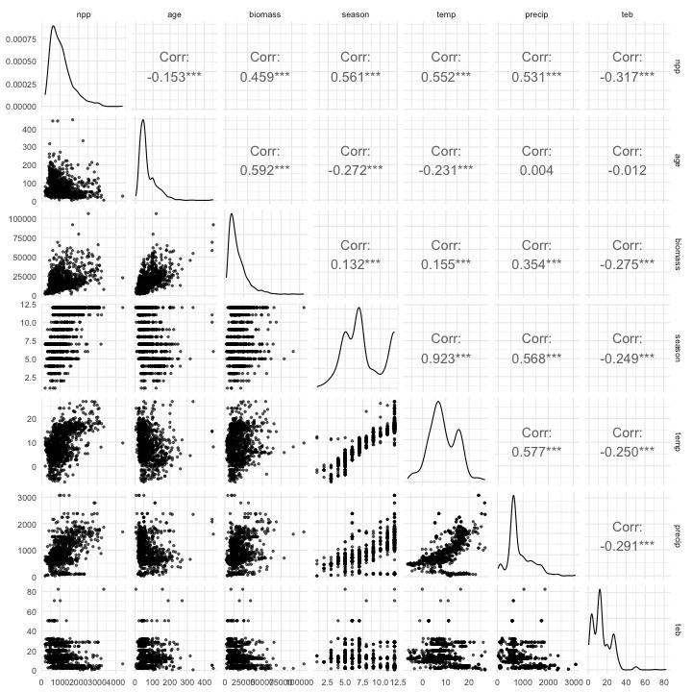

## 2. Initial Multiple Regression Model

Let’s start with a full model including all predictors:

# Fit initial model with all predictors (Model 1)  
model_init <- lm(npp ~ age + biomass + season + temp +   
 precip + teb + leaf, data = forest_df)  
  
# Get model summary  
summary(model_init)

Call:  
lm(formula = npp ~ age + biomass + season + temp + precip + teb +   
 leaf, data = forest_df)  
  
Residuals:  
 Min 1Q Median 3Q Max   
-1331.10 -206.27 -34.09 166.94 2760.41   
  
Coefficients:  
 Estimate Std. Error t value Pr(>|t|)   
(Intercept) 583.92959 53.81169 10.851 < 2e-16 ***  
age -4.78822 0.28518 -16.790 < 2e-16 ***  
biomass 0.03154 0.00122 25.848 < 2e-16 ***  
season 41.18220 9.49073 4.339 1.55e-05 ***  
temp 4.61281 4.37372 1.055 0.291788   
precip 0.09674 0.02852 3.392 0.000716 ***  
teb -2.12880 1.08408 -1.964 0.049794 *   
leafneedle -267.00569 22.43078 -11.904 < 2e-16 ***  
---  
Signif. codes: 0 '***' 0.001 '**' 0.01 '*' 0.05 '.' 0.1 ' ' 1  
  
Residual standard error: 351.7 on 1212 degrees of freedom  
Multiple R-squared: 0.6415, Adjusted R-squared: 0.6394   
F-statistic: 309.8 on 7 and 1212 DF, p-value: < 2.2e-16

### Check for Multicollinearity

# Calculate Variance Inflation Factors (VIF)  
vif_values <- vif(model_init)  
vif_values

age biomass season temp precip teb leaf   
1.993348 2.061766 7.079004 6.972147 1.831127 1.167007 1.236588

# Create a data frame for better visualization  
vif_df <- data.frame(  
 Variable = names(vif_values),  
 VIF = as.numeric(vif_values)  
) %>%  
 arrange(desc(VIF))  
  
# Visualize VIF values  
ggplot(vif_df, aes(x = reorder(Variable, VIF), y = VIF)) +  
 geom_col(fill = "steelblue", alpha = 0.7) +  
 geom_hline(yintercept = 10, color = "red", linetype = "dashed",   
 linewidth = 1) +  
 geom_hline(yintercept = 5, color = "orange", linetype = "dashed",   
 linewidth = 1) +  
 coord_flip() +  
 labs(  
 title = "Variance Inflation Factors",  
 subtitle = "Red line: VIF = 10 (serious concern), Orange line: VIF = 5 (moderate concern)",  
 x = "Variables",  
 y = "VIF"  
 ) +  
 theme_minimal()

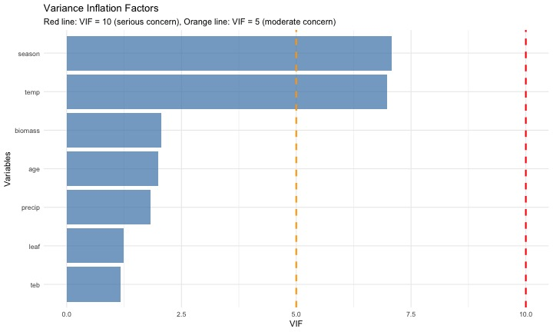

### Address Multicollinearity by Removing Growing Season

Based on the original analysis, season and Temperature are highly correlated. Let’s remove season:

# Model 2: Remove season due to multicollinearity  
model_2 <- lm(npp ~ age + biomass + temp + precip + teb + leaf,   
 data = forest_df)  
  
# Model summary  
summary(model_2)

Call:  
lm(formula = npp ~ age + biomass + temp + precip + teb + leaf,   
 data = forest_df)  
  
Residuals:  
 Min 1Q Median 3Q Max   
-1309.94 -209.40 -42.65 167.71 2898.47   
  
Coefficients:  
 Estimate Std. Error t value Pr(>|t|)   
(Intercept) 7.511e+02 3.785e+01 19.845 < 2e-16 ***  
age -5.004e+00 2.829e-01 -17.690 < 2e-16 ***  
biomass 3.180e-02 1.228e-03 25.905 < 2e-16 ***  
temp 2.112e+01 2.173e+00 9.718 < 2e-16 ***  
precip 1.120e-01 2.851e-02 3.929 9.02e-05 ***  
teb -2.255e+00 1.092e+00 -2.066 0.039 *   
leafneedle -2.634e+02 2.258e+01 -11.666 < 2e-16 ***  
---  
Signif. codes: 0 '***' 0.001 '**' 0.01 '*' 0.05 '.' 0.1 ' ' 1  
  
Residual standard error: 354.3 on 1213 degrees of freedom  
Multiple R-squared: 0.6359, Adjusted R-squared: 0.6341   
F-statistic: 353.1 on 6 and 1213 DF, p-value: < 2.2e-16

# Check VIF again  
vif_values2 <- vif(model_2)  
vif_values2

age biomass temp precip teb leaf   
1.932806 2.056724 1.696787 1.803266 1.166162 1.234906

## 3. Exploring Variable Transformations

### Check the Shape of Relationships with Partial Regression Plots

# Create partial regression plots (Added Variable Plots)  
# This helps us see the relationship between each predictor and response  
# after accounting for other variables  
  
par(mfrow = c(2, 3))  
avPlots(model_2, main = "Partial Regression Plots")

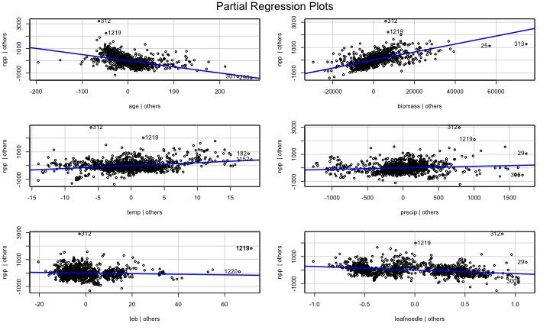

par(mfrow = c(1, 1))

### Apply Log Transformation to age

The original analysis found that age showed a curvy relationship. Let’s try log transformation: REally what you should do is log transform of the response variable first..

# Create dataset with log-transformed age  
forest_df <- forest_df %>%  
 mutate(log_age = log10(age))  
  
# Model 3: With log-transformed age  
model_3 <- lm(npp ~ log_age + biomass + temp + precip + teb + leaf,   
 data = forest_df)  
  
  
# Model summary  
summary(model_3)

Call:  
lm(formula = npp ~ log_age + biomass + temp + precip + teb +   
 leaf, data = forest_df)  
  
Residuals:  
 Min 1Q Median 3Q Max   
-1282.97 -203.31 -23.13 163.75 2810.76   
  
Coefficients:  
 Estimate Std. Error t value Pr(>|t|)   
(Intercept) 2.237e+03 8.961e+01 24.962 < 2e-16 ***  
log_age -1.012e+03 5.064e+01 -19.973 < 2e-16 ***  
biomass 3.313e-02 1.194e-03 27.755 < 2e-16 ***  
temp 1.723e+01 2.159e+00 7.982 3.33e-15 ***  
precip 7.194e-02 2.781e-02 2.587 0.00981 **   
teb -2.315e+00 1.061e+00 -2.183 0.02925 *   
leafneedle -2.852e+02 2.177e+01 -13.105 < 2e-16 ***  
---  
Signif. codes: 0 '***' 0.001 '**' 0.01 '*' 0.05 '.' 0.1 ' ' 1  
  
Residual standard error: 344.7 on 1213 degrees of freedom  
Multiple R-squared: 0.6553, Adjusted R-squared: 0.6536   
F-statistic: 384.4 on 6 and 1213 DF, p-value: < 2.2e-16

# Compare partial regression plots  
par(mfrow = c(2, 3))  
avPlots(model_3, main = "Partial Regression Plots (Log age)")

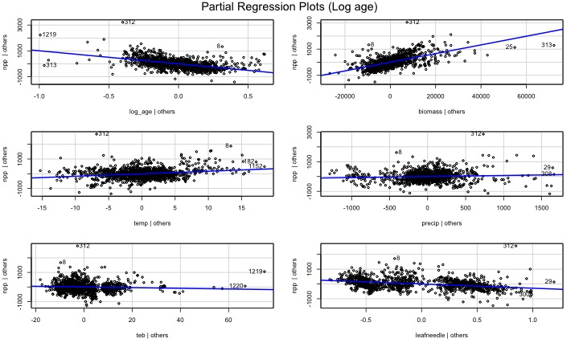

par(mfrow = c(1, 1))

## 4. Model Diagnostics and Assumption Checking

# Create diagnostic plots  
par(mfrow = c(2, 2))  
plot(model_3, main = "Model Diagnostics")

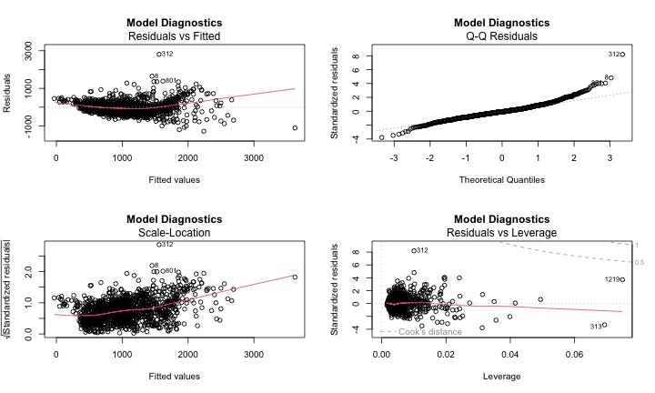

par(mfrow = c(1, 1))

## Residuals - its the upper left above

# Check for normality of residuals  
residuals_data <- data.frame(  
 Fitted = fitted(model_3),  
 Residuals = residuals(model_3),  
 Standardized_Residuals = rstandard(model_3)  
)  
  
# Residuals vs Fitted plot using ggplot  
ggplot(residuals_data, aes(x = Fitted, y = Residuals)) +  
 geom_point(alpha = 0.6) +  
 geom_smooth(method = "lm", color = "red") +  
 geom_hline(yintercept = 0, linetype = "dashed") +  
 labs(  
 title = "Residuals vs Fitted Values",  
 x = "Fitted Values",  
 y = "Residuals"  
 ) +  
 theme_minimal()

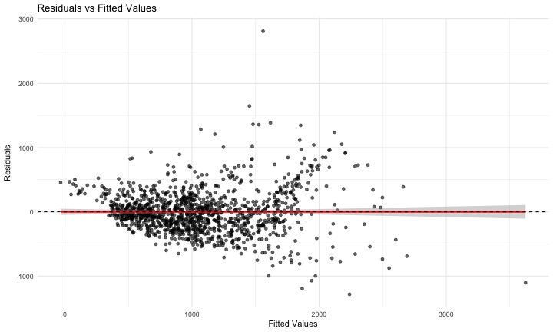

### Try Response Variable Transformation

Following the original analysis, let’s try a cube root transformation of npp:

# Model 4: Cube root transformation of npp  
forest_df <- forest_df %>%  
 mutate(npp_cuberoot = npp^(1/3))  
  
model_4 <- lm(npp_cuberoot ~ log_age + biomass + temp + precip +   
 teb + leaf, data = forest_df)  
  
summary(model_4)

Call:  
lm(formula = npp_cuberoot ~ log_age + biomass + temp + precip +   
 teb + leaf, data = forest_df)  
  
Residuals:  
 Min 1Q Median 3Q Max   
-4.0936 -0.5916 -0.0030 0.6463 5.0795   
  
Coefficients:  
 Estimate Std. Error t value Pr(>|t|)   
(Intercept) 1.391e+01 2.601e-01 53.489 < 2e-16 ***  
log_age -3.151e+00 1.470e-01 -21.436 < 2e-16 ***  
biomass 1.032e-04 3.464e-06 29.791 < 2e-16 ***  
temp 4.507e-02 6.265e-03 7.194 1.10e-12 ***  
precip 6.361e-05 8.072e-05 0.788 0.431   
teb -1.273e-02 3.078e-03 -4.135 3.79e-05 ***  
leafneedle -1.029e+00 6.317e-02 -16.283 < 2e-16 ***  
---  
Signif. codes: 0 '***' 0.001 '**' 0.01 '*' 0.05 '.' 0.1 ' ' 1  
  
Residual standard error: 1 on 1213 degrees of freedom  
Multiple R-squared: 0.6793, Adjusted R-squared: 0.6777   
F-statistic: 428.2 on 6 and 1213 DF, p-value: < 2.2e-16

# Check diagnostics  
par(mfrow = c(2, 2))  
plot(model_4, main = "Model Diagnostics (Cube Root npp)")

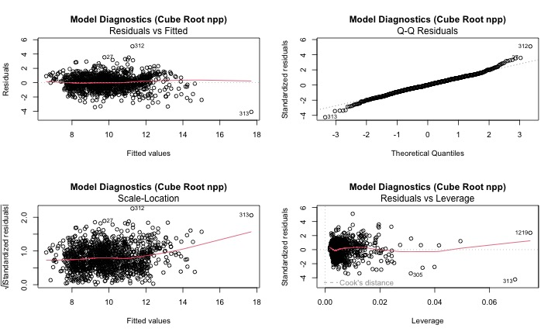

par(mfrow = c(1, 1))

## 5. Model Simplification and Comparison

### Remove Non-significant Variables

# Model 5: Remove non-significant Precipitation  
model_5 <- lm(npp_cuberoot ~ log_age + biomass + temp + teb + leaf,   
 data = forest_df)  
  
summary(model_5)

Call:  
lm(formula = npp_cuberoot ~ log_age + biomass + temp + teb +   
 leaf, data = forest_df)  
  
Residuals:  
 Min 1Q Median 3Q Max   
-4.1085 -0.5919 0.0019 0.6459 5.1261   
  
Coefficients:  
 Estimate Std. Error t value Pr(>|t|)   
(Intercept) 1.396e+01 2.532e-01 55.120 < 2e-16 ***  
log_age -3.159e+00 1.465e-01 -21.559 < 2e-16 ***  
biomass 1.040e-04 3.306e-06 31.465 < 2e-16 ***  
temp 4.719e-02 5.658e-03 8.342 < 2e-16 ***  
teb -1.296e-02 3.064e-03 -4.231 2.5e-05 ***  
leafneedle -1.040e+00 6.150e-02 -16.910 < 2e-16 ***  
---  
Signif. codes: 0 '***' 0.001 '**' 0.01 '*' 0.05 '.' 0.1 ' ' 1  
  
Residual standard error: 1 on 1214 degrees of freedom  
Multiple R-squared: 0.6791, Adjusted R-squared: 0.6778   
F-statistic: 513.9 on 5 and 1214 DF, p-value: < 2.2e-16

# Compare models using AIC  
model_comparison <- data.frame(  
 Model = c("Model 4 (Full)", "Model 5 (No precip)"),  
 AIC = c(AIC(model_4), AIC(model_5)),  
 R_squared = c(summary(model_4)$r.squared, summary(model_5)$r.squared),  
 Adj_R_squared = c(summary(model_4)$adj.r.squared, summary(model_5)$adj.r.squared)  
)  
  
model_comparison

Model AIC R_squared Adj_R_squared  
1 Model 4 (Full) 3472.092 0.6792946 0.6777082  
2 Model 5 (No precip) 3470.717 0.6791304 0.6778089

### Model Performance and Interpretation

# Get tidy summary of final model  
summary(model_5, conf.int = TRUE)

Call:  
lm(formula = npp_cuberoot ~ log_age + biomass + temp + teb +   
 leaf, data = forest_df)  
  
Residuals:  
 Min 1Q Median 3Q Max   
-4.1085 -0.5919 0.0019 0.6459 5.1261   
  
Coefficients:  
 Estimate Std. Error t value Pr(>|t|)   
(Intercept) 1.396e+01 2.532e-01 55.120 < 2e-16 ***  
log_age -3.159e+00 1.465e-01 -21.559 < 2e-16 ***  
biomass 1.040e-04 3.306e-06 31.465 < 2e-16 ***  
temp 4.719e-02 5.658e-03 8.342 < 2e-16 ***  
teb -1.296e-02 3.064e-03 -4.231 2.5e-05 ***  
leafneedle -1.040e+00 6.150e-02 -16.910 < 2e-16 ***  
---  
Signif. codes: 0 '***' 0.001 '**' 0.01 '*' 0.05 '.' 0.1 ' ' 1  
  
Residual standard error: 1 on 1214 degrees of freedom  
Multiple R-squared: 0.6791, Adjusted R-squared: 0.6778   
F-statistic: 513.9 on 5 and 1214 DF, p-value: < 2.2e-16

## using the sensemaker package

library(sensemakr)  
# Calculate partial R-squared for all variables at once  
partial_r2_sensemakr <- partial_r2(model_5)  
partial_r2_sensemakr

(Intercept) log_age biomass temp teb leafneedle   
 0.71450239 0.27686109 0.44919401 0.05421045 0.01453129 0.19064332

# Calculate partial R-squared for each variable  
# Using the car package  
print("Using car package Anova() with Type III sums of squares:")

[1] "Using car package Anova() with Type III sums of squares:"

anova_type2 <- Anova(model_5, type = "III")  
print(anova_type2)

Anova Table (Type III tests)  
  
Response: npp_cuberoot  
 Sum Sq Df F value Pr(>F)   
(Intercept) 3039.52 1 3038.225 < 2.2e-16 ***  
log_age 464.99 1 464.792 < 2.2e-16 ***  
biomass 990.47 1 990.043 < 2.2e-16 ***  
temp 69.61 1 69.584 < 2.2e-16 ***  
teb 17.91 1 17.901 2.502e-05 ***  
leaf 286.08 1 285.957 < 2.2e-16 ***  
Residuals 1214.52 1214   
---  
Signif. codes: 0 '***' 0.001 '**' 0.01 '*' 0.05 '.' 0.1 ' ' 1

# Convert F-statistics to partial R-squared  
# Partial R² = F * df_num / (F * df_num + df_den)  
f_stats <- anova_type2$`F value`[!is.na(anova_type2$`F value`)]  
df_num <- anova_type2$Df[!is.na(anova_type2$`F value`)]  
df_den <- anova_type2$Df[nrow(anova_type2)] # Residual df  
  
partial_r2_from_f <- f_stats * df_num / (f_stats * df_num + df_den)  
  
results_table <- data.frame(  
 Variable = rownames(anova_type2)[!is.na(anova_type2$`F value`)],  
 F_statistic = f_stats,  
 p_value = anova_type2$`Pr(>F)`[!is.na(anova_type2$`F value`)],  
 Partial_R_squared = partial_r2_from_f  
)  
  
print("Complete results with partial R-squared:")

[1] "Complete results with partial R-squared:"

print(results_table)

Variable F_statistic p_value Partial_R_squared  
1 (Intercept) 3038.22472 0.000000e+00 0.71450239  
2 log_age 464.79225 1.532052e-87 0.27686109  
3 biomass 990.04285 2.085787e-159 0.44919401  
4 temp 69.58365 1.967636e-16 0.05421045  
5 teb 17.90111 2.501886e-05 0.01453129  
6 leaf 285.95672 9.100842e-58 0.19064332

## 6. Alternative Approach: Standardized Variables

Following the original analysis, let’s also try the standardized approach:

# Create standardized variables  
forest_standardized <- forest_df %>%  
 mutate(  
 npp_sqrt_scaled = scale(sqrt(npp))[,1],  
 log_age_scaled = scale(log10(age))[,1],  
 biomass_scaled = scale(biomass)[,1],  
 temp_scaled = scale(temp)[,1],  
 precip_scaled = scale(precip)[,1],  
 teb_scaled = scale(teb)[,1]  
 )  
  
# Standardized model  
model_std <- lm(npp_sqrt_scaled ~ log_age_scaled + biomass_scaled +   
 temp_scaled * precip_scaled + teb_scaled,   
 data = forest_standardized)  
  
# Summary  
summary(model_std)

Call:  
lm(formula = npp_sqrt_scaled ~ log_age_scaled + biomass_scaled +   
 temp_scaled * precip_scaled + teb_scaled, data = forest_standardized)  
  
Residuals:  
 Min 1Q Median 3Q Max   
-3.14438 -0.38836 -0.03068 0.39178 3.01216   
  
Coefficients:  
 Estimate Std. Error t value Pr(>|t|)   
(Intercept) -0.064952 0.020075 -3.235 0.001247 **   
log_age_scaled -0.543699 0.024500 -22.192 < 2e-16 ***  
biomass_scaled 0.691415 0.025313 27.315 < 2e-16 ***  
temp_scaled 0.215693 0.023304 9.256 < 2e-16 ***  
precip_scaled -0.008188 0.028714 -0.285 0.775563   
teb_scaled -0.071775 0.018879 -3.802 0.000151 ***  
temp_scaled:precip_scaled 0.112727 0.017068 6.605 5.94e-11 ***  
---  
Signif. codes: 0 '***' 0.001 '**' 0.01 '*' 0.05 '.' 0.1 ' ' 1  
  
Residual standard error: 0.6113 on 1213 degrees of freedom  
Multiple R-squared: 0.6281, Adjusted R-squared: 0.6263   
F-statistic: 341.5 on 6 and 1213 DF, p-value: < 2.2e-16

## 7. Key Findings and Conclusions

1. MULTICOLLINEARITY:
   * Growing season length and temperature were highly correlated
   * Removed growing season to address multicollinearity
2. VARIABLE TRANSFORMATIONS:
   * Log transformation of age improved model fit
   * Cube root transformation of npp addressed assumption violations
3. FINAL MODEL RESULTS:
   * Significant predictors: age (negative), biomass (positive), temp (positive)
   * teb had negative effect, Leaf type differences were significant
4. BIOLOGICAL INTERPRETATION:
   * Younger stands had higher npp (for given biomass)
   * Higher biomass associated with higher npp
   * temp positively related to npp
   * Coniferous forests had lower npp than broadleaf forests

## References and Additional Notes

This analysis is based on:

* **Michaletz, S.T., Cheng, D., Kerkhoff, A.J. & Enquist, B.J.** (2014). Convergence of terrestrial plant production across global climate gradients. *Nature*, 512, 39-43.

**Key Learning Points:**

1. **Multicollinearity Detection**: Use VIF values and correlation matrices
2. **Variable Transformations**: Log and power transformations can improve model fit
3. **Model Diagnostics**: Always check residual plots and assumption violations
4. **Model Comparison**: Use AIC and other criteria for model selection
5. **Interpretation**: Focus on biologically meaningful relationships

# Session information for reproducibility  
sessionInfo()

R version 4.5.1 (2025-06-13)  
Platform: aarch64-apple-darwin20  
Running under: macOS Sequoia 15.6  
  
Matrix products: default  
BLAS: /Library/Frameworks/R.framework/Versions/4.5-arm64/Resources/lib/libRblas.0.dylib   
LAPACK: /Library/Frameworks/R.framework/Versions/4.5-arm64/Resources/lib/libRlapack.dylib; LAPACK version 3.12.1  
  
locale:  
[1] en_US.UTF-8/en_US.UTF-8/en_US.UTF-8/C/en_US.UTF-8/en_US.UTF-8  
  
time zone: America/Chicago  
tzcode source: internal  
  
attached base packages:  
[1] stats graphics grDevices utils datasets methods base   
  
other attached packages:  
 [1] sensemakr_0.1.6 see_0.11.0 performance_0.15.0 broom_1.0.9   
 [5] GGally_2.3.0 corrplot_0.95 car_3.1-3 carData_3.0-5   
 [9] lubridate_1.9.4 forcats_1.0.0 stringr_1.5.1 dplyr_1.1.4   
[13] purrr_1.1.0 readr_2.1.5 tidyr_1.3.1 tibble_3.3.0   
[17] ggplot2_3.5.2 tidyverse_2.0.0   
  
loaded via a namespace (and not attached):  
 [1] gtable_0.3.6 xfun_0.52 insight_1.3.1 lattice_0.22-7   
 [5] tzdb_0.5.0 vctrs_0.6.5 tools_4.5.1 generics_0.1.4   
 [9] parallel_4.5.1 pkgconfig_2.0.3 Matrix_1.7-3 RColorBrewer_1.1-3  
[13] S7_0.2.0 lifecycle_1.0.4 compiler_4.5.1 farver_2.1.2   
[17] codetools_0.2-20 htmltools_0.5.8.1 yaml_2.3.10 Formula_1.2-5   
[21] pillar_1.11.0 crayon_1.5.3 abind_1.4-8 nlme_3.1-168   
[25] ggstats_0.10.0 tidyselect_1.2.1 digest_0.6.37 stringi_1.8.7   
[29] labeling_0.4.3 splines_4.5.1 fastmap_1.2.0 grid_4.5.1   
[33] cli_3.6.5 magrittr_2.0.3 utf8_1.2.6 withr_3.0.2   
[37] scales_1.4.0 backports_1.5.0 bit64_4.6.0-1 timechange_0.3.0   
[41] rmarkdown_2.29 bit_4.6.0 hms_1.1.3 evaluate_1.0.4   
[45] knitr_1.50 mgcv_1.9-3 rlang_1.1.6 glue_1.8.0   
[49] rstudioapi_0.17.1 vroom_1.6.5 jsonlite_2.0.0 R6_2.6.1