Lecture 17 - Principal Component Analysis (PCA)

Bill Perry

# Lecture 16: Review

## Review

* Multivariate data
* Multivariate statistics in ecology: overview
* Eigenvectors, eigenvalues, components
* Distance and dissimilarity in MV space
* Data standardization
* Graphics
* Screening MV data
* MANOVA

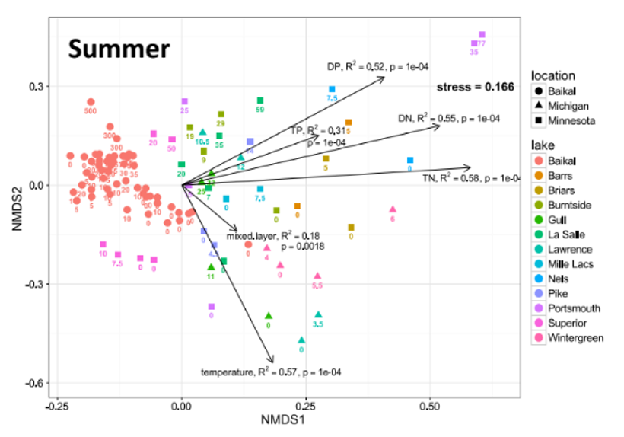

# Review: Eigenvectors and Components

Eigenvectors, eigenvalues and components

* Common goal of MV analysis is variable reduction: can we derive new variables (based on linear combinations of “original” variables) that explain variation in data?
* For data set with i= 1 to n objects and j = 1 to p original variables we seek new variables (principal components) using the equation:

$$z_{ik}=c_{1}y_{i1}+c_{2}y_{i2}+⋯c_{j}y_{ij}+⋯+c_{p}y_{ip}$$

# Review: Component Interpretation

* zik is value of new variable k for object I
* yi1- yip are values of original variables for object i
* c1-cp are coefficients that show importance of the original variables to new derived variable

$$z_{ik}=c_{1}y_{i1}+c_{2}y_{i2}+⋯c_{j}y_{ij}+⋯+c_{p}y_{ip}$$

# Review: Component Properties

Eigenvectors, eigenvalues and components

Derived variables are found so that:

* First derived variable explains most of the variation in the data
* Second most of the remaining variation
* And so on…
* As many derived variables as original variables (p)
* Derived variables are uncorrelated with each other

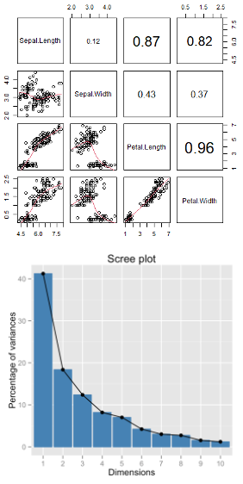

# Review: Eigenvalues and Eigenvectors

Eigenvectors, eigenvalues and components

* Eigenvalues (latent roots) represent amount of variation in data explained by the new k= 1 to p derived variables (λ1, λ2 …λp).
* Eigenvalues are population parameters and are estimated using ML to get sample statistics (l1, l2…lp)
* Eigenvectors are lists of coefficients (c) that show contribution of original variables to new, derived variables
* Each new variable has an eigenvalue and an eigenvector
* New variables (components) are derived from a p x p covariance or correlation matrix of original variables

# Lecture 17: PCA Goals and Introduction

* Common goals of MV data analysis are variable reduction (finding derived variables that summarize data) and exploration of patterns in data (scaling/ordination)
* Can use association (correlation/ covariance) matrices (PCA) or dissimilarity measures (MDS)
* In PCA: take p old variables and transform them into p “new/derived” uncorrelated variables (principal components)

# Data for PCA Analysis

# Load the iris dataset  
iris_df <- iris %>% clean_names() %>% mutate(ind = row_number()) %>%   
 mutate(species_ind = paste(species, ind, sep="_"))  
  
# get values only  
iris_data <- iris_df %>% select(-species, -ind, -species_ind)  
  
# Keep species for later visualization  
iris_species <- iris_df %>% select(species, ind, species_ind)  
  
# pivot to long formt for viewing  
iris_long_df <- iris_df %>%  
 pivot_longer(  
 cols = -c(species, ind, species_ind),  
 names_to = "variable",  
 values_to = "values")  
   
iris_df

sepal_length sepal_width petal_length petal_width species ind  
1 5.1 3.5 1.4 0.2 setosa 1  
2 4.9 3.0 1.4 0.2 setosa 2  
3 4.7 3.2 1.3 0.2 setosa 3  
4 4.6 3.1 1.5 0.2 setosa 4  
5 5.0 3.6 1.4 0.2 setosa 5  
6 5.4 3.9 1.7 0.4 setosa 6  
7 4.6 3.4 1.4 0.3 setosa 7  
8 5.0 3.4 1.5 0.2 setosa 8  
9 4.4 2.9 1.4 0.2 setosa 9  
10 4.9 3.1 1.5 0.1 setosa 10  
11 5.4 3.7 1.5 0.2 setosa 11  
12 4.8 3.4 1.6 0.2 setosa 12  
13 4.8 3.0 1.4 0.1 setosa 13  
14 4.3 3.0 1.1 0.1 setosa 14  
15 5.8 4.0 1.2 0.2 setosa 15  
16 5.7 4.4 1.5 0.4 setosa 16  
17 5.4 3.9 1.3 0.4 setosa 17  
18 5.1 3.5 1.4 0.3 setosa 18  
19 5.7 3.8 1.7 0.3 setosa 19  
20 5.1 3.8 1.5 0.3 setosa 20  
21 5.4 3.4 1.7 0.2 setosa 21  
22 5.1 3.7 1.5 0.4 setosa 22  
23 4.6 3.6 1.0 0.2 setosa 23  
24 5.1 3.3 1.7 0.5 setosa 24  
25 4.8 3.4 1.9 0.2 setosa 25  
26 5.0 3.0 1.6 0.2 setosa 26  
27 5.0 3.4 1.6 0.4 setosa 27  
28 5.2 3.5 1.5 0.2 setosa 28  
29 5.2 3.4 1.4 0.2 setosa 29  
30 4.7 3.2 1.6 0.2 setosa 30  
31 4.8 3.1 1.6 0.2 setosa 31  
32 5.4 3.4 1.5 0.4 setosa 32  
33 5.2 4.1 1.5 0.1 setosa 33  
34 5.5 4.2 1.4 0.2 setosa 34  
35 4.9 3.1 1.5 0.2 setosa 35  
36 5.0 3.2 1.2 0.2 setosa 36  
37 5.5 3.5 1.3 0.2 setosa 37  
38 4.9 3.6 1.4 0.1 setosa 38  
39 4.4 3.0 1.3 0.2 setosa 39  
40 5.1 3.4 1.5 0.2 setosa 40  
41 5.0 3.5 1.3 0.3 setosa 41  
42 4.5 2.3 1.3 0.3 setosa 42  
43 4.4 3.2 1.3 0.2 setosa 43  
44 5.0 3.5 1.6 0.6 setosa 44  
45 5.1 3.8 1.9 0.4 setosa 45  
46 4.8 3.0 1.4 0.3 setosa 46  
47 5.1 3.8 1.6 0.2 setosa 47  
48 4.6 3.2 1.4 0.2 setosa 48  
49 5.3 3.7 1.5 0.2 setosa 49  
50 5.0 3.3 1.4 0.2 setosa 50  
51 7.0 3.2 4.7 1.4 versicolor 51  
52 6.4 3.2 4.5 1.5 versicolor 52  
53 6.9 3.1 4.9 1.5 versicolor 53  
54 5.5 2.3 4.0 1.3 versicolor 54  
55 6.5 2.8 4.6 1.5 versicolor 55  
56 5.7 2.8 4.5 1.3 versicolor 56  
57 6.3 3.3 4.7 1.6 versicolor 57  
58 4.9 2.4 3.3 1.0 versicolor 58  
59 6.6 2.9 4.6 1.3 versicolor 59  
60 5.2 2.7 3.9 1.4 versicolor 60  
61 5.0 2.0 3.5 1.0 versicolor 61  
62 5.9 3.0 4.2 1.5 versicolor 62  
63 6.0 2.2 4.0 1.0 versicolor 63  
64 6.1 2.9 4.7 1.4 versicolor 64  
65 5.6 2.9 3.6 1.3 versicolor 65  
66 6.7 3.1 4.4 1.4 versicolor 66  
67 5.6 3.0 4.5 1.5 versicolor 67  
68 5.8 2.7 4.1 1.0 versicolor 68  
69 6.2 2.2 4.5 1.5 versicolor 69  
70 5.6 2.5 3.9 1.1 versicolor 70  
71 5.9 3.2 4.8 1.8 versicolor 71  
72 6.1 2.8 4.0 1.3 versicolor 72  
73 6.3 2.5 4.9 1.5 versicolor 73  
74 6.1 2.8 4.7 1.2 versicolor 74  
75 6.4 2.9 4.3 1.3 versicolor 75  
76 6.6 3.0 4.4 1.4 versicolor 76  
77 6.8 2.8 4.8 1.4 versicolor 77  
78 6.7 3.0 5.0 1.7 versicolor 78  
79 6.0 2.9 4.5 1.5 versicolor 79  
80 5.7 2.6 3.5 1.0 versicolor 80  
81 5.5 2.4 3.8 1.1 versicolor 81  
82 5.5 2.4 3.7 1.0 versicolor 82  
83 5.8 2.7 3.9 1.2 versicolor 83  
84 6.0 2.7 5.1 1.6 versicolor 84  
85 5.4 3.0 4.5 1.5 versicolor 85  
86 6.0 3.4 4.5 1.6 versicolor 86  
87 6.7 3.1 4.7 1.5 versicolor 87  
88 6.3 2.3 4.4 1.3 versicolor 88  
89 5.6 3.0 4.1 1.3 versicolor 89  
90 5.5 2.5 4.0 1.3 versicolor 90  
91 5.5 2.6 4.4 1.2 versicolor 91  
92 6.1 3.0 4.6 1.4 versicolor 92  
93 5.8 2.6 4.0 1.2 versicolor 93  
94 5.0 2.3 3.3 1.0 versicolor 94  
95 5.6 2.7 4.2 1.3 versicolor 95  
96 5.7 3.0 4.2 1.2 versicolor 96  
97 5.7 2.9 4.2 1.3 versicolor 97  
98 6.2 2.9 4.3 1.3 versicolor 98  
99 5.1 2.5 3.0 1.1 versicolor 99  
100 5.7 2.8 4.1 1.3 versicolor 100  
101 6.3 3.3 6.0 2.5 virginica 101  
102 5.8 2.7 5.1 1.9 virginica 102  
103 7.1 3.0 5.9 2.1 virginica 103  
104 6.3 2.9 5.6 1.8 virginica 104  
105 6.5 3.0 5.8 2.2 virginica 105  
106 7.6 3.0 6.6 2.1 virginica 106  
107 4.9 2.5 4.5 1.7 virginica 107  
108 7.3 2.9 6.3 1.8 virginica 108  
109 6.7 2.5 5.8 1.8 virginica 109  
110 7.2 3.6 6.1 2.5 virginica 110  
111 6.5 3.2 5.1 2.0 virginica 111  
112 6.4 2.7 5.3 1.9 virginica 112  
113 6.8 3.0 5.5 2.1 virginica 113  
114 5.7 2.5 5.0 2.0 virginica 114  
115 5.8 2.8 5.1 2.4 virginica 115  
116 6.4 3.2 5.3 2.3 virginica 116  
117 6.5 3.0 5.5 1.8 virginica 117  
118 7.7 3.8 6.7 2.2 virginica 118  
119 7.7 2.6 6.9 2.3 virginica 119  
120 6.0 2.2 5.0 1.5 virginica 120  
121 6.9 3.2 5.7 2.3 virginica 121  
122 5.6 2.8 4.9 2.0 virginica 122  
123 7.7 2.8 6.7 2.0 virginica 123  
124 6.3 2.7 4.9 1.8 virginica 124  
125 6.7 3.3 5.7 2.1 virginica 125  
126 7.2 3.2 6.0 1.8 virginica 126  
127 6.2 2.8 4.8 1.8 virginica 127  
128 6.1 3.0 4.9 1.8 virginica 128  
129 6.4 2.8 5.6 2.1 virginica 129  
130 7.2 3.0 5.8 1.6 virginica 130  
131 7.4 2.8 6.1 1.9 virginica 131  
132 7.9 3.8 6.4 2.0 virginica 132  
133 6.4 2.8 5.6 2.2 virginica 133  
134 6.3 2.8 5.1 1.5 virginica 134  
135 6.1 2.6 5.6 1.4 virginica 135  
136 7.7 3.0 6.1 2.3 virginica 136  
137 6.3 3.4 5.6 2.4 virginica 137  
138 6.4 3.1 5.5 1.8 virginica 138  
139 6.0 3.0 4.8 1.8 virginica 139  
140 6.9 3.1 5.4 2.1 virginica 140  
141 6.7 3.1 5.6 2.4 virginica 141  
142 6.9 3.1 5.1 2.3 virginica 142  
143 5.8 2.7 5.1 1.9 virginica 143  
144 6.8 3.2 5.9 2.3 virginica 144  
145 6.7 3.3 5.7 2.5 virginica 145  
146 6.7 3.0 5.2 2.3 virginica 146  
147 6.3 2.5 5.0 1.9 virginica 147  
148 6.5 3.0 5.2 2.0 virginica 148  
149 6.2 3.4 5.4 2.3 virginica 149  
150 5.9 3.0 5.1 1.8 virginica 150  
 species_ind  
1 setosa_1  
2 setosa_2  
3 setosa_3  
4 setosa_4  
5 setosa_5  
6 setosa_6  
7 setosa_7  
8 setosa_8  
9 setosa_9  
10 setosa_10  
11 setosa_11  
12 setosa_12  
13 setosa_13  
14 setosa_14  
15 setosa_15  
16 setosa_16  
17 setosa_17  
18 setosa_18  
19 setosa_19  
20 setosa_20  
21 setosa_21  
22 setosa_22  
23 setosa_23  
24 setosa_24  
25 setosa_25  
26 setosa_26  
27 setosa_27  
28 setosa_28  
29 setosa_29  
30 setosa_30  
31 setosa_31  
32 setosa_32  
33 setosa_33  
34 setosa_34  
35 setosa_35  
36 setosa_36  
37 setosa_37  
38 setosa_38  
39 setosa_39  
40 setosa_40  
41 setosa_41  
42 setosa_42  
43 setosa_43  
44 setosa_44  
45 setosa_45  
46 setosa_46  
47 setosa_47  
48 setosa_48  
49 setosa_49  
50 setosa_50  
51 versicolor_51  
52 versicolor_52  
53 versicolor_53  
54 versicolor_54  
55 versicolor_55  
56 versicolor_56  
57 versicolor_57  
58 versicolor_58  
59 versicolor_59  
60 versicolor_60  
61 versicolor_61  
62 versicolor_62  
63 versicolor_63  
64 versicolor_64  
65 versicolor_65  
66 versicolor_66  
67 versicolor_67  
68 versicolor_68  
69 versicolor_69  
70 versicolor_70  
71 versicolor_71  
72 versicolor_72  
73 versicolor_73  
74 versicolor_74  
75 versicolor_75  
76 versicolor_76  
77 versicolor_77  
78 versicolor_78  
79 versicolor_79  
80 versicolor_80  
81 versicolor_81  
82 versicolor_82  
83 versicolor_83  
84 versicolor_84  
85 versicolor_85  
86 versicolor_86  
87 versicolor_87  
88 versicolor_88  
89 versicolor_89  
90 versicolor_90  
91 versicolor_91  
92 versicolor_92  
93 versicolor_93  
94 versicolor_94  
95 versicolor_95  
96 versicolor_96  
97 versicolor_97  
98 versicolor_98  
99 versicolor_99  
100 versicolor_100  
101 virginica_101  
102 virginica_102  
103 virginica_103  
104 virginica_104  
105 virginica_105  
106 virginica_106  
107 virginica_107  
108 virginica_108  
109 virginica_109  
110 virginica_110  
111 virginica_111  
112 virginica_112  
113 virginica_113  
114 virginica_114  
115 virginica_115  
116 virginica_116  
117 virginica_117  
118 virginica_118  
119 virginica_119  
120 virginica_120  
121 virginica_121  
122 virginica_122  
123 virginica_123  
124 virginica_124  
125 virginica_125  
126 virginica_126  
127 virginica_127  
128 virginica_128  
129 virginica_129  
130 virginica_130  
131 virginica_131  
132 virginica_132  
133 virginica_133  
134 virginica_134  
135 virginica_135  
136 virginica_136  
137 virginica_137  
138 virginica_138  
139 virginica_139  
140 virginica_140  
141 virginica_141  
142 virginica_142  
143 virginica_143  
144 virginica_144  
145 virginica_145  
146 virginica_146  
147 virginica_147  
148 virginica_148  
149 virginica_149  
150 virginica_150

# Step 1: Explore the Iris Dataset

As in every case you should be looking at the data first - every time…

Right is the data on iris from a long dataframe

overview_plot <- iris_long_df %>%   
 ggplot(aes(species, values, color=species)) +   
 geom_boxplot() +  
 facet_wrap(~variable, scales = "free")  
overview_plot

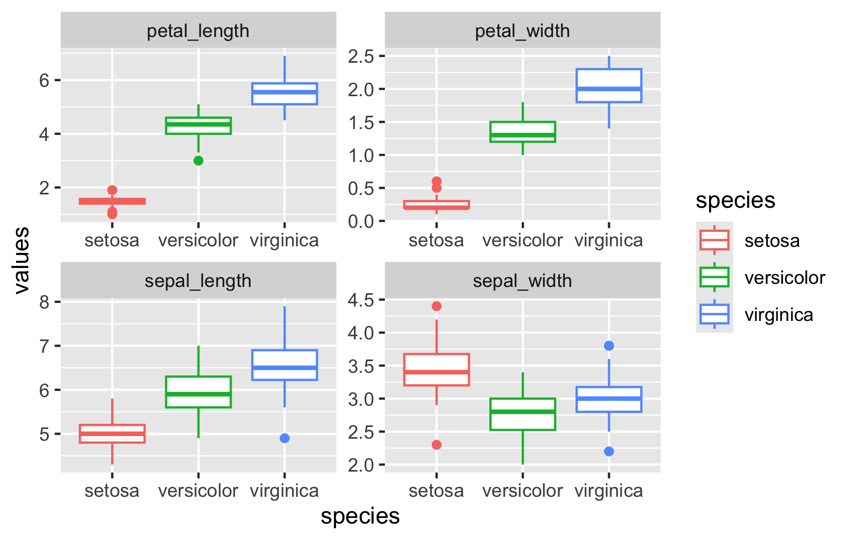

# What is PCA? Goals and Overview

## Principal Component Analysis Goals:

* **Variable Reduction**: Transform many correlated variables into fewer uncorrelated components
* **Data Exploration**: Visualize patterns and relationships in high-dimensional data
* **Noise Reduction**: Focus on the most important sources of variation
* **Dimension Reduction**: Make complex datasets easier to analyze and interpret

**Today’s Example**: Iris flower measurements - can we reduce 4 measurements to 2-3 components that capture most variation?

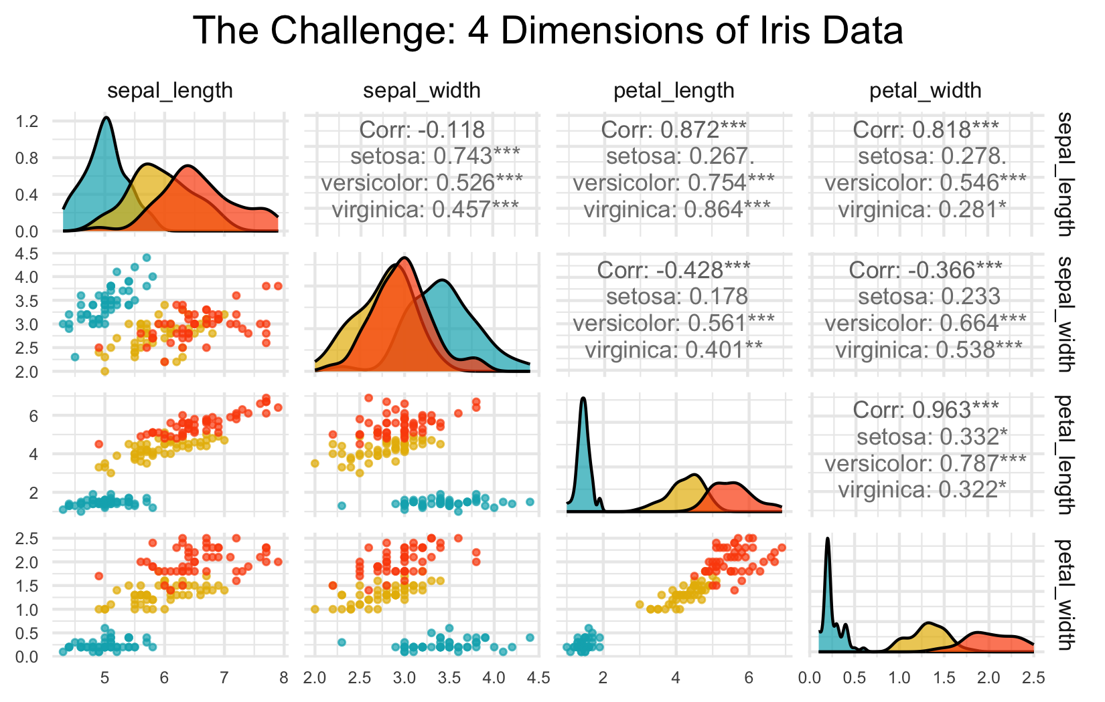

# High-Dimensional Data Visualization

## Principal Component Analysis Goals:

* **Variable Reduction**: Transform many correlated variables into fewer uncorrelated components
* **Data Exploration**: Visualize patterns and relationships in high-dimensional data
* **Noise Reduction**: Focus on the most important sources of variation
* **Dimension Reduction**: Make complex datasets easier to analyze and interpret

**Today’s Example**: Iris flower measurements - can we reduce 4 measurements to fewer components that capture most variation?

# PCA Assumptions - Critical to Check First!

## Key Assumptions:

1. **Linear relationships** between variables
2. **No extreme outliers** (can distort results)
3. **Variables should be correlated** (if not, PCA won’t reduce dimensions)
4. **Adequate sample size** (generally n > 50, preferably n > 100)
5. **No missing data** (complete cases only)
6. **Consider standardization** when variables have different scales

**Important**: PCA works best when original variables are moderately to highly correlated!

**Let’s check these assumptions with our iris data…**

# Step 2: Check PCA Assumptions - Correlations

[1] "Correlation Matrix:"

sepal_length sepal_width petal_length petal_width  
sepal_length 1.000 -0.118 0.872 0.818  
sepal_width -0.118 1.000 -0.428 -0.366  
petal_length 0.872 -0.428 1.000 0.963  
petal_width 0.818 -0.366 0.963 1.000

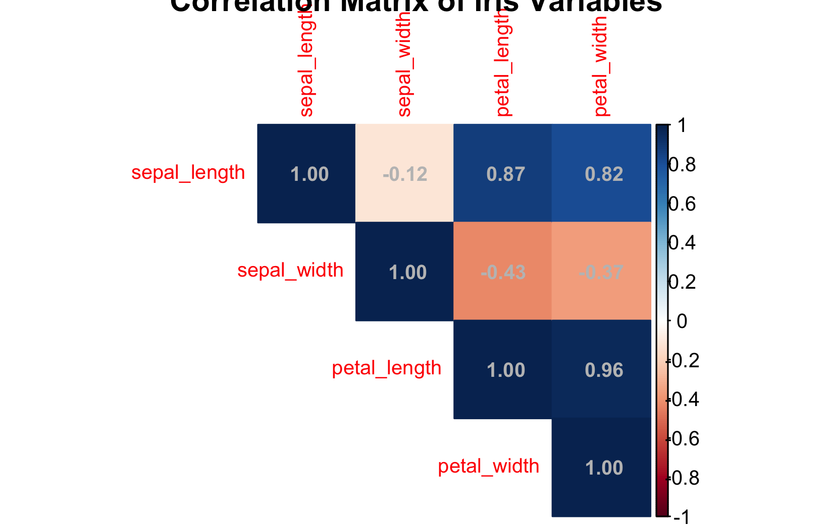

# Step 2: Check PCA Assumptions - Linearity

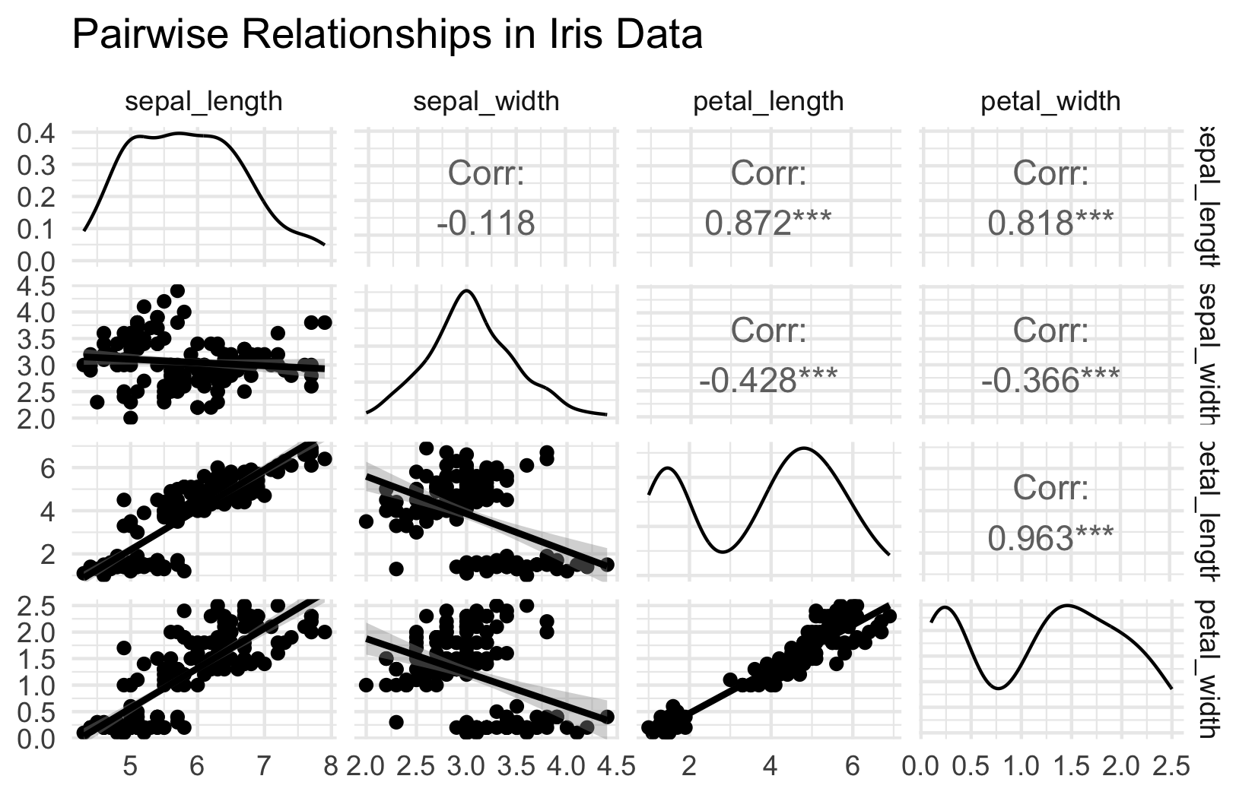

# Step 2: Check PCA Assumptions - Outliers

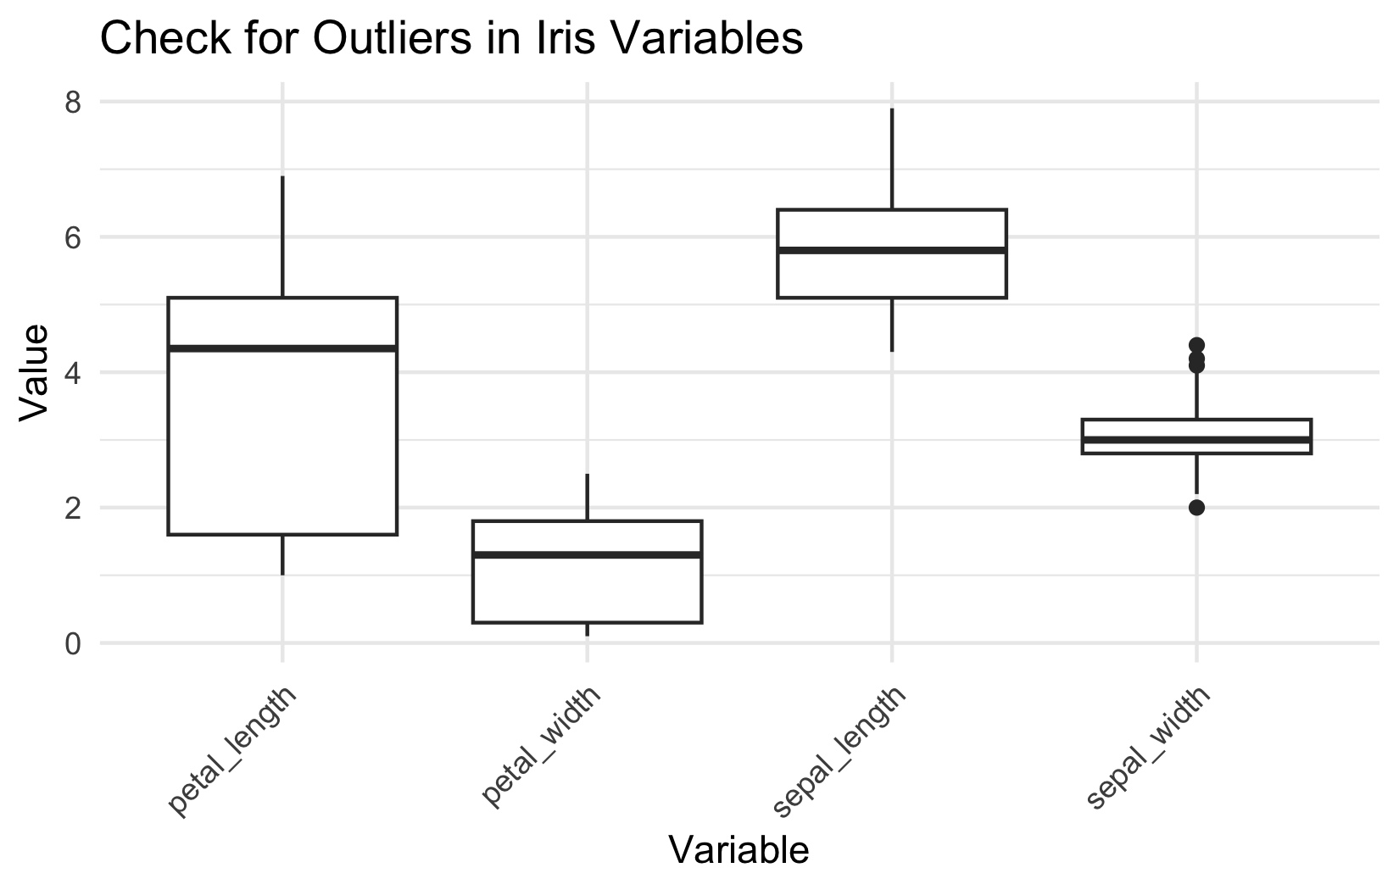

# Step 3: Standardize the Data

## STANDARDIZATION: Making all variables comparable

Why standardize?

Our measurements have different units and scales:

* Sepal length: ranges from ~4-8 cm
* Sepal width: ranges from ~2-4 cm
* Petal length: ranges from ~1-7 cm
* Petal width: ranges from ~0.1-2.5 cm

Without standardization, PCA would be dominated by variables with larger numbers (like petal length) simply because they have bigger values, not because they’re more important biologically

What does standardization do?

* Converts each variable to have:
  + Mean = 0 (centered at zero)
  + Standard deviation = 1 (same spread)
  + This gives all variables equal weight in the analysis

How to interpret standardized values: Example: A sepal length of 5.1 cm might become -0.9 after standardization, meaning it’s 0.9 standard deviations below the average sepal length

[1] "Means after standardization (should be ~0):"

sepal_length sepal_width petal_length petal_width   
 0 0 0 0

[1] "Standard deviations after standardization (should be 1):"

sepal_length sepal_width petal_length petal_width   
 1 1 1 1

# Step 4: Perform PCA - The Mathematics

## What is PCA doing?

Principal Component Analysis finds new variables (called components) that capture the most variation in your data. Think of it as finding the “best viewing angles” to see differences between flowers.

## The mathematics (simplified):

* PCA rotates your data to find the direction with maximum spread (PC1)
* Then finds the next direction with maximum spread perpendicular to PC1 (PC2)
* Continues until it has as many components as original variables (4 in our case)

## Why center = FALSE and scale = FALSE?

We already standardized our data in Step 3, so we tell R not to do it again: - center = FALSE: Don’t subtract the mean (we already did) - scale = FALSE: Don’t divide by standard deviation (we already did)

## What the summary shows:

* **Standard deviation**: How much variation each component captures
* **Proportion of Variance**: Percentage of total variation explained by each component
* **Cumulative Proportion**: Running total of variance explained

# Perform PCA on standardized data  
iris_pca <- prcomp(iris_scaled, center = FALSE, scale. = FALSE)  
# Note: center and scale are FALSE because we already standardized  
  
# Alternative using vegan package  
iris_pca_vegan <- rda(iris_scaled)  
  
# Summary of PCA results  
summary(iris_pca)

Importance of components:  
 PC1 PC2 PC3 PC4  
Standard deviation 1.7084 0.9560 0.38309 0.14393  
Proportion of Variance 0.7296 0.2285 0.03669 0.00518  
Cumulative Proportion 0.7296 0.9581 0.99482 1.00000

# Deriving Components: 2D Visualization

How are new uncorrelated components derived? One way to think it is in terms of axis rotation Consider a 2-variable dataset:

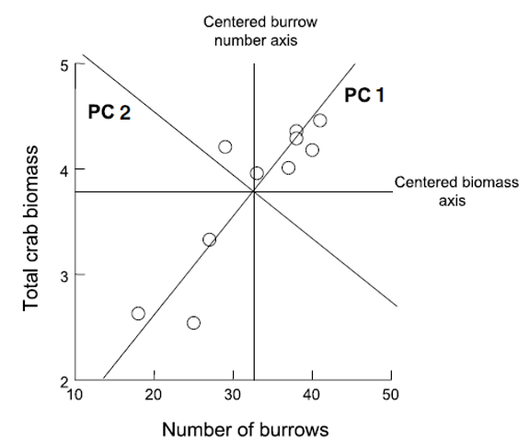

# Component Derivation: Axis Rotation

Goal is to “rotate the axes” around center of the data “cloud” in such a way that most of the variation lies along the first axis Then find second axis that explains the second-most variation AND is orthogonal to first axis

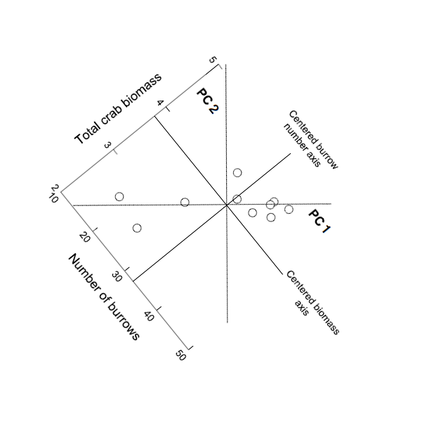

# Component Derivation: Multivariate Extension

Easy to picture in 2D (or even 3D), but harder in multivariate space Practically, components are “extracted” from a covariance of correlation matrix among original variables Will extract as many principal components as original variables

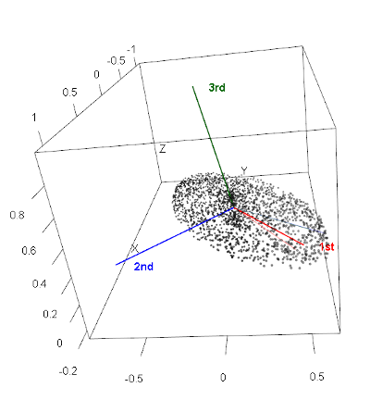

# Component Information: Eigenvalues and Eigenvectors

* Get two important pieces of information from PCA: eigenvectors and eigenvalues
* Eigenvalues (latent roots)- how much of the variation is explained by each component?
* Eigenvectors- list of coefficients for original variables. There are p coefficients in an eigenvector and p eigenvectors
* Correlation bw original variables will result in fewer components explaining more variance; variable reduction will fail if original variables are not correlated

# Step 4: Understanding Eigenvalues and Variance

## Understanding Eigenvalues and Variance

### What are eigenvalues?

* Eigenvalues tell us how much variation each principal component captures.
* Larger eigenvalues = more important components.

### Key terms explained:

* **Eigenvalue**: The amount of variance captured by each component (always positive)
* **Proportion of Variance**: What percentage of total variation this component explains
* **Cumulative Variance**: Running total - helps us decide how many components we need

### How to read the results:

* If PC1 has eigenvalue = 2.9, it captures 2.9 “units” of variance
* If Prop_Variance = 0.728, PC1 explains 72.8% of all variation in the data
* If Cumsum_Variance = 0.959 at PC2, the first 2 components together explain 95.9% of variation

### Why this matters:

This table helps us decide how many components to keep.

* If 2 components explain 95% of variance, we’ve successfully reduced 4 variables to 2
* We only lose 5% of information without including the other variables!

# Extract eigenvalues (variance explained by each component)  
eigenvalues <- iris_pca$sdev^2  
prop_variance <- eigenvalues / sum(eigenvalues)  
cumsum_variance <- cumsum(prop_variance)  
  
# Create a summary table  
pca_summary <- data.frame(  
 Component = paste0("PC", 1:length(eigenvalues)),  
 Eigenvalue = eigenvalues,  
 Prop_Variance = prop_variance,  
 Cumsum_Variance = cumsum_variance  
)  
  
print("PCA Summary:")

[1] "PCA Summary:"

kable(pca_summary, digits = 3)

| Component | Eigenvalue | Prop_Variance | Cumsum_Variance |
| --- | --- | --- | --- |
| PC1 | 2.918 | 0.730 | 0.730 |
| PC2 | 0.914 | 0.229 | 0.958 |
| PC3 | 0.147 | 0.037 | 0.995 |
| PC4 | 0.021 | 0.005 | 1.000 |

# Step 5: Determine Number of Components - Scree Plot

## What is a Scree Plot?

A scree plot shows how much variance each component explains, helping us decide how many components we need. The name comes from the geological term “scree” - loose rocks at the base of a cliff - because the plot often looks like a steep cliff followed by rubble.

## How to read a Scree Plot:

* **Y-axis**: Percentage of variance explained by each component
* **X-axis**: Component number (PC1, PC2, etc.)
* **The pattern**: Usually shows a steep drop followed by a leveling off

## The “Elbow Method”:

Look for where the line “bends” or forms an elbow:

* Components before the elbow = important (steep slope)
* Components after the elbow = less important (gentle slope)
* Keep components up to and including the elbow

## What to look for in our plot:

* If PC1 explains 70% and PC2 explains 20%, but PC3 only explains 5%, the elbow is at PC2
* This suggests keeping the first 2 components
* The dramatic drop from PC1 to PC2, then gentle decline after, confirms our dimension reduction worked well

# Step 5: Component Selection Rules

# Eigenvalue > 1 rule (Kaiser criterion)  
components_to_keep <- sum(eigenvalues > 1)  
print(paste("Components with eigenvalue > 1:", components_to_keep))

[1] "Components with eigenvalue > 1: 1"

# Components explaining at least 80% of variance  
components_80_percent <- which(cumsum_variance >= 0.80)[1]  
print(paste("Components needed for 80% variance:", components_80_percent))

[1] "Components needed for 80% variance: 2"

# Step 6: Interpret the Components - Loadings

## What are Component Loadings

Loadings tell us how much each original variable contributes to each principal component. Think of them as “recipes” that show how to mix your original measurements to create the new components.

## How to read the loadings table

* **Values range from -1 to +1** (like correlations)
* **Large positive values** (e.g., 0.8): This variable contributes strongly in the positive direction
* **Large negative values** (e.g., -0.8): This variable contributes strongly in the negative direction
* **Values near 0**: This variable doesn’t contribute much to this component

## Interpreting the patterns:

* **If all loadings have similar signs**: Component represents overall size (all measurements increase/decrease together)
* **If loadings have mixed signs**: Component represents shape or proportions (some measurements increase while others decrease)
* **Dominant variables**: Variables with the largest absolute loadings drive that component’s meaning

## Example interpretation:

If PC1 has all negative loadings around -0.5, it means:

* Flowers with high PC1 scores have small values for ALL measurements
* This component captures “overall flower size”
* The negative sign just indicates direction (could flip signs and interpretation)

# Component loadings (how much each original variable contributes)  
loadings_df <- data.frame(  
 Variable = rownames(iris_pca$rotation),  
 PC1 = iris_pca$rotation[, 1],  
 PC2 = iris_pca$rotation[, 2],  
 PC3 = iris_pca$rotation[, 3],  
 PC4 = iris_pca$rotation[, 4]  
)  
  
print("Component Loadings:")

[1] "Component Loadings:"

loadings_df

Variable PC1 PC2 PC3 PC4  
sepal_length sepal_length 0.5210659 -0.37741762 0.7195664 0.2612863  
sepal_width sepal_width -0.2693474 -0.92329566 -0.2443818 -0.1235096  
petal_length petal_length 0.5804131 -0.02449161 -0.1421264 -0.8014492  
petal_width petal_width 0.5648565 -0.06694199 -0.6342727 0.5235971

# Step 6: Eigenvector Properties

### Key properties of eigenvectors/loadings:

* **Unit length**: Each eigenvector has length 1 (sum of squares = 1)
* **Orthogonal**: Eigenvectors are perpendicular to each other (dot product = 0)
* **Ordered by importance**: First eigenvector (PC1) explains most variance

### The complete picture:

* **Eigenvectors** = The directions (loadings)
* **Eigenvalues** = The importance of each direction (variance explained)
* Together they fully describe the PCA transformation

# Step 6b: Visualization of Component Loadings

What does this plot show?

This is a visual representation of the loadings table, showing how each original variable contributes to PC1 and PC2. It’s like a map of how your original measurements relate to the new principal components.

How to read the plot:

* Arrows represent your original variables (sepal_length, sepal_width, etc.)
* Arrow direction shows which PC the variable contributes to
* Arrow length indicates the strength of contribution (longer = stronger)
* Arrow color shows the overall contribution magnitude (red = highest, blue = lowest)
* The circle represents the maximum possible contribution

Key interpretations from this plot:

* PC1 (horizontal axis, 73% variance):
  + All arrows point roughly left (negative direction)
  + All variables contribute almost equally to PC1
  + This confirms PC1 represents “overall flower size”

PC2 (vertical axis, 22.9% variance):

* Sepal_width points down (negative)
* Other variables point slightly up (positive)
* This creates a contrast: sepal width vs. everything else
* PC2 captures “flower shape” - wide sepals vs. long petals

# Loading Plot Interpretation

What the arrow positions tell us:

* Variables pointing in same direction = positively correlated
* Variables at 90° angles = uncorrelated
* Variables pointing opposite directions = negatively correlated

The practical meaning:

* Flowers with high PC1 scores have large values for all measurements
* Flowers with high PC2 scores have narrow sepals but long/wide petals
* The plot confirms our dimension reduction worked - we’ve captured 95.9% of variation in just 2 dimensions!

# Step 7: PCA Biplot - The Main Result

## Key insights from this biplot:

### Species separation:

* **Setosa (blue)**: Clearly separated on the left (negative PC1)
* **Versicolor (yellow)**: In the middle
* **Virginica (red)**: On the right (positive PC1)
* PCA successfully separates species without being told about them!

### Understanding flower characteristics:

* **Setosa flowers**: Small overall (negative PC1), relatively wide sepals (positive PC2)
* **Virginica flowers**: Large overall (positive PC1), especially long petals
* **Versicolor flowers**: Intermediate in most characteristics

### Variable relationships:

* Petal measurements point together → highly correlated
* Sepal width points differently → captures different information
* All arrows point right → all measurements increase from setosa to virginica

# Step 7: PCA Scores Plot - Alternative Visualization

# Alternative scores plot  
ggplot(pca_scores, aes(x = PC1, y = PC2, color = species)) +  
 geom_point(size = 3, alpha = 0.7) +  
 stat_ellipse(level = 0.68, linetype = 2) + # Add ellipses  
 labs(title = "PCA Scores Plot",  
 subtitle = paste0("PC1 explains ", round(prop_variance[1]*100, 1),   
 "% of variance, PC2 explains ", round(prop_variance[2]*100, 1), "%"),  
 x = paste0("PC1 (", round(prop_variance[1]*100, 1), "%)"),  
 y = paste0("PC2 (", round(prop_variance[2]*100, 1), "%)"),  
 color = "Species") +  
 theme_minimal() +  
 scale_color_manual(values = c("#00AFBB", "#E7B800", "#FC4E07"))

# Step 8: Interpret PC1 Results

### Understanding PC1 Loadings:

The loadings show how each original variable contributes to PC1:

* **Sepal length: 0.521** - Strong positive contribution
* **Sepal width: -0.269** - Moderate negative contribution
* **Petal length: 0.580** - Strong positive contribution
* **Petal width: 0.565** - Strong positive contribution

# What does PC1 represent?  
pc1_loadings <- iris_pca$rotation[, 1]  
print("PC1 Loadings (all variables contribute similarly):")

[1] "PC1 Loadings (all variables contribute similarly):"

round(pc1_loadings, 3)

sepal_length sepal_width petal_length petal_width   
 0.521 -0.269 0.580 0.565

cat("\nPC1 Interpretation: Overall flower size")

PC1 Interpretation: Overall flower size

cat("\n- All variables have similar negative loadings")

- All variables have similar negative loadings

cat("\n- Higher PC1 values = smaller flowers overall")

- Higher PC1 values = smaller flowers overall

cat("\n- Lower PC1 values = larger flowers overall")

- Lower PC1 values = larger flowers overall

# PC1 Interpretation: Overall Flower Size

### PC1 Interpretation: Overall flower size (with a twist)

Note: The output says “all variables have similar negative loadings” but the actual values show mostly positive loadings. This is likely due to a sign flip - PCA signs can be arbitrary. Let’s interpret based on the actual values shown:

* **Three variables (sepal length, petal length, petal width) have similar positive loadings** (~0.52-0.58)
* **Sepal width has a negative loading** (-0.269)
* This means PC1 captures flowers where length and width measurements (except sepal width) vary together

### What PC1 scores mean:

* **Higher PC1 values** = Longer petals, longer sepals, wider petals, but narrower sepals
* **Lower PC1 values** = Shorter petals, shorter sepals, narrower petals, but wider sepals
* PC1 essentially captures “overall flower size except sepal width goes opposite”

### Biological interpretation:

PC1 distinguishes between:

* Small flowers with relatively wide sepals (negative PC1) - typical of setosa
* Large flowers with relatively narrow sepals (positive PC1) - typical of virginica

# Step 8: Interpret PC2 Results

### Understanding PC2 Loadings:

The loadings show how each original variable contributes to PC2:

* **Sepal length: -0.377** - Moderate negative contribution
* **Sepal width: -0.923** - Very strong negative contribution
* **Petal length: -0.024** - Almost no contribution
* **Petal width: -0.067** - Very small negative contribution

# What does PC2 represent?  
pc2_loadings <- iris_pca$rotation[, 2]  
print("PC2 Loadings:")

[1] "PC2 Loadings:"

round(pc2_loadings, 3)

sepal_length sepal_width petal_length petal_width   
 -0.377 -0.923 -0.024 -0.067

cat("\nPC2 Interpretation: Flower shape contrast")

PC2 Interpretation: Flower shape contrast

cat("\n- Positive loadings: sepal width")

- Positive loadings: sepal width

cat("\n- Negative loadings: petal length and width, sepal length")

- Negative loadings: petal length and width, sepal length

cat("\n- Higher PC2 = wider sepals relative to petal size")

- Higher PC2 = wider sepals relative to petal size

cat("\n- Lower PC2 = longer/wider petals relative to sepal width")

- Lower PC2 = longer/wider petals relative to sepal width

# PC2 Interpretation: Flower Shape Contrast

### PC2 Interpretation: Correcting the output

Note: The output says “Positive loadings: sepal width” but the actual value is -0.923 (negative). All loadings are actually negative, with sepal width being the most strongly negative.

### What PC2 actually represents:

* **All variables have negative loadings**, but sepal width is dominant (-0.923)
* **Petal measurements contribute very little** (-0.024 and -0.067)
* **This component is primarily driven by sepal width**, with some contribution from sepal length

### What PC2 scores mean:

* **Higher PC2 values** = Smaller measurements overall, especially narrow sepals
* **Lower PC2 values** = Larger measurements overall, especially wide sepals
* Since sepal width has the strongest loading, PC2 primarily captures sepal width variation

### Biological interpretation:

PC2 helps distinguish:

* Flowers with narrow sepals and smaller overall size (positive PC2)
* Flowers with wide sepals and larger overall size (negative PC2)
* This dimension helps separate species that have similar PC1 scores but different sepal proportions

# Step 9: How Well Does PCA Work?

# Calculate total variance explained by first 2 components  
variance_explained_2pc <- sum(prop_variance[1:2])  
caption_pca <- paste("Variance explained by first 2 components:", round(variance_explained_2pc * 100, 1), "%")  
  
# This means we reduced 4 variables to 2 components while retaining most information!  
  
# Create a summary plot showing dimension reduction success  
tibble(  
 Component = factor(paste0("PC", 1:4), levels = paste0("PC", 1:4)),  
 Variance = prop_variance * 100,  
 Cumulative = cumsum_variance * 100  
) %>%   
 ggplot(aes(x = Component)) +  
 geom_col(aes(y = Variance), fill = "lightblue", alpha = 0.7) +  
 geom_line(aes(y = Cumulative, group = 1), color = "red", size = 1) +  
 geom_point(aes(y = Cumulative), color = "red", size = 3) +  
 labs(title = "PCA Dimension Reduction Success",  
 subtitle = "Blue bars = individual variance, Red line = cumulative variance",  
 caption = caption_pca,  
 x = "Principal Component",   
 y = "Percentage of Variance Explained") +  
 theme_minimal()

# Summary: What We Learned

## Key Findings:

1. **Successful dimension reduction**: 4 variables → 2 components explaining ~96% of variance
2. **PC1 (72.8% variance)**: Overall flower size
   * All measurements contribute similarly
   * Separates large from small flowers
3. **PC2 (23.1% variance)**: Shape contrast
   * Sepal width vs. petal dimensions
   * Separates flower shape types
4. **Species separation**: PCA naturally groups the three iris species based on their morphological differences

## PCA Success Criteria Met:

✓ Variables were correlated  
✓ Linear relationships  
✓ No major outliers  
✓ Adequate sample size  
✓ Clear dimension reduction  
✓ Interpretable components

# When to Use PCA vs. Other Methods

## Use PCA when:

* Variables are **continuous and correlated**
* Goal is **dimension reduction** or **data exploration**
* Linear relationships between variables
* Want to **remove redundancy** in measurements

## Consider alternatives when:

* Variables are categorical → use MCA (Multiple Correspondence Analysis)
* Focus on **species composition** → use ordination methods like NMDS
* Want to **classify/predict** → use discriminant analysis or machine learning

**PCA is excellent for exploring patterns in biological measurements like morphology, physiology, or environmental variables!**