Multiple Linear Regression Analysis - Ant Species Density

Your Name

# Introduction to Multiple Linear Regression Analysis

## Background and Theory

Multiple linear regression extends simple linear regression to model the relationship between a continuous response variable (Y) and multiple predictor variables (X₁, X₂, …, Xₚ). In this analysis, we will examine how ant species density varies with both latitude and elevation across sampling sites.

Gotelli, N. J. and A. M. Ellison. 2002a. Biogeography at a regional scale: determinants of ant species density in New England bogs and forest. Ecology 83: 1604–1609.

Gotelli, N. J. and A. M. Ellison. 2002b. Assembly rules for New England ant assemblages. Oikos 99: 591–599.

|  |
| --- |
| Ant Species Diversity Study Background |
| This dataset examines factors affecting ant species density:   1. **Research Question**: How do latitude and elevation jointly affect ant species density? 2. **Study Design**: Observational study across multiple geographic locations 3. **Response Variable**: Number of ant species per sampling site (species density) 4. **Predictor Variables**:    * **Latitude**: Geographic latitude (degrees north)    * **Elevation**: Elevation above sea level (meters) 5. **Biological Expectations**:    * **Latitude**: Species density may decrease with increasing latitude (latitudinal diversity gradient)    * **Elevation**: Species density may decrease with increasing elevation (elevational diversity gradient) |

The multiple linear regression model is:

$$Y_{i}=β_{0}+β_{1}X_{i1}+β_{2}X_{i2}+ε_{i}$$

Where:

* $Y_{i}$ is the response variable (ant species density for site i)
* $X_{i1}$ is the first predictor variable (latitude for site i)
* $X_{i2}$ is the second predictor variable (elevation for site i)
* $β_{0}$ is the intercept (expected species density when latitude = 0 and elevation = 0)
* $β_{1}$ is the partial slope for latitude (change in species density per unit change in latitude, holding elevation constant)
* $β_{2}$ is the partial slope for elevation (change in species density per unit change in elevation, holding latitude constant)
* $ε_{i}$ is the error term (random deviation from the regression hyperplane)

|  |
| --- |
| Key Concept: Partial Slopes |
| In multiple regression, each slope coefficient represents the **partial effect** of that predictor: $β_{1}$  * : Change in Y per unit change in X₁, **holding X₂ constant $β_{2}$** * : Change in Y per unit change in X₂, **holding X₁ constant**   This allows us to isolate the effect of each predictor while controlling for the others. |

## Method of Least Squares

The regression hyperplane is fitted using the method of least squares, minimizing:

$$\sum_{i=1}^{n}{{\left(y_{i}−{\hat{y}}_{i}\right)}^{2}}$$

Where ${\hat{y}}_{i}=b_{0}+b_{1}x_{i1}+b_{2}x_{i2}$ is the predicted value from the fitted model.

# Data Analysis

## Loading Libraries and Data

# Load required libraries  
library(lmtest) # For Breusch-Pagan test  
library(patchwork) # For combining plots  
library(car) # For regression diagnostics and VIF  
library(skimr) # For data summary  
library(tidyverse) # For data manipulation and visualization  
  
# Load the ant species density data  
ant_df <- read_csv("data/AntSpeciesDensity.csv")  
  
# Preview the data  
head(ant_df)

# A tibble: 6 × 3  
 Latitude Elevation AntSpeciesDensity  
 <dbl> <dbl> <dbl>  
1 42.0 389 6  
2 42.0 8 16  
3 42.0 152 18  
4 42.0 1 17  
5 42.0 210 9  
6 42.2 78 15

## Data Overview

Let’s first examine the structure of our dataset:

ant_df %>%   
 skim()

Data summary

|  |  |
| --- | --- |
| Name | Piped data |
| Number of rows | 22 |
| Number of columns | 3 |
| _______________________ |  |
| Column type frequency: |  |
| numeric | 3 |
| ________________________ |  |
| Group variables | None |

**Variable type: numeric**

| skim_variable | n_missing | complete_rate | mean | sd | p0 | p25 | p50 | p75 | p100 | hist |
| --- | --- | --- | --- | --- | --- | --- | --- | --- | --- | --- |
| Latitude | 0 | 1 | 43.02 | 1.08 | 41.98 | 42.18 | 42.56 | 44.23 | 44.95 | ▇▁▁▂▂ |
| Elevation | 0 | 1 | 232.73 | 163.07 | 1.00 | 101.50 | 223.00 | 348.50 | 543.00 | ▇▇▅▅▃ |
| AntSpeciesDensity | 0 | 1 | 9.18 | 4.31 | 4.00 | 6.00 | 7.50 | 11.50 | 18.00 | ▇▆▃▂▃ |

|  |
| --- |
| Understanding the Ant Species Data |
| The dataset contains:   * **Sample size**: 22 sampling sites * **Latitude**: Ranges from ~42.0 to 45.0 degrees north * **Elevation**: Ranges from 1 to 543 meters above sea level * **Ant Species Density**: Ranges from 4 to 18 species per site * **Study region**: Appears to be from a temperate region (possibly northeastern North America) |

## Data Visualization

### Exploratory Scatterplots

Let’s examine the relationships between variables:

# Create individual scatterplots for each predictor  
p1 <- ant_df %>%   
 ggplot(aes(x = Latitude, y = AntSpeciesDensity)) +  
 geom_point(alpha = 0.7, size = 3, color = "darkgreen") +  
 geom_smooth(method = "lm", se = TRUE, color = "blue", alpha = 0.3) +  
 labs(  
 x = "Latitude (degrees N)",  
 y = "Ant Species Density"  
 ) +  
 theme_minimal()  
  
p2 <- ant_df %>%   
 ggplot(aes(x = Elevation, y = AntSpeciesDensity)) +  
 geom_point(alpha = 0.7, size = 3, color = "brown") +  
 geom_smooth(method = "lm", se = TRUE, color = "red", alpha = 0.3) +  
 labs(  
 x = "Elevation (m)",  
 y = "Ant Species Density"  
 ) +  
 theme_minimal()  
  
# Combine plots  
p1 + p2

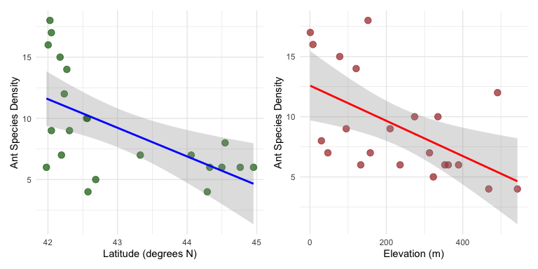

### Correlation Matrix

# Check correlations between all variables  
cor(ant_df)

Latitude Elevation AntSpeciesDensity  
Latitude 1.0000000 0.1787454 -0.5879407  
Elevation 0.1787454 1.0000000 -0.5545244  
AntSpeciesDensity -0.5879407 -0.5545244 1.0000000

|  |
| --- |
| Checking for Multicollinearity |
| The correlation between latitude and elevation is important to examine:   * **High correlation (|r| > 0.7)**: May indicate multicollinearity problems * **Moderate correlation (0.3 < |r| < 0.7)**: Usually acceptable * **Low correlation (|r| < 0.3)**: No multicollinearity concerns   Multicollinearity can make parameter estimates unstable and difficult to interpret. |

### 3D Visualization Concept

# Create a scatterplot showing both predictors with color-coded response  
ant_df %>%  
 ggplot(aes(x = Latitude, y = Elevation, color = AntSpeciesDensity, size = AntSpeciesDensity)) +  
 geom_point(alpha = 0.7) +  
 scale_color_viridis_c(name = "Species\nDensity") +  
 scale_size_continuous(name = "Species\nDensity", range = c(2, 6)) +  
 labs(  
 x = "Latitude (degrees N)",  
 y = "Elevation (m)",  
 title = "Ant Species Density in Geographic Space"  
 ) +  
 theme_minimal()

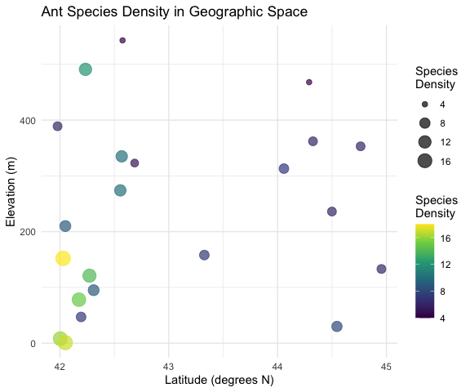

|  |
| --- |
| Interpreting the Geographic Plot |
| This plot shows the relationship between our two predictors and how species density varies across geographic space:   * **Color intensity**: Represents species density * **Point size**: Also represents species density * **Spatial patterns**: Help identify if there are geographic clusters or gradients |

# Multiple Linear Regression Analysis

## Fitting the Multiple Regression Model

# Fit the multiple linear regression model  
ant_model <- lm(AntSpeciesDensity ~ Latitude + Elevation, data = ant_df)  
  
# Display the model summary  
summary(ant_model)

Call:  
lm(formula = AntSpeciesDensity ~ Latitude + Elevation, data = ant_df)  
  
Residuals:  
 Min 1Q Median 3Q Max   
-6.1180 -2.3759 0.3218 1.9070 5.8369   
  
Coefficients:  
 Estimate Std. Error t value Pr(>|t|)   
(Intercept) 98.49651 26.50701 3.716 0.00147 **  
Latitude -2.00981 0.61956 -3.244 0.00427 **  
Elevation -0.01226 0.00411 -2.983 0.00765 **  
---  
Signif. codes: 0 '***' 0.001 '**' 0.01 '*' 0.05 '.' 0.1 ' ' 1  
  
Residual standard error: 3.022 on 19 degrees of freedom  
Multiple R-squared: 0.5543, Adjusted R-squared: 0.5074   
F-statistic: 11.82 on 2 and 19 DF, p-value: 0.000463

## Line-by-Line Interpretation of Multiple Regression Output

Let’s break down the multiple regression output:

1. **Call**: Shows the model formula: AntSpeciesDensity ~ Latitude + Elevation
2. **Residuals**: Summary statistics of residuals (observed - predicted values)
3. **Coefficients**:
   * **(Intercept)**: Expected ant species density when Latitude = 0 and Elevation = 0
   * **Latitude**: Partial slope - change in species density per 1-degree increase in latitude, holding elevation constant
   * **Elevation**: Partial slope - change in species density per 1-meter increase in elevation, holding latitude constant
   * **Std. Error**: Standard error of each coefficient estimate
   * **t value**: t-statistic for testing if each coefficient ≠ 0
   * **Pr(>|t|)**: p-value for each coefficient’s significance test
4. **Residual standard error**: Estimate of σ (standard deviation of residuals)
5. **Multiple R-squared**: Proportion of total variance in species density explained by both predictors combined
6. **Adjusted R-squared**: R² adjusted for the number of predictors (penalizes for additional variables)
7. **F-statistic**: Tests the overall significance of the regression model (H₀: β₁ = β₂ = 0)
8. **p-value**: Probability of observing this relationship by chance if no true relationships exist

|  |
| --- |
| Key Interpretations for Ecological Data |
| * **Intercept**: Often not biologically meaningful (no sites at 0° latitude, 0m elevation) * **Latitude coefficient**: Expected to be negative if species diversity decreases northward * **Elevation coefficient**: Expected to be negative if species diversity decreases with altitude * **Adjusted R²**: More conservative measure of model fit than regular R² * **Overall F-test**: Tests whether the model explains significantly more variance than a null model |

## ANOVA Table for Multiple Regression

# Get ANOVA table for the multiple regression  
anova(ant_model)

Analysis of Variance Table  
  
Response: AntSpeciesDensity  
 Df Sum Sq Mean Sq F value Pr(>F)   
Latitude 1 134.562 134.562 14.7370 0.001107 **  
Elevation 1 81.224 81.224 8.8955 0.007652 **  
Residuals 19 173.487 9.131   
---  
Signif. codes: 0 '***' 0.001 '**' 0.01 '*' 0.05 '.' 0.1 ' ' 1

The ANOVA table shows:

* **Sequential sums of squares**: How much variance each predictor explains when added to the model
* **Latitude**: Variance explained by latitude alone
* **Elevation**: Additional variance explained by elevation after accounting for latitude
* **Residuals**: Unexplained variance remaining in the model

|  |
| --- |
| Understanding Sequential ANOVA |
| The order matters in this ANOVA table:   1. **Latitude** row: Tests significance of latitude when entered first 2. **Elevation** row: Tests significance of elevation when added after latitude 3. This is **sequential** (Type I) sums of squares - results can change if you reorder predictors |

# Testing Multiple Regression Assumptions

Multiple regression has the same assumptions as simple regression, but with additional considerations for multiple predictors.

## Assumptions of Multiple Linear Regression

1. **Linearity**: Linear relationships between Y and each X, and Y and the combination of X’s
2. **Independence**: Observations are independent
3. **Homoscedasticity**: Constant variance of residuals
4. **Normality**: Residuals are normally distributed
5. **No multicollinearity**: Predictor variables are not highly correlated with each other
6. **Sufficient sample size**: Generally need at least 10-20 observations per predictor

### 1. Sample Size Check

# Check sample size relative to number of predictors  
n_obs <- nrow(ant_df)  
n_predictors <- 2  
obs_per_predictor <- n_obs / n_predictors  
  
n_obs

[1] 22

n_predictors

[1] 2

obs_per_predictor

[1] 11

|  |
| --- |
| Sample Size Considerations |
| With 22 observations and 2 predictors:   * **Ratio**: 11 observations per predictor * **Adequate**: Generally acceptable (>10 per predictor) * **Limitation**: Relatively small sample size limits model complexity * **Power**: May have limited power to detect small effects |

### 2. Multicollinearity Assessment

# Calculate Variance Inflation Factors (VIF)  
vif(ant_model)

Latitude Elevation   
 1.033004 1.033004

|  |
| --- |
| Interpreting VIF Values |
| **Variance Inflation Factor (VIF) interpretation**:   * **VIF = 1**: No correlation with other predictors * **VIF < 5**: Generally acceptable multicollinearity * **VIF 5-10**: Moderate multicollinearity (interpret coefficients carefully) * **VIF > 10**: Severe multicollinearity problem (consider removing predictors)   **Rule of thumb**: VIF > 10 indicates problematic multicollinearity |

### 3. Linearity, Homoscedasticity, and Normality

# Standard diagnostic plots for multiple regression  
par(mfrow = c(2, 2))  
plot(ant_model)

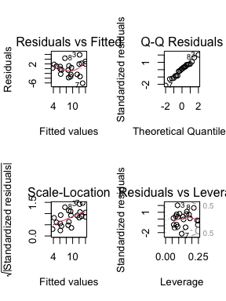

par(mfrow = c(1, 1))

|  |
| --- |
| Diagnostic Plot Interpretation for Multiple Regression |
| 1. **Residuals vs Fitted**: Should show random scatter    * Patterns suggest non-linearity or missing predictors    * Funnel shapes indicate heteroscedasticity 2. **Normal Q-Q**: Points should follow diagonal line    * Systematic deviations suggest non-normal residuals 3. **Scale-Location**: Should show horizontal trend    * Increasing trend suggests heteroscedasticity 4. **Residuals vs Leverage**: Identifies influential observations    * Points beyond Cook’s distance lines are highly influential |

### 4. Formal Tests of Assumptions

#### Test for Normality of Residuals

# Shapiro-Wilk test for normality of residuals  
shapiro.test(residuals(ant_model))

Shapiro-Wilk normality test  
  
data: residuals(ant_model)  
W = 0.983, p-value = 0.9562

#### Test for Homoscedasticity

# Breusch-Pagan test for homoscedasticity  
bptest(ant_model)

studentized Breusch-Pagan test  
  
data: ant_model  
BP = 5.9769, df = 2, p-value = 0.05037

#### Individual Predictor Linearity

# Create added-variable plots (partial regression plots)  
par(mfrow = c(1, 2))  
avPlots(ant_model)

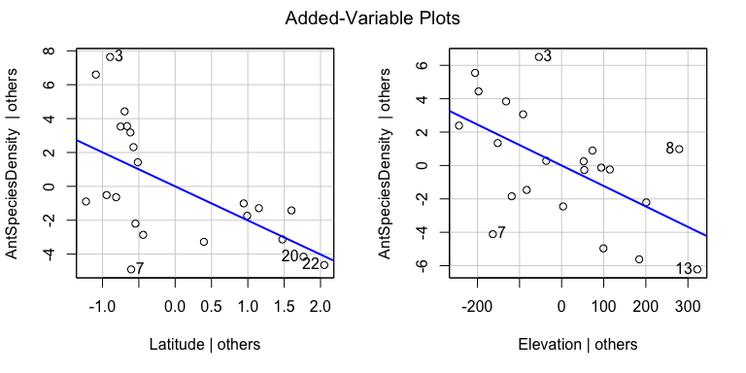

par(mfrow = c(1, 1))

|  |
| --- |
| Added-Variable (Partial Regression) Plots |
| These plots show the relationship between:   * **Y-axis**: Response variable with effects of other predictors removed * **X-axis**: Focal predictor with effects of other predictors removed * **Purpose**: Visualize the partial relationship while controlling for other variables * **Interpretation**: Slope of line equals the partial regression coefficient |

## Interpretation of Assumption Tests

Based on diagnostic plots and formal tests:

1. **Linearity**: Added-variable plots show whether relationships are linear after controlling for other predictors
2. **Multicollinearity**: VIF values indicate whether predictors are too highly correlated
3. **Homoscedasticity**:
   * Scale-Location plot should show constant spread
   * Breusch-Pagan test: p > 0.05 suggests homoscedasticity
4. **Normality**:
   * Q-Q plot should show points on diagonal line
   * Shapiro-Wilk test: p > 0.05 suggests normality
   * With small samples (n=22), this test is quite sensitive
5. **Independence**: Cannot be tested statistically; depends on study design

|  |
| --- |
| If Assumptions Are Violated |
| **For multiple regression problems**:   * **Multicollinearity**: Remove highly correlated predictors or use ridge regression * **Non-linearity**: Add polynomial terms or transform variables * **Heteroscedasticity**: Use weighted least squares or transform response variable * **Non-normality**: Transform response variable or use robust regression * **Small sample size**: Interpret results cautiously, consider model simplification |

# Results and Model Interpretation

## Model Equation

Based on our multiple regression analysis:

# Extract coefficients  
coef(ant_model)

(Intercept) Latitude Elevation   
 98.4965080 -2.0098124 -0.0122576

**Ant Species Density = Intercept + β₁(Latitude) + β₂(Elevation)**

# Create the equation string  
intercept <- coef(ant_model)[1]  
lat_coef <- coef(ant_model)[2]   
elev_coef <- coef(ant_model)[3]  
  
paste("Ant Species Density =", round(intercept, 2), "+",   
 round(lat_coef, 3), "× Latitude", "+",   
 round(elev_coef, 4), "× Elevation")

[1] "Ant Species Density = 98.5 + -2.01 × Latitude + -0.0123 × Elevation"

# Model Comparison and Variable Importance

## Comparing Nested Models

# Fit reduced models to test variable importance  
model_lat_only <- lm(AntSpeciesDensity ~ Latitude, data = ant_df)  
model_elev_only <- lm(AntSpeciesDensity ~ Elevation, data = ant_df)  
  
# Compare model summaries  
summary(model_lat_only)$r.squared

[1] 0.3456743

summary(model_elev_only)$r.squared

[1] 0.3074973

summary(ant_model)$r.squared

[1] 0.5543306

# Test significance of adding elevation to latitude-only model  
anova(model_lat_only, ant_model)

Analysis of Variance Table  
  
Model 1: AntSpeciesDensity ~ Latitude  
Model 2: AntSpeciesDensity ~ Latitude + Elevation  
 Res.Df RSS Df Sum of Sq F Pr(>F)   
1 20 254.71   
2 19 173.49 1 81.224 8.8955 0.007652 **  
---  
Signif. codes: 0 '***' 0.001 '**' 0.01 '*' 0.05 '.' 0.1 ' ' 1

# Test significance of adding latitude to elevation-only model   
anova(model_elev_only, ant_model)

Analysis of Variance Table  
  
Model 1: AntSpeciesDensity ~ Elevation  
Model 2: AntSpeciesDensity ~ Latitude + Elevation  
 Res.Df RSS Df Sum of Sq F Pr(>F)   
1 20 269.57   
2 19 173.49 1 96.085 10.523 0.004272 **  
---  
Signif. codes: 0 '***' 0.001 '**' 0.01 '*' 0.05 '.' 0.1 ' ' 1

|  |
| --- |
| Model Comparison Interpretation |
| **ANOVA F-tests compare nested models**:   * **Null hypothesis**: Reduced model fits as well as full model * **Alternative hypothesis**: Full model fits significantly better * **Interpretation**: p < 0.05 suggests the additional variable(s) significantly improve model fit   **R² comparison**: - Shows how much additional variance each predictor explains - Cannot use R² alone to compare models (always increases with more predictors) |

# Methods Section (for Publication)

**Statistical Analysis**: We used multiple linear regression to examine the relationship between ant species density and two environmental predictors: latitude and elevation. Prior to analysis, we examined the data for outliers and tested model assumptions including linearity (using added-variable plots), independence, homoscedasticity (Breusch-Pagan test), normality of residuals (Shapiro-Wilk test), and multicollinearity (variance inflation factors). We assessed the significance of individual predictors using t-tests and the overall model using F-tests. Model comparison was conducted using ANOVA to test the significance of each predictor’s contribution. Statistical significance was set at α = 0.05. All analyses were conducted in R (version X.X.X).

# Results Section (for Publication)

The multiple regression model significantly explained variation in ant species density across sampling sites (F(2,19) = [F-value], p = [p-value], R² = [R² value], adjusted R² = [adj R² value]). [Interpret individual coefficients based on significance]. Latitude had a [significant/non-significant] partial effect on species density (β = [coefficient], t = [t-value], p = [p-value]), with species density [increasing/decreasing] by [absolute coefficient] species per degree increase in latitude when elevation was held constant. Elevation had a [significant/non-significant] partial effect (β = [coefficient], t = [t-value], p = [p-value]), with species density [increasing/decreasing] by [absolute coefficient] species per meter increase in elevation when latitude was held constant. Model assumptions were adequately met [or describe any violations and how they were addressed].

# Publication Quality Figure

# Create a comprehensive figure showing the multiple regression results  
  
# Panel A: Latitude relationship (partial effect)  
p1 <- ant_df %>%  
 ggplot(aes(x = Latitude, y = AntSpeciesDensity)) +  
 geom_point(size = 3, alpha = 0.7, color = "darkgreen") +  
 geom_smooth(method = "lm", se = TRUE, color = "blue", alpha = 0.3) +  
 labs(  
 x = "Latitude (°N)",  
 y = "Ant Species Density",  
 title = "A) Latitude Effect"  
 ) +  
 theme_classic() +  
 theme(  
 axis.title = element_text(size = 11, face = "bold"),  
 axis.text = element_text(size = 10),  
 plot.title = element_text(size = 12, face = "bold")  
 )  
  
# Panel B: Elevation relationship (partial effect)   
p2 <- ant_df %>%  
 ggplot(aes(x = Elevation, y = AntSpeciesDensity)) +  
 geom_point(size = 3, alpha = 0.7, color = "brown") +  
 geom_smooth(method = "lm", se = TRUE, color = "red", alpha = 0.3) +  
 labs(  
 x = "Elevation (m)",  
 y = "Ant Species Density",   
 title = "B) Elevation Effect"  
 ) +  
 theme_classic() +  
 theme(  
 axis.title = element_text(size = 11, face = "bold"),  
 axis.text = element_text(size = 10),  
 plot.title = element_text(size = 12, face = "bold")  
 )  
  
# Panel C: Model fit (observed vs predicted)  
ant_df$predicted <- fitted(ant_model)  
p3 <- ant_df %>%  
 ggplot(aes(x = predicted, y = AntSpeciesDensity)) +  
 geom_point(size = 3, alpha = 0.7, color = "purple") +  
 geom_abline(slope = 1, intercept = 0, linetype = "dashed", color = "black") +  
 labs(  
 x = "Predicted Species Density",  
 y = "Observed Species Density",  
 title = "C) Model Fit"  
 ) +  
 theme_classic() +  
 theme(  
 axis.title = element_text(size = 11, face = "bold"),  
 axis.text = element_text(size = 10),  
 plot.title = element_text(size = 12, face = "bold")  
 )  
  
# Panel D: Geographic distribution  
p4 <- ant_df %>%  
 ggplot(aes(x = Latitude, y = Elevation, color = AntSpeciesDensity, size = AntSpeciesDensity)) +  
 geom_point(alpha = 0.8) +  
 scale_color_viridis_c(name = "Species\nDensity") +  
 scale_size_continuous(name = "Species\nDensity", range = c(2, 6)) +  
 labs(  
 x = "Latitude (°N)",  
 y = "Elevation (m)",  
 title = "D) Geographic Distribution"  
 ) +  
 theme_classic() +  
 theme(  
 axis.title = element_text(size = 11, face = "bold"),  
 axis.text = element_text(size = 10),  
 plot.title = element_text(size = 12, face = "bold"),  
 legend.title = element_text(size = 10, face = "bold")  
 )  
  
# Combine all panels  
combined_plot <- (p1 + p2) / (p3 + p4)  
  
combined_plot

