Lecture 11 — One-Way ANOVA: Comparing Many Groups
  - Partitioning variance, checking assumptions, and post-hoc tests with emmeans
Bill Perry
2026-07-05

Where we left off (Lecture 10)
- Factors — categorical variables with an ordered set of levels
- fct_reorder() / fct_relevel() — set the order and the reference group
- Cleaner, better-ordered plots for grouped data
 Note
✅ Transition
The t-test (Lecture 04) compared two groups. But biology is full of three-or-more group questions — three species, four sites, five treatments. Now that you can control factor levels, today we learn the test for many groups: one-way ANOVA.

Goals for today
- Understand why we don’t just run many t-tests
- See how the F-statistic compares between- vs within-group variance
- State ANOVA hypotheses (H₀: all means equal)
- Check assumptions — normality of residuals, equal variance
- Run it two ways: aov() and car::Anova()
- Find which groups differ with emmeans post-hoc tests
Tools today:
- palmerpenguins, tidyverse
- car — Levene’s test, Anova()
- emmeans, multcomp — post-hoc
Textbook:
- 📖 Whitlock & Schluter, Ch. 15 — ANOVA
- 📖 R4DS Ch. 16 — Factors
- 📖 R4DS Ch. 9 — Layers
Naming: models → _model, plots → _plot

How to Use These Slides — Predict · Type · Run
This lecture runs in four short chunks. After each chunk you switch to the activity and type the code yourself.
For every code block, do three things:
- Predict — before it runs, say what you think the output will be
- Type it out by hand — do not copy-paste
- Run it and compare to your prediction
Note
✅ Why bother? (the evidence)
- Predicting first forces you to retrieve what you know — the gap between guess and answer is what makes it stick.
- Typing by hand builds the finger-memory and error-spotting that copy-paste skips.
- Chunk → immediate practice keeps each idea in working memory long enough to form a lasting schema.

🧩 Chunk 1 of 4 · Why ANOVA & the F-Statistic
We will cover: why not many t-tests, what ANOVA asks, how F partitions variance, and a first look at the penguin data.
 Tip
🖐 After this chunk: Activity Parts 1–3 (load the penguins, explore, state hypotheses).

Why Not Just Run Many t-Tests?
With 3 groups you’d need 3 t-tests (A–B, A–C, B–C). With 4 groups, 6 tests.
Every test at α = 0.05 has a 5% chance of a false positive. Run several and those risks stack up:
- 3 tests → ~14% chance of at least one false positive
- 6 tests → ~26%
ANOVA asks the question once, holding the overall error rate at 0.05.
 Important
The multiple-comparisons problem
More tests = more chances to be fooled by noise. ANOVA is the single, honest test for “do any of these groups differ?”

📖 W&S §15.1 — why a single test

What One-Way ANOVA Asks
One numeric response (Y) across the levels of one categorical predictor (X).
 | Hypothesis
H₀ — null | all group means are equal ($μ_{1}=μ_{2}=μ_{3}$)
Hₐ — alternate | at least one group mean differs
Note what Hₐ does not say: it does not tell you which group differs — that comes later, from the post-hoc test.
Our question today:
Do the three penguin species differ in body mass?
- Y = body_mass_g
- X = species (Adelie, Chinstrap, Gentoo)

The F-Statistic — Between vs. Within
$$F=\frac{\text{variance BETWEEN groups}}{\text{variance WITHIN groups}}$$
- Between — how far apart the group means are
- Within — how much the individuals scatter inside each group
Big F → the groups are far apart relative to their internal noise → small p-value.
F ≈ 1 → the spread between groups is no bigger than the spread within them → no real difference.
Note
✅ Key idea
ANOVA is a signal-to-noise ratio. The “signal” is the gap between group means; the “noise” is the within-group scatter.

📖 W&S §15.1–15.2

Meet the Data — Palmer Penguins
# Load packages at the top — always -------------------
library(tidyverse) # wrangling + ggplot2
library(palmerpenguins) # the penguins data
library(car) # Levene's test, Anova()
library(emmeans) # post-hoc pairwise tests
# Drop rows missing mass or species -------------------
penguins_df <- penguins %>%
drop_na(body_mass_g, species)
penguins_df %>% count(species)
# A tibble: 3 × 2
species n
<fct> <int>
1 Adelie 151
2 Chinstrap 68
3 Gentoo 123
Three species, one lab: body mass (g) of penguins at Palmer Station, Antarctica.
- drop_na() removes rows with missing mass
- count(species) shows the sample size per group
Important
The groups are unbalanced (different n per species) — that matters when we pick our ANOVA type later.

Explore First — Boxplot by Species
Note
🔮 Predict first: Before the plot renders — do you expect all three species to differ, or just one? Which species do you think is heaviest?

mass_box_plot <- penguins_df %>%
ggplot(aes(x = species, y = body_mass_g, fill = species)) +
geom_boxplot(alpha = 0.5, outlier.shape = NA) +
geom_point(
position = position_jitter(width = 0.15, seed = 42),
alpha = 0.3, size = 1.5
) +
labs(x = "Species", y = "Body Mass (g)") +
theme_minimal() +
theme(legend.position = "none")
mass_box_plot
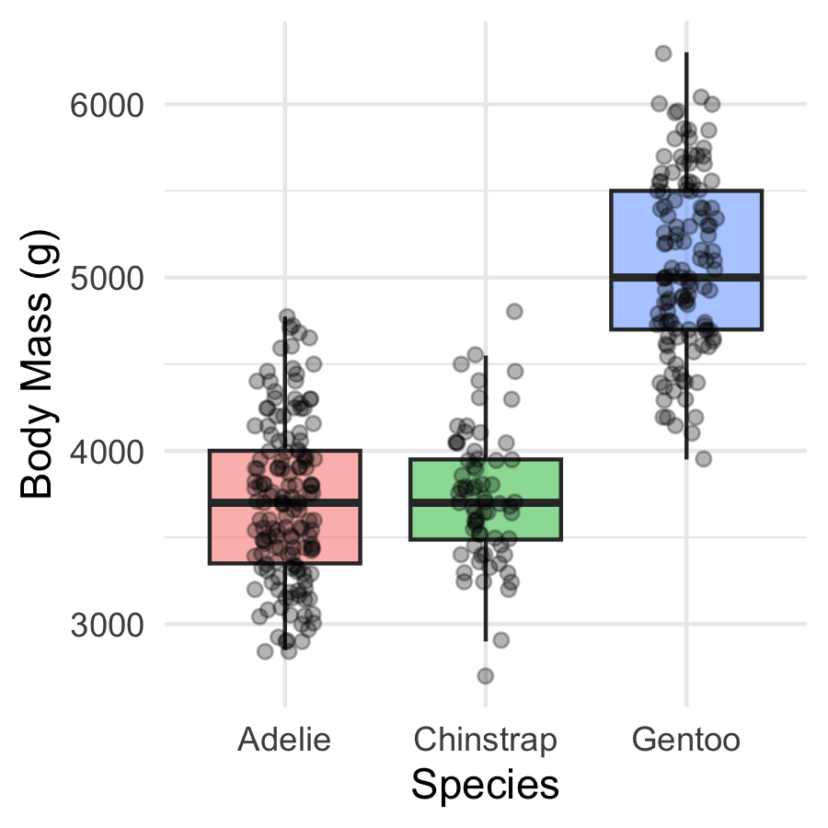
Always plot before you test.
- The picture usually tells the story before the p-value confirms it
- Look for separation between boxes and roughly similar spread
📖 R4DS §9 — Layers

🛑 Pause — Do Activity Parts 1–3 Now
Load the penguins, plot body mass by species, and write your hypotheses. Predict which species differ before you run anything.

🧩 Chunk 2 of 4 · Fit the Model & Check Assumptions
We will cover: fitting the model, then checking normality of the residuals and equal variance across groups.
Tip
🖐 After this chunk: Activity Parts 4–6 (fit, QQ + Shapiro on residuals, Levene’s test).

Fit the Model
# ANOVA is a linear model with a categorical X ---------
mass_model <- lm(body_mass_g ~ species, data = penguins_df)
- lm(Y ~ X) — the same syntax as regression (Lecture 06)
- When X is categorical, that linear model is a one-way ANOVA
- We check assumptions on this model before reading any p-value
Note
✅ Key idea
ANOVA and regression are the same machinery (lm). ANOVA just has a grouping variable instead of a numeric one.

📖 W&S §15.2

Assumption 1 — Normality of the Residuals
# QQ plot of residuals — points should track the line -
qq_mass_plot <- penguins_df %>%
mutate(resid = residuals(mass_model)) %>%
ggplot(aes(sample = resid)) +
stat_qq() +
stat_qq_line(color = "red", linewidth = 0.8) +
labs(x = "Theoretical", y = "Sample residuals") +
theme_minimal()
qq_mass_plot
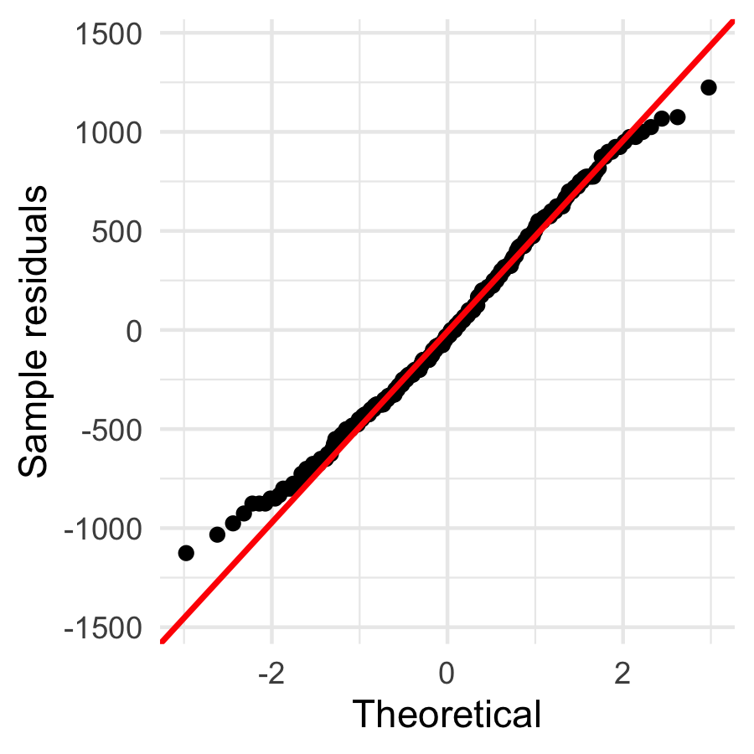
shapiro.test(residuals(mass_model))
Shapiro-Wilk normality test
data: residuals(mass_model)
W = 0.99166, p-value = 0.05118
- Check normality of the residuals, not the raw masses
- The QQ plot is the main tool; Shapiro-Wilk is a formal check
Important
Large-sample caution: with ~340 birds, Shapiro-Wilk flags tiny departures as “significant.” Trust the QQ plot — if points track the line, you’re fine.

Assumption 2 — Equal Variance (Levene’s Test)
Note
🔮 Predict first: Look back at the boxplot spreads. Predict — will Levene’s test call the variances equal (p > 0.05) or unequal?

# Levene's test — H0: all groups have equal variance --
leveneTest(body_mass_g ~ species, data = penguins_df)
Levene's Test for Homogeneity of Variance (center = median)
Df F value Pr(>F)
group 2 5.1203 0.006445 **
339
---
Signif. codes: 0 '***' 0.001 '**' 0.01 '*' 0.05 '.' 0.1 ' ' 1
- p > 0.05 → variances similar → classic ANOVA is fine
- p < 0.05 → variances differ → use Welch’s ANOVA:
oneway.test(body_mass_g ~ species,
data = penguins_df,
var.equal = FALSE)
Same spirit as Welch’s t-test — robust when spreads differ.

🛑 Pause — Do Activity Parts 4–6 Now
Fit lm(body_mass_g ~ species), check the residual QQ plot + Shapiro, and run Levene’s test. Predict each result before you run it.

🧩 Chunk 3 of 4 · Run the ANOVA & Read the F Table
We will cover: the ANOVA table two ways — base aov() and car::Anova() — and why the difference matters for unbalanced data.
Tip
🖐 After this chunk: Activity Parts 7–8 (run both, read F / df / p).

Run the ANOVA — aov() and summary()
Note
🔮 Predict first: The boxplot looked very separated. Predict the p-value — closer to 0.5, 0.05, or far below 0.001?

# Classic ANOVA table (Type I sums of squares) --------
mass_aov <- aov(body_mass_g ~ species, data = penguins_df)
summary(mass_aov)
Df Sum Sq Mean Sq F value Pr(>F)
species 2 146864214 73432107 343.6 <2e-16 ***
Residuals 339 72443483 213698
---
Signif. codes: 0 '***' 0.001 '**' 0.01 '*' 0.05 '.' 0.1 ' ' 1
Reading the table:
Column | Meaning
Df | groups − 1, and residual df
F value | between ÷ within variance
Pr(>F) | the p-value for H₀
p < 0.05 → reject H₀ → at least one species differs. But which? Chunk 4.

Live Demo — Watch It Break (on purpose)
For unbalanced data we prefer car::Anova(). I’ll reach for it but type lowercase, and forget the package:
anova(mass_model) # base R — Type I, one model at a time
Anova(mass_model) # capital A — but car isn't loaded!
R stops:
Error in Anova(mass_model) :
could not find function "Anova"
The fix — load car, and mind the capital A:
library(car)
Anova(mass_model, type = "II")
Tip
✅ Why show a broken run?
anova() (base) and Anova() (car) are different functions — lowercase compares models with Type I sums of squares; capital-A gives the Type II/III table you want. “could not find function” almost always means a missing library().

car::Anova() — Type II for Unbalanced Data
# Type II sums of squares — the right call here -------
Anova(mass_model, type = "II")
Anova Table (Type II tests)
Response: body_mass_g
Sum Sq Df F value Pr(>F)
species 146864214 2 343.63 < 2.2e-16 ***
Residuals 72443483 339
---
Signif. codes: 0 '***' 0.001 '**' 0.01 '*' 0.05 '.' 0.1 ' ' 1
Why Type II?
- Our groups have different n (unbalanced)
- With one predictor the F is the same, but Type II is the habit you want before you meet two-way ANOVA, where the type genuinely changes the answer
Note
anova() = Type I (order-dependent). Anova(type = "II") = order-independent.

🛑 Pause — Do Activity Parts 7–8 Now
Run aov() + summary(), then car::Anova(type = "II"). Predict the F and p before you read them, and confirm both tables agree.

🧩 Chunk 4 of 4 · Which Groups Differ? Post-Hoc with emmeans
We will cover: ANOVA says “some differ” — emmeans says which, with the comparisons properly adjusted.
Tip
🖐 After this chunk: Activity Parts 9–11 (pairwise tests, letters, plot, report).

Post-Hoc — Pairwise Comparisons with emmeans
Note
🔮 Predict first: From the boxplot, predict — will all three species differ from each other, or will two be statistically tied?

# Estimated marginal means + Tukey-adjusted pairs -----
mass_emm <- emmeans(mass_model, pairwise ~ species)
mass_emm$contrasts
contrast estimate SE df t.ratio p.value
Adelie - Chinstrap -32.4 67.5 339 -0.480 0.8807
Adelie - Gentoo -1375.4 56.1 339 -24.495 <0.0001
Chinstrap - Gentoo -1342.9 69.9 339 -19.224 <0.0001
P value adjustment: tukey method for comparing a family of 3 estimates
Reading it:
- emmeans(..., pairwise ~ species) gives each group’s mean and every pairwise comparison
- The p-values are Tukey-adjusted — they already correct for multiple comparisons, so the family-wise error stays at 0.05
📖 W&S §15.4 — planned vs. unplanned comparisons

Compact Letter Display — Who Shares a Letter?
# Groups that SHARE a letter are NOT different --------
multcomp::cld(mass_emm$emmeans, Letters = letters)
species emmean SE df lower.CL upper.CL .group
Adelie 3701 37.6 339 3627 3775 a
Chinstrap 3733 56.1 339 3623 3843 a
Gentoo 5076 41.7 339 4994 5158 b
Confidence level used: 0.95
P value adjustment: tukey method for comparing a family of 3 estimates
significance level used: alpha = 0.05
NOTE: If two or more means share the same grouping symbol,
then we cannot show them to be different.
But we also did not show them to be the same.
How to read letters:
- Same letter → not significantly different
- Different letters → significantly different
This is the compact summary you see in published figures — one letter above each bar.
Tip
Install once: install.packages("multcomp")

Plot the Result — Means ± CI
mass_emm_plot <- as.data.frame(mass_emm$emmeans) %>%
ggplot(aes(x = species, y = emmean, color = species)) +
geom_point(size = 3) +
geom_errorbar(
aes(ymin = lower.CL, ymax = upper.CL),
width = 0.15, linewidth = 0.9
) +
labs(x = "Species", y = "Estimated mean mass (g)") +
theme_minimal() +
theme(legend.position = "none")
mass_emm_plot
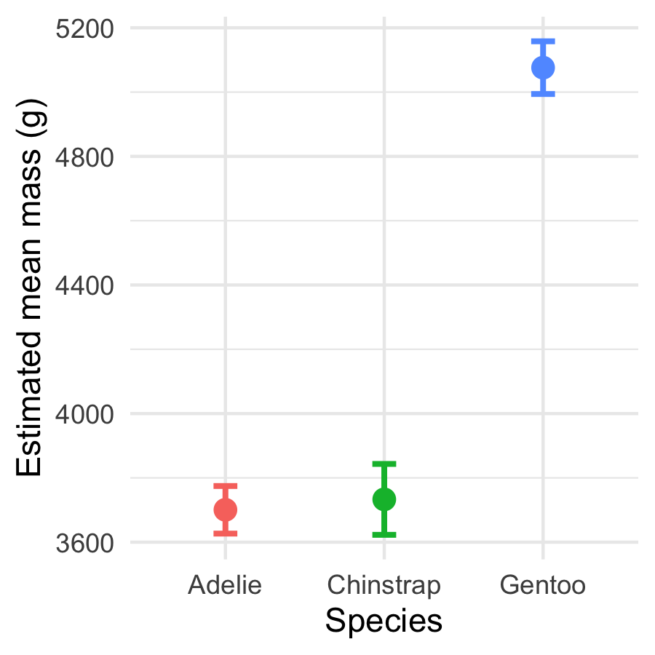
Estimated marginal means with 95% confidence intervals.
- Non-overlapping intervals hint at real differences
- Pair this plot with the letters for a publication-ready figure
The emmeans plot is the ANOVA cousin of Lecture 03’s mean ± SE plot.

How to Report an ANOVA
# Pull the F table values for reporting ---------------
mass_tab <- Anova(mass_model, type = "II")
mass_tab
Anova Table (Type II tests)
Response: body_mass_g
Sum Sq Df F value Pr(>F)
species 146864214 2 343.63 < 2.2e-16 ***
Residuals 72443483 339
---
Signif. codes: 0 '***' 0.001 '**' 0.01 '*' 0.05 '.' 0.1 ' ' 1
“Body mass differed significantly among the three penguin species (one-way ANOVA: F(2, 339) = 343.6, p < 0.001). Tukey-adjusted comparisons showed all three species differed, with Gentoo heaviest and Adelie lightest.”
Always include:
- Test type (one-way ANOVA)
- F, both df, and the p-value
- The post-hoc result (which groups differ)
- Group means ± SE or CI
Never write “p = 0.000” — use “p < 0.001”.

🛑 Pause — Do Activity Parts 9–11 Now
Run the emmeans pairwise test, get the letters, plot the means ± CI, and write your results sentence. Predict which species differ before you run the comparisons.

What We Learned Today
Concepts:
- Many t-tests inflate the false-positive rate — ANOVA asks once
- F = between-group ÷ within-group variance (signal ÷ noise)
- Assumptions: normal residuals, equal variance (Levene)
- ANOVA rejects H₀ for the group, but post-hoc finds which pairs differ
- Tukey adjustment keeps the family-wise error at 0.05
R skills:
- lm(Y ~ group) and aov() + summary()
- car::Anova(model, type = "II")
- leveneTest(), shapiro.test(residuals())
- emmeans(model, pairwise ~ group) + multcomp::cld()
References:
- 📖 W&S Ch. 15 — ANOVA
- 📖 R4DS Ch. 16 — Factors
- 📖 emmeans vignettes
Up next — Lecture 12:
- Joins — combine two tables on a shared key
- The prerequisite for bigger datasets — and for maps

